**U19EC046 | CN Lab 6**

**ICMP**

ICMP ( Internet Control Message Protocol ) - It is a protocol which is used for reachability, troubleshooting and network management. ICMP mainly used in Ping Utility Protocol Ping uses ICMP Request & Reply for its process. If any source is not reachable, ICMP sends an error message to source.

Types of ICMP packet

* 8 - ICMP Request
* 0 - ICMP Reply
* 3 - Destination Unreachable
* 0 - Destination network unreachable
* 1 - Destination host unreachable
* 13 - Packet administratively Filtered Checksum - Correct or not
* 11 - Time to live exceeded

Creating Ping request and analyzing using WireShark

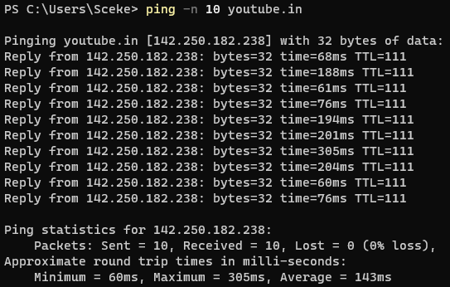

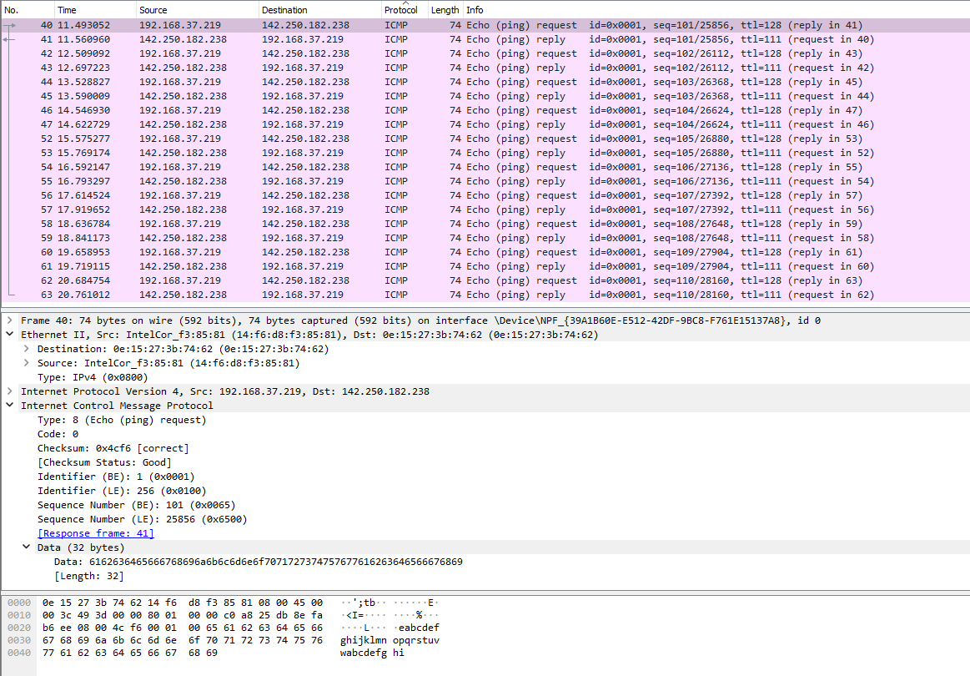

**Tracert**

It is used to trace the route from source to destination

* In linux tracert uses UDP protocol
* In windows, it uses ICMP protocol to trace route

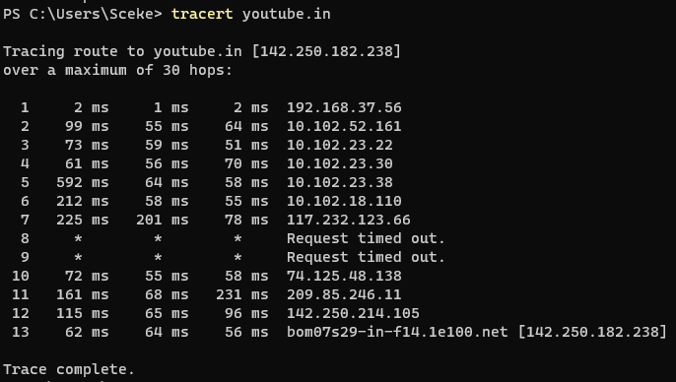

**UDP ( User Datagram Protocol )**

UDP is a protocol for transmitting data where there is requirement of Low Latency Transmission. It is assumed to be faster than a TCP connection. It formally doesn't make connection before transmitting data. UDP is faster bit less reliable than TCP Why UDP when we have TCP ? In TCP Handshake,

Step 1: In the first step, the client establishes a connection with a server. It sends a segment with SYN and informs the server about the client should start communication, and with what should be its sequence number.

Step 2: In this step server responds to the client request with SYN-ACK signal set. ACK helps you to signify the response of segment that is received and SYN signifies what sequence number it should able to start with the segments.

Step 3: In this final step, the client acknowledges the response of the Server, and they both create a stable connection that will begin the actual data transfer process.

TCP communications indicate the order in which data packets should be received and confirm that packets arrive as intended. If a packet does not arrive, TCP requires that it be re-sent. UDP communications do not include any of this functionality.

Because UDP doesn't need a handshake, or doesn't need to check whther data had been recieved properly or not, due to this the transmission in UDP is much faster than TCP.

Hence there is tradeoff, if data got lost in between then it will not be re-send again. Hence applications should be loss-tolerant.

It is mostly used in those applications where sometimes dropping packets is more beneficial than waiting for it to retransmit.

Hence, voice & video traffic is sent through this protocol. Even VoIP uses UDP for transmission.

**WireShark Analysis:**

Youtube live uses UDP so I turn on Youtube live and captured packet using wireshark

