**U19EC046 | DCOM | LAB 12**

**Date: 15-11-2021**

**AIM**

To study the effect of ISI and implement Raised Cosine Filter.

**THEORY**

***Inter Symbol Interference (ISI)***

This spreading and smearing of symbols such thatthe energy from one symbol effects the next onesin such a way that the received signal has a higherprobability of being interpreted incorrectly is calledInter Symbol Interference or ISI.

It can be caused by filtering effects from hardwareor frequency selective fading, from non-linearities and from charging effects.

This ISI effect can be overcome by Pulse Shaping Filter which we refer as Raised Cosine Filter.

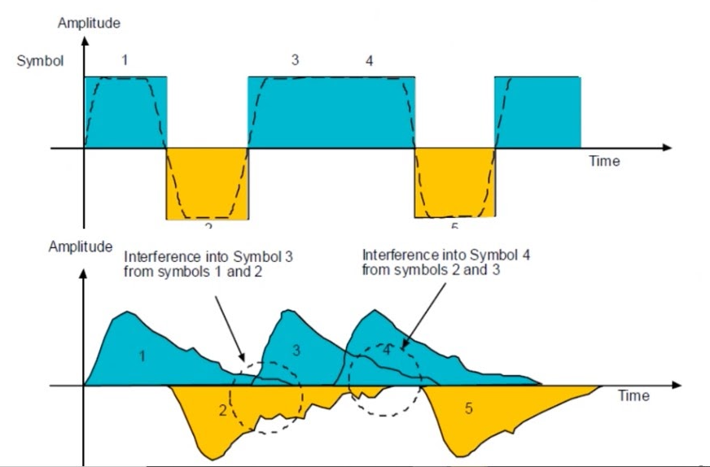

***Raised Cosine Filter***

The factor a is called the roll-of factor. It indicates how much bandwidth is being used over the ideal bandwidth.

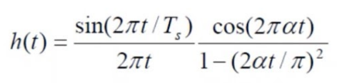

The first part is the sinc pulse. The second part is a cosine correction applied to the sinc pulse to make it behave better. The sinc pulse insures that the function transitions at integer multiples of symbol rate which makes it easy to extract timing information of the signal. The cosine part works to reduce the excursion in between the sampling instants.

**MATLAB CODE**

|  |
| --- |
| **clc;**  **clear all;**  **close all;**  **t= -10:0.1:10;**  **a=[0 0.5 1]; *% Alpha***  **w=1; *% bandwidth***  **subplot(1,2,1);**  **for x = 1:3**  **p_t = (sinc(2*w*t).*cos(2*pi*a(x)*w*t))./(1-(16*(a(x).^2)*(w^2)*(t.^2)));**  **plot(t,p_t,'LineWidth',2)**  **legendInfo{x} = ['alpha = ' num2str(a(x))];**  **legend(legendInfo)**  **hold on;**  **grid on;**  **end**  **title('Time Domain');**  **xlabel('t');**  **ylabel('Amplitude');**  **hold off;**  **subplot(1,2,2);**  **f=-10:0.1:10;**  **for i= 1:3**  **p_t = (sinc(2*w*t).*cos(2*pi*a(i)*w*t))./(1-(16*(a(i).^2)*(w^2)*(t.^2)));**  **p_f = abs(fftshift(fft(p_t)));**  **plot(f,p_f,'LineWidth',2)**  **legendInfo{i} = ['alpha = ' num2str(a(i))];**  **hold on;**  **grid on;**  **end**  **title('Frequency Domain');**  **xlabel('frequency');**  **ylabel('Amplitude');**  **legend(legendInfo);** |

**OUTPUT**

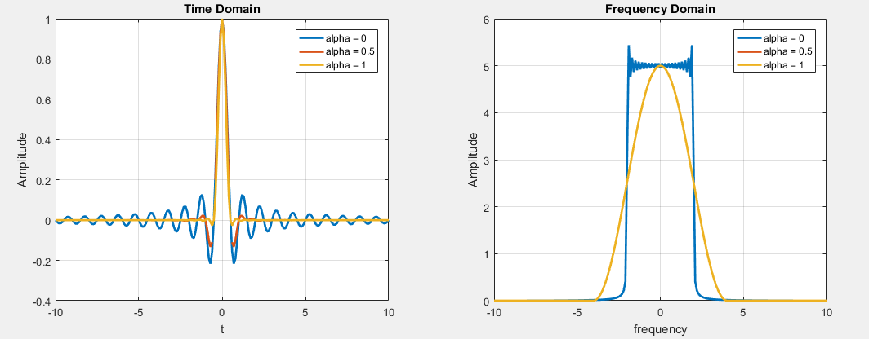

**CONCLUSION**

In this practical we have studied the effect of ISI and implemented the Raised Cosine Filter.