**U19EC046 | DCOM | LAB 11**

**Date: 15-11-2021**

**AIM**

1. To study and simulate Quadrature Amplitude Modulation and Demodulation and also plot its Constellation and Eye diagram
2. To compare and plot BER performance of 16_QAM modulation for AWGN channels.

**THEORY**

Quadrature Amplitude Modulation, QAM is a form of modulation that is a combination of phase modulation and amplitude modulation. The QAM scheme represents bits as points in a quadrant grid know as a constellation map.  
Constellation Map

* Is a graph of the phase and amplitude modulation points in a given modulation scheme.
* Shown below is the constellation map of 16-QAM

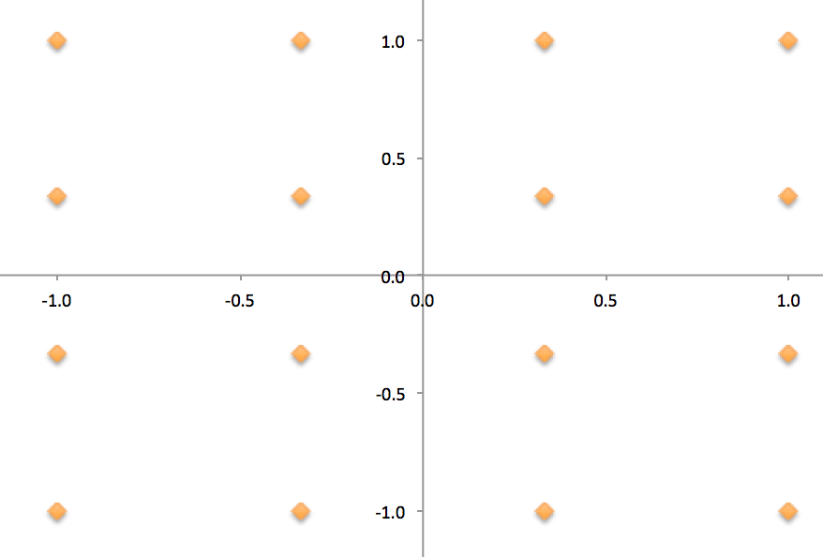

**Phase Modulation**

* Represents bits by changing the angle of a wave.
* An example of Phase Modulation is QPSK-4.

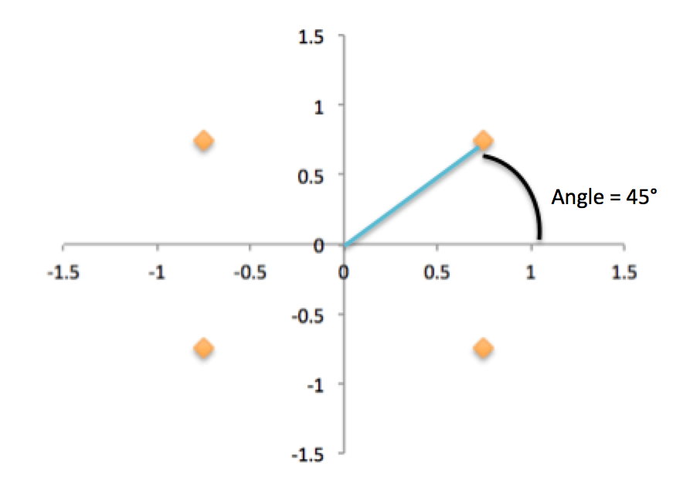

* As seen above, QPSK can have four different phase changes as four different angles.
* Is the angle of the constellation point.

## **QAM modulator**

The QAM modulator essentially follows the idea that can be seen from the basic QAM theory where there are two carrier signals with a phase shift of 90° between them. These are then amplitude modulated with the two data streams known as the I or In-phase and the Q or quadrature data streams. These are generated in the baseband processing area.

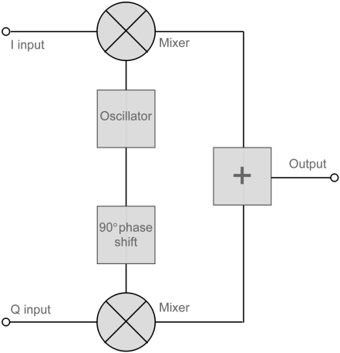

The two resultant signals are summed and then processed as required in the RF signal chain, typically converting them in frequency to the required final frequency and amplifying them as required.

It is worth noting that as the amplitude of the signal varies any RF amplifiers must be linear to preserve the integrity of the signal. Any non-linearities will alter the relative levels of the signals and alter the phase difference, thereby distorting he signal and introducing the possibility of data errors.

## **QAM demodulator**

The QAM demodulator is very much the reverse of the QAM modulator.

The signals enter the system, they are split and each side is applied to a mixer. One half has the in-phase local oscillator applied and the other half has the quadrature oscillator signal applied.

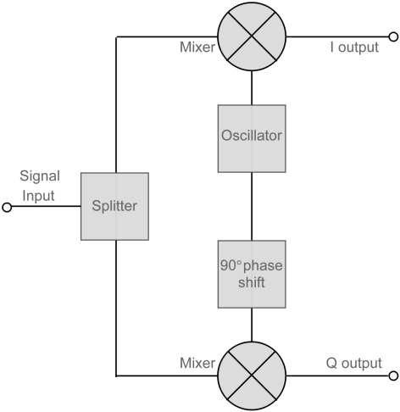

The basic modulator assumes that the two quadrature signals remain exactly in quadrature.

A further requirement is to derive a local oscillator signal for the demodulation that is exactly on the required frequency for the signal. Any frequency offset will be a change in the phase of the local oscillator signal with respect to the two double sideband suppressed carrier constituents of the overall signal.

Systems include circuitry for carrier recovery that often utilises a phase locked loop - some even have an inner and outer loop. Recovering the phase of the carrier is important otherwise the bit error rate for the data will be compromised.

**MATLAB CODE**

|  |
| --- |
| **clc; clear all;**  **M = 16; %for QAM-16 modulation**  **k = log2(M); %no of bits per symbol**  **data = randi([0 15],100*k,1); %generating random data from 0 to 15**  **figure;**  **stairs(data) %plotting data**  **txSig = qammod(data,M); %modulation using QAMMOD**  **scatterplot(txSig) %constellation diagram for transmitted signal**  **eyediagram(txSig,2); %eye diagram for transmitted signal**  **rxSig = awgn(txSig,25); %simulating noise due to channel**  **rxData = qamdemod(rxSig, M); %demodulating the received signal**  **figure;**  **stairs(rxData) %plotted the demodulated data**  **scatterplot(rxSig) %constellation diagram for received signal**  **eyediagram(rxSig,2); %eye diagram for received signal**  **k=log2(M);**  **S_nr=3:1:13;**  **B_er=(1/k)*3/2*erfc(sqrt(k*0.05*(10.^(S_nr/10))));**  **semilogy (S_nr,B_er);**  **hold on**  **grid on**  **xlabel('SNR dB')**  **ylabel('BER')**  **title('BER VS SNR')** |
|  |

**OUTPUT**

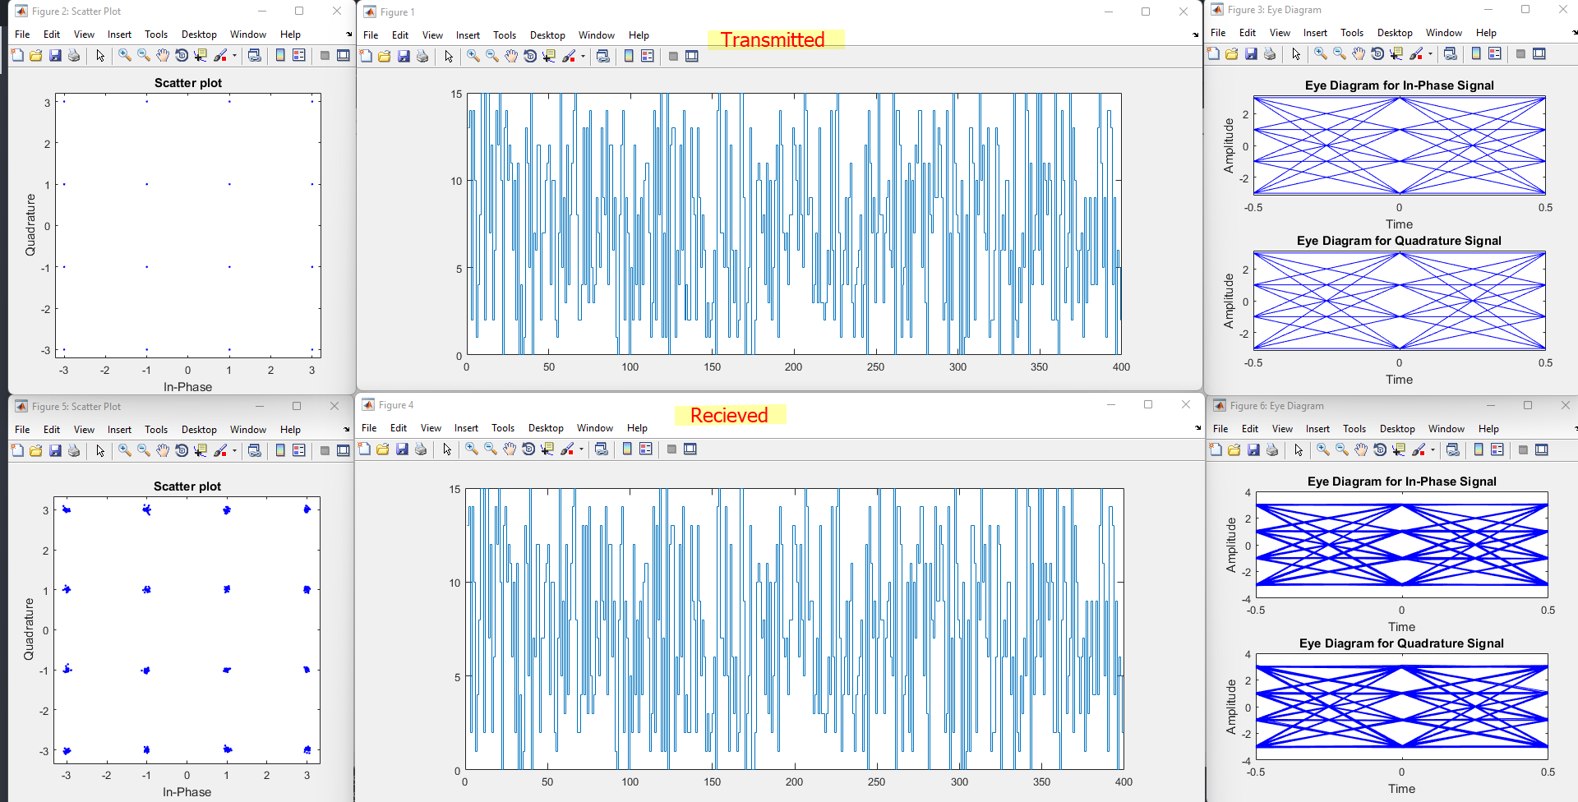

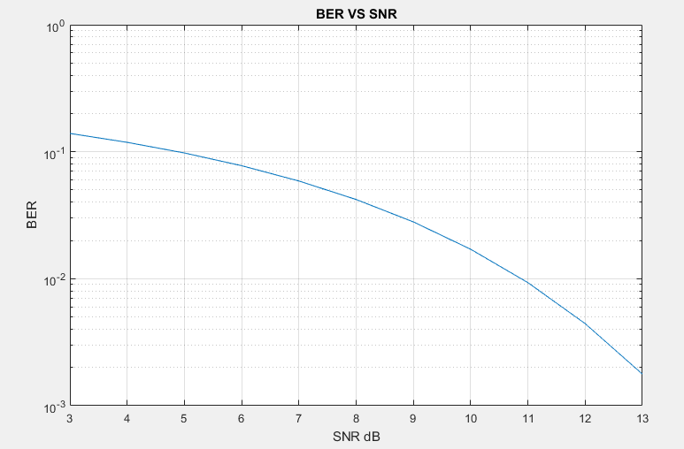

**CONCLUSION**

In this practical we have simulate Quadrature Amplitude Modulation and Demodulation and also plotted its Constellation and Eye diagram.