**U19EC045 | DCOM | LAB 2**

**AIM**

Using Matlab Find:

1. Entropy of symbols given probability of each symbol
2. Convert an image to greyscale image and find the entropy of the image

**THEORY**

Entropy can be defined as a measure of the average information content per source symbol. Claude Shannon, the “father of the Information Theory”, provided a formula for it as −

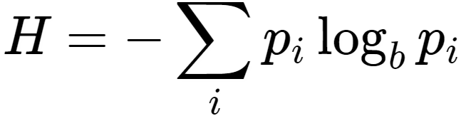

Where pi is the probability of the occurrence of character number i from a given stream of characters and b is the base of the algorithm used. Hence, this is also called as Shannon’s Entropy.

The amount of uncertainty remaining about the channel input after observing the channel output, is called as Conditional Entropy. It is denoted by H(x|y)

**MATLAB CODE**

1. Entropy of symbols

|  |
| --- |
| **n = input('Enter number of Symbols : '); *%read number of symbols***  **p = zeros(1,n) *%initialize probability vector***  **for i = 1:n *%read probabilities***  **p(i) = input(['Enter probability p(' num2str(i) ') : ']);**  **end**  **res = -sum(p.*log2(p)); *%calculate entropy***  **disp(['Entropy = ' num2str(res)]); *%display result*** |

1. Entropy of an image

|  |
| --- |
| **[coloredImage, map] = imread('coloredImage.png'); *% Read the image***  **figure;**  **imshow(coloredImage, map); *% Show the image***  **grayscaledImage = rgb2gray(map); *% Convert the image to grayscale***  **figure;**  **imshow(coloredImage,grayscaledImage); *% Show the greyscaled image***  **J = entropy(grayscaledImage); *% Calculate the entropy of the image***  **disp(['Entropy of grayscaled image is ' num2str(J)]) *% Display the entropy*** |

**OUTPUT**

1. Entropy of symbols

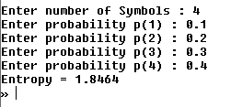

1. Entropy of an image

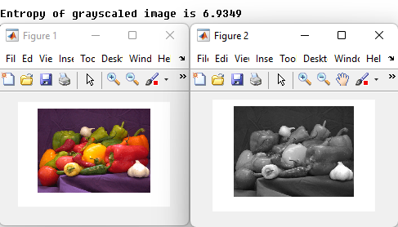

**CONCLUSION**

In this practical we have implemented the Matlab code for finding the entropy of symbols given its probability and also implemented the code to find the entropy of a grayscale image.