**U19EC045 | DCOM | LAB 3**

**AIM**

To determine Channel Capacity and Mutual Information for a Binary Symmetric Channel.

**THEORY**

***Binary symmetric channel:***

This type of channel transmits only two distinct characters, generally interpreted as 0 and 1, hence the designation binary. The probability of correctly receiving either character is the same, namely, p, which accounts for the designation symmetric.

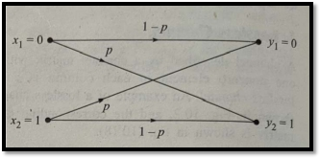

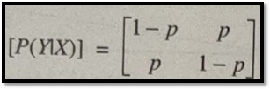

***The channel capacity(C)***

It is defined to be the maximum rate at which information can be transmitted through a channel. The fundamental theorem of information theory

says that at any rate below channel capacity, an error control code can be designed

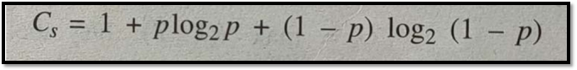

whose probability of error is arbitrarily small.

Channel Capacity of a Binary Symmetric Channel.

### ***Mutual Information:***

* The mutual information I(x,y) measures how much information the channel transmits, which depends on two things:
  + The transition probabilities Q(j|i) and
  + The input distribution p(i)
* We can’t change transition probabilities, but we can change input distribution.
* Hence, the capacity of the channel (C) is the maximum value of the I(x,y) that can be obtained with any choice of input distribution.
* It is the rate at which data can be sent through the channel with vanishingly small probability of error.



* Hence, C = max(I(x,y)).

IMG_260

## **FORMULAS:**



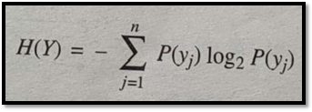

**MATLAB CODE**

1. Channel Capacity:

|  |
| --- |
| **clc;**  ***%error probability vector***  **p1 = 0.001:0.001:1;**  ***%Channel capacity vector calculation***  **Ci = zeros(1,length(p1));**  **for i=1:length(p1)**  **Ci(i)=1+p1(i)\*log2(p1(i))+(1-p1(i))\*log2(1-p1(i));**  **end**  ***% plotting channel capacity vs error probabilty***  **plot(p1,Ci);**  **grid on;**  **title('Channel Capacity vs Error Probability');**  **xlabel('Error Probability');**  **ylabel('Channel Capacity');**  **axis([0 1 0 1.1]);** |

1. Mutual Information:

|  |
| --- |
| **clc;**  ***%Probabilty of Inputs***  **PX=zeros(1,2);**  **PX(1)=input('Enter probabilty for input x1 : ');**  **PX(2)=1-PX(1);**  ***%Error probabilty***  **p=input('Enter error probability : ');**  ***%Channel Matrix***  **PC=[1-p p;p 1-p];**  ***%Probabilty of Output***  **PY=PX\*PC;**  ***%Calculating Entropy***  **H=0;**  **for i=1:length(PY)**  **H=H+PY(i)\*log2(PY(i));**  **end**  **H=-H;**  ***%Calculating Mutual Information***  **I=H+p\*log2(p)+(1-p)\*log2(1-p);**  ***%displaying***  **disp('oinput matrix P(X):');**  **disp(PX);**  **disp('Channel matrix P(Y/X):');**  **disp(PC);**  **disp('output matrix P(Y):');**  **disp(PY);**  **disp('Entropy of output H(Y): ');**  **disp(H);**  **disp('Mutual Information is ');**  **disp(I);** |

**OUTPUT**

|  |  |
| --- | --- |
| 1. *Channel Capacity:* | *2. Mutual Information:* |
|  |  |

**CONCLUSION**

In this experiment, we plotted the channel Capacity vs Error Probability Graph and we observed that channel capacity is minimum(zero) for error probability of 0.5. In the second Part calculation we calculated Mutual Information by taking input from user and we observed that entropy of output is 1, if we take input equiprobable.