**U19EC046 | DCOM | LAB 7**

**Date: 11-10-2021**

**AIM**

To study and simulate Linear Block Code.

**THEORY**

In the linear block codes, the parity bits and message bits have a linear combination, which means that the resultant code word is the linear combination of any two code words.

Let us consider some blocks of data, which contains **k** bits in each block. These bits are mapped with the blocks which has **n** bits in each block. Here **n** is greater than **k**. The transmitter adds redundant bits which are ***n*−*k*** bits. The ratio **k/n** is the **code rate**. It is denoted by **r** and the value of **r** is **r < 1**.

The ***n*−*k*** bits added here, are **parity bits**. Parity bits help in error detection and error correction, and also in locating the data. In the data being transmitted, the left most bits of the code word correspond to the message bits, and the right most bits of the code word correspond to the parity bits.

**ALGORITHM:**

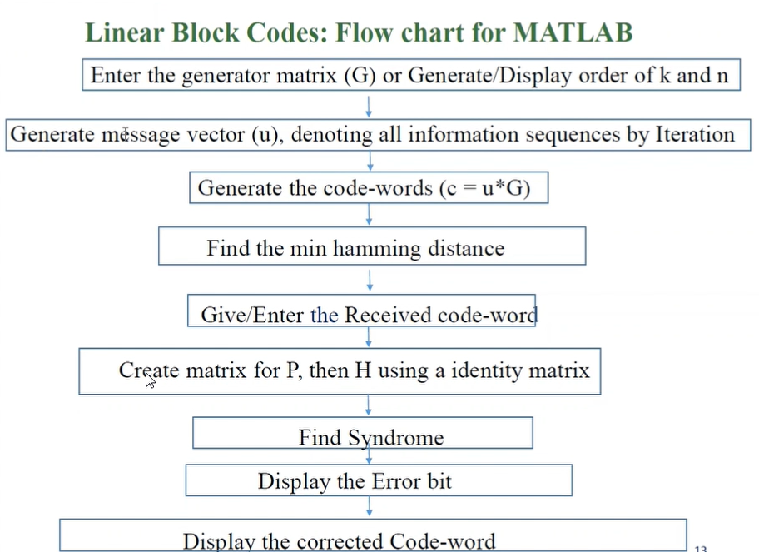

**MATLAB CODE**

|  |
| --- |
| **clc;**  **clear all;**  **g = input('enter the generator matrix:')**  **[k,n] = size(g);**  **disp(['order of the linear block code (n,k) = (' num2str(n) ',' num2str(k) ')'])**  **disp('possible data:')**  **u = dec2bin(0 : 1 : 2^k-1);**  **d = u - '0'**  **disp('the possible codewords are:')**  **c = rem(u*g,2)**  **d_min = min(sum((c(2:2^k,:))'));**  **disp(['the minimum hamming distance dmin for given block code = ' num2str(d_min)])**  **r = input('enter the received code word:');**  **disp('H transpose Matrix : ')**  **p=[g(:,k+1:n)];**  **ht=[p;eye(n-k)]**  **s=rem(r*ht,2);**  **disp(['syndrome of a given codeword is:' num2str(s)])**  **for i=1:1:size(ht)**  **if (ht(i,1:3)==s)**  **r(i)=1-r(i);**  **break;**  **end**  **end**  **disp(['the error is in bit:' num2str(i)])**  **disp(['the corrected codeword is:' num2str(r)])** |

**OUTPUT**

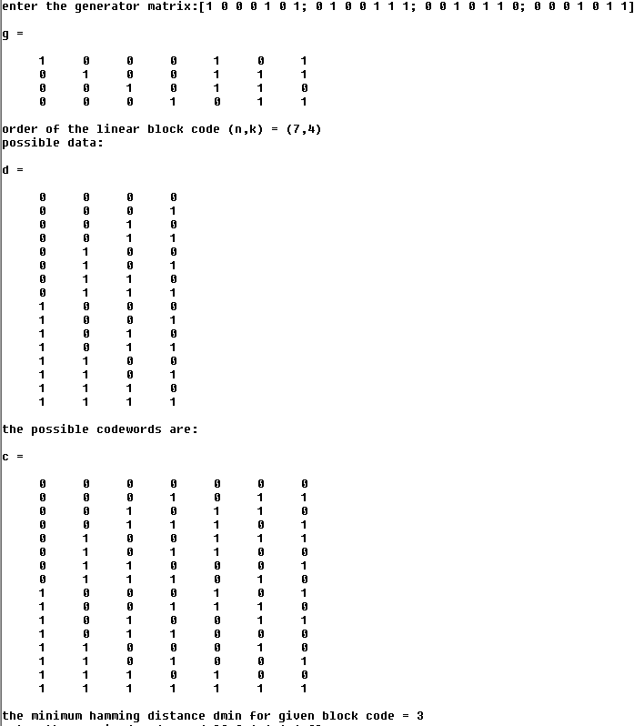

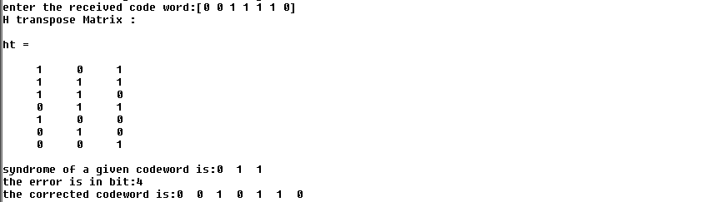

**CONCLUSION**

In this practical we have implemented (7, 4) hamming block code and we also corrected the error from the received code word using Ht matrix and syndrome.