**U19EC046 | DCOM | LAB 9**

**Date: 25-10-2021**

**AIM**

To study and simulate ASK, FSK and PSK.

**THEORY**

Digital Modulation provides more information capacity, high data security, quicker system availability with great quality communication. Hence, digital modulation techniques have a greater demand, for their capacity to convey larger amounts of data than analog ones.

There are many types of digital modulation techniques and we can even use a combination of these techniques as well. In this chapter, we will be discussing the most prominent digital modulation techniques.

## *Amplitude Shift Keying*

The amplitude of the resultant output depends upon the input data whether it should be a zero level or a variation of positive and negative, depending upon the carrier frequency.

**Amplitude Shift Keying (ASK)** is a type of Amplitude Modulation which represents the binary data in the form of variations in the amplitude of a signal.

Following is the diagram for ASK modulated waveform along with its input.

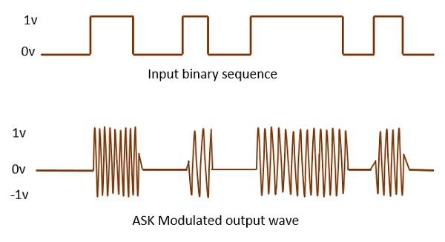

Any modulated signal has a high frequency carrier. The binary signal when ASK is modulated, gives a zero value for LOW input and gives the carrier output for HIGH input.

## 

## *Frequency Shift Keying*

The frequency of the output signal will be either high or low, depending upon the input data applied.

**Frequency Shift Keying (FSK)** is the digital modulation technique in which the frequency of the carrier signal varies according to the discrete digital changes. FSK is a scheme of frequency modulation.

Following is the diagram for FSK modulated waveform along with its input.

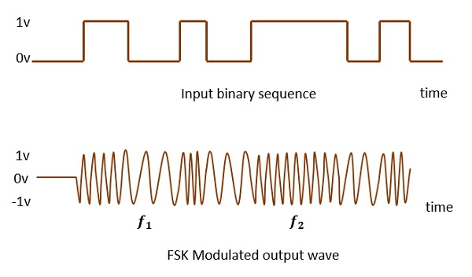

The output of a FSK modulated wave is high in frequency for a binary HIGH input and is low in frequency for a binary LOW input. The binary 1s and 0s are called **Mark** and **Space frequencies**.

## *Phase Shift Keying*

The phase of the output signal gets shifted depending upon the input. These are mainly of two types, namely BPSK and QPSK, according to the number of phase shifts. The other one is DPSK which changes the phase according to the previous value.

**Phase Shift Keying (PSK)** is the digital modulation technique in which the phase of the carrier signal is changed by varying the sine and cosine inputs at a particular time. PSK technique is widely used for wireless LANs, bio-metric, contactless operations, along with RFID and Bluetooth communications.

PSK is of two types, depending upon the phases the signal gets shifted. They are −

### Binary Phase Shift Keying (BPSK)

This is also called as **2-phase PSK** (or) **Phase Reversal Keying**. In this technique, the sine wave carrier takes two phase reversals such as 0° and 180°.

BPSK is basically a DSB-SC (Double Sideband Suppressed Carrier) modulation scheme, for message being the digital information.

Following is the image of BPSK Modulated output wave along with its input.

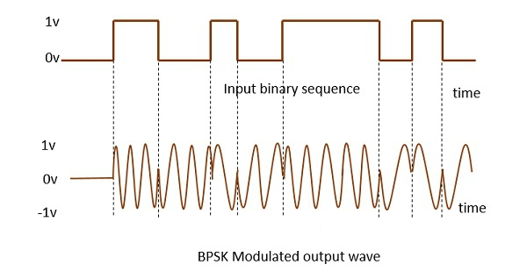

**MATLAB CODE**

|  |
| --- |
| ***% waveGen.m***  **function op = waveGen( bits )**  **op = cell(1, 3);**  **dt = 0.01;**  **t = 0 : dt : length(bits) - dt;**  **op{1} = unipolarNRZ(bits);**  **op{2} = polarNRZ(bits);**  **op{3} = AMI(bits);**  **op{4} = t;**  **end**  **function op = unipolarNRZ( bits )**  **one = ones(1, 100);**  **zero = zeros(1, 100);**  **graph = [];**  **for i = 1:length(bits)**  **if(bits(i)==1)**  **graph = [graph one];**  **else**  **graph = [graph zero];**  **end**  **end**  **op = graph;**  **end**  **function op = polarNRZ( bits )**  **one = ones(1, 100);**  **zero = zeros(1, 100) - 1;**  **graph = [];**  **for i = 1:length(bits)**  **if(bits(i)==1)**  **graph = [graph one];**  **else**  **graph = [graph zero];**  **end**  **end**  **op = graph;**  **end**  **function op = AMI( bits )**  **one = [ones(1, 50), zeros(1, 50)];**  **onebar = [zeros(1, 50)-1 , zeros(1, 50)];**  **zero = zeros(1, 100);**  **graph = [];**  **flag = 1;**  **for i = 1:length(bits)**  **if(bits(i)==1)**  **if(flag == 1)**  **graph = [graph one];**  **flag = 0;**  **else**  **graph = [graph onebar];**  **flag = 1;**  **end**  **else**  **graph = [graph zero];**  **end**  **end**  **op = graph;**  **end**  ***% main.m***  **clc; clear all;**  **bits = input('Enter bits matrix : ');**  **waves = waveGen(bits);**  **unipolarNRZ = waves{1};**  **polarNRZ = waves{2};**  **bipolarNRZ = waves{3};**  **t = waves{4};**  ***%% ASK --------------------------------------->***  **carrier = sin(2*pi*t);**  **ASK = unipolarNRZ.*carrier;**  **figure;**  **subplot(3, 1, 1);**  **plot(t, unipolarNRZ);**  **title(['Unipolar NRZ of  ' num2str(bits)]);**  **subplot(3, 1, 2);**  **plot(t, carrier);**  **title('carrier signal');**  **subplot(3, 1, 3);**  **plot(t, ASK);**  **title('ASK signal')**  **ASKbipolar = bipolarNRZ.*carrier;**  **figure;**  **subplot(3, 1, 1);**  **plot(t, bipolarNRZ);**  **title(['Bipolar NRZ of  ' num2str(bits)]);**  **subplot(3, 1, 2);**  **plot(t, carrier);**  **title('carrier signal');**  **subplot(3, 1, 3);**  **plot(t, ASKbipolar);**  **title('ASK of bipolar signal')**  ***%% FSK --------------------------------------->***  **carrier1 = sin(2*pi*t);**  **carrier2 = sin(2*pi*2*t);**  **bitsInv = mod(bits+1, 2);**  **waveInv = waveGen(bitsInv);**  **unipolarNRZInv = waveInv{1};**  **first = unipolarNRZInv.*carrier1;**  **second = unipolarNRZ.*carrier2;**  **FSK = first + second;**  **figure;**  **subplot(4, 1, 1);**  **plot(t, unipolarNRZ);**  **title(['Unipolar NRZ of  ' num2str(bits)]);**  **subplot(4, 1, 2);**  **plot(t, carrier1);**  **title('carrier signal 1');**  **subplot(4, 1, 3);**  **plot(t, carrier2);**  **title('carrier signal 2');**  **subplot(4, 1, 4);**  **plot(t, FSK);**  **title('FSK signal')**  ***%% PSK --------------------------------------->***  **carrier = sin(2*pi*t);**  **PSK = polarNRZ.*carrier;**  **figure;**  **subplot(3, 1, 1);**  **plot(t, polarNRZ);**  **title(['Polar NRZ of  ' num2str(bits)]);**  **subplot(3, 1, 2);**  **plot(t, carrier);**  **title('carrier signal');**  **subplot(3, 1, 3);**  **plot(t, PSK);**  **title('PSK signal')** |

**OUTPUT**

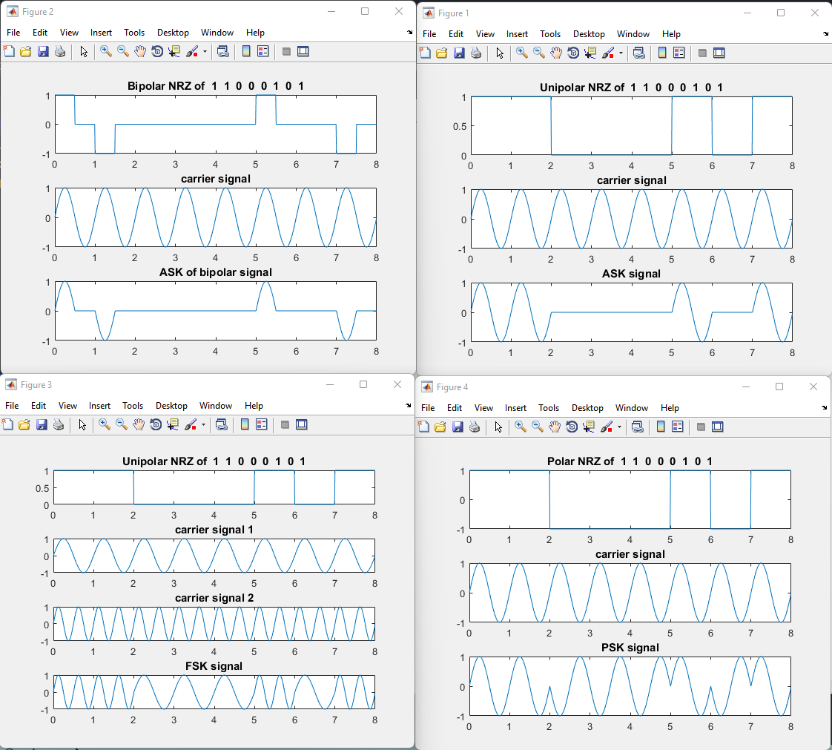

**CONCLUSION**

In this practical we have studied and implemented matlab code for ASK, FSK and PSK.