**PRACTICAL X : X**

|  |  |
| --- | --- |
| **U19EC046 - Harsh Suthar** | **Date: 06-08-2021** |

**AIM**

1. Write a MATLAB program to perform time shifting, time scaling and time reversal of the continuous as well as discrete time signal.
2. Write a MATLAB program to generate sum of two continuous as well as discrete time signal.

**THEORY**

**Time Shifting:**

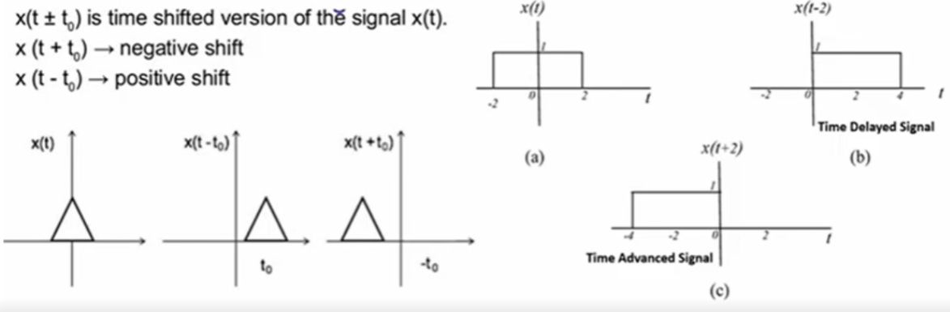

**Time Reversal:**

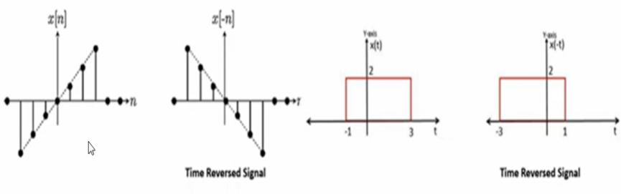

**Time Scaling:**

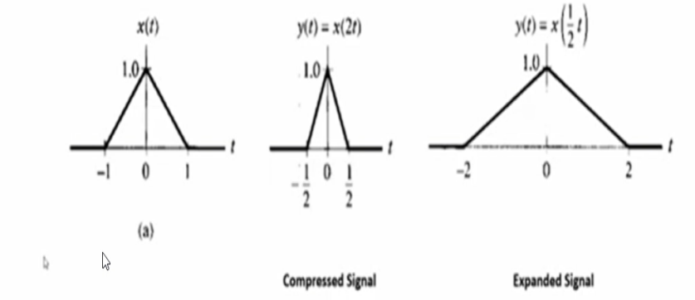

**ALGORITHM**

1. Define time window of signal and input signal.
2. Adjust the axis bounds based on output of your signal.
3. Plot the original signal and Plot the signal according to the properties.
4. In the case of sum of two signals, if the ranges of both signals are different then first do padding with zeros.

**CODE**

1. Time Shifting

|  |
| --- |
| **clc;**  **close all;**  ***%%***  ***%For Continuous Part***  **t=-2:0.01:2; *%time window***  **x=sin(2*pi*t); *%defining input signal***  ***%plotting Original signal***  **subplot(3,2,1);**  **plot(t,x);**  **grid on;**  **xlabel('t');**  **ylabel('x(t)');**  **axis([-4 4 -1 1]);**  **title('Original Signal in Continuous U19EC046');**  ***%plotting Advanced signal***  **subplot(3,2,3);**  **plot(t+2,x);**  **grid on;**  **xlabel('t');**  **ylabel('x(t)');**  **axis([-4 4 -1 1]);**  **title('Advanced Signal by 2 in Continuous');**  ***%plotting Delayed signal***  **subplot(3,2,5);**  **plot(t-2,x);**  **grid on;**  **xlabel('t');**  **ylabel('x(t)');**  **axis([-4 4 -1 1]);**  **title('Delayed Signal by 2 in Continuous');**  ***%%***  ***%For Discrete Part***  **n=-2:1:2;*%time window***  **x=[-2 -1 0 1 2];*%defining input signal***  **subplot(3,2,2);**  **stem(n,x);**  **xlabel('n');**  **ylabel('x(n)');**  **axis([-4 4 -3 3]);**  **title('Original Signal in Discrete U19EC046');**  **subplot(3,2,4);**  **stem(n+2,x);**  **xlabel('n');**  **ylabel('x(n)');**  **axis([-5 5 -3 3]);**  **title('Advanced Signal by 2 in Discrete');**  **subplot(3,2,6);**  **stem(n-2,x);**  **xlabel('n');**  **ylabel('x(n)');**  **axis([-5 5 -3 3]);**  **title('Delayed Signal by 2 in Discrete');** |

1. **Time Scaling**

|  |
| --- |
| **clc;**  **close all;**  ***%%***  ***%For Continuous Part***  **t=-1:0.01:1;*%time window***  **x=sin(pi*t);*%defining input signal***  ***%plotting Original signal***  **subplot(3,2,1);**  **plot(t,x);**  **grid on;**  **xlabel('t');**  **ylabel('x(t)');**  **axis([-2 2 -1 1]);**  **title('Original Signal U19EC046 in Continuous');**  ***%plotting Expanded signal***  **subplot(3,2,3);**  **plot(t*2,x);**  **grid on;**  **xlabel('t');**  **ylabel('x(t)');**  **axis([-3 3 -1 1]);**  **title('Expanded Signal by 2 in Continuous');**  ***%plotting Compressed signal***  **subplot(3,2,5);**  **plot(t/2,x);**  **grid on;**  **xlabel('t');**  **ylabel('x(t)');**  **axis([-2 2 -1 1]);**  **title('Compressed Signal by 2 in Continuous');**  ***%%***  ***%For Discrete Part***  **n=-4:2:4;*%time window***  **x=[-2 -1 0 1 2];*%Defining Input signal***  ***%plotting Original signal***  **subplot(3,2,2);**  **stem(n,x);**  **xlabel('n');**  **ylabel('x(n)');**  **axis([-8 8 -3 3]);**  **title('Original Signal in Discrete U19EC046');**  ***%plotting Expanded signal***  **subplot(3,2,4);**  **stem(n*2,x);**  **xlabel('n');**  **ylabel('x(n)');**  **axis([-9 9 -3 3]);**  **title('Expanded Signal by 2 in Discrete');**  ***%plotting Compressed signal***  **subplot(3,2,6);**  **stem(n/2,x);**  **xlabel('n');**  **ylabel('x(n)');**  **axis([-4 4 -3 3]);**  **title('Compressed Signal by 2 in Discrete');** |

1. Time reversal

|  |
| --- |
| **clc;**  **close all;**  ***%%***  ***%For Continuous Part***  **t=-1:0.01:1;*%time window***  **x=sin(pi*t); *%defining input signal***  ***%plotting Original signal***  **subplot(2,2,1);**  **plot(t,x);**  **grid on;**  **xlabel('t');**  **ylabel('x(t)');**  **axis([-2 2 -1 1]);**  **title('Original Signal U19EC046 in Continuous');**  ***%plotting Reversed signal***  **subplot(2,2,3);**  **plot(-t,x);**  **grid on;**  **xlabel('t');**  **ylabel('x(-t)');**  **axis([-2 2 -1 1]);**  **title('Reversed Signal in Continuous');**  ***%%***  ***%For Discrete Part***  **n=-2:1:2;*%time window***  **x=[-2 -1 0 1 2];*%defining input signal***  ***%plotting Original signal***  **subplot(2,2,2);**  **stem(n,x);**  **xlabel('n');**  **ylabel('x(n)');**  **axis([-3 3 -3 3]);**  **title('Original Signal U19EC046 in Discrete');**  ***%plotting Reversed signal***  **subplot(2,2,4);**  **stem(-n,x);**  **xlabel('n');**  **ylabel('x(n)');**  **axis([-3 3 -3 3]);**  **title('Reversed Signal in Discrete');** |

1. Sum of two signals Same range

|  |
| --- |
| **clc;**  **close all;**  ***%%***  ***%For Continuous Part***  ***%Defining time window***  **t1=-2:0.01:2;**  **t2=-2:0.01:2;**  ***%Defining Signals***  **x1=sin(pi*t1);**  **x2=cos(pi*t2);**  ***%Plotting signal 1***  **subplot(3,2,1);**  **plot(t1,x1);**  **xlabel('t');**  **ylabel('x1(t)');**  **grid on;**  **axis([-3 3 -1 1]);**  **title('Signal 1 in Continuous U19EC046');**  ***%Plotting signal 2***  **subplot(3,2,3);**  **plot(t1,x2);**  **xlabel('t');**  **ylabel('x2(t)');**  **grid on;**  **axis([-3 3 -1 1]);**  **title('Signal 2 in Continuous');**  ***%Plotting summation of signals***  **x3=x1+x2;**  **subplot(3,2,5);**  **plot(t1,x3);**  **xlabel('t');**  **ylabel('x1(t)+x2(t)');**  **grid on;**  **axis([-3 3 -1.414 1.414]);**  **title('Signal 1+2 in Continuous');**  ***%%***  ***%For Discrete Part***  ***%time window***  **n1=-2:1:2;**  **n2=-2:1:2;**  ***%defining input signal***  **x1=[-2 -1 0 1 2];**  **x2=[1 2 0 -2 -1];**  ***%Plotting signal 1***  **subplot(3,2,2);**  **stem(n1,x1);**  **xlabel('n');**  **ylabel('x1(n)');**  **axis([-3 3 -3 3]);**  **title('Signal 1 in Discrete U19EC046');**  ***%Plotting signal 2***  **subplot(3,2,4);**  **stem(n2,x2);**  **xlabel('n');**  **ylabel('x2(n)');**  **axis([-3 3 -3 3]);**  **title('Signal 2 in Discrete');**  ***%Plotting summation of signals***  **y=x1+x2;**  **subplot(3,2,6);**  **stem(n1,y);**  **xlabel('n');**  **ylabel('x1(n)+x2(n)');**  **axis([-3 3 -3 3]);**  **title('Signal 1+2 in Discrete')** |

1. Sum of two signal different range

|  |
| --- |
| **clc;**  **close all;**  ***%%***  ***%For Continuous Part***  ***%Defining time window***  **t1=-2:0.01:3;**  **t2=-3:0.01:2;**  ***%defining input signal***  **x1=sin(pi*t1);**  **x2=cos(pi*t2);**  ***%Plotting signal 1***  **subplot(3,2,1);**  **plot(t1,x1);**  **xlabel('t');**  **ylabel('x1(t)');**  **grid on;**  **axis([-4 4 -1 1]);**  **title('Signal 1 n Continuous U19EC046');**  ***%Plotting signal 2***  **subplot(3,2,3);**  **plot(t2,x2);**  **xlabel('t');**  **ylabel('x2(t)');**  **grid on;**  **axis([-4 4 -1 1]);**  **title('Signal 2 in Continuous U19EC046');**  ***%Performing Padding.***  **t=min(min(t1),min(t2)):0.01:max(max(t1),max(t2));**  **y1=zeros(1,length(t));**  **y2=zeros(1,length(t));**  **y1((t>=min(t1) & t<=max(t1)))=x1();**  **y2((t>=min(t2) & t<=max(t2)))=x2();**  ***%Adding signal1 and Signal 2.***  **y=y1+y2;**  ***%Plotting summation of signal 1 and signal 2***  **subplot(3,2,5);**  **plot(t,y1+y2);**  **xlabel('t');**  **ylabel('x1(t)+x2(t)');**  **axis([-4 4 -1.414 1.414]);**  **title('Signal 1+2 DIFF RANGE U19EC046');**  ***%%***  ***%For Discrete Part***  ***%time window***  **n1=-2:1:2;**  **n2=-3:1:0;**  ***%defining input signal***  **x1=[-2 -1 0 1 2];**  **x2=[2 3 2 1];**  ***%Plotting signal 1***  **subplot(3,2,2);**  **stem(n1,x1);**  **xlabel('n');**  **ylabel('x1(n)');**  **axis([-4 3 -3 3]);**  **title('Signal 1 in Discrete U19EC046');**  ***%Plotting signal 2***  **subplot(3,2,4);**  **stem(n2,x2);**  **xlabel('n');**  **ylabel('x2(n)');**  **axis([-4 3 -3 4]);**  **title('Signal 2 in Discrete U19EC046');**  ***%Performing Padding.***  **n=min(min(n1),min(n2)):1:max(max(n1),max(n2));**  **y1=zeros(1,length(n));**  **y2=zeros(1,length(n));**  **y1((n>=min(n1) & n<=max(n1)))=x1();**  **y2((n>=min(n2) & n<=max(n2)))=x2();**  ***%Adding signal1 and Signal 2.***  **y=y1+y2;**  ***%Plotting summation of signal 1 and signal 2***  **subplot(3,2,6);**  **stem(n,y);**  **xlabel('n');**  **ylabel('x1(n)+x2(n)');**  **axis([-4 3 -3 3]);**  **title('Signal 1+2 DIFF RANGE U19EC046');** |

**OUTPUT**

1. Time Shifting

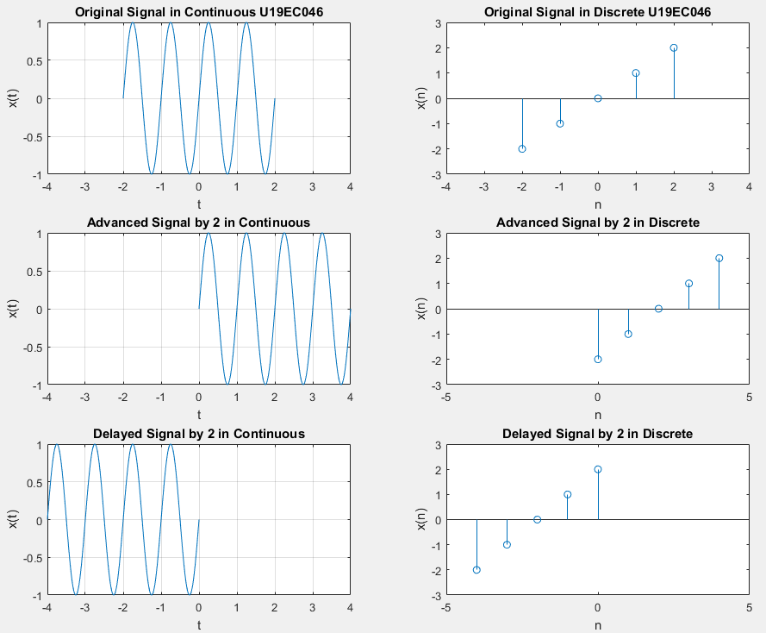

1. **Time Scaling**

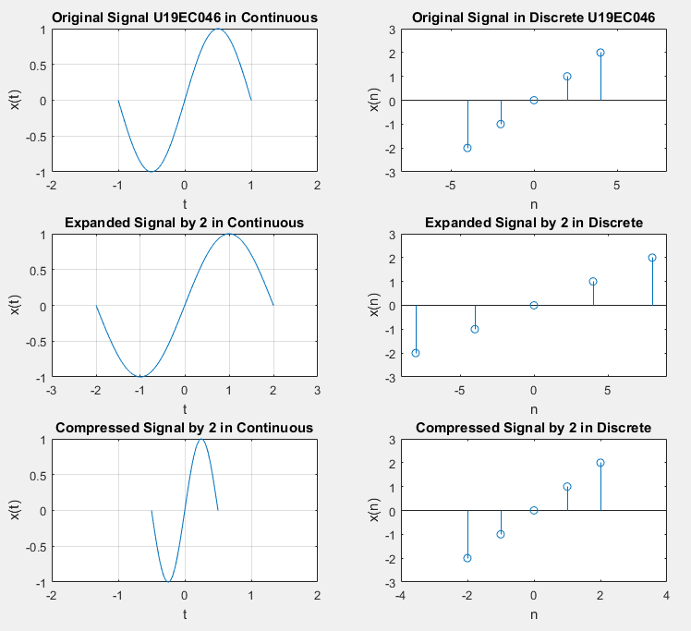

1. Time Reversal

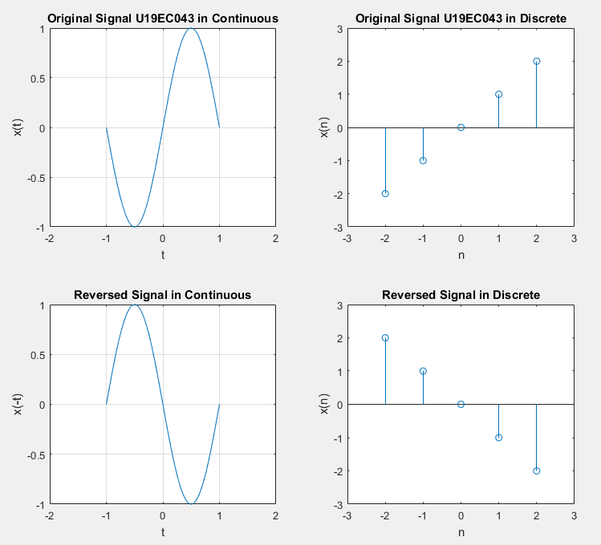

1. Sum, equal range

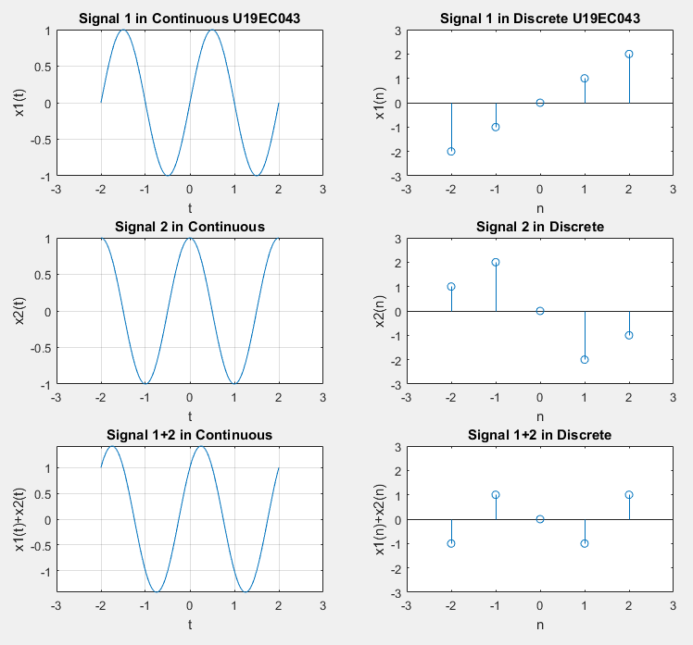

1. Sum, different range

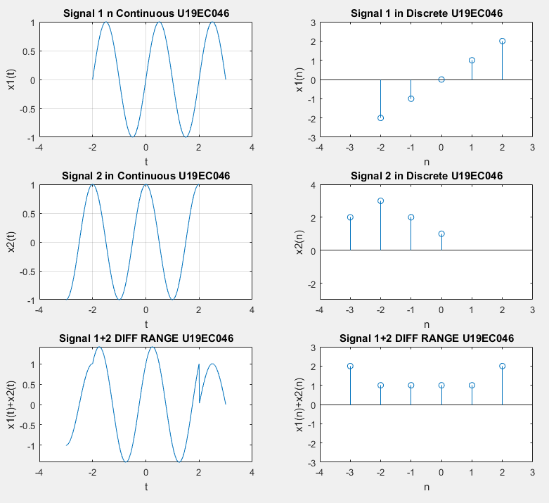

**CONCLUSION**

In this practical we implemented time shifting, time scaling, time inversion properties of Continuous and Discrete time signals. We additionally carried out the summation of two signs of same range and distinct range in both continuous and discrete.