**U19EC046 | OS LAB 1 | BASIC UNIX COMMANDS**

Commands

1. echo [string]

* Prints the string.



1. date

* Displays the date



1. Help

* Shows help

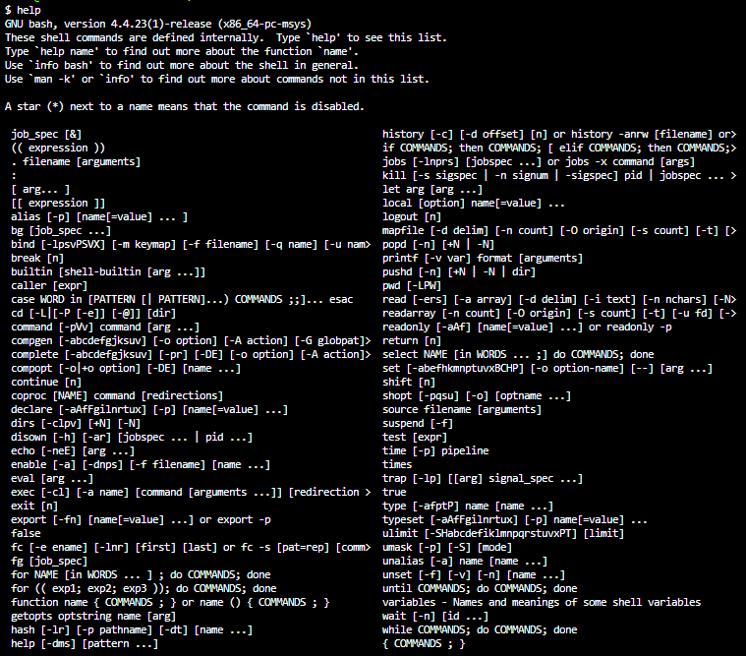

1. man

* display the user manual of any command that we can run on the terminal.

1. info

* used to find out more about Linux commands

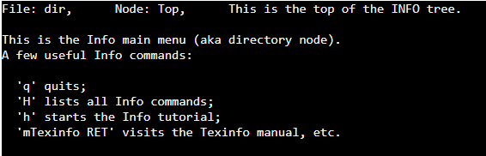

1. pwd

* Shows present working directory



1. Cat[filename]

* Shows the content of given filename



1. more

* more command is used to view the text files in the command prompt, displaying one screen at a time in case the file is large

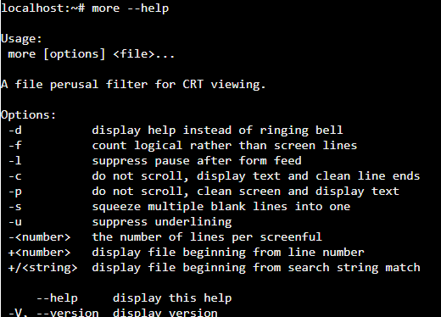

1. mv

* Rename source to dest, or move source(s) to directory

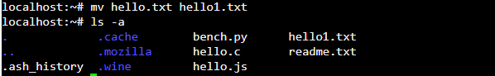

1. cd [path]

* Change current directory



1. Ls -a

* Lists all files.

1. touch [filename] [filename] …

* Creates a file/s

1. rm [filename] [filename] …

* Deletes the file/s

1. cp [source file path] [destination file name]

* Copies the file

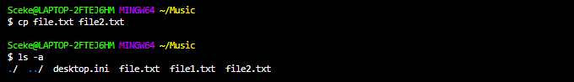

1. mkdir [directiory name]

* Creates a directory

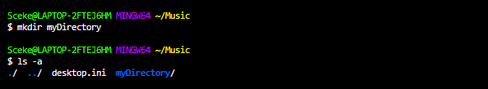

1. rmdir [directory name]

* Removes a directory

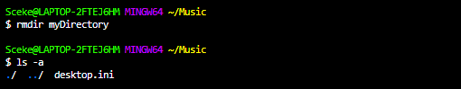

1. Whoami:

* prints the logged in user’s identity.
* 

1. Wc:

* sed to find out number of lines,word count,byte and characters count in the files specified in the file arguments.
* By default it displays four-columnar output.
* First column shows number of lines present in a file specified, second column shows number of words present in the file, third column shows number of characters present in file and fourth column itself is the file name which are given as argument.
* 

# GREP:

* The grep filter searches a file for a particular pattern of characters, and displays all lines that contain that pattern.
* 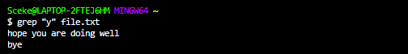

# SORT:

* Sort command is used to sort a file i.e, sorts the content of a text file,line by line assuming the content is in ascii.
* 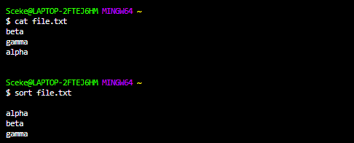

# cd:

* this command is used to change the working directory.
* 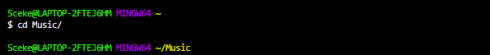

# Tail:

The tail command prints the last N number of data of the given input.



# cmp:

* cmp command in Linux/UNIX is used to compare the two files byte by byte and helps you to find out whether the two files are identical or not.
* 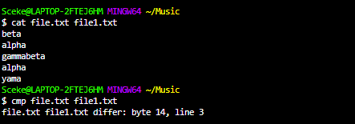

# diff:

* This command is used to display the differences in the files by comparing the files line by line.
* 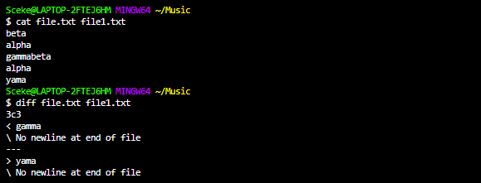

# clear:

* clear is a standard Unix computer operating system command that is used to clear the terminal screen.
* 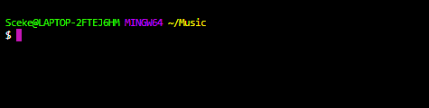

# Df:

* This command (short for disk free), is used to display information related to file systems about total space and available space.
* 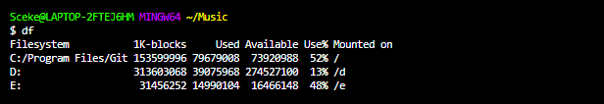

# Du:

* This command, short for disk usage, is used to estimate file space usage.
* 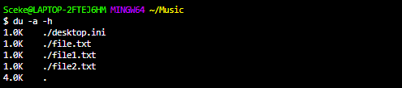

# Uname:

* displays the information about the system.
* 

# Find:

* It can be used to find files and directories and perform subsequent operations on them.

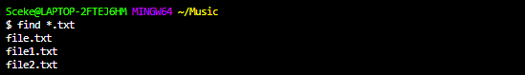

# Wget:

* Wget is the non-interactive network downloader which is used to download files from the server even when the user has not logged on to the system and it can work in the background without hindering the current process
* 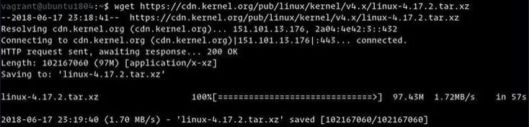

# Top:

* top command is used to show the Linux processes. It provides a dynamic real-time view of the running system.

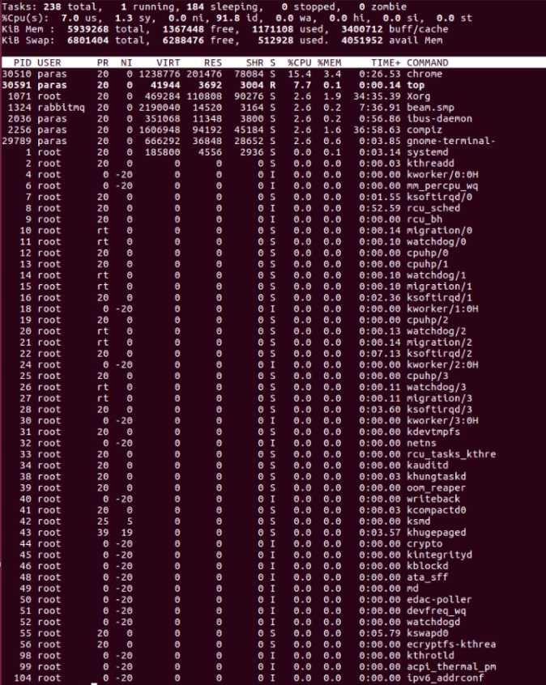

# Mpstat:

* mpstat is a command that is used to report processor related statistics. It accurately displays the statistics of the CPU usage of the system.
* 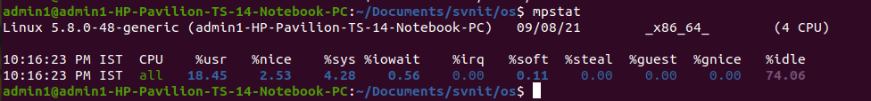

# Netstat:

* Netstat command displays various network related information such as network connections, routing tables,etc.
* 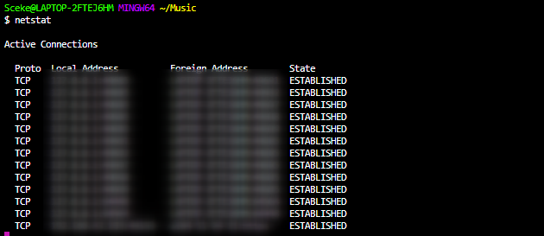
* P

# Q2.

1. ps:

* ps command is used to list the currently running processes and their PIDs along with some other information depends on different options. It reads the process information from the virtual files.
* 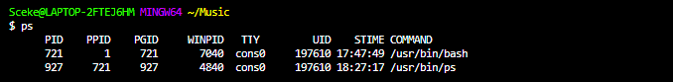

# kill

* *kill* command in Linux (located in /bin/kill), is a built-in command which is used to terminate processes manually. *Kill* command sends a signal to a process which terminates the process
* 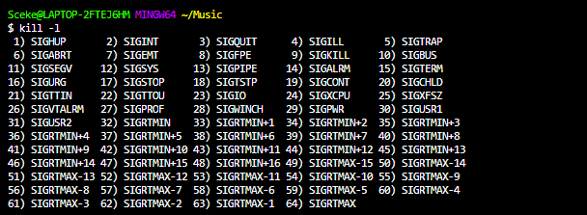

# Background process (with &):

* Background Process:run in the background without keyboard input and waits till keyboard input is required. Thus, other processes can be done in parallel with the process running in the background since they do not have to wait for the previous process to be completed.Adding & along with the command starts it as a background process
* 