**Aim**

**U19EC046 LAB 2**

Develop a Transmission Line of given determinations and figure its Characteristic Impedance for 100 MHz and 300 MHz utilizing AN-SOF Software.

**Theory**

Transmission Lines convey phone signals, PC information in LANs, TV frameworks, and signs from a transmitter to an antenna or from a antenna to a receiver. They are otherwise called circuits.

The two essential prerequisites of a transmission lines are :

1. The line ought to acquaint least weakening with the sign.
2. The line ought not emanate any of the signs as radio energy.

**Types of Transmission Lines**

* **Parallel Wire Line** is made of two parallel conductors separated by a space of 0.5 inch to several inches.
* The most widely used is the **Coaxial Cable**. It consists of a solid centre conductor surrounded by a dielectric material, usually a plastic such as a Teflon.
* **Twisted Pair Cable** uses two insulated solid copper wires covered with insulation and loosely twisted together.

**Balanced Versus Unbalanced Transmission Lines**

* Transmission Lines can be **balanced** or **unbalanced**.
* A balanced line is one in which neither wire is connected to ground.
* The signal on each wire is referenced to ground.
* In an unbalanced line, one conductor is connected to ground.
* Open wire line has a balanced configuration.

**Formulas Used**

The Specifications of the Transmission Line are :

Length of the Wire = l = 500 mm

Cross Section Radius of the Wire = a = 2 mm

Now, $Z_{in}= Z_{0}\left(\frac{z_{l}\cos{βl + j\sin{βl}}}{\cos{βl + jz_{l}\sin{βl}}}\right)= Z_{0}\left(\frac{z_{l}{+ j\tan{βl}}}{1{ + jz_{l}\tan{βl}}}\right)$

$Z_{in}^{sc}= \frac{V_{sc}(l)}{I_{sc}(l)}=jZ_{0}\tan{βl}$ by putting $z_{l}=0$ for short circuit

$Z_{in}^{oc}= \frac{V_{oc}(l)}{I_{oc}(l)}=−jZ_{0}\cot{βl}$ by putting $z_{l}=∞$ for open circuit

On the other hand, the relation for the Characteristic Impedance of a line above a ground plane is given by :

$$Z_{c}=138 \log{(\frac{2h}{a}})=138 \log\left(\frac{2∗40}{2}\right)=221.084 Ω$$

where h is the height of the wire from the ground, whose value for our experiment is 40 mm.

**AN-SOF Model**

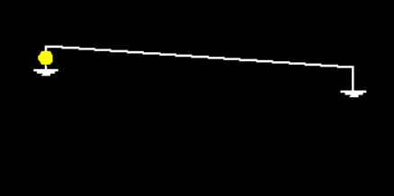

Short Circuit Configuration

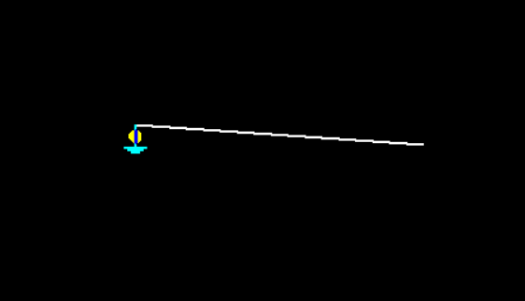

Open Circuit Configuration

**AN-SOF Output and Plots**

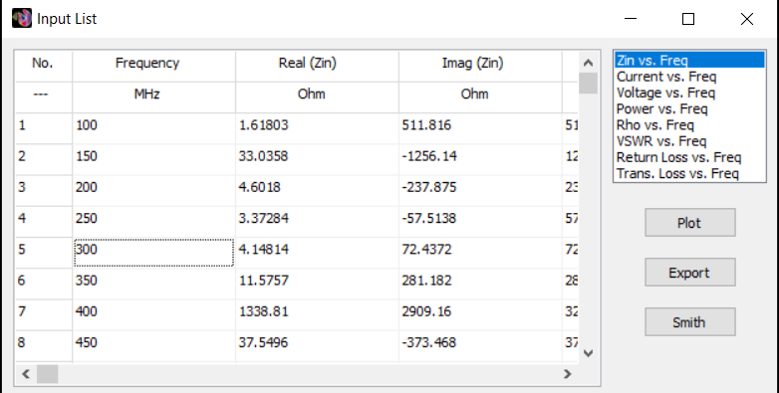

Short Circuit Output

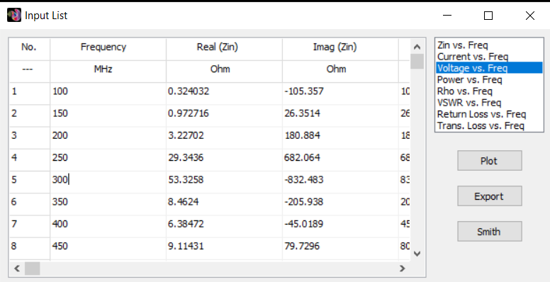

Open Circuit Output

**Calculations**

For 100 MHz : $Z_{in}^{sc}= j511.816 Ω Z_{in}^{oc}= −j105.357Ω$

$Z_{c}= \sqrt{Z_{sc}Z_{oc}} =232.1412Ω$

For 150 MHz : $Z_{in}^{sc}= j1256.14 Ω Z_{in}^{oc}= −j26.35Ω$

$Z_{c}= \sqrt{Z_{sc}Z_{oc}} =181.93Ω$

For 200 MHz : $Z_{in}^{sc}= −j237.875 Ω Z_{in}^{oc}= −j180.884Ω$

$Z_{c}= \sqrt{Z_{sc}Z_{oc}} =207.43Ω$

For 250 MHz : $Z_{in}^{sc}= j57.514Ω Z_{in}^{oc}= −j682.064Ω$

$Z_{c}= \sqrt{Z_{sc}Z_{oc}} =198.061Ω$

For 300 MHz : $Z_{in}^{sc}= j72.4372 Ω Z_{in}^{oc}= −j832.483Ω$

$Z_{c}= \sqrt{Z_{sc}Z_{oc}} =245.566Ω$

**Conclusion**

In the above Practical we executed a Transmission Line Wire utilizing AN-SOF Software and determined its Characteristic Impedance from the resultant plots which is extremely shut to the theoretical value of 221 Ω.