PRACTICAL 3 | TLEM LAB

U19EC046

AIM

Design and simulate RLCG equivalent circuit of the transmission line for three different frequencies in the range of 500-1000Hz

SOFTWARE

AN-SOF simulation software

THEORY

Accordingly R,L,G, and C are likewise alluded to as resistance, inductance, conductance, and capacitance per unit length. In the decimal standard for measuring, ohms per meter (Ω/m), henries per meter (H/m), siemens per meter (S/m) and farads per meter (F/m), individually, are utilized. The upsides of R,L,G, and C are influenced by the calculation of the transmission line and by the electrical properties of the dielectrics and channels. C depicts the capacity to store electrical energy and is for the most part because of the properties of the dielectric. G depicts loss in the dielectric which gets from conduction in the dielectric and from dielectric unwinding.Most microwave substrates have negligible conductivity so dielectric relaxation loss dominates. Dielectric relaxation loss results from the movement of charge centers which result in distortion of the dielectric lattice (if a crystal) or molecular structure. The intermittent variety of the E field moves energy from the EM field to mechanical vibrations. R is because of ohmic loss in the metal more than whatever else. L depicts the capacity to store magnetic energy and is generally an function of geometry, as most materials utilized with transmission lines have μr=1.

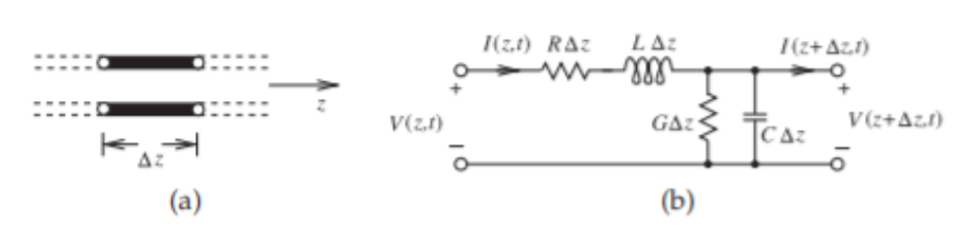

For most lines the impacts because of L and C overwhelm as a result of the generally low series resistance and shunt conductance. The propagation characteristics of the line are depicted by its loss-free, or lossless, identical line, albeit practically speaking some data about R or G is important to decide power.

FORMULAS

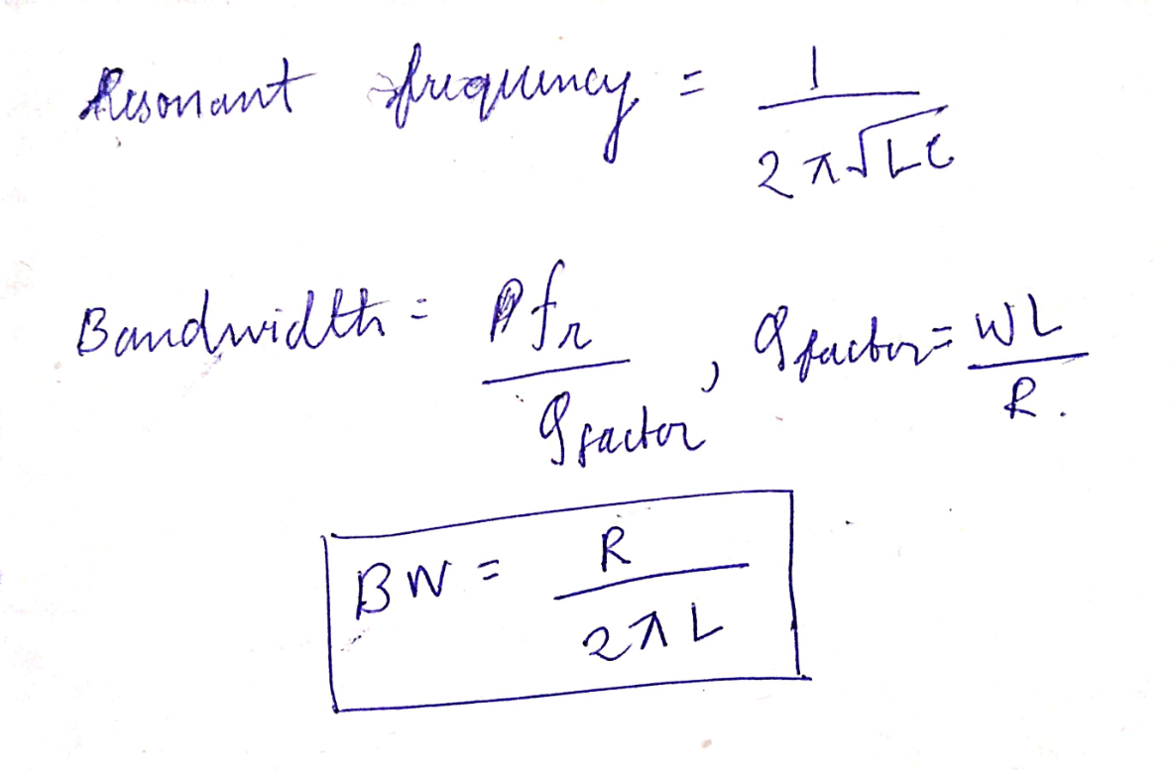

PROCEDURE

1. Open AN-SOF software and go to configure. Set frequency range as 600 – 1000 Hz
2. Now in workspace, draw 3 lines of length 50 mm by going in draw menu and then selecting Line option. Line coordinates are (0, 0, 0) to (0, 0, 50) to (0, 50, 50) to (0, 50, 0).
3. First two lines should have only 1 segment whereas the last line should have 3 segments. All three lines have cross section of 0.1mm.
4. Add source on the first line by right clicking and then source/load and add a voltage source of 1V.
5. Next add a resistance of value 10ohm on the second line. On the third line add an inductance of calculated value in the 1st segment and a capacitance of value 2uF in the 3rd segment.
6. Now, go to simulate menu and select run currents.
7. Right click on source voltage and select list currents.
8. Plot Current vs Frequency graph

CONFIGURATION

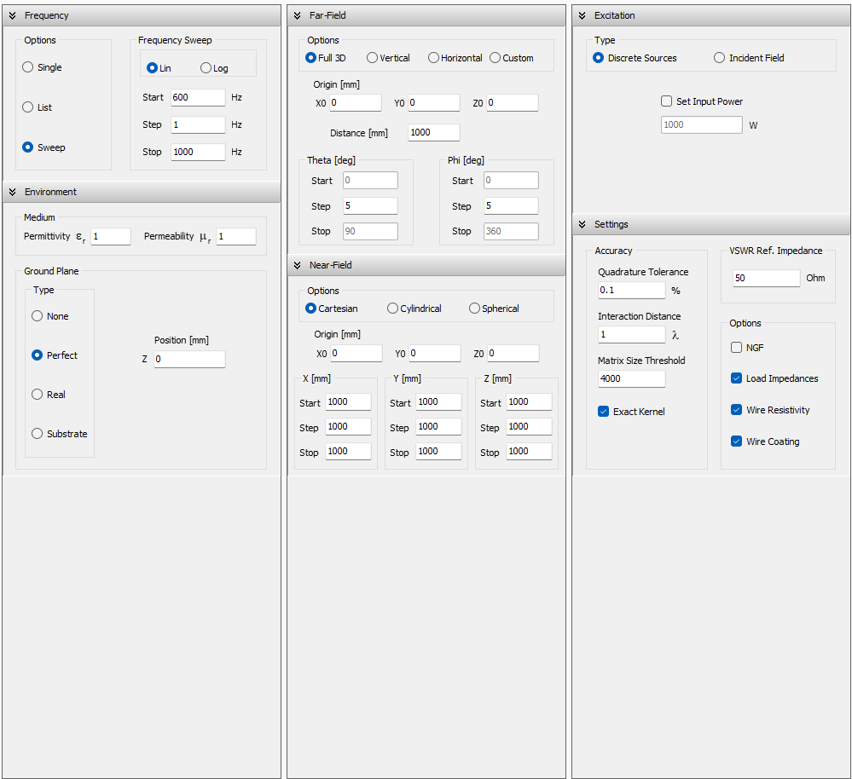

CIRCUIT DIAGRAM

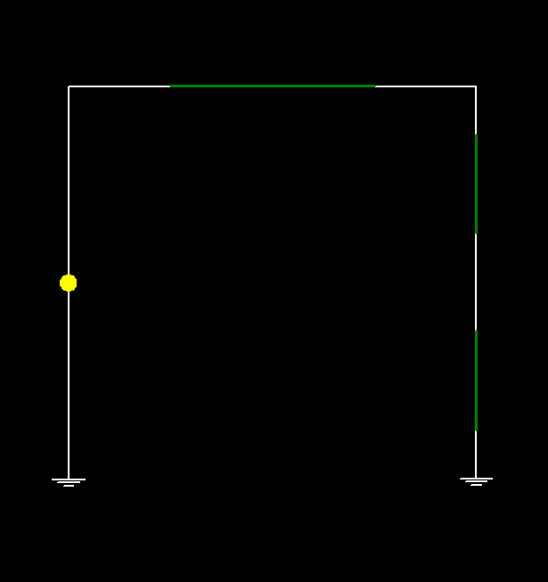

PLOTS

Fr = 500 Hz

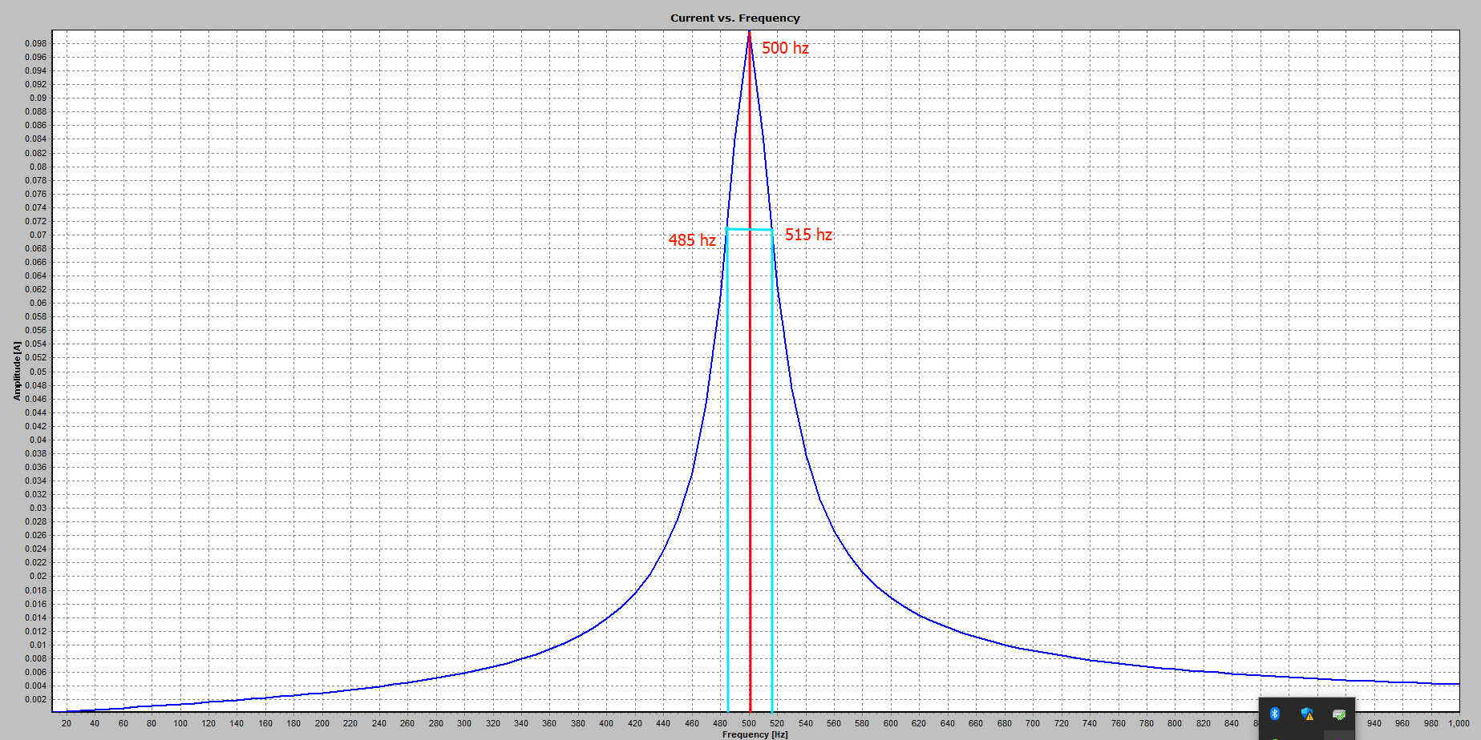

Fr = 750 Hz

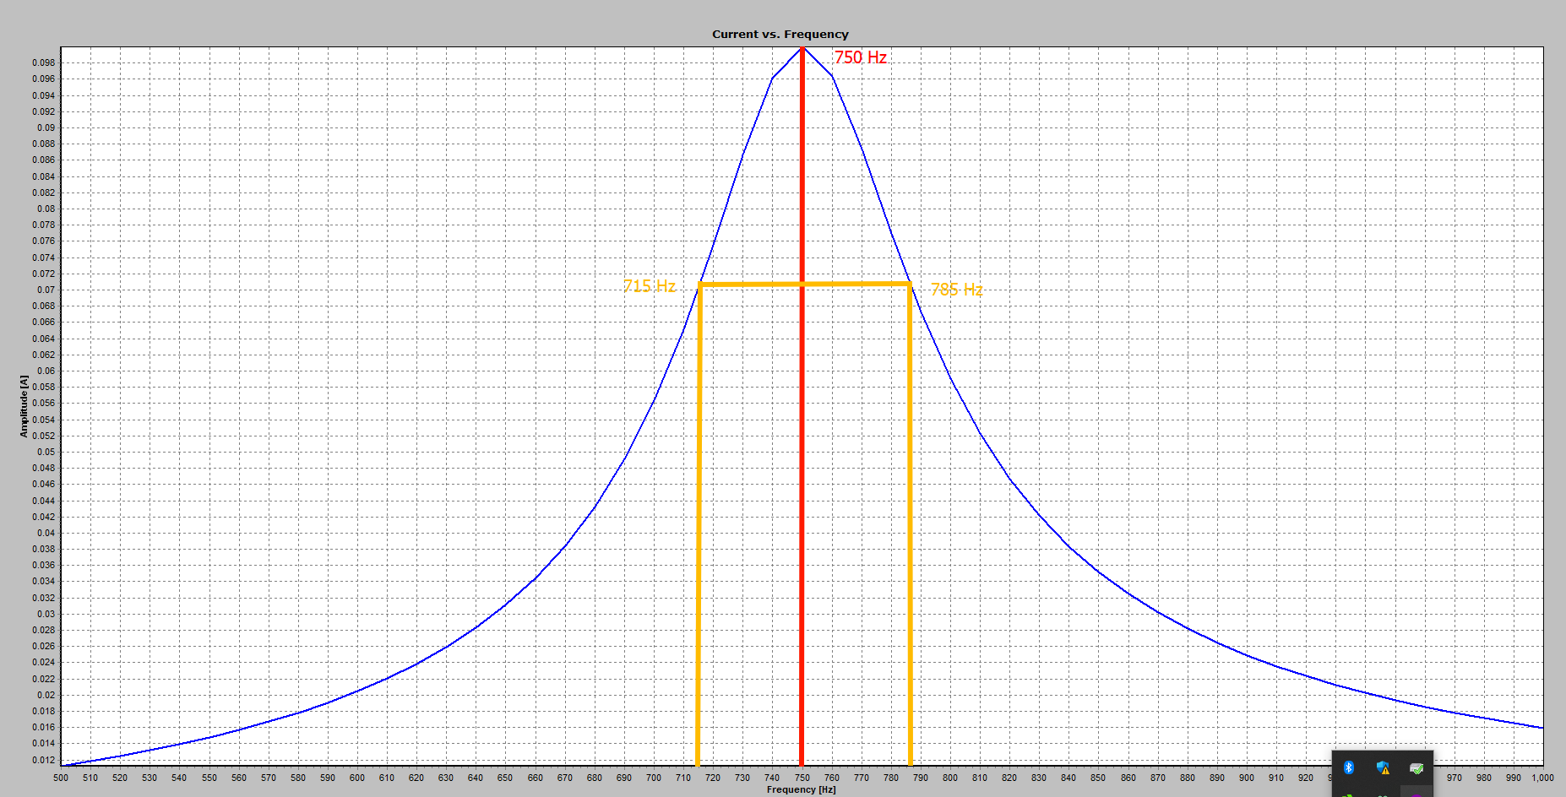

Fr = 1000 Hz

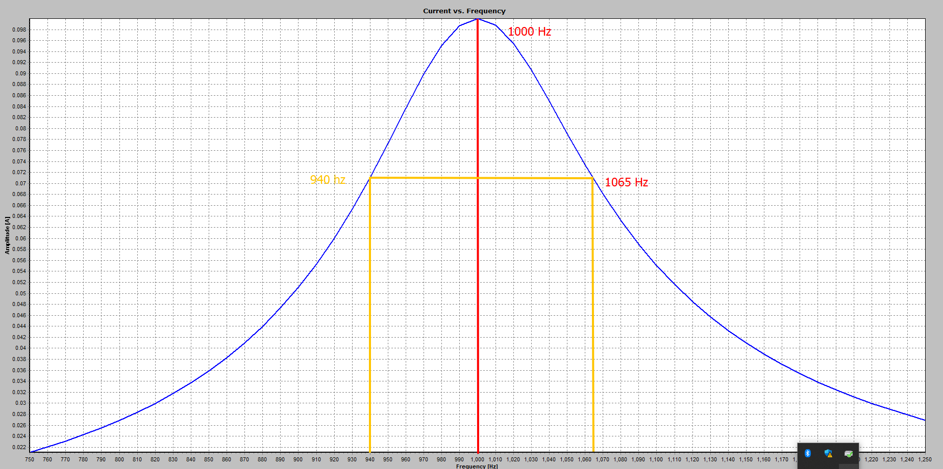

CALCULATIONS

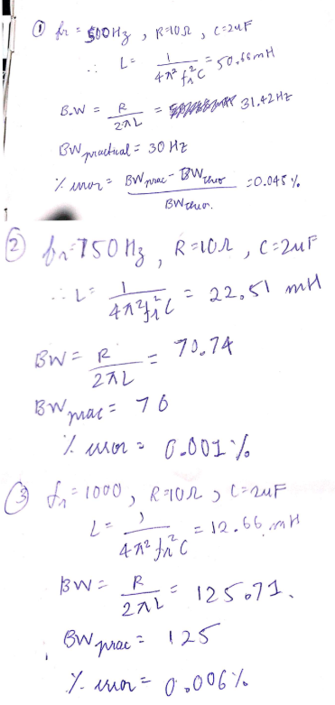

CONCLUSION

RLCG equivalent circuit of the transmission line was simulated in this practical for three distinct frequencies in the scope of 500-1000Hz. We discovered that a portion of a uniform transmission line can be demonstrated by the RLGC circuit. We additionally determined the bandwidth for various resonant frequencies utilizing the above equations. It was tracked down that the hypothetical worth of bandwidth capacity was in close match with the practical value