**U19EC046 | TLEM | LAB 10**

**AIM**

Design a directional helical antenna with the dimensions N= 9, C(circumference) = 0.8IMG_256λ, S(spacing between two turns) = 0.2IMG_257λ for 450MHz operating frequency and plot the

a). Current distribution 3D plot

b). 2D plot of Directivity at Ø (phi) = 0° and find out the front to back ratio, HPBW and FNBW

c). Observe the 3D polar plot of directivity.

**Software Used**

AN-SOF

**THEORY**

Helical antenna or helix antenna is the antenna in which the conducting wire is wound in helical shape and connected to the ground plate with a feeder line. It is the simplest antenna, which provides circularly polarized waves. It is used in extra-terrestrial communications in which satellite relays etc., are involved. It consists of a helix of thick copper wire or tubing wound in the shape of a screw thread used as an antenna in conjunction with a flat metal plate called a ground plate. One end of the helix is connected to the centre conductor of the cable and the outer conductor is connected to the ground plate.

The radiation of helical antenna depends on the diameter of helix, the turn spacing and the pitch angle. The frequency range of operation of helical antenna is around 30MHz to 3GHz. This antenna works in VHF and UHF ranges.

The predominant modes of operation of a helical antenna are −

* **Normal** or perpendicular mode of radiation.
* **Axial** or end-fire or beam mode of radiation.

**i). Normal Mode:-** In normal mode of radiation, the radiation field is normal to the helix axis. The radiated waves are circularly polarized. This mode of radiation is obtained if the dimensions of helix are small compared to the wavelength. The radiation pattern of this helical antenna is a combination of short dipole and loop antenna. It depends upon the values of diameter of helix D and its turn spacing S. Drawbacks of this mode of operation are low radiation efficiency and narrow bandwidth. Hence, it is hardly used.

**ii). Axial Mode:-** In axial mode of radiation, the radiation is in the end-fire direction along the helical axis and the waves are circularly or nearly circularly polarized. This mode of operation is obtained by raising the circumference to the order of one wavelength (λ) and spacing of approximately λ/4. The radiation pattern is broad and directional along the axial beam producing minor lobes at oblique angles. If this antenna is designed for right-handed circularly polarized waves, then it will not receive left-handed circularly polarized waves and vice versa. This mode of operation is generated with great ease and is more practically used.

The geometry of the helical antenna is shown in Fig.1. It consist of parameters viz., diameter of the helix (D), the pitch angle (α), spacing (S) and the number of turns (N).

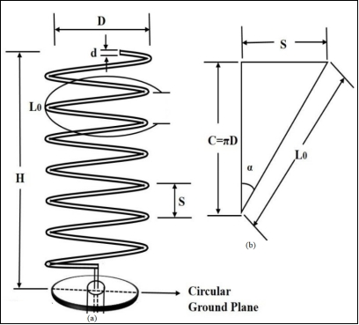

Fig. 1. a) Geometry of helical antenna and b) Representation of one turns

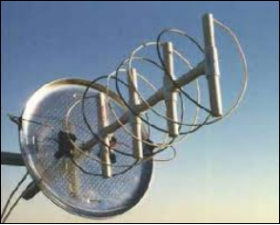

Fig. 2. Helix Antenna

**PROCEDURE**

* Set the frequency of antenna by going in *configure,* then into Option 🡪 Single *(Frequency window),* then set ground by going into Ground Plane 🡪 Perfect *(Environment window)* sand make sure all parameters are in meter (m) by going into Tools 🡪 Preferences.
* Construct helical structure in *workspace* from the Draw 🡪Helix and set the coordinates given in the calculations below by right clicking on the helical structure, go to the option modify. Make 75 segments of the helical structure by going into attributes and select circular and write 3 mm as the radius of circular cross section.
* Construct a line joining the helix and the ground in *workspace* from Draw 🡪Line and set the coordinates given in the calculations below by right clicking on the line, go to the option modify. Make 1 segment of the line by going into attributes and select circular and write 3 mm as the radius of circular cross section.
* Add the 1V source at the 1st segment of the line and then simulate the design.
* Observe the various required plots given in the aim.

**CALCULATIONS**

Given, *f* = 450MHz , N= 9, C(circumference) = 0.8 $×$ λ, and S(spacing between two turns) = 0.2 $×$ λ

λ = $\frac{C}{f}$ = $\frac{{3×10}^{8} m/s}{{450×10}^{6 }Hz}$ = 0.6 m. $C= 0.8×λ=0.8×0.6=0.48$ 
 m.

$S= 0.2×λ=0.2×0.6=0.12$ m.

$$C= π×D$$

$$∴0.8×λ= π×D$$

$D= \frac{0.8×λ}{π}= \frac{0.8×0.6}{π}=0.1526$ m

$$R\left(radius\right)= \frac{D}{2}= \frac{0.1526 }{2}=0.0763 m$$

$L_{0} = \sqrt{S^{2}+C^{2}} = 0.495$ m.

The pitch of helix antenna is (P) = $1.5×R=1.5×0.0763=0.$ 11445 m.

The length to which helix would be extended is = $0.65×R=0.65×0.0763=0.0496$ m.

The pitch angle $(α)=\tan^{−1}{\frac{S}{C }}= \tan^{−1}{\frac{S}{ π×D}}$ = 14.036.

where,

c = speed of light (m/s)

f = operating frequency (MHz)

λ = wavelength (m)

N = Number of turns

C = Circumference (m)

D = Diameter of the helix (m)

S = Spacing between two turns (m)

$L_{0}$ = Length of one turn of helix (m)

* Thus, the coordinate of helical structure is (0, 0, 0.0496) with radius is 0.0726 metre having the pitch of helix is 0.1145 metre and number of turns are 9.
* The coordinates of line joining the helix structure and ground are (0, 0, 0) and (0, 0, 0.0496).

Note is to be taken that the **coordinates** written above are in **metre (m)**.

**REQUIRED PLOTS**

**Preferences**

**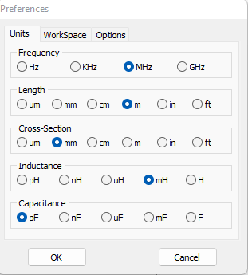**

**Configuration**

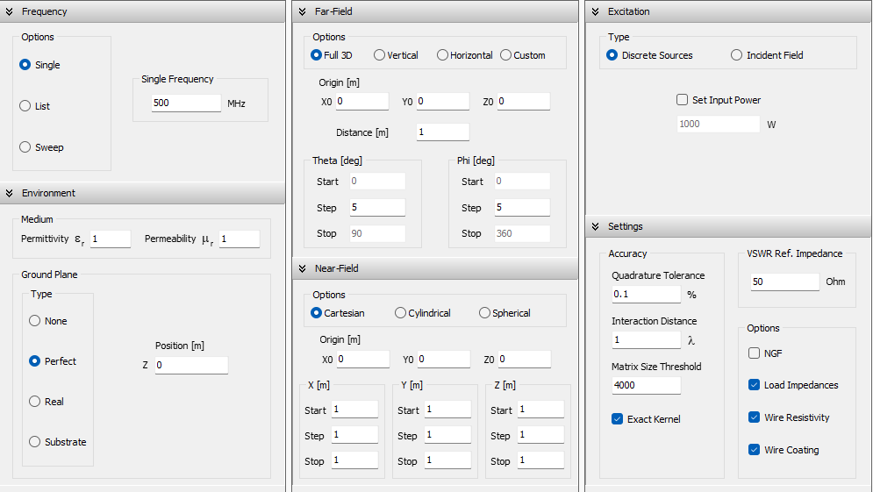

**Helical Antenna Parameters**

|  |  |  |
| --- | --- | --- |
|  |  |  |

**Design of Directional Helical Antenna**

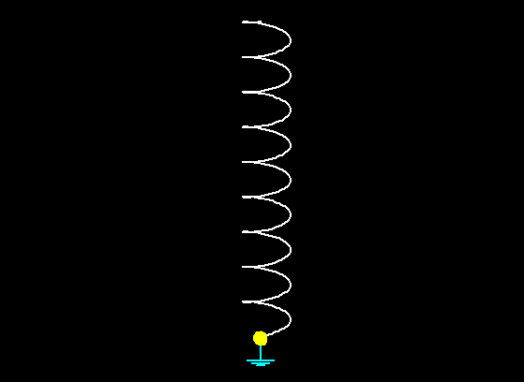

**Current distribution 3D plot for Helical Antenna**

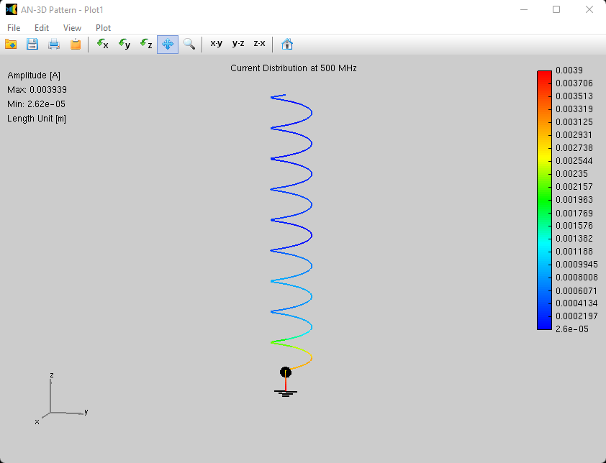

**2D plot of Directivity at Ø (phi) = 0°**

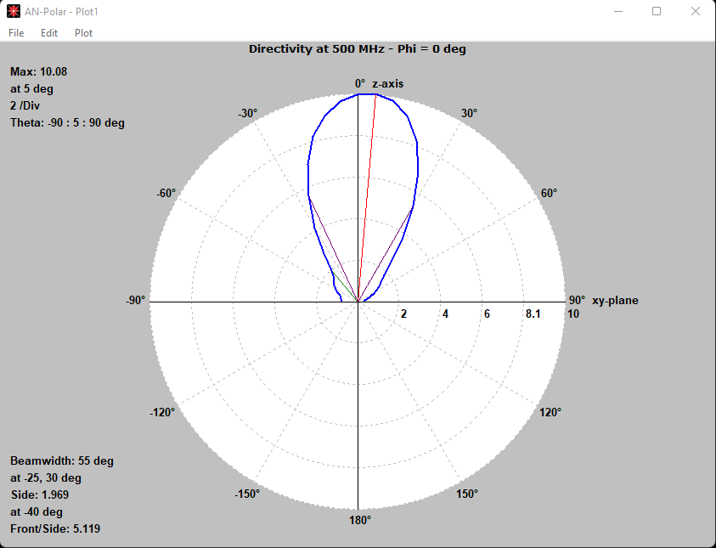

**3D polar plot of Directivity**

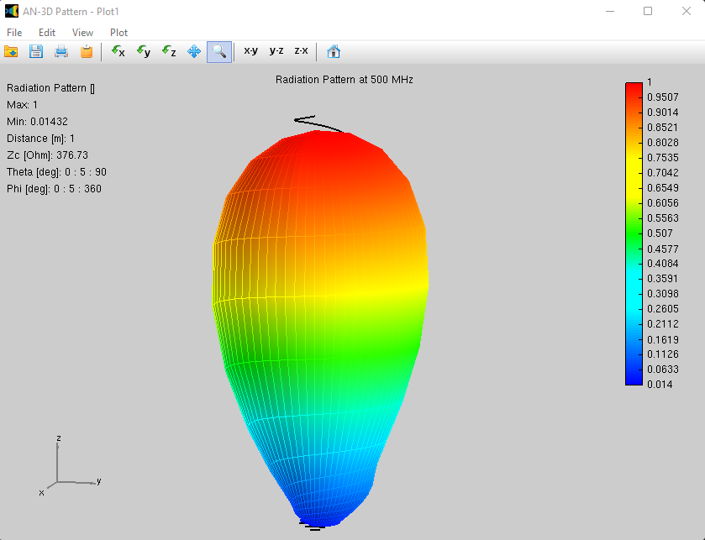

**OBSERVATION**

**Practically**

We are required to find the Front-to-Back Ratio, HPBW and FNBW.

Now, FNBW = 2.25 $×$ HPBW

From the graph no. 2, i.e. 2D plot of Directivity at Ø (phi) = 0°, it is obtained that Front-to-Back Ratio is equal to 7.546 and HPBW is °.

Front/Back = 7.546

HPBW = 55°

FNBW = 2.25 $×$ HPBW

= 2.25 $×$ 55°

|  |
| --- |
| FNBW = 123.75° |

**Theoretically**

The formulas for calculating HPBW, FNBW and directivity are given below:

1. HPBW = $\frac{52}{\frac{C}{λ}\sqrt{N\left(\frac{S}{λ}\right)}}$ degree
2. FNBW = $\frac{115}{\frac{C}{λ}\sqrt{N\left(\frac{S}{λ}\right)}}$ degree
3. Directivity = $15×{\left(\frac{C}{λ}\right)}^{2}×N×\left(\frac{S}{λ}\right)$

* HPBW = $\frac{52}{\frac{C}{λ}\sqrt{N\left(\frac{S}{λ}\right)}}= \frac{52}{0.8\sqrt{9×0.2}}=$ 48.448°
* FNBW = $\frac{115}{\frac{C}{λ}\sqrt{N\left(\frac{S}{λ}\right)}}= \frac{115}{0.8\sqrt{9×0.2}}=$ 107.145°
* Directivity =

= 150.82 90.2

= 17.28

Directivity in (dB) = $10\log_{10}{(17.28)}$

= $10×1.2375$

|  |
| --- |
| Directivity in (dB) = 12.375 dB |

So theoretically we have HPBW = 48.448°, FNBW = 107.145° and directivity = 12.375 dB.

**COMPARISON TABLE:**

|  |  |  |
| --- | --- | --- |
| Parameters | Practical Value | Theoretical Value |
| HPBW (in degree) | 55° | 48.448° |
| FNBW (in degree) | 123.75° | 107.145° |
| Directivity (in dB) | 10.05 | 12.375 |

**CONCLUSION**

In this experiment, we designed directional helical antenna for the given specification at operating frequency 500MHz. Further we found the HPBW, FNBW and Directivity practically i.e. observing the plot on An-Sof software and theoretically as well. On comparing those parameters practically and theoretically we can say that we got the nearly same results.