**U19EC046 | TLEM | LAB 5**

**AIM**

Design ƛ/4, ƛ/2, ƛ and 3ƛ/2 dipole antenna for the operating frequency of 575MHz in an-sof software and plot:

a. Current Distribution 2D and 3D Plot.

b. 2D Plot of Directivity of θ = 90 degree and φ = 90 degree and find out

the front to back ratio, HPBW and FNBW.

c. Observe the 3D Polar Plot of Directivity.

**THEORY**

An Antenna is a transducer which converts electrical power into electromagnetic waves and vice versa. It is a coupling device that radiates/receives EM waves. It is tuned and is mostly passive. The energy radiated by an antenna is represented by the Radiation pattern of the antenna. Radiation Patterns are diagrammatic representations of the distribution of

radiated energy into space, as a function of direction.

**FEW COMMON TYPES OF ANTENNA RADIATION ARE AS FOLLOWS:**

**1. ISOTROPIC RADIATOR**

• This is an impractical antenna, it is capable of radiating uniformly in all directions.

• It is used for reference purpose Ex: Point Source.

• Also called Non- Directional Radiator.

**2. DIRECTIONAL RADIATOR**

All Practical Antennas are Directional Radiators, they are capable of radiating or receiving EM waves through some particular direction.

**3. OMNI DIRECTIONAL RADIATOR**

It is a special kind of Directional radiator capable of radiating uniformly in (θ = 90 degree) azimuthal plane and having non-uniform radiation in elevation plane (ϕ = constant) Ex: Dipole Antenna.

**BEAM WIDTH**

Beam width is the aperture angle from where most of the power is radiated. The two main considerations of this beam width are Half Power Beam Width (HPBW) and First Null Beam Width (FNBW).

**HALF-POWER BEAM WIDTH**

The angular separation, in which the magnitude of the radiation pattern decreases by 50% (or -3dB) from the peak of the main beam, is the Half Power Beam Width. In other words, Beam width is the area where most of the power is radiated, which is the peak power. Half power beam width is the angle in which relative power is more than 50% of the peak power, in the effective radiated field of the antenna.

**FIRST NULL BEAM WIDTH**

The angular span between the first pattern nulls adjacent to the main lobe, is called the First Null Beam Width. Simply, FNBW is the angular separation, quoted away from the main beam, which is drawn between the null points of the radiation pattern, on its major lobe.

Procedure:

• Configure the frequency of the antenna and make sure all the parameters are in mm.

• Construct an antenna from the draw tab and set the coordinates based on the wavelength we calculated for the given frequency.

• Select the number of segments as 11, and set the cross-section as 0.25mm.

• Add the source to the centre and simulate, using the Run All command.

• Observe the current plots and the Directive plots to draw the conclusions.

**CALCULATIONS:**

For f = 575 MHz,

λ= c/f = (3*10^8)/(575*10^6) = 52.17 cm

λ/2 = 26.08 cm

λ/4 = 13.04 cm

3λ/2 = 78.24 cm

**OBSERVATIONS**

1. **At L = λ/4**

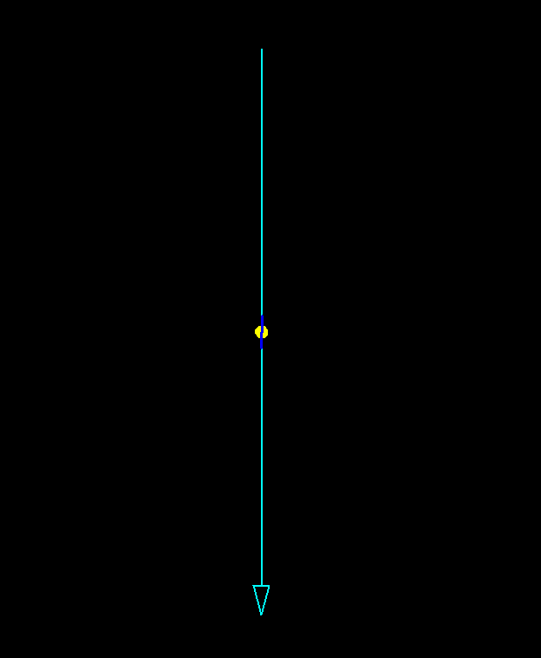

AN-SOF DESIGN

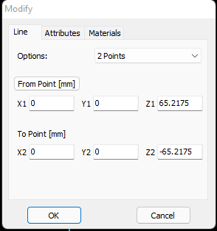

COORDINATES

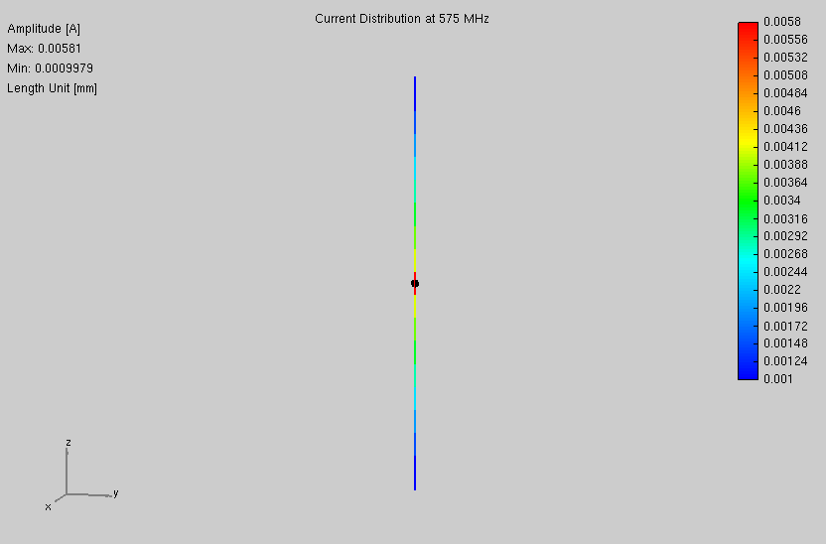

3D CURRENT DISTRIBUTION

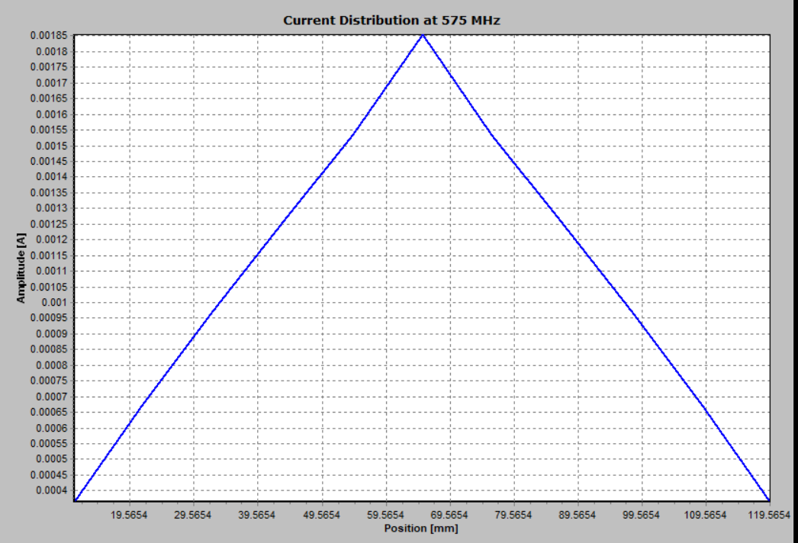

2D CURRENT DISTRIBUTION

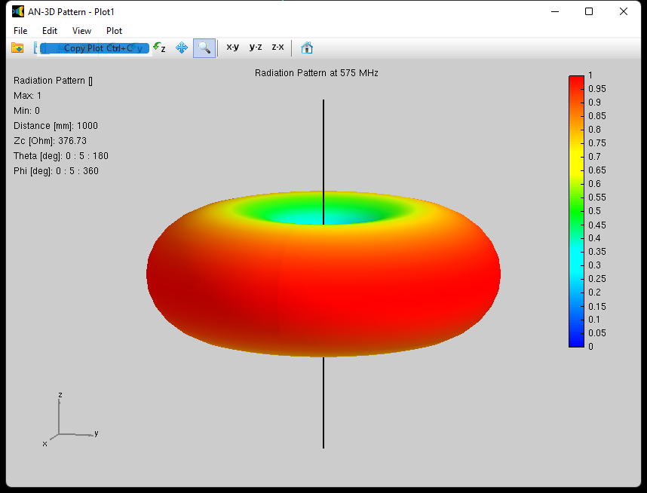

3D DIRECTIVITY PLOT

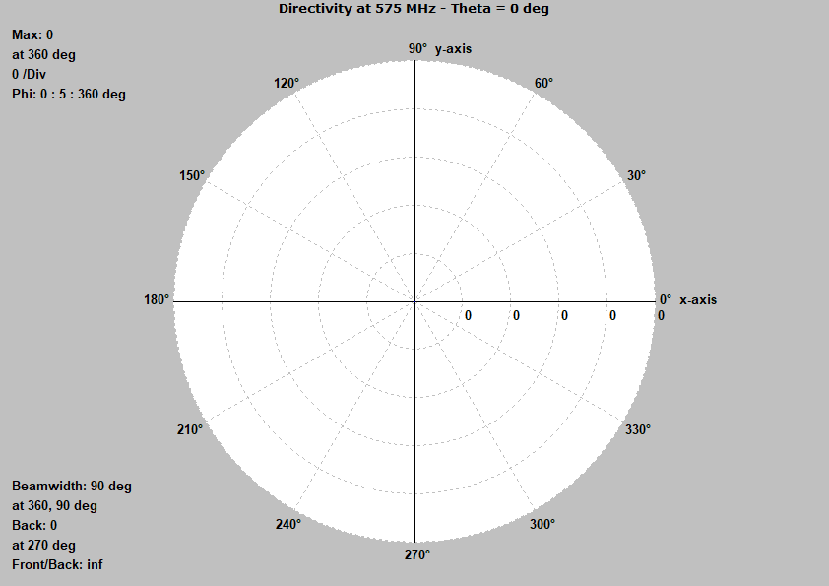

2-D Radiation Plot for θ = 0 degree

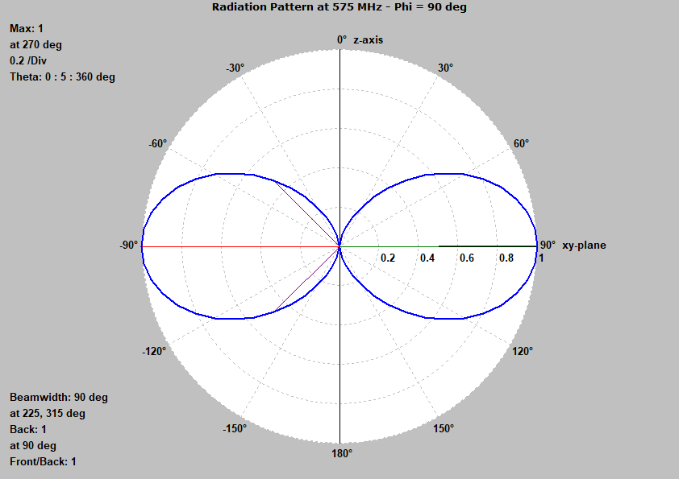

2-D Radiation Plot for ϕ = 90 degree

1. **At L = λ/2**



AN-SOF DESIGN

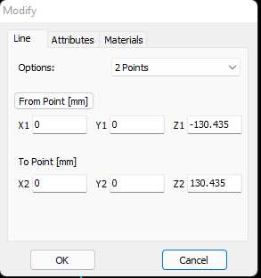

COORDINATES

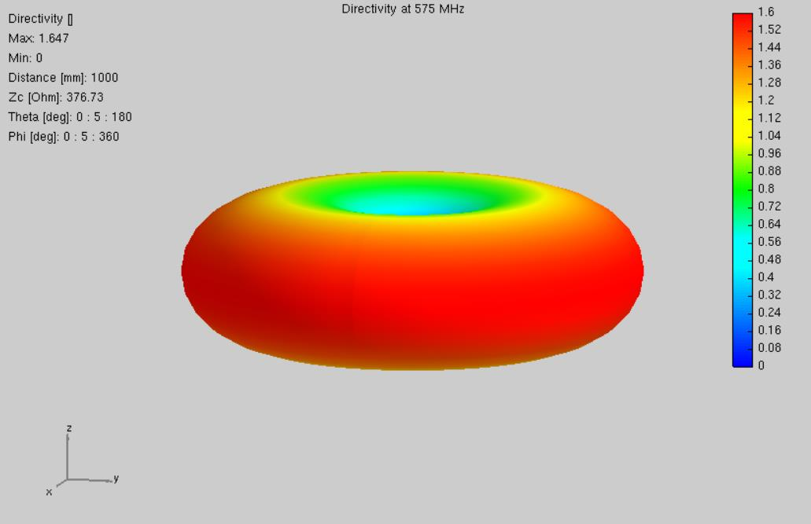

3D CURRENT DISTRIBUTION

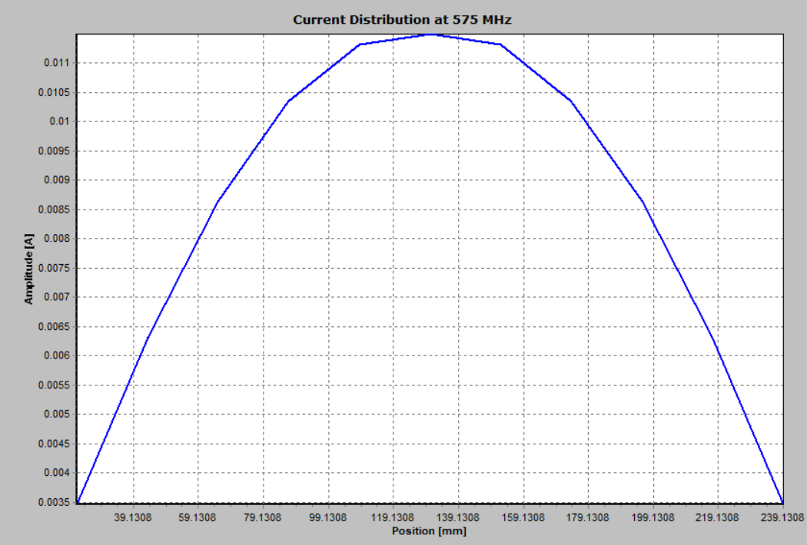

2D CURRENT DISTRIBUTION

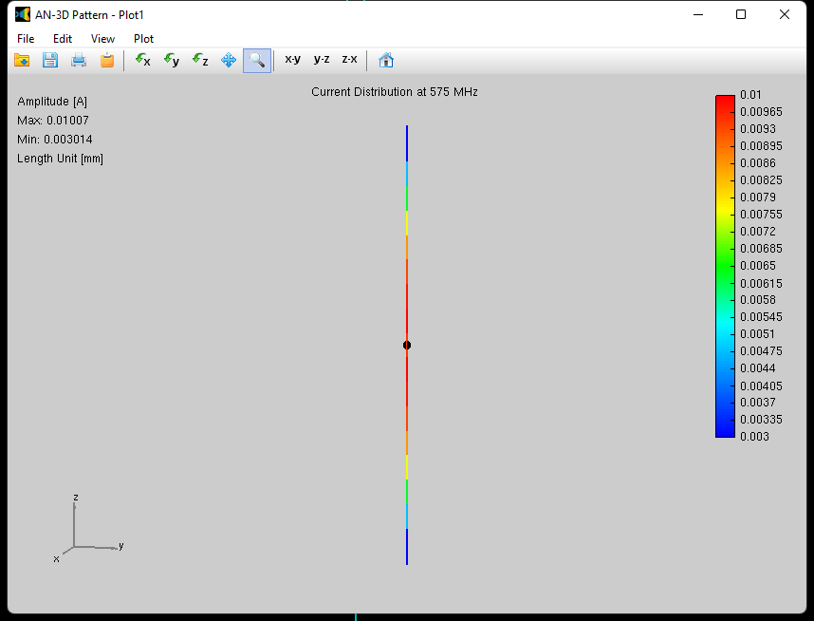

3D DIRECTIVITY PLOT

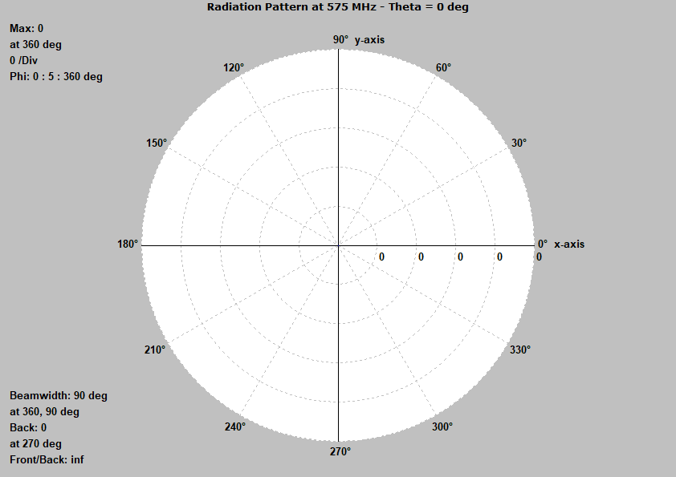

2-D Radiation Plot for θ = 0 degree

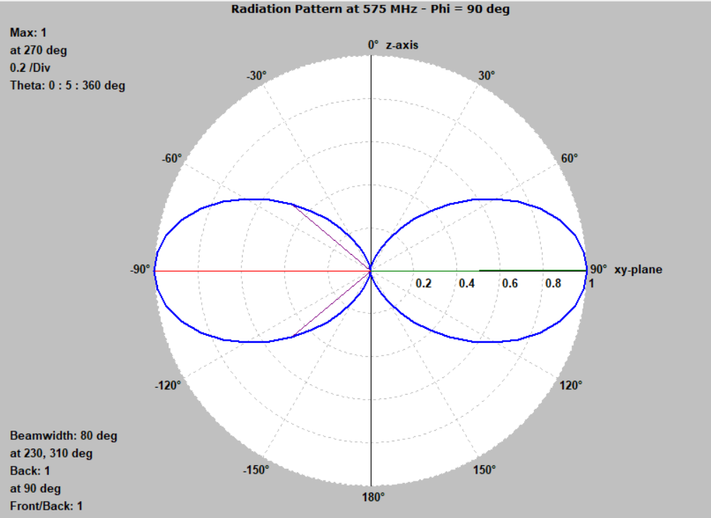

2-D Radiation Plot for ϕ = 90 degree

1. **At L = λ**



AN-SOF DESIGN

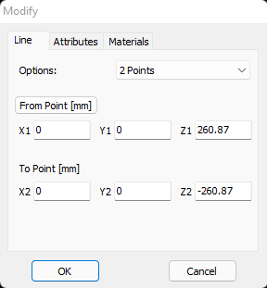

COORDINATES

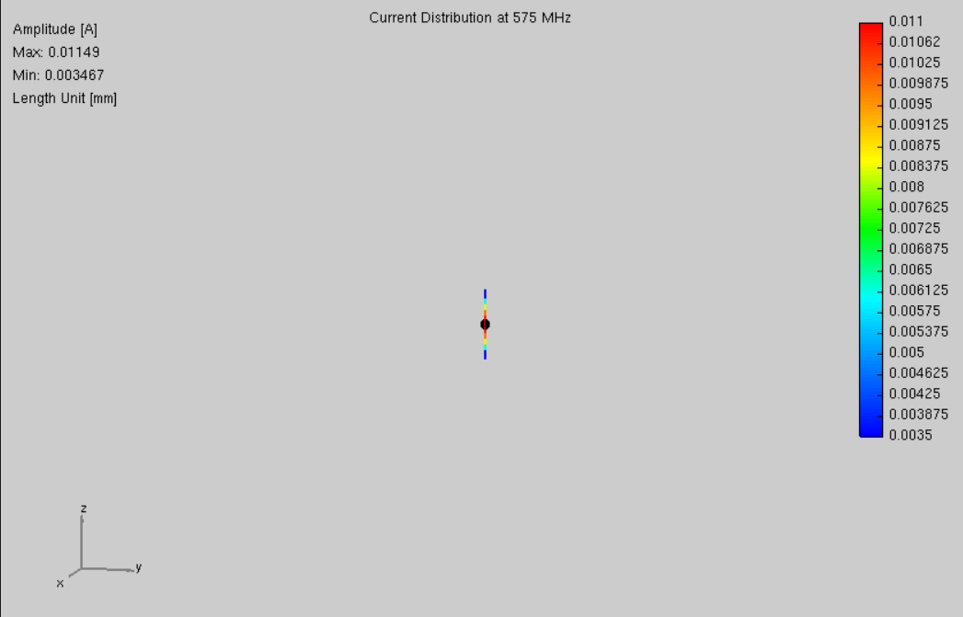

3D CURRENT DISTRIBUTION



2D CURRENT DISTRIBUTION



3D DIRECTIVITY PLOT

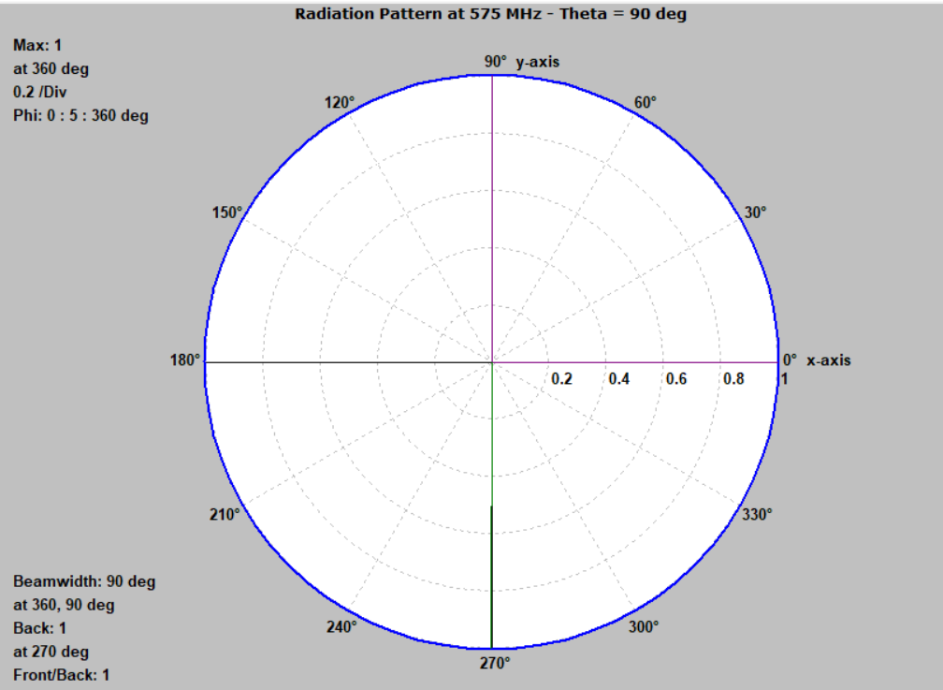

2-D Radiation Plot for θ = 0 degree



2-D Radiation Plot for ϕ = 90 degree

**4. At L = λ/4**



AN-SOF DESIGN

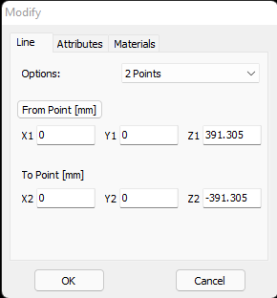

COORDINATES

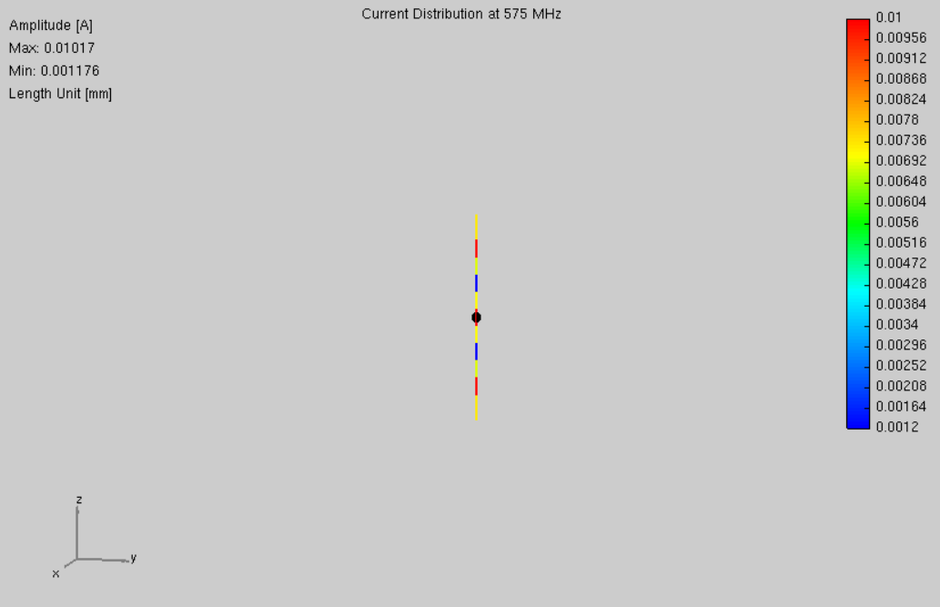

3D CURRENT DISTRIBUTION

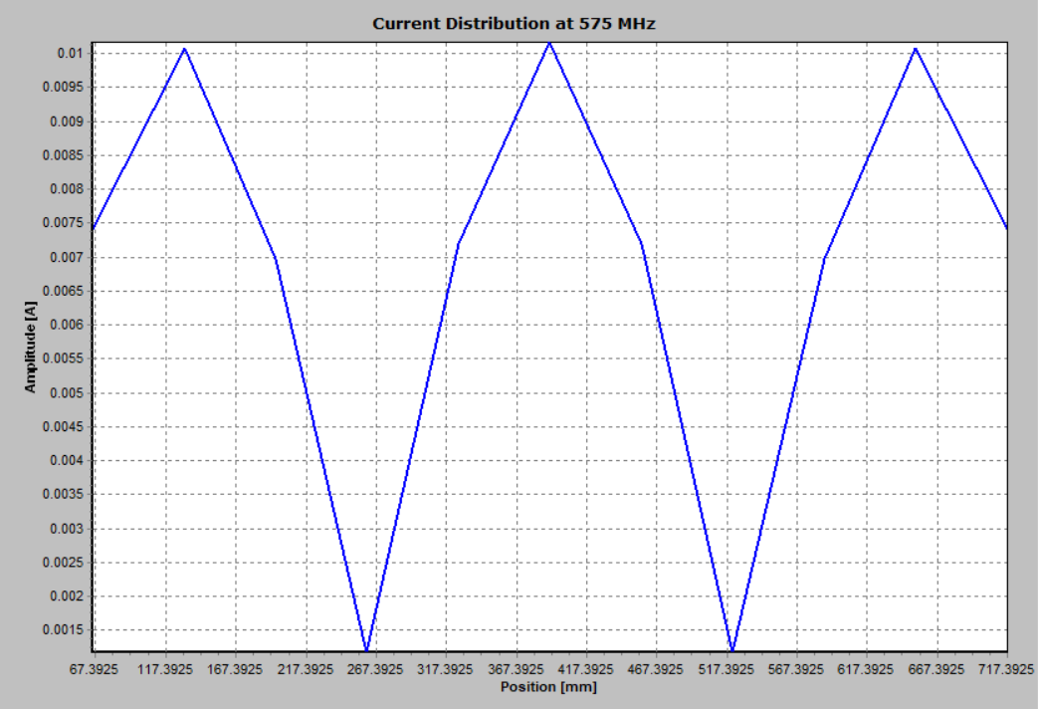

2D CURRENT DISTRIBUTION

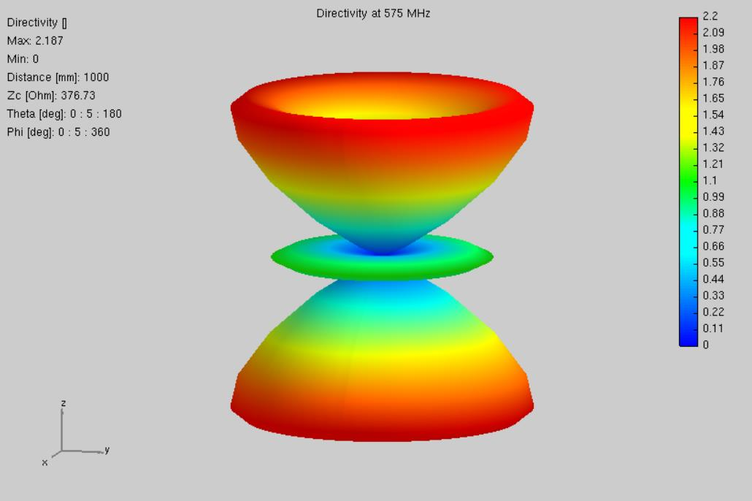

3D DIRECTIVITY PLOT

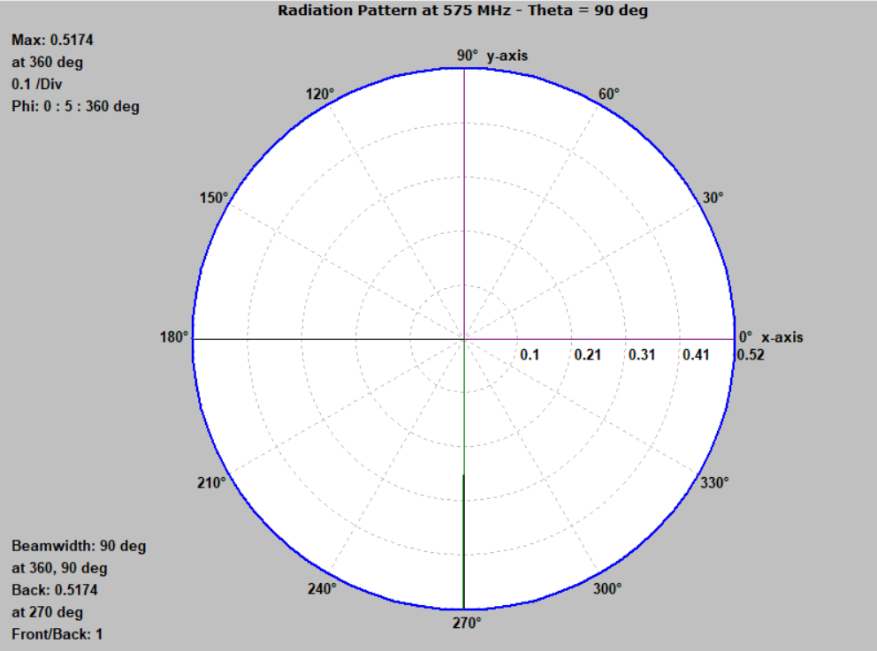

2-D Radiation Plot for θ = 0 degree

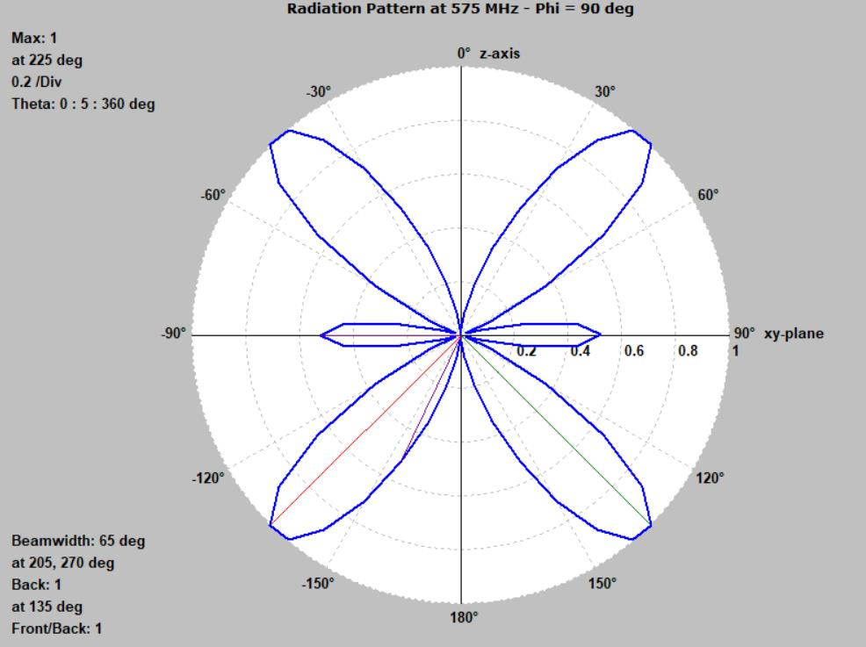

2-D Radiation Plot for ϕ = 90 degree

**CALCULATIONS**

From these graphs:

1. Front to Back Ratio= 1 for λ, λ/2, λ/4, 3λ/2

2. HPBW = 90 degree for λ/4

= 80 degree for λ/2

= 50 degree for λ

= 65 degree for 3λ/2

3. FNBW= 2.25*HPBW = 2.25*90 degree = 202.5 degree for λ/4

= 2.25*80 degree = 180 degree for λ/2

= 2.25*50 degree = 112.5 degree for λ

= 2.25*65 degree = 146.25 degree for 3λ/2

**CONCLUSION**

Through this Practical we planned ƛ/4, ƛ/2, ƛ and 3ƛ/2 dipole antenna for 575MHz and plot current distribution, 2D plot and 3D plot of different antenna lengths utilizing AN-SOF Simulation Software and we likewise determined front to back proportion, HPBW and FNBW.