**U19EC046 | TLEM | LAB 6**

**AIM**

Design a 3 element Yagi Uda antenna for the operating frequency of 650MHz in An-sof software and plot the

a). Current distribution 2D plot & 3D plot

b). 2D plot of Directivity at Ø (phi) = 90° and find out the front to back ratio, HPBW and FNBW

c). Observe the 3D polar plot of directivity.

d). Also observe the strength of signal at different distances d=1m, 10m, 100m, 500m.

**Software Used**

An-sof Software

**THEORY**

A Yagi–Uda antenna or simply Yagi antenna, is a [directional antenna](https://en.wikipedia.org/wiki/Directional_antenna" \o "Directional antenna) consisting of two or more parallel [resonant](https://en.wikipedia.org/wiki/Antenna_(radio)" \l "Resonant_antennas" \o "Antenna (radio)) antenna elements in an [end-fire array](https://en.wikipedia.org/wiki/Antenna_array" \l "Types" \o "Antenna array); these elements are most often metal rods acting as [half-wave dipoles](https://en.wikipedia.org/wiki/Half-wave_dipole" \o "Half-wave dipole). Yagi–Uda antennas consist of a single [driven element](https://en.wikipedia.org/wiki/Driven_element" \o "Driven element) connected to a radio [transmitter](https://en.wikipedia.org/wiki/Transmitter" \o "Transmitter) and/or [receiver](https://en.wikipedia.org/wiki/Radio_receiver" \o "Radio receiver) through a [transmission line](https://en.wikipedia.org/wiki/Transmission_line" \o "Transmission line), and additional "[parasitic elements](https://en.wikipedia.org/wiki/Parasitic_element" \o "Parasitic element)" with no electrical connection, usually including one so-called reflector and any number of directors. The Yagi-Uda antenna is a particularly popular form of antenna where directivity and gain are required. Although, the Yagi antenna has become particularly popular for television reception, it is also used in many other applications, both domestic and commercial or professional.

The frequency range in which the Yagi-Uda antennas operate is around 30 MHz to 3GHz which belong to the VHF and UHF bands.

The gain and directivity of the Yagi antenna enable improved reception by enabling better levels of signal to noise ratio to be achieved, and by reducing interference levels by only picking up signals from a given direction. For transmitting much better use of the available power is made because it is possible to focus the transmitted power on areas where it is needed. Similarly levels of general interference can be reduced to other users because the signal is not transmitted to areas where it is not needed.

There are three types of element within a Yagi antenna:

• **Driven or Active Element**:

The active element is the Yagi antenna element to which power is applied. It is normally a half wave dipole or often a folded dipole.

• **Reflector**:

The reflector element is made to be about 5% longer than the driven element. The Yagi antenna will generally only have one reflector. This is behind the main driven element, i.e. the side away from the direction of maximum sensitivity.

Further reflectors behind the first one make no noticeable different to the antenna performance. However many designs use reflectors consisting of a reflecting plate, or a series of parallel rods simulating a reflecting plate. This gives a slight improvement in performance, reducing the level of radiation or pick-up from behind the antenna, i.e. in the backwards direction. This can help in reducing the level of interference received.

Typically a reflector will add around 4 or 5 dB of gain in the forward direction.

• **Director**:

The director or directors are made to be shorter than the driven element. There may be none, one of more reflectors in the Yagi antenna. The director or directors are placed in front of the driven element, i.e. in the direction of maximum sensitivity. Typically each director will add around 1 dB of gain in the forward direction, although this level reduces as the number of directors increases.

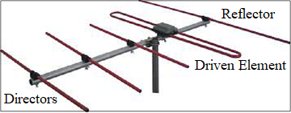

Fig. Yagi-Uda Antenna

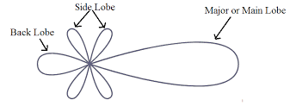

Fig. Radiation Pattern of Yagi-Uda Antenna

**PROCEDURE:**

* Configure the frequency of antenna by going into option 🡪 single and make sure all parameters are in meter (m) by going into Tools 🡪 Preferences.
* Construct Reflector, Driven Element and Director from the Draw 🡪Line and set the coordinates given in the calculations below by right clicking on the line, go to the option modify.
* Make 15 segments of the line by going into attributes and select circular and write 5 mm as the radius of circular cross section.
* Add the 1V source in the middle of the line i.e. at the 8th segment of the line and then simulate the results.
* Observe the various required plots given in the aim.

**CALCULATIONS:-**

1 foot = 0.3 m

λ = $\frac{C}{f}$ = $\frac{{3×10}^{8} m/s}{{650×10}^{6 }Hz}$ = 0.4615 m

d = 0.15 $×$ λ = 0.15 $×$ 0.4615m = 0.0692 m

$L_{R}= \frac{492}{f(MHz)}$ = 0.7569 foot = 0.227 m

$L_{A}= \frac{478}{f(MHz)}$ = 0.7354 foot = 0.2206 m

$L_{D}= \frac{461.5}{f(MHz)}$ = 0.71 foot = 0.213 m

$$P_{rad}= \iint_{0 0}^{2π π}{P_{D}(r^{2}sinθdθdφ)d\hat{r}}$$

where,

c = speed of light (m/s)

f = operating frequency (MHz)

λ = wavelength (m)

d = spacing between two consecutive elements of antenna (m)

$L_{R}$ = Length of Reflector (m)

$L_{A}$ = Length of Driven or Active element (m)

$L_{D}$ = Length of Director (m)

$P_{rad}$ = Radiated Power (Watt)

$P_{D}$ = Power Density (Watt/m2)

= Far Field Distance (m)

* Thus, the coordinates of line (Reflector) are (0.1135, -0.0692, 0) and (-0.1135, -0.0692, 0).
* The Coordinates of line (Driven or Active element) are (0.1103, 0, 0) and (-0.1103, 0, 0).
* The Coordinates of line (Director) are (0.1065, 0.0692, 0) and (-0.1065, 0.0692, 0).

Note is to be taken that the **coordinates** written above are in **metre (m).**

**Design of Yagi-Uda Antenna**

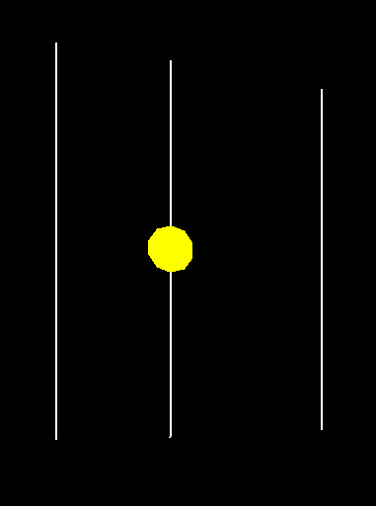

**Yagi-Uda Antenna Parameters**

**Reflector:**

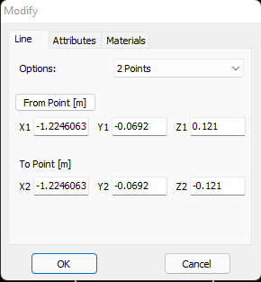

Active Element:

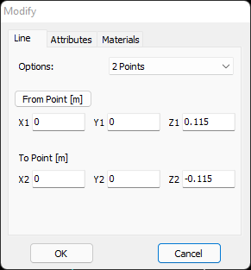

Director

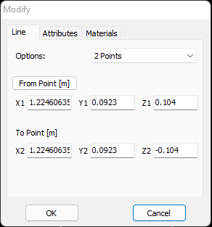

* The number of segment are 15 and circular cross section radius is 5 mm, and this attribute will remain same for all 3 element i.e. Reflector, Active or Driven Element and Director of Yagi-Uda Antenna.

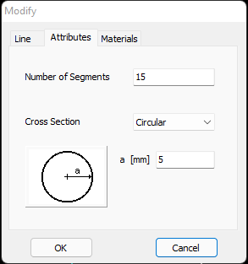

* The voltage source value which has been used by the antenna in this experiment is given below:-

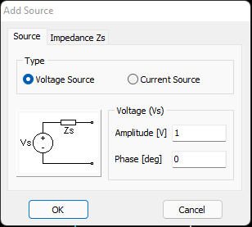

**REQUIRED PLOTS:-**

1. **Current distribution 2D plot for Reflector**

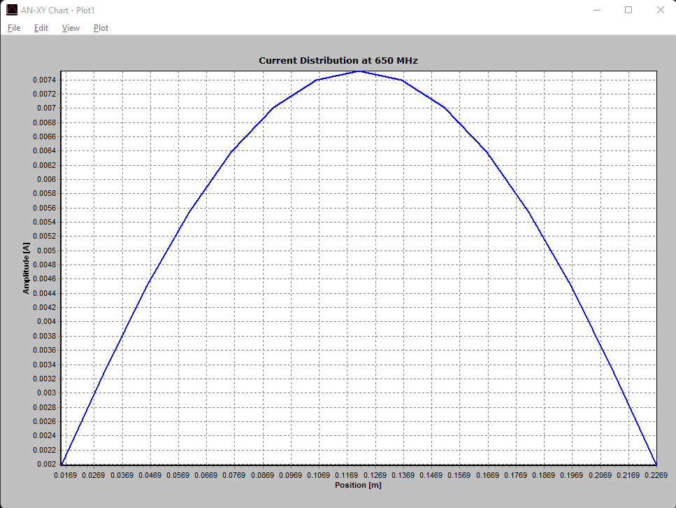

1. **Current distribution 2D plot for Active or Driven Element**

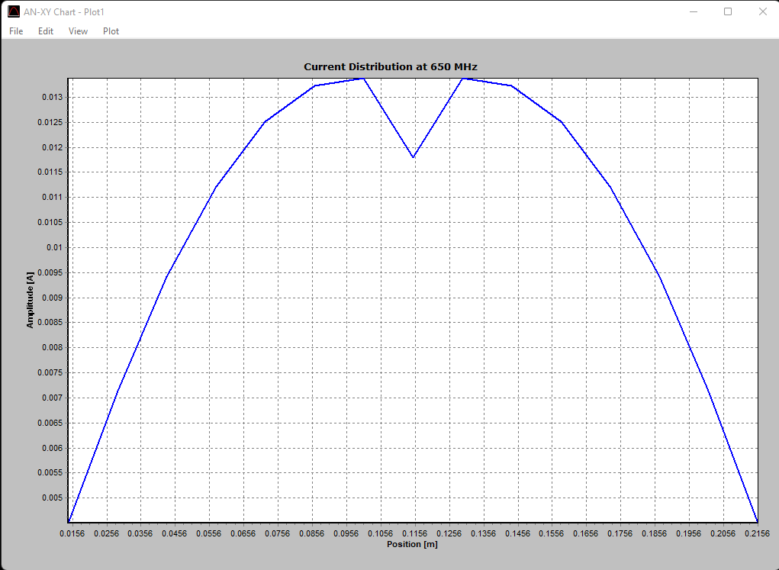

1. **Current distribution 2D plot for Director**

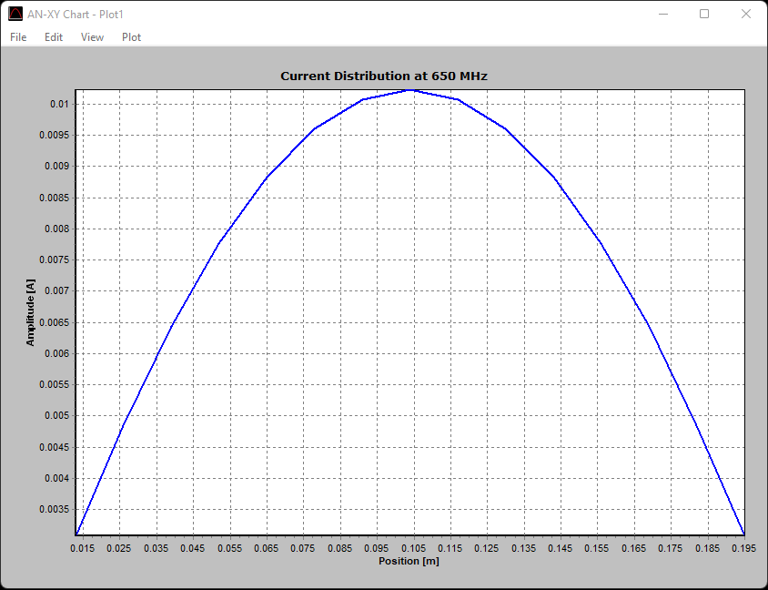

1. **Current distribution 3D plot for Yagi-Uda Antenna**

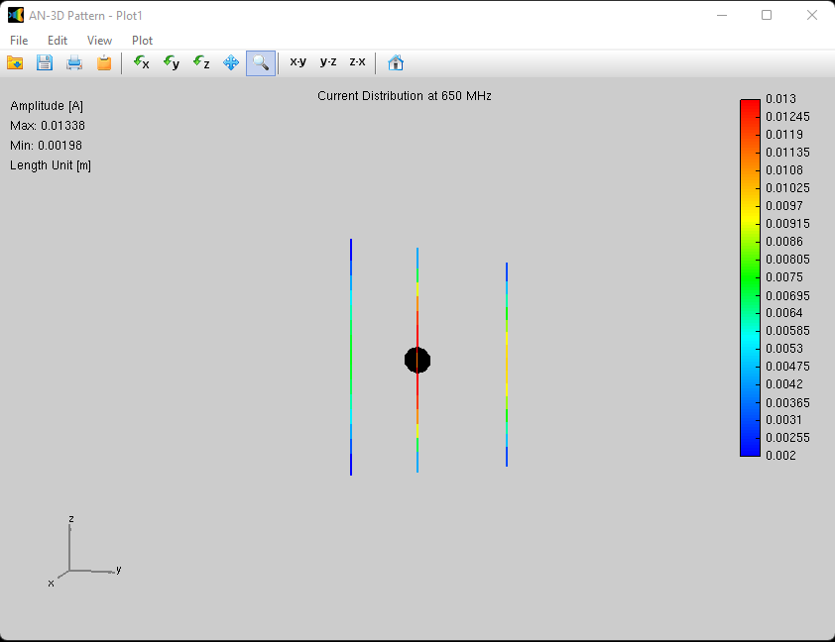

1. **2D plot of Directivity at Ø (phi) = 90°**

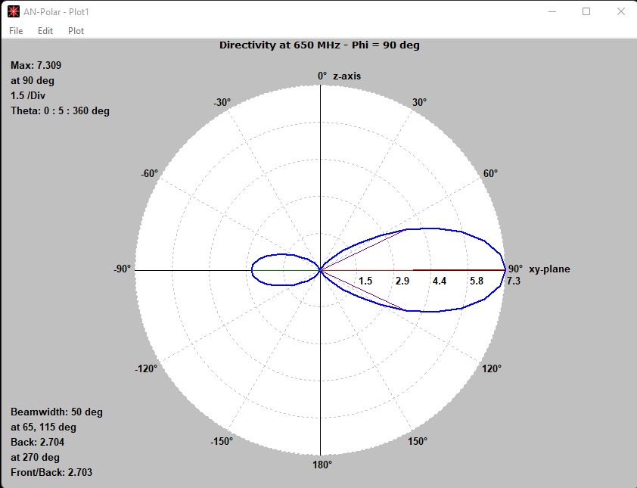

1. **3D polar plot of Directivity**

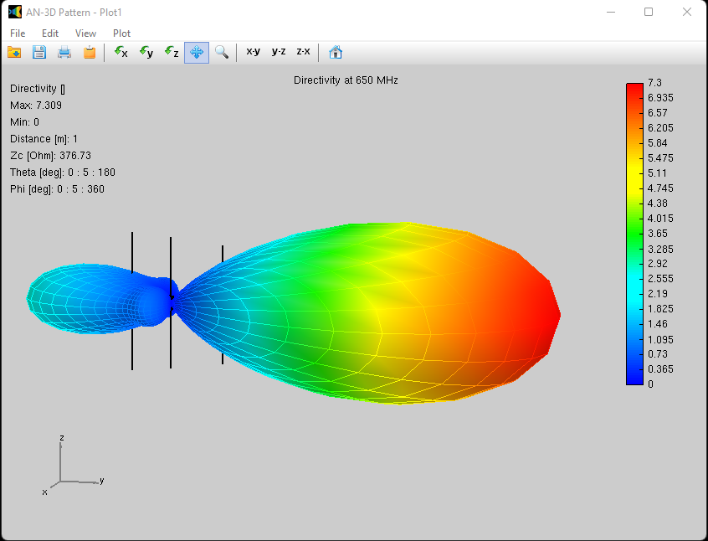

**OBSERVATION:-**

We are required to find the Front-to-Back Ratio, HPBW and FNBW.

Now, FNBW = 2.25 $×$ HPBW

From the graph no. 5, i.e. 2D plot of Directivity at Ø (phi) = 90°, it is obtained that Front-to-Back Ratio is equal to 3.165 and HPBW is 60°.

* Front/Back =2.7
* HPBW = 50°
* FNBW = 2.25 $×$ HPBW

= 2.25 $×$ 50°

|  |
| --- |
| FNBW = 112.5° |

**Strength of Signal at Different Distances:-**

1. **At 1 m**

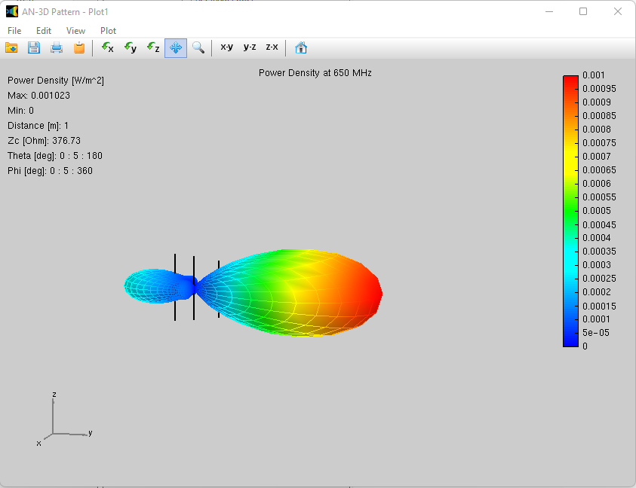

PD = 0.001023 W/m2 , r = 1 metre

Solving the integral for Radiated Power calculation, $P_{rad}= \iint_{0 0}^{2π π}{P_{D}(r^{2}sinθdθdφ)d\hat{r}}$

$$P_{rad}=4πP_{D}r^{2}$$

$$P_{rad}=4π×({0.001023)×1}^{2}$$

|  |
| --- |
| $P_{rad}$ = 0.0129 Watt |

1. **At 10 m**

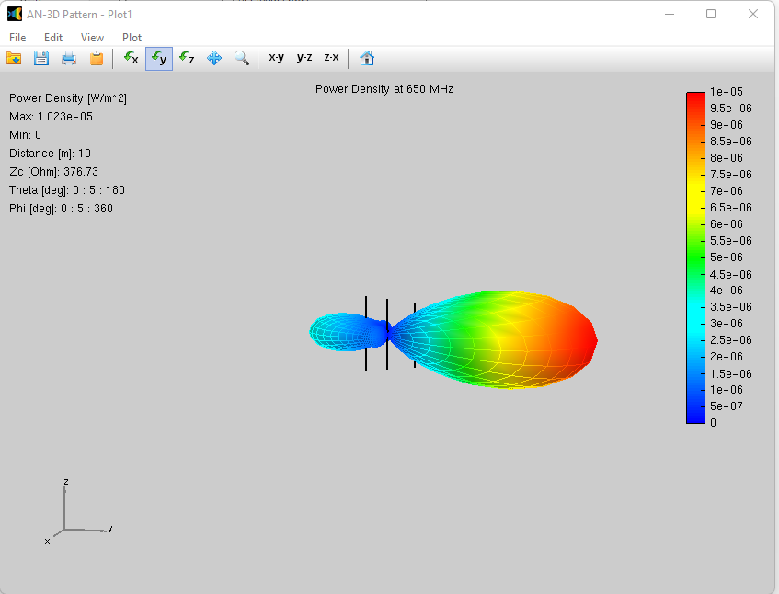

PD = 0.00001023 W/m2 , r = 10 metrse

Solving the integral for Radiated Power calculation, $P_{rad}= \iint_{0 0}^{2π π}{P_{D}(r^{2}sinθdθdφ)d\hat{r}}$

$$P_{rad}=4πP_{D}r^{2}$$

$$P_{rad}=4π×({0.00001023)×10}^{2}$$

|  |
| --- |
| $P_{rad}$ = 0.0129 Watt |

1. **At 100 m**

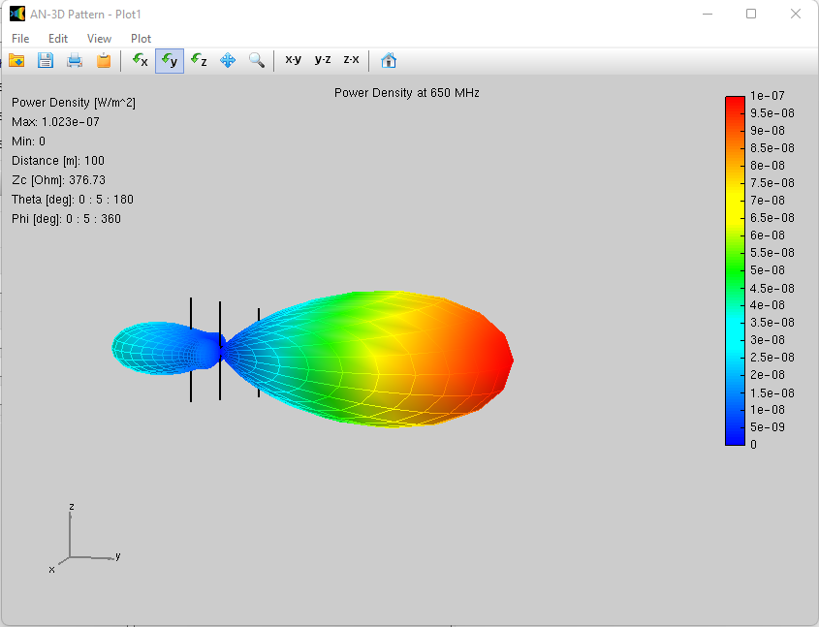

PD = 0.0000001023 W/m2, r = 100 metre

Solving the integral for Radiated Power calculation, $P_{rad}= \iint_{0 0}^{2π π}{P_{D}(r^{2}sinθdθdφ)d\hat{r}}$

$$P_{rad}=4πP_{D}r^{2}$$

$$P_{rad}=4π×({0.0000001023)×100}^{2}$$

|  |
| --- |
| $P_{rad}$ = 0.0129 Watt |

1. **At 500 m**

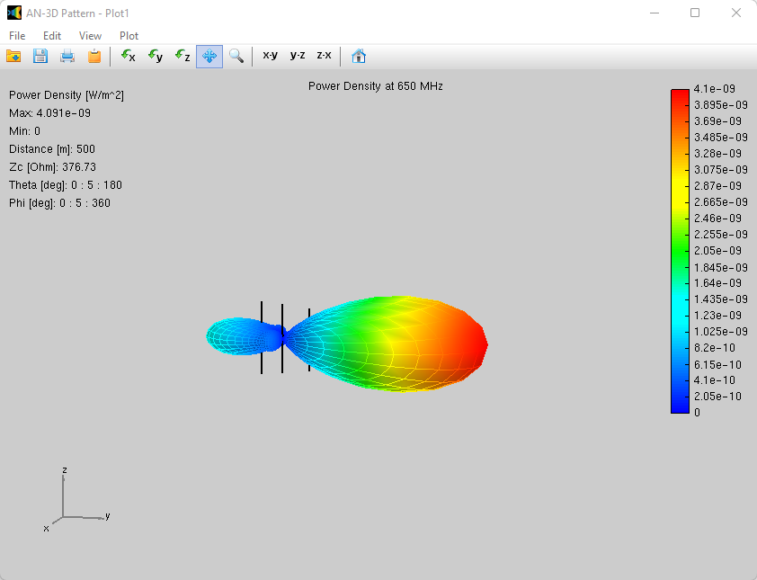

PD = 0.000000004091 W/m2, r = 500 metre

Solving the integral for Radiated Power calculation, $P_{rad}= \iint_{0 0}^{2π π}{P_{D}(r^{2}sinθdθdφ)d\hat{r}}$

$$P_{rad}=4πP_{D}r^{2}$$

|  |
| --- |
| $P_{rad}$ = 0.0129 Watt |

$P_{rad}=4π×({0.000000004091)×500}^{2}$

**CONCLUSION**

In this experiment we also conclude that the Power Density (Pd) is inversely

proportional to the distance (r). And the Power radiated will remain same for all

distances