**U19EC046 | TLEM | LAB 6**

**AIM**

Design 5 element & 6 element yagi uda antenna for 575 MHz and plot the 2D & 3D plot of directivity and find out front to back ratio, HPBW and FNBW

**Software Used**

ANSOF

**THEORY**

A Yagi-Uda antenna was seen on top of almost every house during the past decades. The parasitic elements and the dipole together form this Yagi-Uda antenna

*Construction Yagi-Uda Antenna:*

A Yagi-Uda antenna was seen on top of almost every house during the past decades. The parasitic elements and the dipole together form this Yagi-Uda antenna

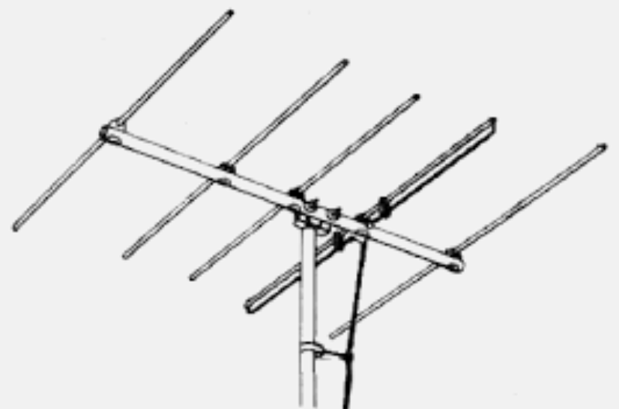

The figure shows a Yagi-Uda antenna. It is seen that there are many directors placed to increase the directivity of the antenna. The feeder is the folded dipole. The reflector is the lengthy element, which is at the end of the structure. The figure depicts a clear form of the YagiUda antenna. The center rod like structure on which the elements are mounted is called as boom. The element to which a thick black head is connected is the driven element to which the transmission line is connected internally, through that black stud. The single element present at the back of the driven element is the reflector, which reflects all the energy towards the direction of the radiation pattern. The other elements, before the driven element, are the directors, which direct the beam towards the desired angle.

**CALCULATIONS**

f=575MHz. •

λ = c/f = (3 X 108 ) / (575 X 106 ) = 521.74 mm. •

Length of Activator 0.47 x λ = 0.245 m. •

Length of Reflector = 0.498 x λ = 0.260 m •

Length of Deflector = 0.404 x λ = 0.211 m •

Distance between Activator and Reflector = 0.498 x λ = 0.260 m •

Distance between Activator and Deflector = 0.15 x λ = 0.15 m •

Distance between Deflector and Deflector = 0.34 x λ = 0.178 m

**PROCEDURE**

1. Configure the frequency of the antenna as 575MHz and set the preferences as shown in below figure.
2. Construct an Activator from the draw tab and set the coordinates based on above calculated length. Now, draw one Reflector and three Deflector based on above calculated lengths and distances.
3. Select the number of segments as 9, and set the cross-section as 5m.
4. Add the source to the centre of Activator and simulate, using the Run All command.
5. Observe the current plots and the Directive plots and Power Distribution Plots to draw the conclusions.
6. **5 Element yagi uda antenna**
7. Configuration

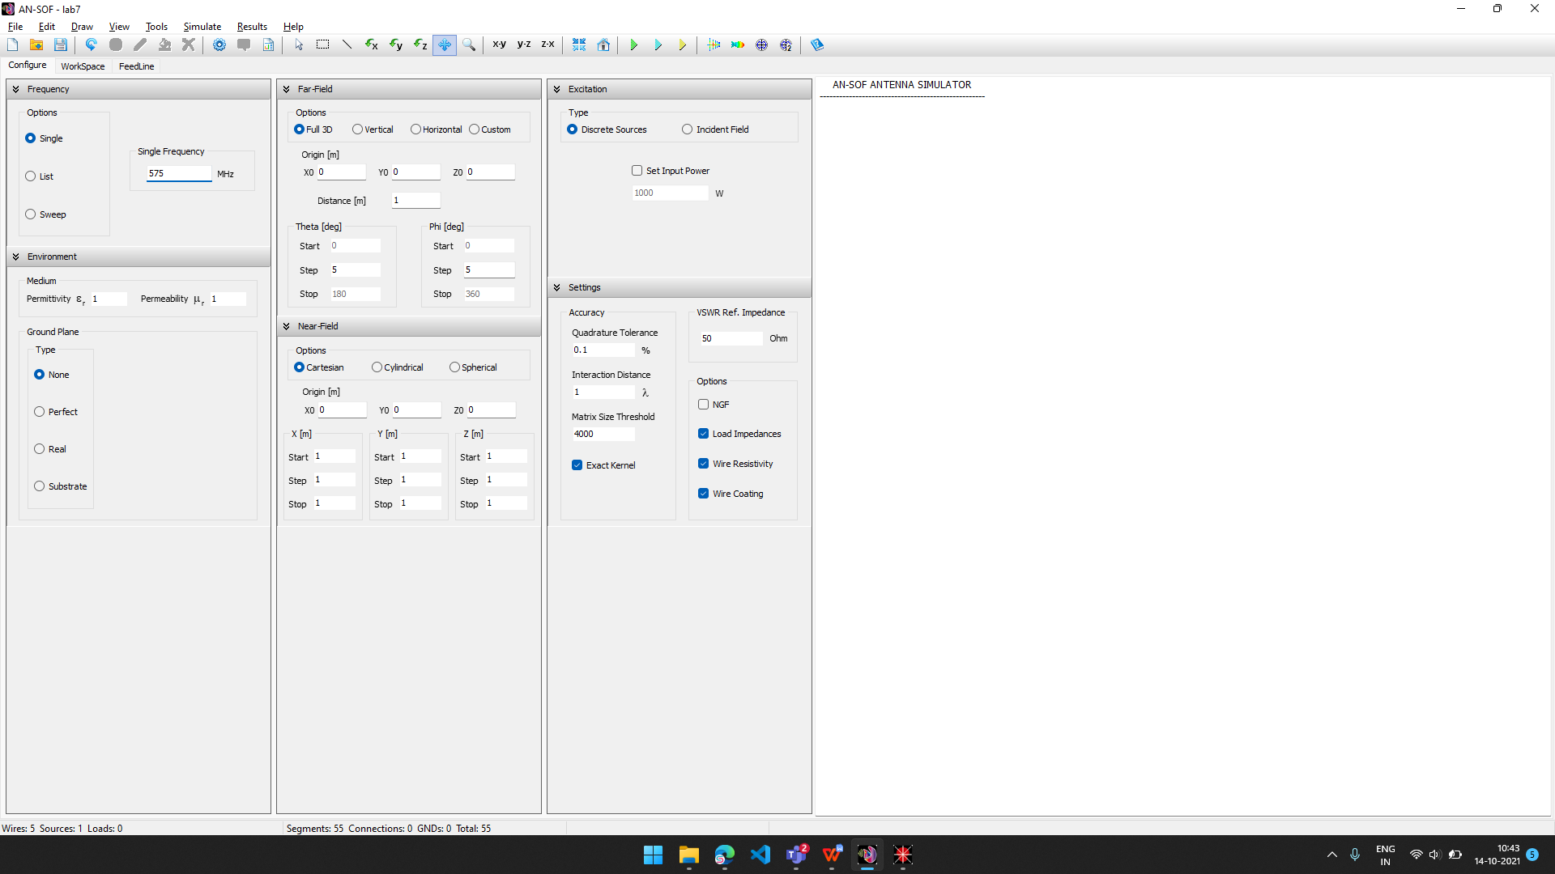

1. Circuit diagram

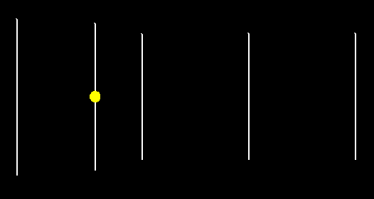

1. Element lengths

|  |  |
| --- | --- |
| CopyQ.FujyBB |  |
|  |  |

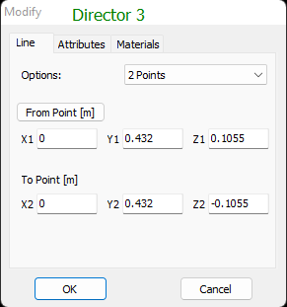

1. 2-D Plot of Directivity at θ = 90 degree and ϕ = 90 degree

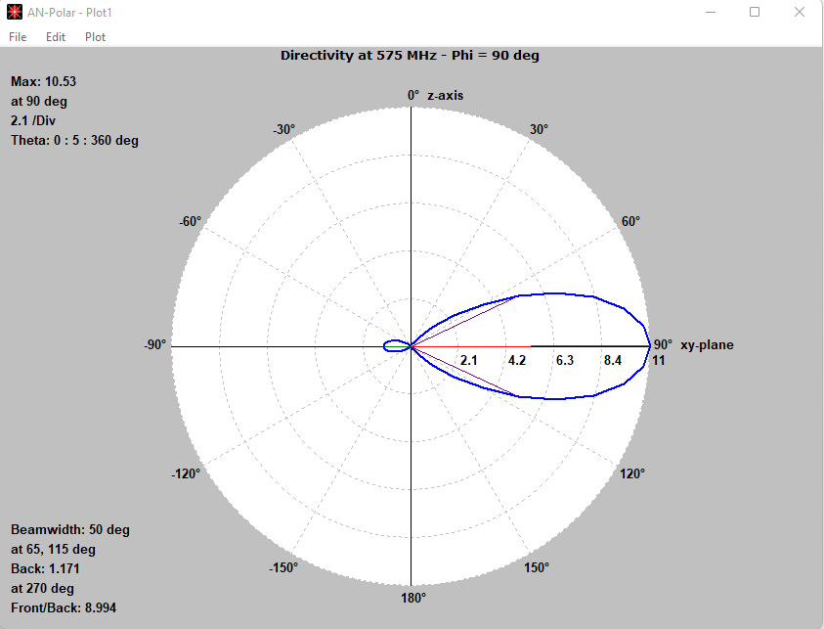

1. 3-D Plot of Directivity

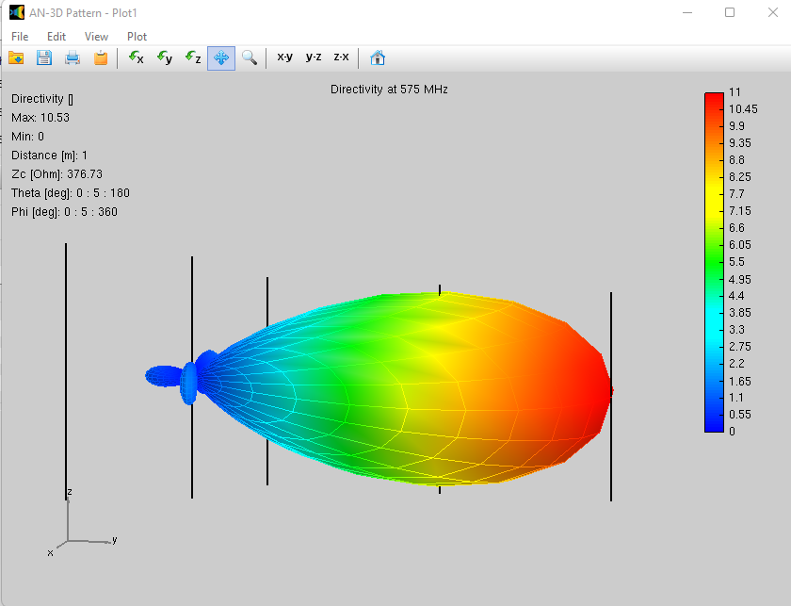

1. **6 Element yagi uda antenna**
2. Configuration



1. Circuit diagram

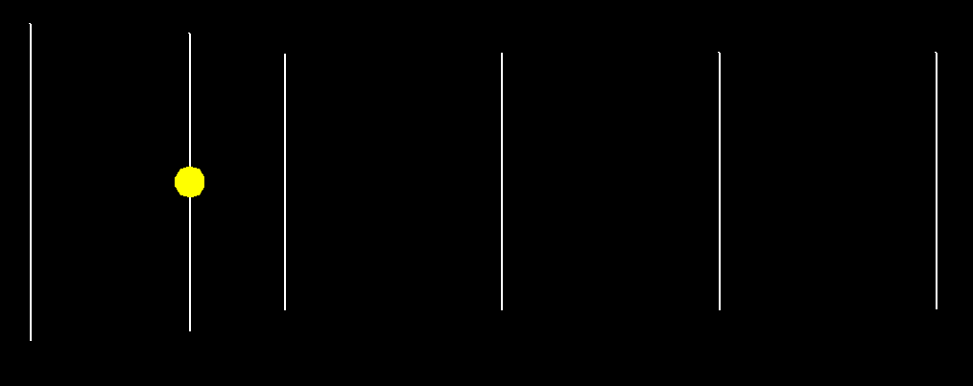

1. Element lengths

|  |  |
| --- | --- |
| CopyQ.ONsner |  |
|  |  |
|  |  |

1. 2-D Plot of Directivity at θ = 90 degree and ϕ = 90 degree

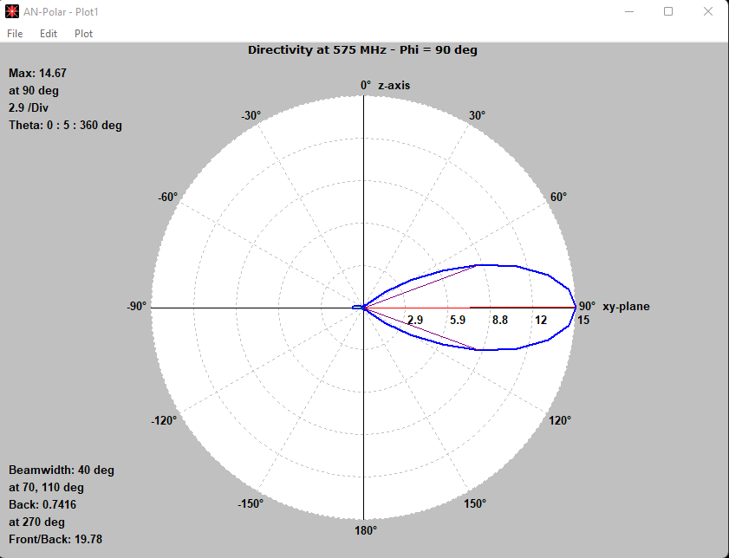

1. 3-D Plot of Directivity

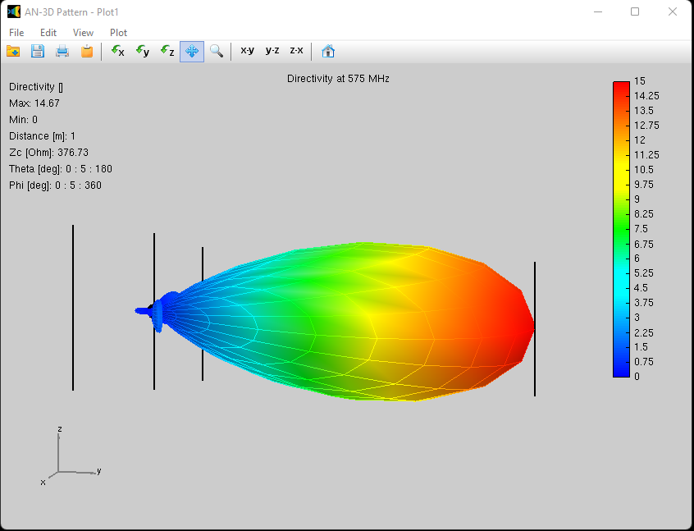

**CALCULATIONS**

From observation plots:

1. ***5 Element Yagi – Uda Antenna •***

HPBW = 50 degree. •

Front/Back = 8.994. •

FPBW = 2.25 * HPBW = 2.25 x 50 = 112.5 degree.

1. ***6 Element Yagi – Uda Antenna •***

HPBW = 40 degree. •

Front/Back = 19.78 •

FPBW = 2.25 * HPBW = 2.25 x 40 = 90 degree.

**CONCLUSION**

In this practical we have implemented five and six element Yagi Uda antenna at 575MHz using ANSOF, and also plotted it directivity. It was found that the directivity gain of six element Yagi antenna (14.67) was higher than the five element Yagi uda antenna (10.53). Also, the beamwidth of six element yagi uda antenna (40 deg) is smaller than the Five element antenna (50 deg)