**U19EC046 | TLEM | LAB 6**

**AIM**

Designing of folded dipole antenna using ANSOF software for frequency

500 MHz and plot

a). Current Distribution

b). 2D plot at phi=0 and theta=90

c). 3D polar plot of directivity and find out front to back ratio, HPBW and

FNBW

**Software Used**

ANSOF

**THEORY**

The basic dipole antenna or aerial is widely used in its basic form. However under a number of circumstances a modification to this referred to as the folded dipole antenna provides a number of advantages. The folded dipole antenna or folded dipole aerial is widely used, not only on its own, but also as the driven element in other antennas like the Yagi antenna and various other types of antenna.

***Folded dipole antenna basics***

The folded dipole antenna consists of a basic dipole, but with an added conductor connecting the two ends together. This makes a ‘loop’ of wire that is a short circuit to DC. As the ends appear to be folded back, the antenna is called a folded dipole antenna.

The basic format for the folded dipole aerial is shown below. Like the basic dipole, the folded dipole antenna is a balanced antenna, and needs to be fed with a balanced feeder. Unbalanced feeders can be used provided that a balun (unbalanced to balanced transformer) is used.

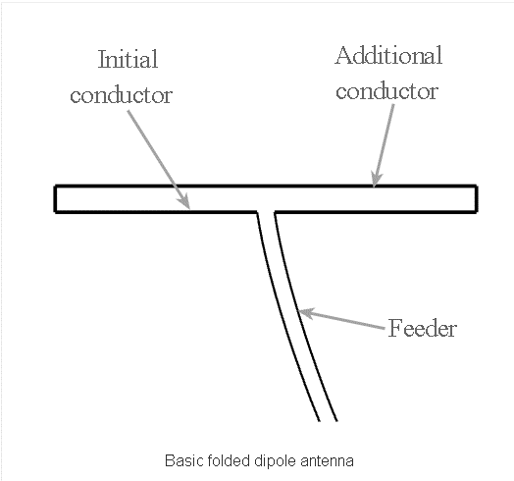

The additional part of the folded dipole antenna is often made by using a wire or rod of the same diameter as the basic dipole section. However this is not always the case. Also the wires or rods are typically equi-spaced along the length of the parallel elements. This can be achieved in a number of ways. Often for VHF or UHF antennas the rigidity of the elements is sufficient, but at lower frequencies spacers may need to be employed. To keep the wires apart.

In this experiment we implemented folded dipole antenna using ANSOF software for frequency 500 MHz. We plotted the directivity and current distribution plots. The radiation pattern of folded dipole antenna is Omni-directional pattern. The Impedance of folded dipole antenna increases than standard dipole antenna. So, Power Density and Bandwidth also increases. Obviously if they are not insulated it is imperative to keep them from shorting. In some instances flat feeder can be used.

One of the main reasons for using a folded dipole antenna is the increase in feed impedance that it provides. If the conductors in the main dipole and the second or "fold" conductor are the same diameter, then it is found that there is a fourfold increase (i.e. two squared) in the feed impedance. In free space, this gives an increase in feed impedance from 73Ω to around 300Ω ohms. Additionally the RF antenna has a wider bandwidth.

***Folded dipole advantages***

There are two main advantages for using a folded dipole antenna over a standard dipole:

***Increase in impedance***

When higher impedance feeders need to be used, or when the impedance of the dipole is reduced by factors such as parasitic elements, a folded dipole provides a significant increase in impedance level that enables the antenna to be matched more easily to the feeder available.

***Wide bandwidth***

The folded dipole antenna has a flatter frequency response - this enables it to be used over a wider bandwidth with many transmissions utilising a variety of different select-able channels, e.g. television and broadcast radio, a wide bandwidth antenna is needed. The standard dipole antenna does not always provide the required bandwidth and the additional bandwidth of the folded dipole meets the requirements.

**PROCEDURE**

1. Configure the frequency of the antenna as 500MHz and set the preferences as shown in below figure.
2. Draw 2 antennas of length calculated above and place one at origin and other at a distance of 25mm from the other antenna.
3. Draw 2 conducting conductors of length 25mm to connect both the antennas.
4. Select the number of segments as 17, and set the cross-section as 5m.
5. Add the source to one of the antennas and simulate, using the Run All command.
6. Observe the Current Distribution and Directivity plots to draw the conclusions.

**CALCULATIONS**

• f=500MHz.

• λ = c/f = (3 X 108) / (500 X 106) = 600 mm.

• Length of Antenna (λ/2) = 300 m.

• Length of connecting conductor = 25mm ( < 0.05 x λ).

**REQUIRED PLOTS**

1. Preference

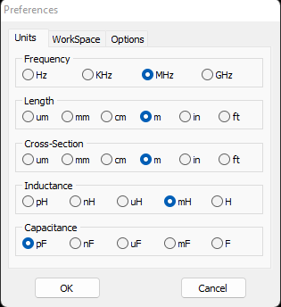

1. Configuration

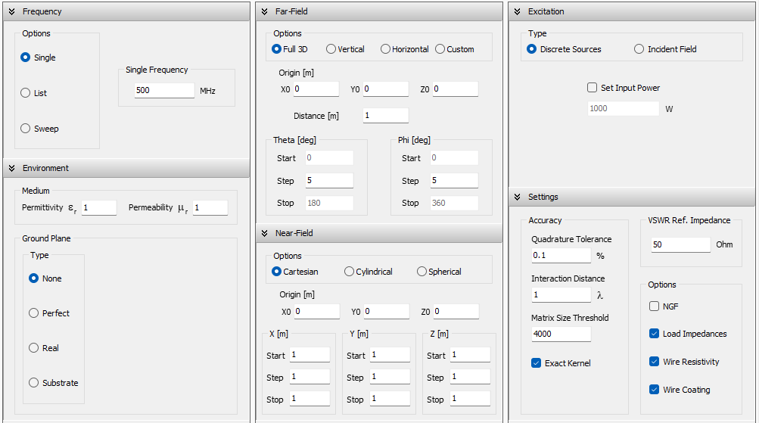

1. Circuit Diagram

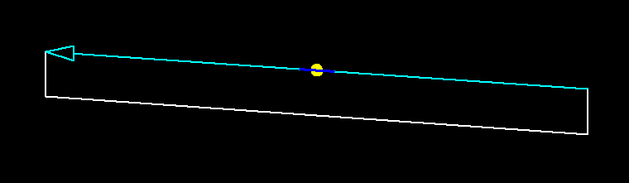

1. Antenna parameters

|  |  |
| --- | --- |
| *Antenna 1* | *Antenna 2* |
| *Conductor 1* | *Conductor 2* |

1. 2D current distribution

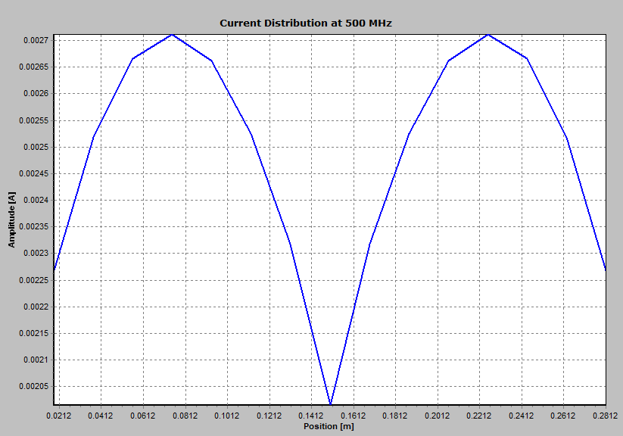

1. 3D current distribution

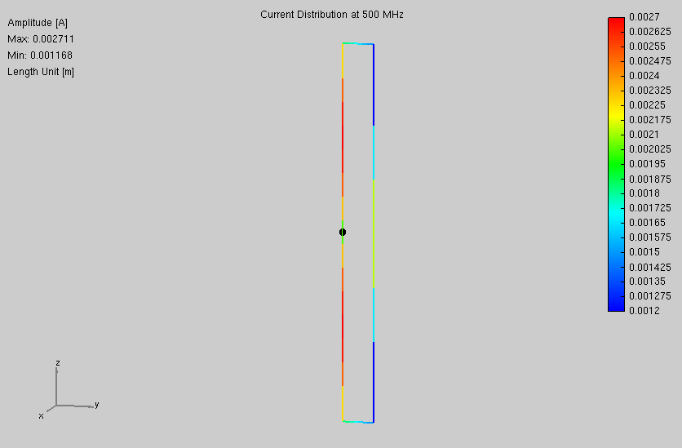

1. Directivity plot phi=0, theta=90

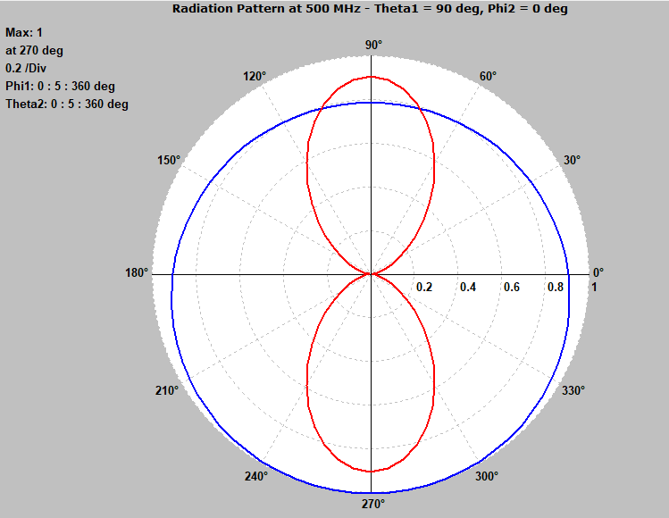

1. Directivity plot phi=90

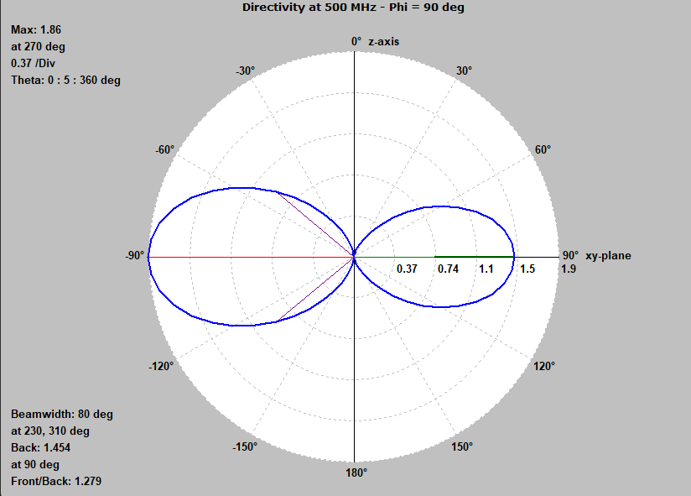

1. 3D directivity polar plot

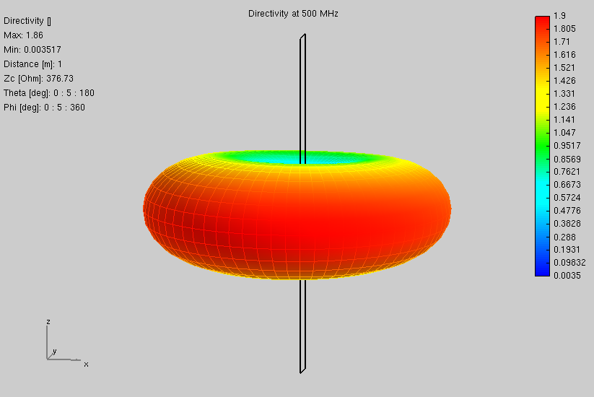

**OBSERVATION**

• Front to Back Ratio: 1.279

• HPBW = 80 degree

• FPBW = 2.25 x HPBW = 2.25 X 80 = 180 degree.

**CONCLUSION**

In this experiment we implemented folded dipole antenna using ANSOF software for frequency 500 MHz. We plotted the directivity and current distribution plots. The radiation pattern of folded dipole antenna is Omni-directional pattern. The Impedance of folded dipole antenna increases than standard dipole antenna. So, Power Density and Bandwidth also increases.