**U19EC046 | TLEM | LAB 6**

**AIM**

Design a Yagi Uda Antenna with folded dipole of 650MHz in using ansof

software and plot the

a). Current Distribution

b). 2D plot at phi=0 and theta=90

c). 3D polar plot of directivity and find out front to back ratio, HPBW and

FNBW.

**Software Used**

AN-SOF

**THEORY**

A folded dipole is an antenna, with two conductors connected on both sides, and folded to form a cylindrical closed shape, to which feed is given at the center. The length of the dipole is half of the wavelength. Hence, it is called as half wave folded dipole antenna.

***Frequency range***

The range of frequency in which half wave folded dipole operates is around 3KHz to 300GHz. This is mostly used in television receivers.

***Construction & Working of Half-wave Folded Dipole***

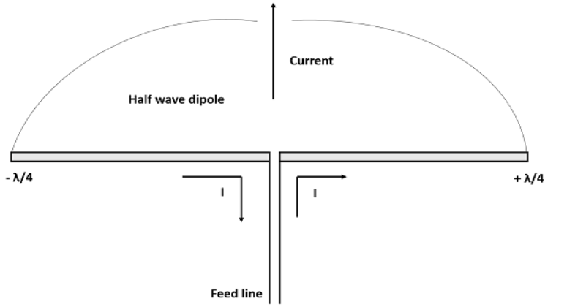

This antenna is commonly used with the array type antennas to increase the feed resistance. The most commonly used one is with Yagi-Uda antenna. The following figure shows a half-wave folded dipole antenna. This antenna uses an extra conducting element (a wire or a rod) when compared with previous dipole antenna. This is continued by placing few conducting elements in parallel, with insulation in-between, in array type of antennas. The following figure explains the working of a half-wave folded dipole antenna, when it is provided with excitation.

If the diameter of the main conductor and the folded dipole are same, then there will be four folded (two times of squared one) increase in the feed impedance of the antenna. This increase in feed impedance is the main reason for the popular usage of this folded dipole antenna. Due of the twin-lead, the impedance will be around 300Ω.

***Radiation Pattern***

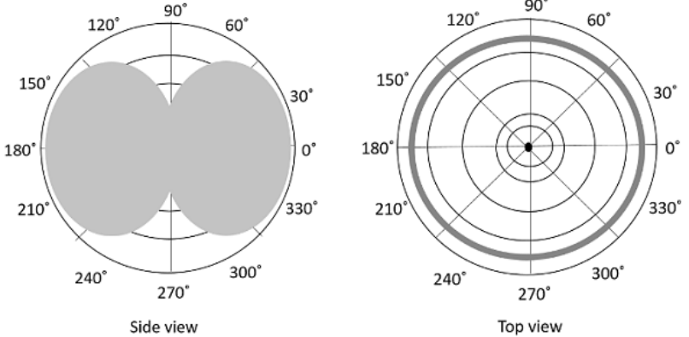

The radiation pattern of half-wave folded dipoles is the same as that of the halfwave dipole antennas. The following figure shows the radiation pattern of halfwave folded dipole antenna, which is Omni-directional pattern. Half-wave folded dipole antennas are used where optimum power transfer is needed and where large impedances are needed.

This folded dipole is the main element in Yagi-Uda antenna. The following figure shows a Yagi-Uda antenna, which we will study later. The main element used here is this folded dipole, to which the antenna feed is given. This antenna has been used extensively for television reception over the last few decades.

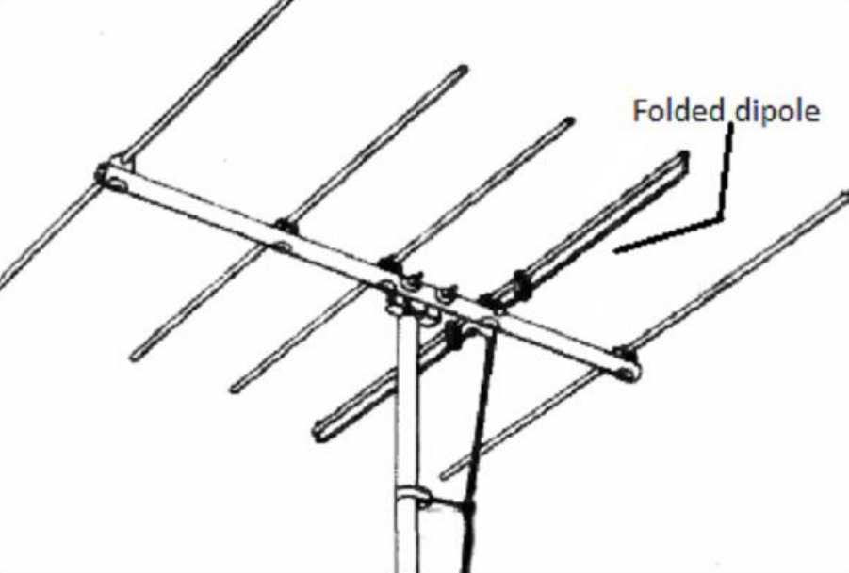

**CALCULATION:**

* f=650MHz.
* λ = c/f = (3 X 108) / (650 X 106) = 461.54 mm.
* Length of Active element = 478/650 = 0.7354 feet = 0.224 m.
* Length of Reflector = 492/650 = 0.7569 feet = 0.230 m.
* Length of Deflector = 461.5/650 = 0.710 feet = 0.216 m.
* Length of Connecting Conductor = 0.2 m.
* Distance between Reflector and Active Element = 0.15 x λ = 0.0692 m.
* Distance between Deflector and Active Element = 0.2 x λ = 0.0923 m.

**PROCEDURE**

1. Configure the frequency of the antenna as 650MHz and set the preferences

as shown in below figure.

2. Draw 2 antennas of length calculated above and place one at origin and other

at a distance of 0.2m from the other antenna and add a source of 1V.

3. Draw 2 conducting conductors of length 0.2m to connect both the antennas

which will form a folded dipole.

4. Select the number of segments as 11, and set the cross-section as 5m.

5. Draw the reflector and deflector elements using above caluclations.

6. Add the source to one of the antennas and simulate, using the Run All

command.

7. Observe the Current Distribution and Directivity plots to draw the

conclusions.

**REQUIRED PLOTS**

1. **Prefrences**

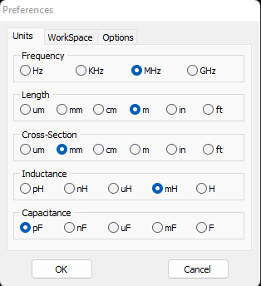

1. **Configuration**

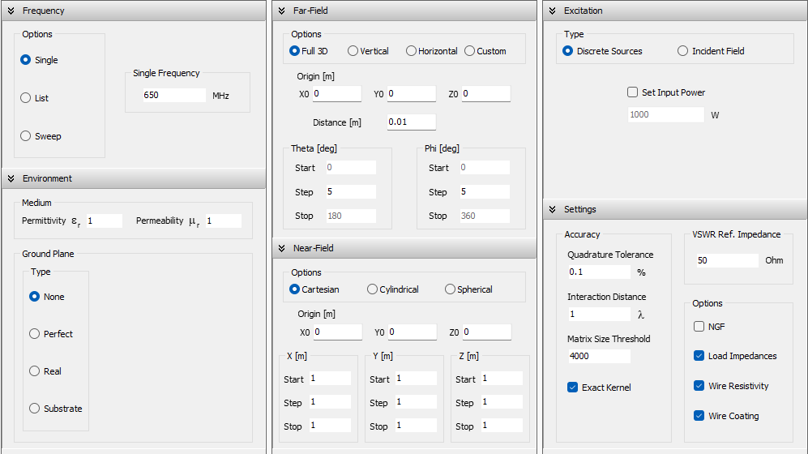

1. **Circuit Diagram**

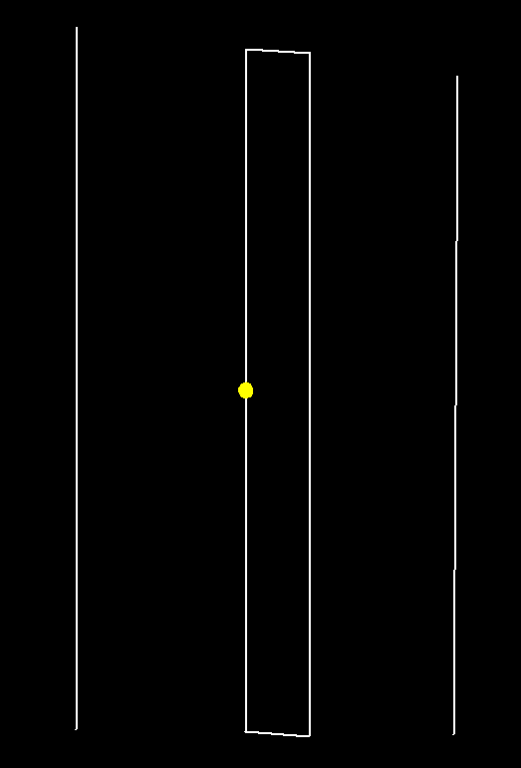

1. **Wire lengths**

|  |  |  |
| --- | --- | --- |
|  |  |  |
|  |  |  |

1. **2-D current distribution**

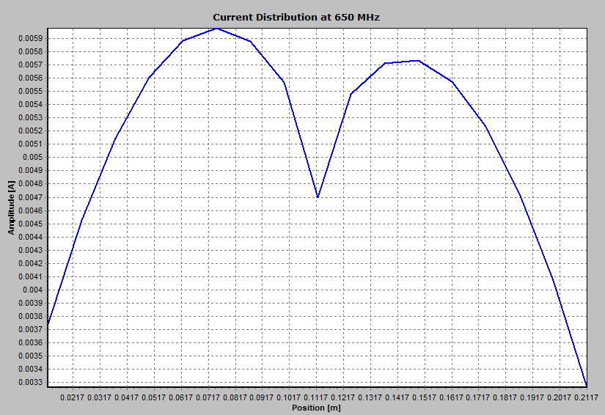

1. **3-D current Distribution**

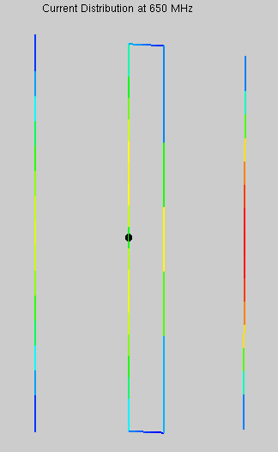

1. **Directivity plot at theta = 90 and phi = 0**

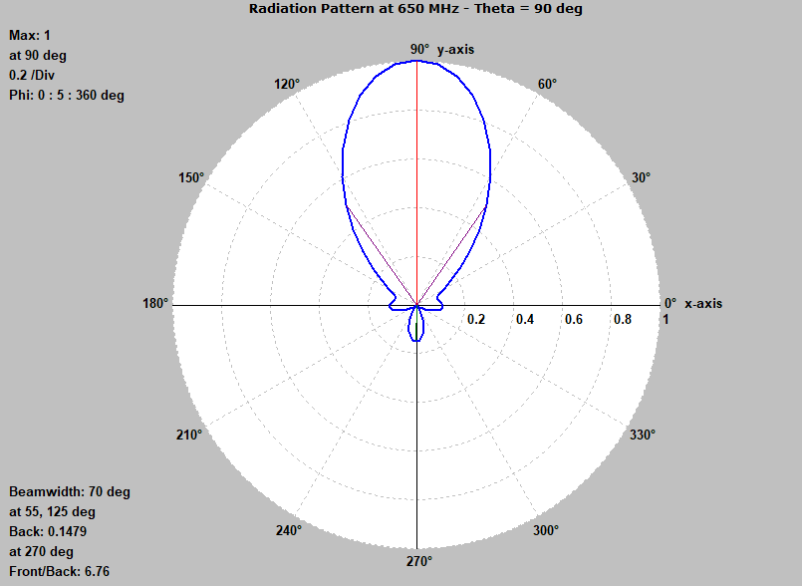

1. **3D Directivity polar plot**

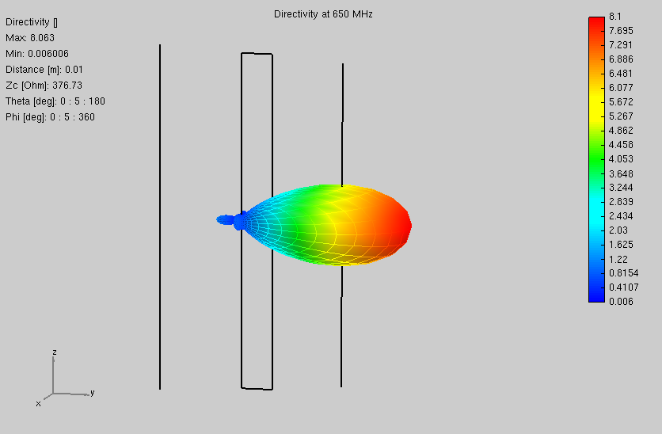

**OBSERVATION**

* Front to Back Ratio: 6.76
* HPBW = 70 degree
* FPBW = 2.25 x HPBW = 2.25 X 70 = 157.5 degree.

**CONCLUSION**

In this experiment we implemented a Yagi uda antenna with folded dipole at frequency of 650 MHz and plotted 2D current distribution, 3D current distribution and 3D polar plot of directivity.