**Sardar Vallabhbhai National Institute of Technology Surat**

**Electronics Engineering Department**

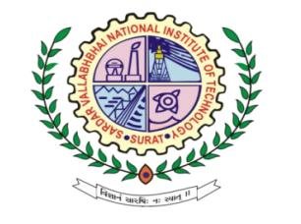

**LABORATORY JOURNAL**

**Digital Integrated Circuits**

**(EC-304)**

**Name: Harsh Suthar**

**Roll No. U19EC046**

Sem – VI , Academic Year – 21/22

1

CERTIFICATE

This is to Certify that Mr. Harsh Suthar of B.Tech IIIrd E.C, Admission No. U19EC046 has Satisfactorily Completed His course work in Digital Integrated Circuits (EC-**304**) Laboratory during the 6th Semester Session of Academic Year 2021-2022 and the same is submitted on 2022.

|  |
| --- |
|  |
| **Dr. Vivek Garg** |
| **Course Coordinator** |

**Electronics Engineering Department**



**Sardar Vallabhbhai National Institute of Technology, Surat**

