**U19EC046 | DIC LAB 11**

**AIM**

To generate Layout for CMOS NAND circuit and Simulate it for verification.

**Software used:** DSCH and Microwind Tool

**THEORY**

DSCH is software for logic design & based on primitives a hierarchical circuit can be built and simulated & it also includes delay and power consumption evaluation& 7ith the help of this software one can implement digital circuits at its basic gate primitives or at its transistor level. Microwind is a tool for designing and simulating circuits at layout level& The tool features full editing facilities "copy, cut, past, duplicate, move, various views "MOS characteristics6 (2D cross section6 3D process Viewer and an analog simulator.

*Truth Table of NAND:*

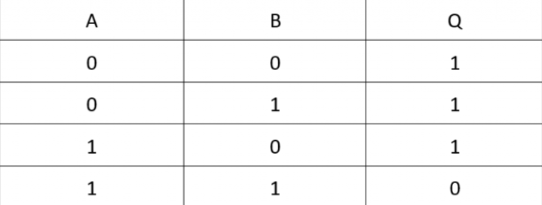

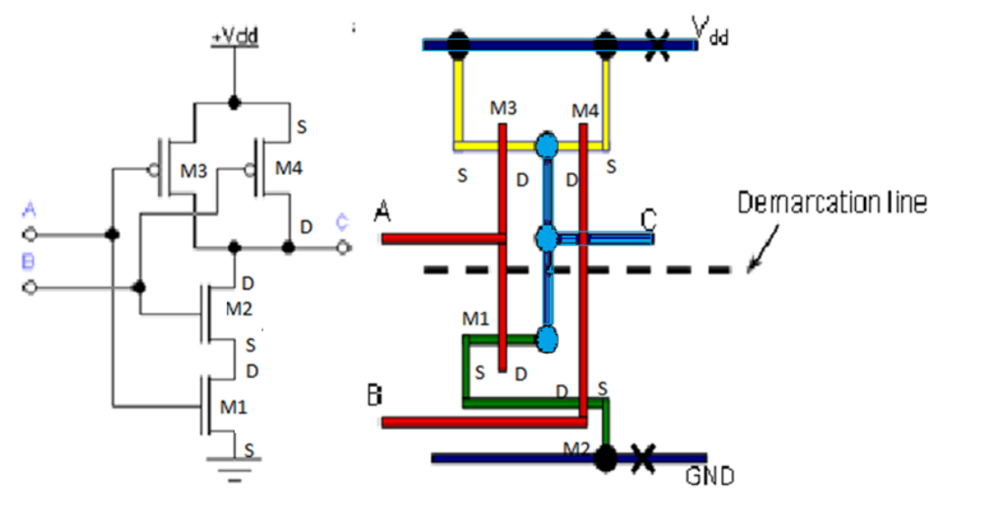

**CMOS Invertor in DSCH**

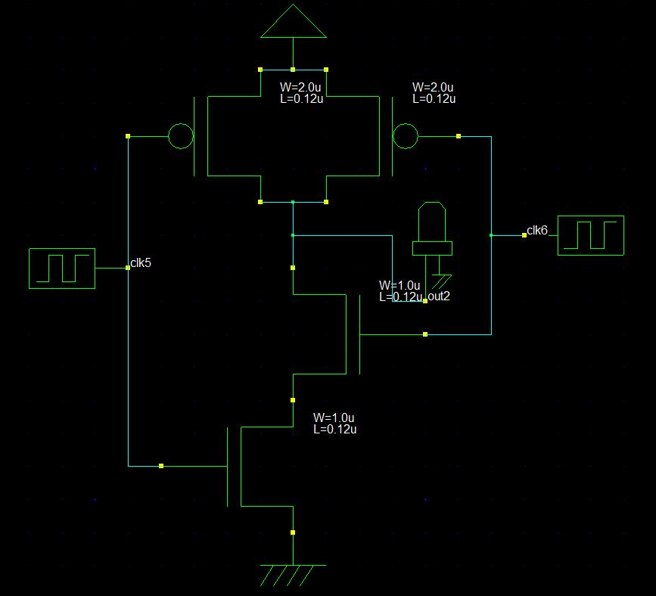

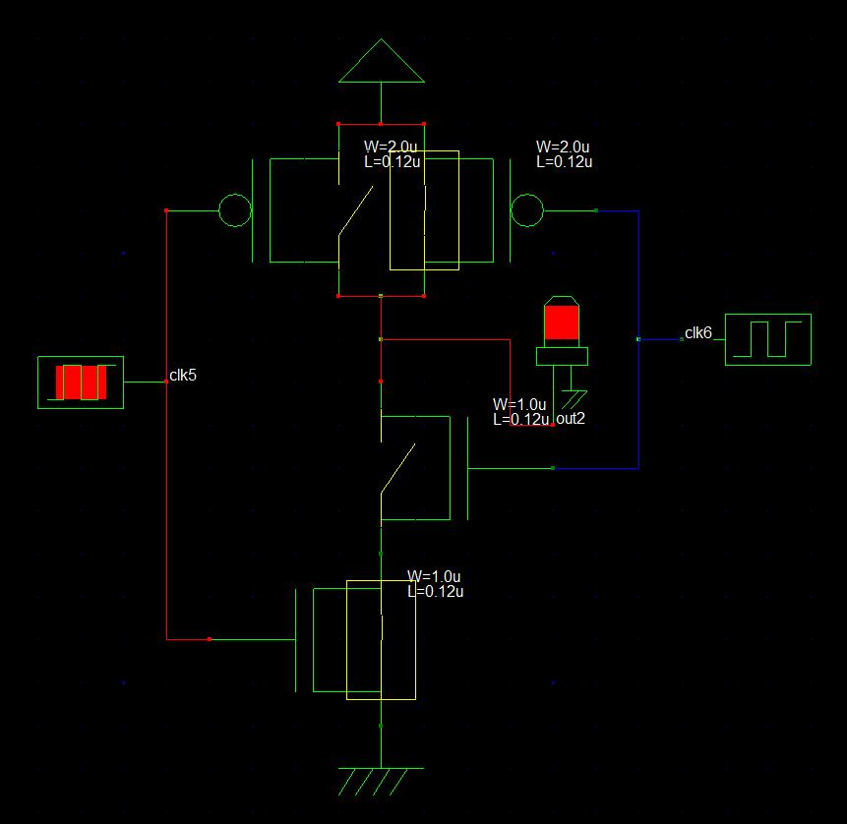

**CMOS Inverter in Microwind**

1. **Custom**

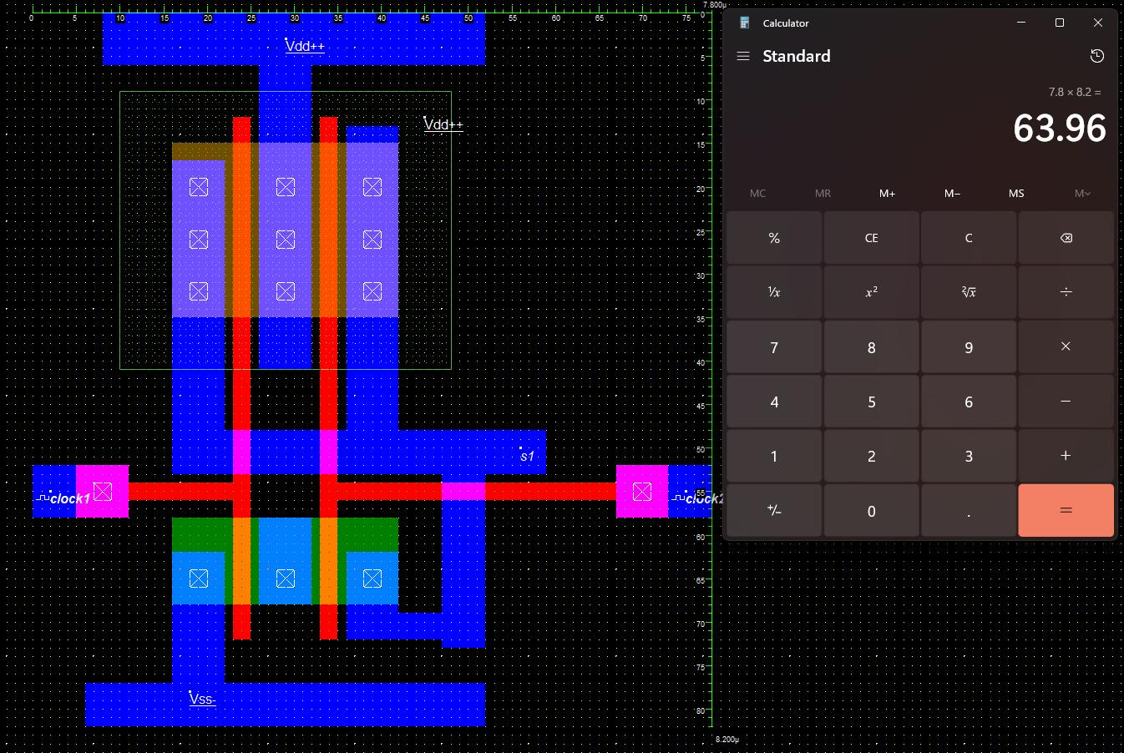

1. **Generated from DSCH**

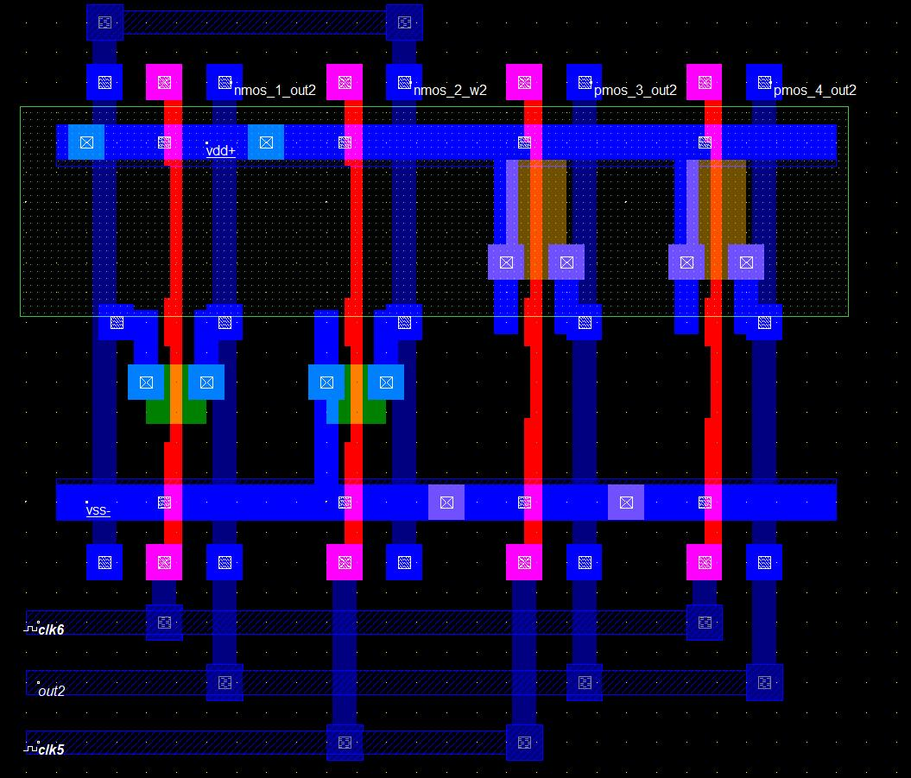

**Output**

1. **DSCH**

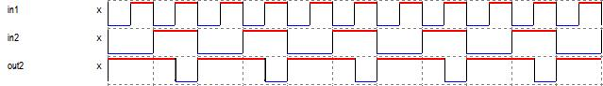

1. **uWind**

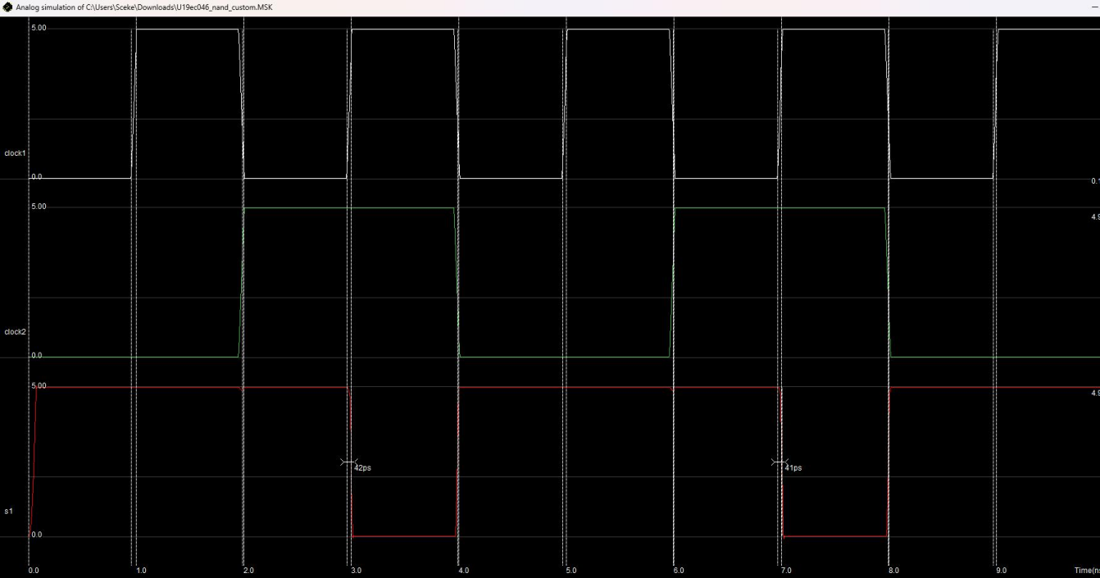

**CONCLUSION**

In this practical we have fabricated CMOS nand gate using microwind and verified its functionality. We also learnt about various fabrication rules.