**U19EC046 | DIC LAB 12**

**AIM**

To generate Layout for CMOS NOR circuit and Simulate it for verification.

**Software used:** DSCH and Microwind Tool

## THEORY:

DSCH is software for logic design & based on primitives a hierarchical circuit can be built and simulated & it also includes delay and power consumption evaluation& 7ith the help of this software one can implement digital circuits at its basic gate primitives or at its transistor level. Microwind is a tool for designing and simulating circuits at layout level& The tool features full editing facilities "copy, cut, past, duplicate, move, various views "MOS characteristics6 (2D cross section6 3D process Viewer and an analog simulator. The circuit consists of a parallel-connected n-net and a series-connected complementary p-net. The input voltages VX and VY are applied to the gates of one nMOS and one pMOS transistor. When either one or both inputs are high, i.e., when the n-net creates a conducting path between the output node and the ground, the p-net is cut—off. If both input voltages are low, i.e., the n-net is cut-off, then the p-net creates a conducting path between the output node and the supply voltage.

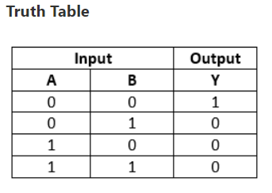

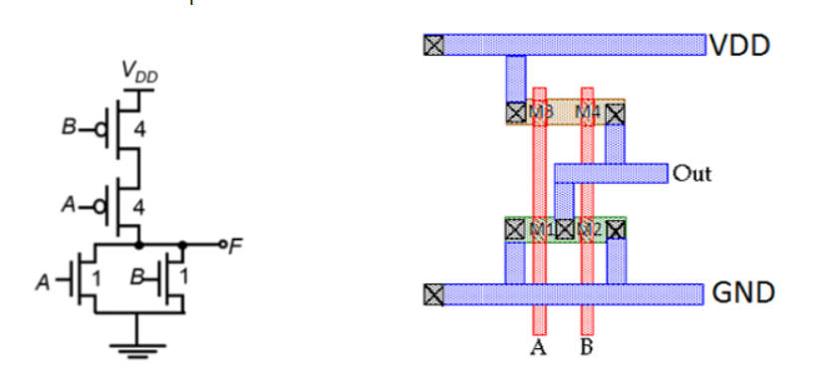

**CMOS Invertor in DSCH:**

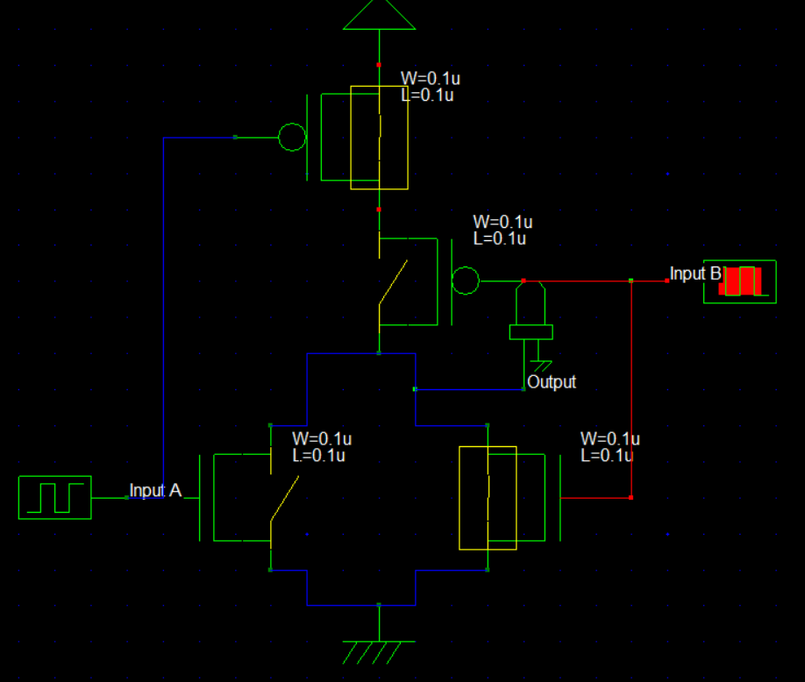

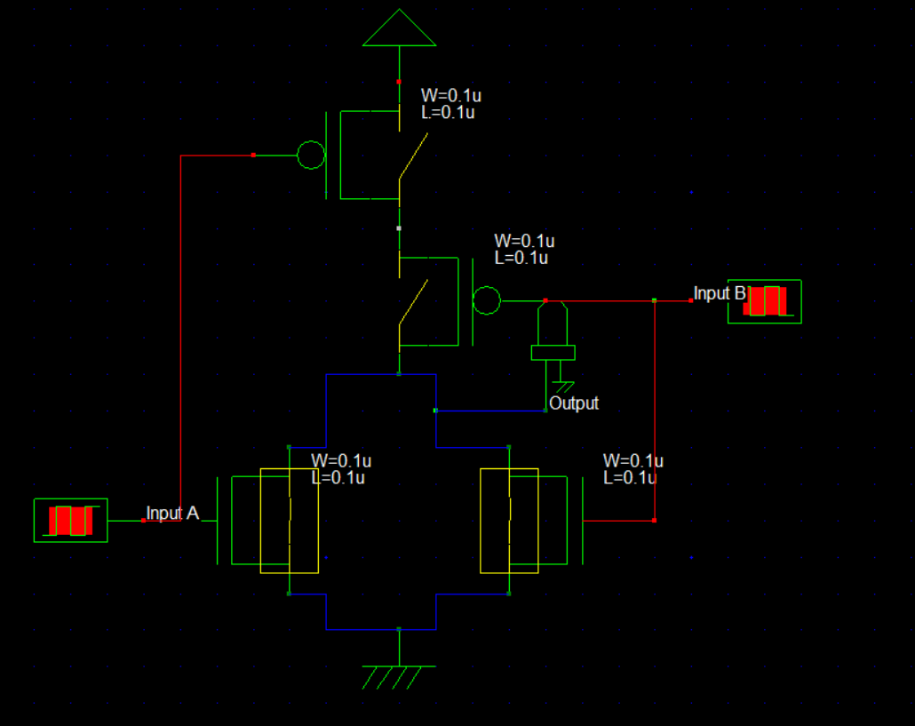

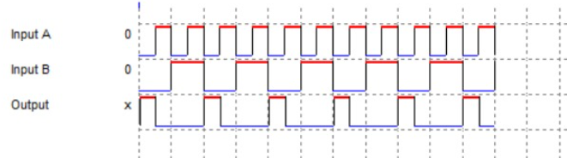

**Timing Diagram**

**CMOS Inverter in Microwind Using VHDL code**

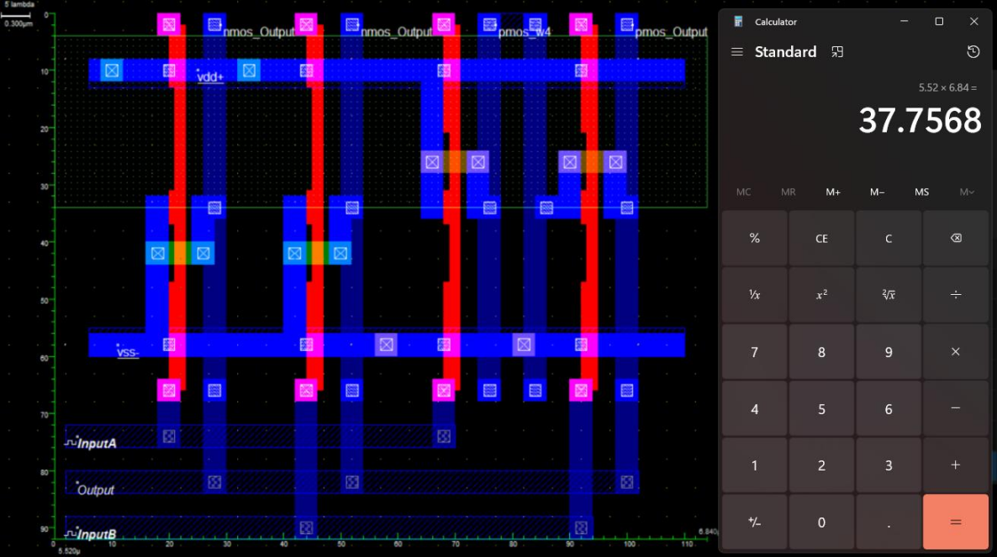

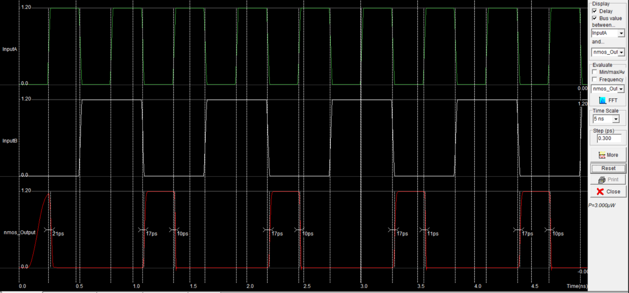

P = 3uW

**CMOS Inverter in Microwind Manually**

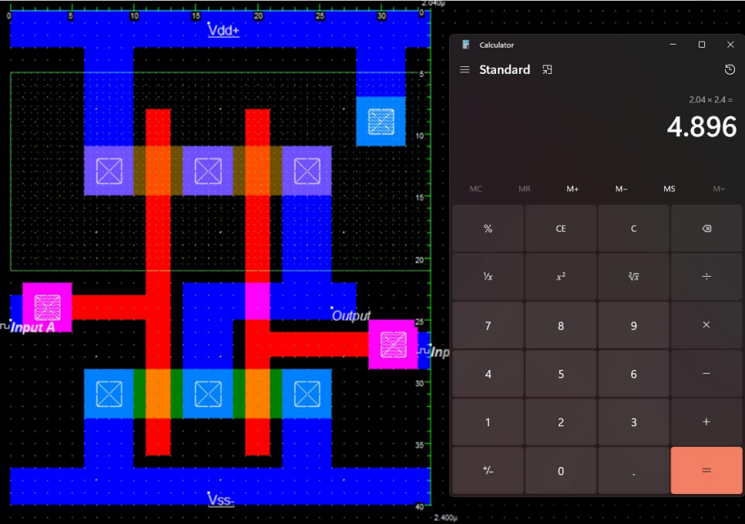

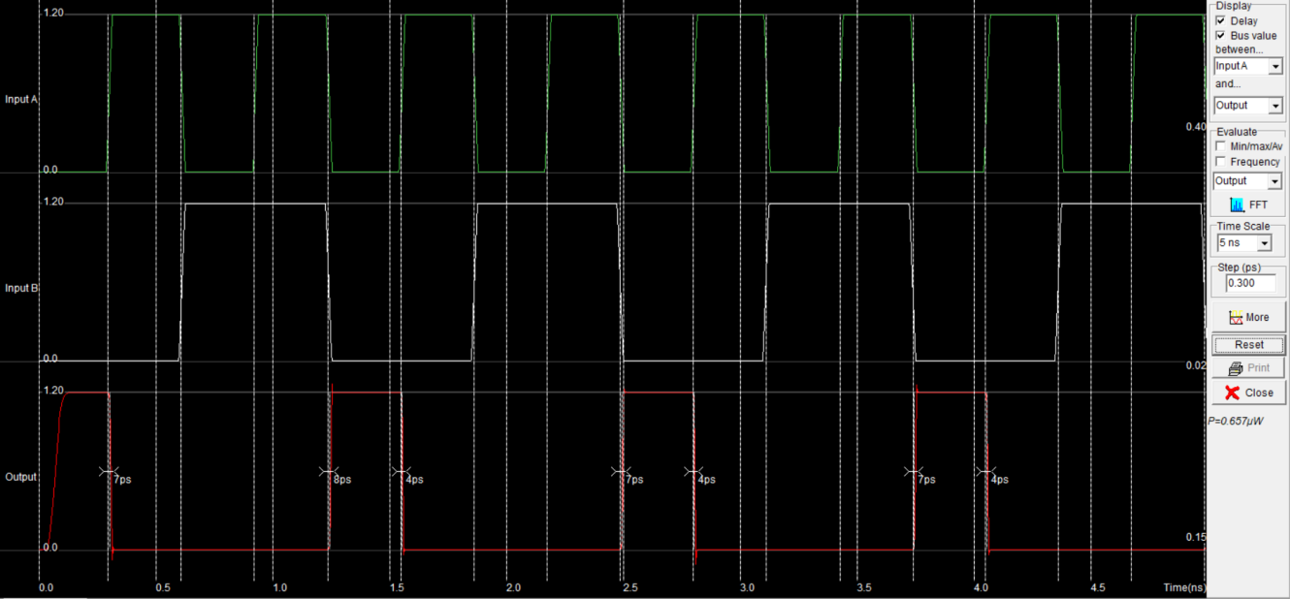

P = 0.653 uW

**CONCLUSION**

In this practical we have fabricated CMOS nand gate using microwind and verified its functionality. We also learnt about various fabrication rules.