**U19EC046 | DIC LAB 1**

**AIM**

To plot the forward and reverse characteristics of PN Junction Diode for the given Parameters. Also extract the following parameters :

1. Forward Resistance and Cut-in Voltage from forward characteristics.
2. Reverse resistance from reverse characteristics.
3. Reverse Recovery Time of the Diode (trr).

**THEORY**

**Introduction**

A PN Junction Diode is one of the simplest semiconductor devices around, and which has the electrical characteristic of passing current through itself in one direction only. However, unlike a resistor, a diode does not behave linearly with respect to the applied voltage. Instead it has an exponential current-voltage ( I-V ) relationship and therefore we can not describe its operation by simply using an equation such as Ohm’s law.

If a suitable positive voltage (forward bias) is applied between the two ends of the PN junction, it can supply free electrons and holes with the extra energy they require to cross the junction as the width of the depletion layer around the PN junction is decreased.

By applying a negative voltage (reverse bias) results in the free charges being pulled away from the junction resulting in the depletion layer width being increased. This has the effect of increasing or decreasing the effective resistance of the junction itself allowing or blocking the flow of current through the diodes pn-junction.

Then the depletion layer widens with an increase in the application of a reverse voltage and narrows with an increase in the application of a forward voltage. This is due to the differences in the electrical properties on the two sides of the PN junction resulting in physical changes taking place. One of the results produces rectification as seen in the PN junction diodes static I-V (current-voltage) characteristics.

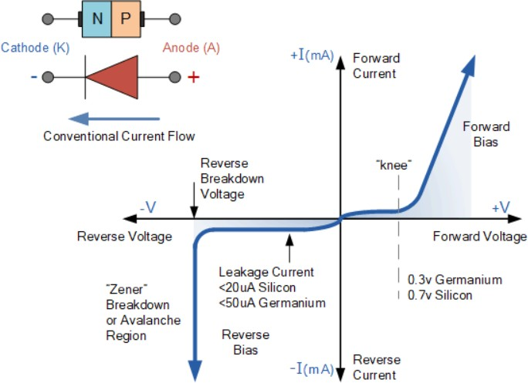

There are two operating regions and three possible “biasing” conditions for the standard Junction Diode and these are:

1. Zero Bias – No external voltage potential is applied to the PN junction diode.
2. Reverse Bias – The voltage potential is connected negative, (-ve) to the P-type material and positive, (+ve) to the N-type material across the diode which has the effect of Increasing the PN junction diode’s width.
3. Forward Bias – The voltage potential is connected positive, (+ve) to the P-type material and negative, (-ve) to the N-type material across the diode which has the effect of Decreasing the PN junction diodes width.

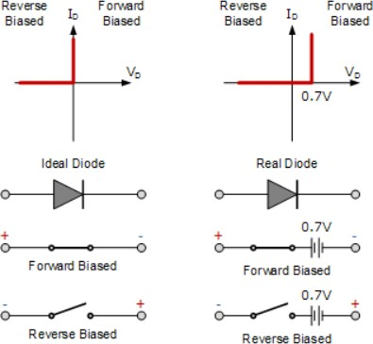

**Circuit Diagram**

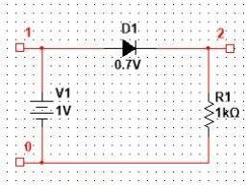

**SPICE CODE**

1. FORWARD CHARACTERISTICS

|  |
| --- |
| ***\*Diode Forward ch/cs***  **.Model mod1 D (IS=1E-12 RS=10 CJO=5P TT=10N BV=10)**  **D1 2 0 mod1**  **R1 1 2 1k**  **V1 1 0 dc 1**  **.dc V1 0 5 0.05**  **.control**  **run**  ***\* plot v(1)-v(2)***  **plot -I(V1)**  **.endc**  **.end** |

1. REVERSE CHARACTERISTICS

|  |
| --- |
| ***\* Diode Reverse ch/cs***  **.Model mod1 D (IS=1E-12 RS=10 CJO=5P TT=10N BV=10)**  **D1 2 0 mod1**  **R1 1 2 1k**  **V1 1 0 dc 1**  **.dc V1 -5 0 0.05**  **.control**  **run**  **plot -I(V1)**  **.endc**  **.end** |

1. REVERSE RECOVERY TIME

|  |
| --- |
| ***\* Reverse recovery time of diode***  **.MODEL SWITCH D (IS=1E-12 RS=10 CJO=5P TT=10N BV=10)**  **V1 1 0 pulse (5 -3 10N 0.05N 0.05N 30N 50N)**  **RS 1 2 1K**  **D1 2 3 Switch**  **Vo 3 0 0**  **.TRAN 1N 50N**  **.control**  **run**  **plot v(1) v(2)**  **plot i(Vo)**  **.endc**  **.end** |

**SIMULATION RESULTS AND PRACTICAL CALCULATIONS**

1. FORWARD CHARACTERISTICS

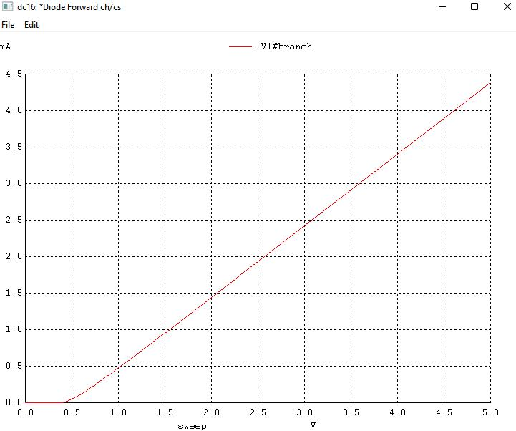

Forward Resistance = 0.5/0.5mA = 1k Ohm, Cut off vol = 0.5 V

1. REVERSE CHARACTERISTICS

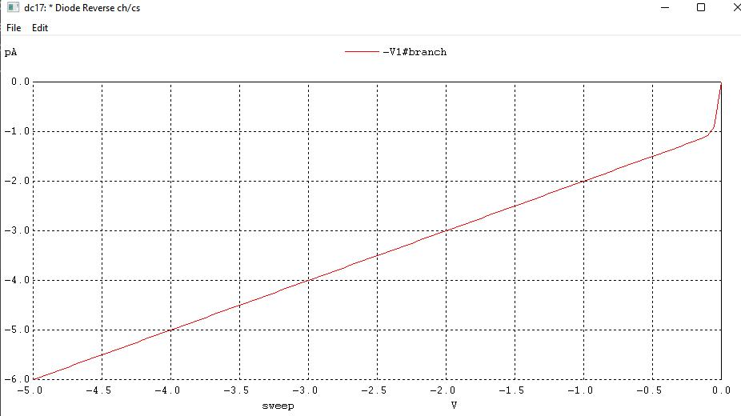

Reverse resistance = 1V/1pA = 106 M Ohm

1. REVERSE RECOVERY TIME

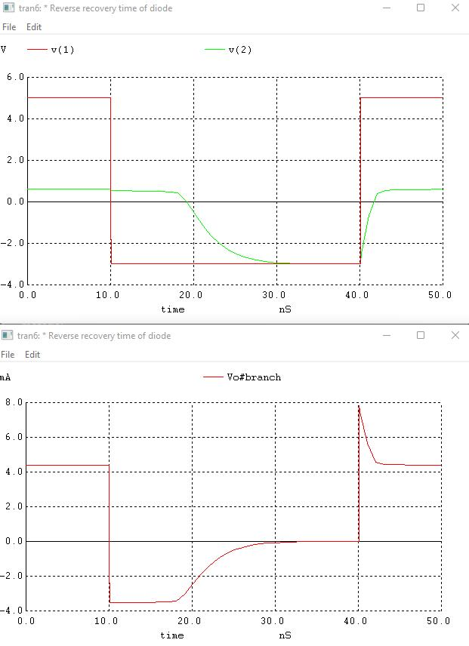

Trr = 8ns

**CONCLUSION**

In this experiment, we were introduced to Winspice software and developed a netlist to plot forward and reverse characteristics of a p-n junction diode. We also calculated various parameters of diode like forward and reverse resistance, cut-in voltage and Trr.