**U19EC046 | DIC LAB X**

**AIM**

Implement TTL inverter using NPN BJT having Bf = 50, Rb = 4k and Rc = 1.6k.

1. Verify its functionality by performing transient analysis.
2. Plot the VTC & Calculate the Noise margin.
3. Find out theoretical and practical fan-out & compare them.

**THEORY**

**Introduction**

DTL was able to improve fan-out compared to RTL. However, that was done at the expense of Transient response and Chip area.

A solution for the problem was proposed in the form of a new logic family which utilizes only transistors and resistors. BJTs are smaller than diodes.

**Circuit Diagram**

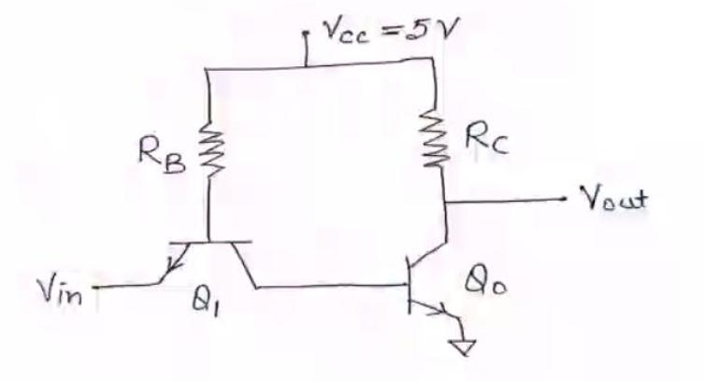

**Working principle**

For Vin very low, the base-emitter junction of Q1 will be forward biased. The base-collector junction will also be forward biased. Therefore, Q1 will be saturated.

The base-emitter voltage of Q0 is:

VBE, 0 = VCE,1(Sat) + Vin

Therefore, Q0 will be cut-off

Therefore,

Vout = VOH = VCC

As Vin is increased, VB of Q0 will also increase. Eventually, Q0 will turn on.

This happens when:

Vin = VIL = VBE,0(FA) – VCE,I(Sat)

As Vin is increased even more, Q0 comes closer to Saturation and eventually saturates.

At that point:

Vout = VOL = VCE,0 (Sat)

**SPICE CODE**

1. Transient Analysis

|  |
| --- |
| ***\*TTL Inverter Transient Analysis***  **.model switch NPN (Bf=50)**  **.subckt ttl out in vcc_power gnd**  **Q1 out q1_base gnd switch**  **Q2 q1_base q2_base in switch**  **Rc out vcc_power 1.6k**  **Rb q2_base vcc_power 4k**  **.ends ttl**  **xd out input vcc_node 0 ttl**  **Vcc vcc_node 0 5**  **Vin input 0 pulse(0 5 1ns 1ns 1ns 20us 40us)**  **c_load out 0 1p**  **.tran 1ns 80us**  **.control**  **run**  **plot v(input) v(out)**  **.endc**  **.end** |

1. VTC and noise Margin

|  |
| --- |
| ***\*TTL Inverter  Analysis***  **.model switch NPN (Bf=50)**  **.subckt ttl out in vcc_power gnd**  **Q1 out q1_base gnd switch**  **Q2 q1_base q2_base in switch**  **Rc out vcc_power 1.6k**  **Rb q2_base vcc_power 4k**  **.ends ttl**  **xd out input vcc_node 0 ttl**  **Vcc vcc_node 0 5**  **Vin input 0 5**  **c_load out 0 1p**  **.dc Vin 0 5 0.05**  **.control**  **run**  **plot v(input) v(out)**  **.endc**  **.end** |

1. Fan-out

|  |
| --- |
| ***\*TTL Inverter Fanout Analysis***  **.model switch NPN (Bf=50)**  **.subckt ttl out in vcc_power gnd**  **Q1 out q1_base gnd switch**  **Q2 q1_base q2_base in switch**  **Rc out vcc_power 1.6k**  **Rb q2_base vcc_power 4k**  **.ends ttl**  **xd out input vcc_node 0 ttl**  **Vcc vcc_node 0 5**  **Vin input 0 pulse(0 5 1ns 1ns 1ns 20us 40us)**  **x1 out1 out vcc_node 0 ttl**  **x2 out2 out vcc_node 0 ttl**  **x3 out3 out vcc_node 0 ttl**  **x4 out4 out vcc_node 0 ttl**  **x5 out5 out vcc_node 0 ttl**  **x6 out6 out vcc_node 0 ttl**  **x7 out7 out vcc_node 0 ttl**  **.dc Vin 0 5 0.001**  **.control**  **run**  **plot v(input) v(out) v(out1)**  **.endc**  **.end** |

**SIMULATION RESULTS AND PRACTICAL CALCULATIONS**

1. Transient Analysis

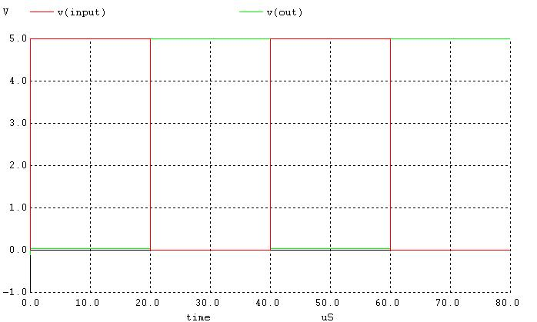

For Low to High:

t1 = 2.0025us, t2 = 2.0039us

tLH = 1.4ns

For High to Low

t1 = 40.00125, t2 = 40.0015

tHL = 1.25ns

Propagation Delay = 1.325ns

1. VTC and noise Margin

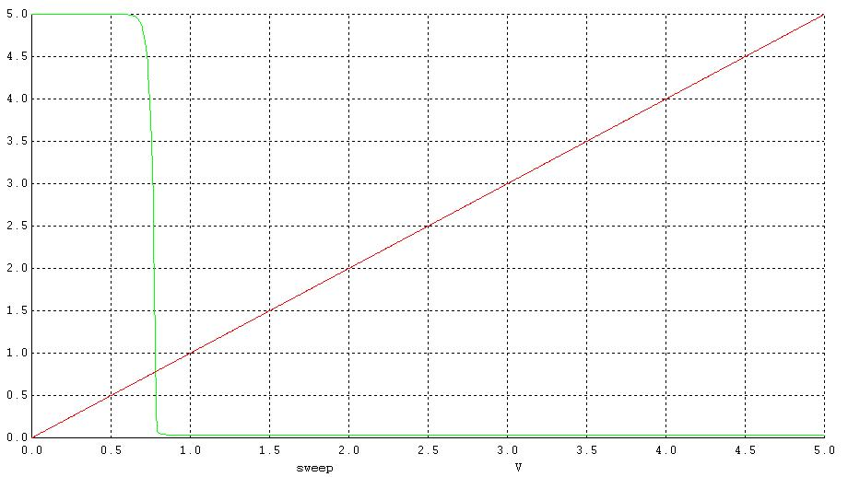

Vih =0.8V, Vil=0.65V, Voh=5V, Vih=0.8V

NML=0.591V, NMH = 4.2V, NM = 0.591V

1. Fan-out

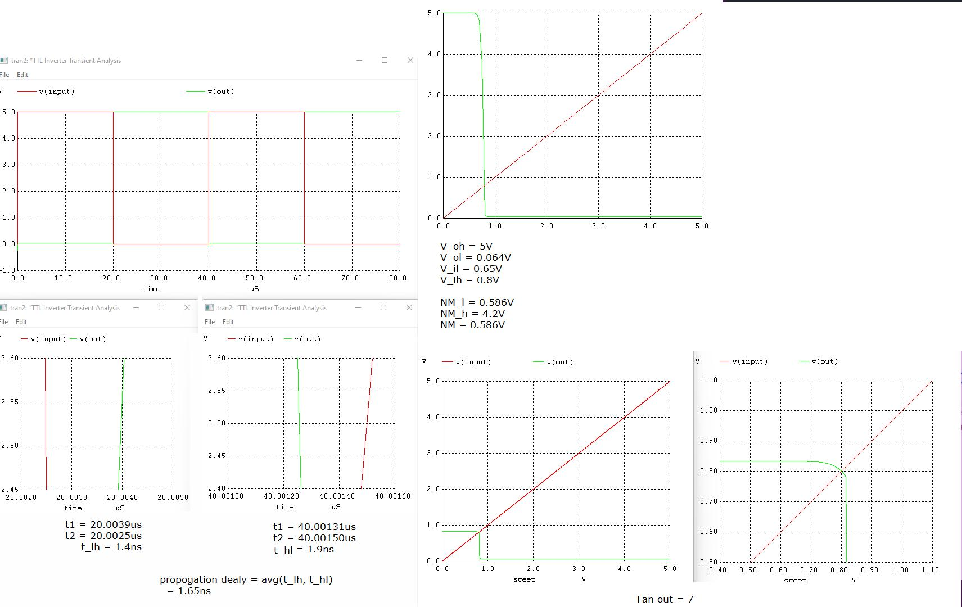

**CONCLUSION**

In this practical we have implemented spice code TTL inverter and found out its VTC, Noise margin, Propagation delay and fanout. it was observed that the propagation delay of TTL family is lower than DTL