**Sardar Vallabhbhai National Institute of Technology Surat**

**Electronics Engineering Department**

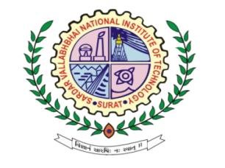

**LABORATORY JOURNAL**

**MACHINE**

**LEARNING**

**Name: Harsh Suthar**

**Roll No. U19EC046**

Sem – VI , Academic Year – 21/22

1

CERTIFICATE

This is to Certify that Mr. Harsh Suthar of B.Tech IIIrd E.C, Admission No. U19EC046 has Satisfactorily Completed His course work in Machine Learning Laboratory during the 6th Semester Session of Academic Year 2021-2022 and the same is submitted on 2022.

|  |
| --- |
|  |
| **Prof. P.K. Shah** |
| **Course Coordinator** |

**Electronics Engineering Department**



**Sardar Vallabhbhai National Institute of Technology, Surat**