**U19EC046 | ML | LAB 8**

**AIM**

Write a program to implement the support vector machine for a sample training data set stored as a .CSV file. Compute the accuracy of the classifier, considering few test data sets.

**THEORY:**

Support Vector Machine or SVM is one of the most popular Supervised Learning algorithms, which is used for Classification as well as Regression problems.​ The goal of the SVM algorithm is to create the best line or decision boundary that can segregate n-dimensional space into classes so that we can easily put the new data point in the correct category in the future. This best decision boundary is called a hyperplane.​

SVM chooses the extreme points/vectors that help in creating the hyperplane. These extreme cases are called as support vectors, and hence algorithm is termed as Support Vector Machine. SVM algorithm can be used for **Face detection, image classification, text categorization,** etc.

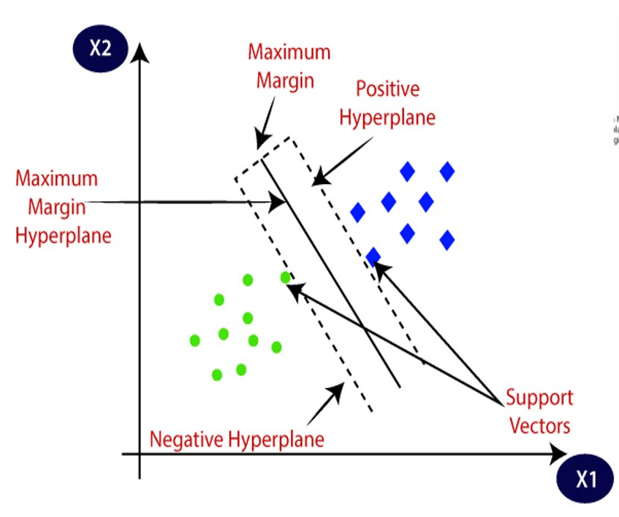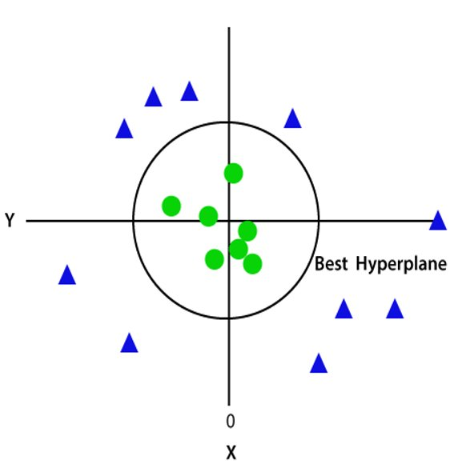

**Types of SVM:**

***Linear SVM:*** Linear SVM is used for linearly separable data, which means if a dataset can be classified into two classes by using a single straight line, then such data is termed as linearly separable data, and classifier is used called as Linear SVM classifier.​

***Non-linear SVM:*** Non-Linear SVM is used for non-linearly separated data, which means if a dataset cannot be classified by using a straight line, then such data is termed as non-linear data and classifier used is called as Non-linear SVM classifier.

**CODE**

|  |
| --- |
| **import numpy as np**  **import matplotlib.pyplot as plt**  **import pandas as pd** |
| **dataset = pd.read_csv('Social_Network_Ads.csv')**  **X = dataset.iloc[:, :-1].values**  **y = dataset.iloc[:, -1].values**  **from sklearn.model_selection import train_test_split**  **X_train, X_test, y_train, y_test = train_test_split(X, y, test_size = 0.25, random_state = 0)**  **from sklearn.preprocessing import StandardScaler**  **sc = StandardScaler()**  **X_train = sc.fit_transform(X_train)**  **X_test = sc.transform(X_test)**  **from sklearn.svm import SVC**  **classifier = SVC(kernel = 'linear', random_state = 0)**  **classifier.fit(X_train, y_train)**  **from sklearn.metrics import confusion_matrix, accuracy_score**  **cm = confusion_matrix(y_test, y_pred)**  **print(cm)**  **accuracy_score(y_test, y_pred)** |

|  |
| --- |
| **import numpy as np**  **import matplotlib.pyplot as plt**  **import pandas as pd**  **dataset = pd.read_csv('Position_Salaries.csv')**  **X = dataset.iloc[:, 1:-1].values**  **y = dataset.iloc[:, -1].values**  **y = y.reshape(len(y),1)**  **from sklearn.preprocessing import StandardScaler**  **sc_X = StandardScaler()**  **sc_y = StandardScaler()**  **X = sc_X.fit_transform(X)**  **y = sc_y.fit_transform(y)**  **from sklearn.svm import SVR**  **regressor = SVR(kernel = 'rbf')**  **regressor.fit(X, y)**  **from sklearn.metrics import r2_score, mean_squared_error**  **Y_model = sc_y.inverse_transform(regressor.predict(X).reshape(-1,1))**  **score = r2_score(Y_model, sc_y.inverse_transform(y))**  **print(f"score: {round(score*100, 3)} %")**  **mse = mean_squared_error(y_true=y, y_pred=Y_model)**  **print(f"mean squared error: {round(mse, 3)}")*## Predicting a new result***  **plt.scatter(sc_X.inverse_transform(X), sc_y.inverse_transform(y), color = 'red')**  **plt.plot(sc_X.inverse_transform(X), sc_y.inverse_transform(regressor.predict(X).reshape(-1, 1)), color = 'blue')**  **plt.title('Support vector regression')**  **plt.xlabel('years of experience')**  **plt.ylabel('Salary')**  **plt.show()**  **X_grid = np.arange(min(sc_X.inverse_transform(X)), max(sc_X.inverse_transform(X)), 0.1)**  **X_grid = X_grid.reshape((len(X_grid), 1))**  **plt.scatter(sc_X.inverse_transform(X), sc_y.inverse_transform(y), color = 'red')**  **plt.plot(X_grid, sc_y.inverse_transform(regressor.predict(sc_X.transform(X_grid)).reshape(-1,1)), color = 'blue')**  **plt.title('Truth or Bluff (SVR)')**  **plt.xlabel('Position level')**  **plt.ylabel('Salary')**  **plt.show()** |

**OUTPUT**

1. SVM Classifier

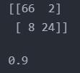

1. SVM regression

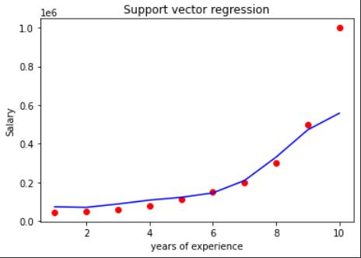

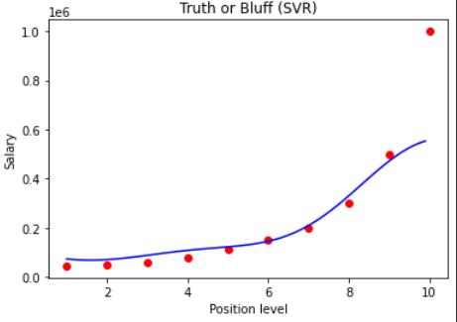

**CONCLUSION**

Hence, we have studied and implemented SVM classifier and regression using scikit learn library in python.