**U19EC046 | WMC | LAB 2**

**AIM**

To study and observe the effect of multipath at different time instants.

* To observe transmitted signal and received signal after multipath in time domain and frequency domain
* To obtain the transfer function and impulse response of the time varying channel for various time instants

**THEORY**

Consider the signal e(j*2*π*f0*t) transmitted from the transmitter and the corresponding received signal after subjected to multipath transmission is represented as follows:

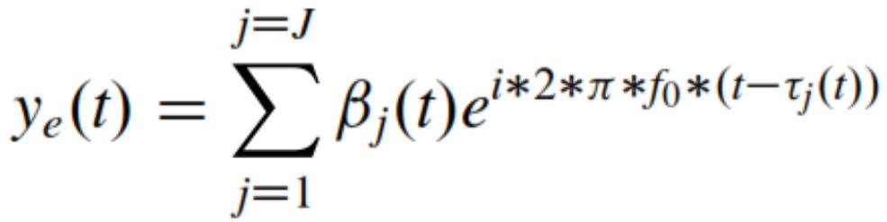

Where,

• J is the total no. of multipath,

• βj (t) is the attenuation in the jth path

• τj (t) is the time delay in the jth path

Attenuation and time delay of the jth path are functions of time. The function of the multipath channel at fo ,

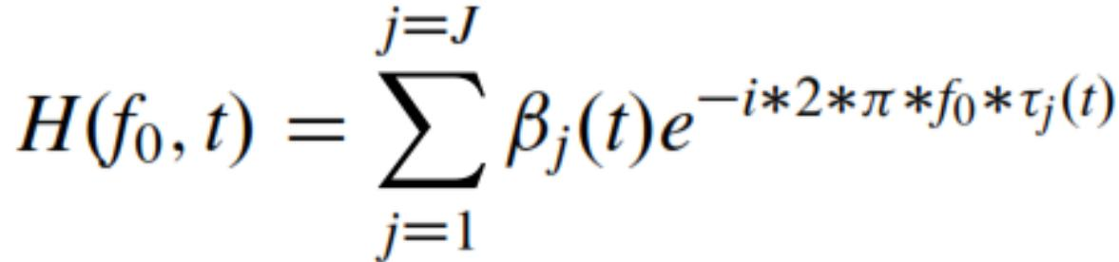

Similarly, it can be interpreted as the transfer function of the time varying for any value of f

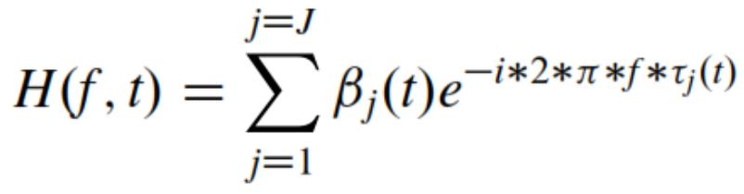

Thus the impulse response of the time-varying channel is obtained as follows

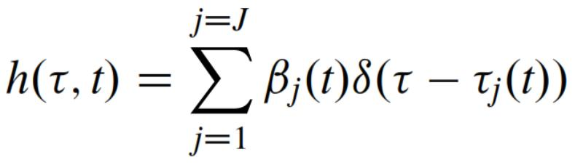

Here, the response of time varying multipath channel to the input signal is given by,

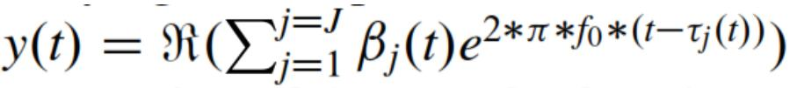

* Ideally, we expect channel transfer function envelop to be the flat response. But because of the presence of the Doppler spread, channel transfer function varies with time.
* We would like to have the rate at which channel transfer function is changing with time should be minimal.
* Thus the received signal is represented a

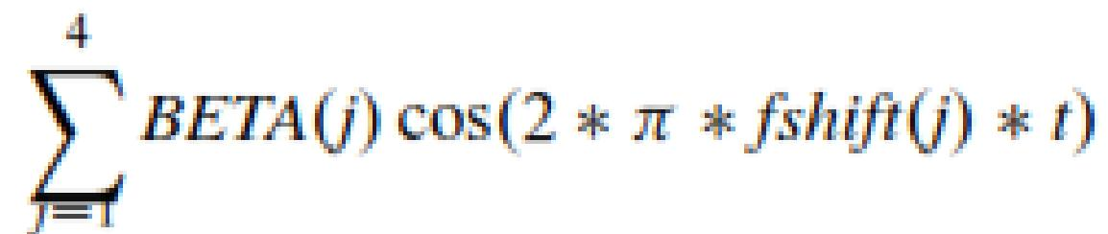

**MATLAB CODE**

|  |
| --- |
| **clc**  **clear all**    **f=5;**  **nop=2; % initial value of nop = 2**  **received_signal=[];**  **t=0:1/100:1; % choosing sampling freg=100Hz**  **transmitted_signal=cos(2*pi*f*t); % transmitted signal**  **z=1;**  **for t=0:1/100:1**  **temp=0;**  **for p=1:1:nop**  **beta(p)=rand/5; % for every delayed singal there will be 10**  **delay(p)=rand*t/5; % delay of each multipth component generated**  **temp=temp+beta(p)*exp(1i*2*pi*f*(t-delay(p)));**  **end**  **BETACOL{z}=beta;**  **DELAYCOL{z}=delay;**  **beta=0;**  **delay=0;**  **received_signal=[received_signal temp];**  **z=z+1;**  **end**    **save CONSTANTS BETACOL DELAYCOL**    **figure('name', 'U19EC046')**    **subplot(4,1,1)**    **plot(transmitted_signal)**    **title('U19EC046 Transmitted Signal');**    **subplot(4,1,2)**    **plot(real(received_signal))**    **title('U19EC046 received signal after multipath');**  **subplot(4,1,3)**    **plot(abs(fft(transmitted_signal)))**    **title('U19EC046 spectrum of the transmitted signal');**  **subplot(4,1,4)**    **plot(abs(fft(real(received_signal))))**    **title('U19EC046 spectrum of the received signal after multipath');**    **hold**    **load CONSTANTS**  **fs=100;**  **u=1;**  **for f=0:fs/101:(50*fs)/101**  **received_signal=[];**  **temp=0;**  **z=1;**  **for t=0:1/100:1**  **temp=0;**  **for p=1:1:nop**  **temp=temp+BETACOL{z}(p)*exp(1i*2*pi*f*(t-DELAYCOL{z}(p)));**  **end**  **received_signal=[received_signal temp];**  **z=z+1;**  **end**  **% The impulse response of the time-varying channel is computed as follows**  **t=0:1/100:1;**  **timevaryingTF_at_freq_f{u}=received_signal.*exp(-1i*2*pi*f*t);**  **u=u+1;**  **end**    **TEMP=cell2mat(timevaryingTF_at_freq_f');**  **for i=1:1:101**  **u=TEMP(:,i);**  **u1=[u;transpose(u(length(u):-1:2)')];**  **timevaringIR_at_time_t{i} = ifft(u1);**  **end**    **TFMATRIX=abs(cell2mat(timevaryingTF_at_freq_f'));**  **IRMATRIX=cell2mat(timevaringIR_at_time_t);**  **s=[2:2:8];**    **figure('name', 'U19EC046 Impulse Response');**  **for i=1:1:4**  **subplot (2,2,i)**  **plot(IRMATRIX(1:1:101,s(i)))**  **title(strcat('t=',num2str((s(i)-1)/100)))**  **end**    **figure('name', 'U19EC046 Transfer Function');**  **for j=1:1:4**  **subplot (2,2,j)**  **plot(real(ifft(IRMATRIX(1:1:101,s(j)))))**  **title(strcat('t=',num2str((s(j)-1)/100)))**  **end** |

**OUTPUT**

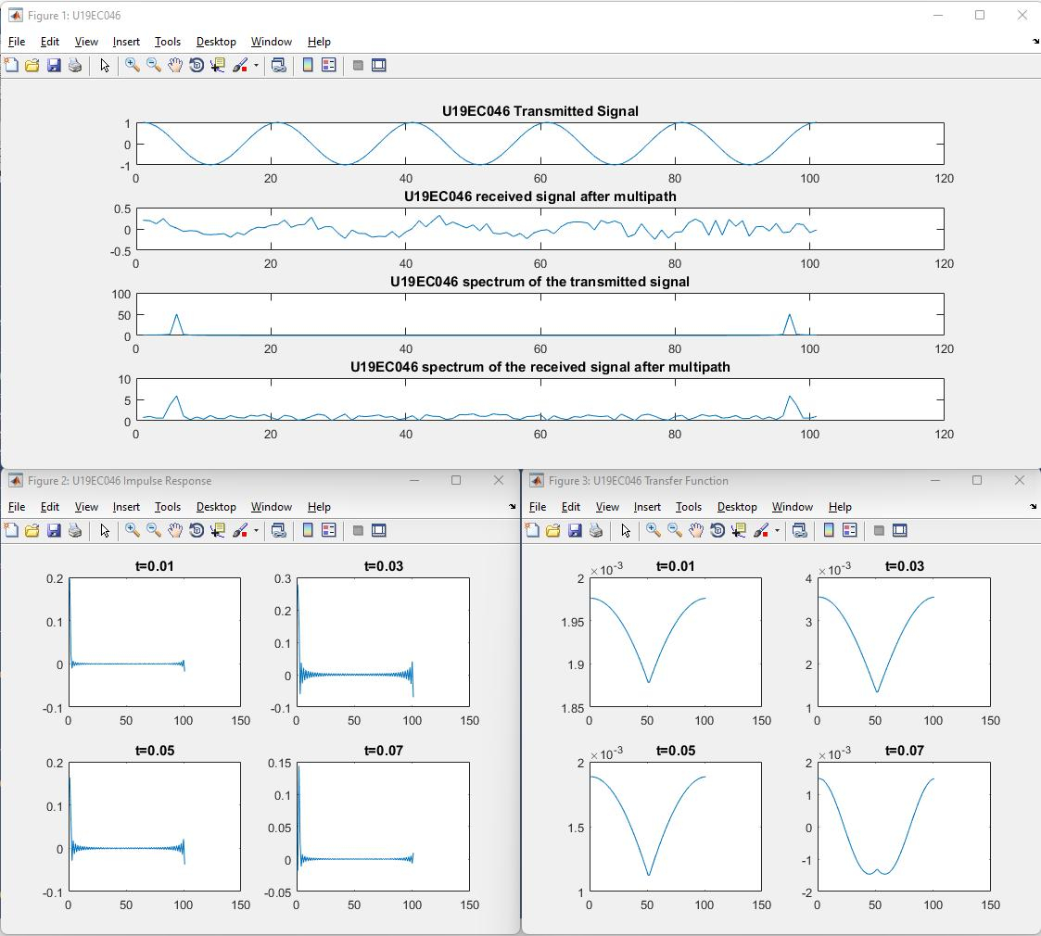

**CONCLUSION**

Hence, In this practical we have studied the effects of multipath signal transmission and also implemented the code for same in matlab. We have also plotted the transmitted and received signal in time and frequency domain and the channel impulse response as well as transfer function.