**U19EC046 | WMC | LAB 3**

**AIM**

To Simulate M-PSK and M-QAM Modulation Techniques using AWGN channel considering input as an Image with the help of MATLAB software. Plot SNR v/s BER where M= 4, 8, 16, 32, 64 and constellation as well.

**THEORY**

**AWGN**- A basic noise model used to mimic the effect of many random processes that occur in nature. Channel produces Additive White Gaussian Noise (AWGN)

**Additive**- The received signal equals the transmit signal plus some noise, where the noise is statistically independent of the signal.

r(t) = s(t)+w(t)

**White**- It refers that the noise has the same power distribution at every frequency or it has uniform power across the frequency band for the information system.

It is an analogy to the color white which has uniform emissions at all frequencies in the visible spectrum. if I focused a beam of light for each color on the visible spectrum onto a single spot, that combination would result in a beam of white light. As a consequence, the Power Spectral Density (PSD) of white noise is constant for all frequencies ranging from −∞ to +∞, as shown in figure below.

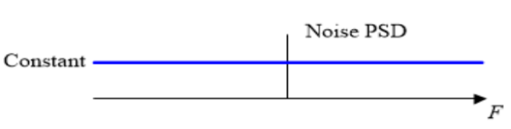

**Gaussian**- Gaussian distribution, or a normal distribution, has an average of zero in the time domain, and is represented as a bell-shaped curve. The probability distribution of the noise samples is Gaussian with a zero mean. The values close to zero have a higher chance of occurrence while the values far away from zero are less likely to appear.

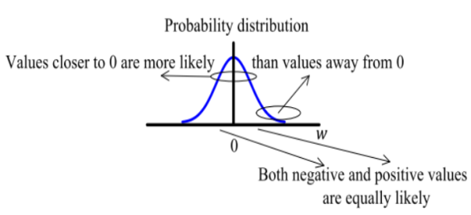

In reality, the ideal flat spectrum from −∞ to +∞ is true for frequencies of interest in wireless communications (a few kHz to hundreds of GHz) but not for higher frequencies.

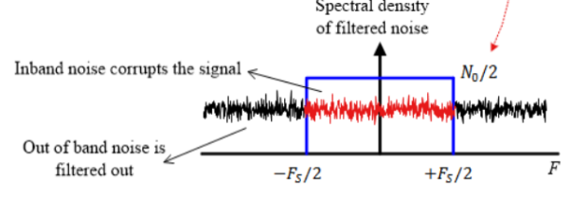

**Signal to Noise Ratio:**

The SNR or S/N is a measure used in science and engineering that compares the level of a desired signal to the level of background noise. It is defined as the ratio of signal power to the noise power, often expressed in decibels. A ratio higher than 1:1 (greater than 0 dB) indicates more signal than noise. SNR, bandwidth, and channel capacity of a communication channel are connected by the Shannon –Hartley theorem.

SNRdB = 10 log10 (Psignal/Pnoise)

**Shannon-Hartley theorem:**

It states the channel capacity (bits per second) OR information rate of data that can be communicated at low error rate using an average received signal power through communication channel subject to additive white Gaussian noise (AWGN) of power.

C = B log2(1+S/N)

Where, B is the Bandwidth of the channel in hertz.

5dB – 10dB : is below the minimum level to establish a connection, due to the noise level being nearly indistinguishable from the desired signal.

25dB – 40dB : is deemed to be good.

4dB or higher : is considered to be excellent.

**Algorithm:**

**MATLAB CODE**

|  |
| --- |
| clc  clear all;  close all;    % read the image  img=imread('cameraman.tif');    maxM = 6; % maximum symbol rate  maxSNR = 40; % maximum SNR value    % initializing an matrix to store BER for different symbol rates  BERQAM = zeros(maxM,maxSNR/2);  BERPSK = zeros(maxM,maxSNR/2);    QAMstr = 'QAM (M = %d)';  PSKstr = 'PSK (M = %d)';    % SNR ranges  t = 1:2:maxSNR;      figure(1);  subplot(maxM/3,3,1);  imshow(img);  title('Original');    figure(2);  subplot(maxM/3,3,1);  imshow(img);  title('Original');    % for loop to calculate stuff on different symbol rates  for m = 2:maxM    % modulation order  ModOrd = 2^m;  symbolSize = log2(ModOrd);    % we need to pad zeros, why?  % suppose image size is 256*256 and each elment represents rgb value from  % 0 to 255, i.e. 8 bits. Consider symbol rate 3, we need to represent image  % in array of 3 bits. if 256*256 is not divisible by 3 then we cannot  % reshape it into array of 3 bits. hence we need to pad the image matriz  % so that number of elements in image size is divisible by symbol rate.    AddZero = rem(length(img),symbolSize);    if AddZero ~= 0  img = [img; zeros(symbolSize - AddZero, numel(img)/length (img))];  end    % stuff meant to reshape the image matrix to array of m bits  binaryImage = de2bi(img);  reshapedImage = reshape(binaryImage, 8*length(binaryImage)/symbolSize, symbolSize);  img_dec = bi2de(reshapedImage);    % finnaly modulate  yQAM = qammod(img_dec, ModOrd);  yPSK = pskmod(double(img_dec), ModOrd);    % for each SNR value populate BER values  for s = 1:2:maxSNR  nQAM = awgn(yQAM,s);  nPSK = awgn(yPSK,s);  zQAM = qamdemod(nQAM, ModOrd);  zPSK = pskdemod(nPSK, ModOrd);  [a,b] = biterr(img_dec,zQAM);  % (s+1)/2 because SNR jumps 2 value each time  % and BER matrix has size [m, maxSNR]  BERQAM(m,(s+1)/2) = 100*b;  [c,d] = biterr(img_dec,zPSK);  BERPSK(m,(s+1)/2) = 100*d;  end    % get the image matrix from demod, exatly opposite during modulation  QAM_dec = de2bi(zQAM);  QAM_rsp = reshape(QAM_dec, size(binaryImage));  QAMM = bi2de(QAM_rsp);  QAMM = uint8(reshape(QAMM,size(img)));    PSK_dec = uint8(de2bi(zPSK));  PSK_rsp = reshape(PSK_dec, size(binaryImage));  PSKK = bi2de(PSK_rsp);  PSKK = uint8(reshape(PSKK,size(img)));    % plot the scatter plot  scatterplot(nQAM);  scatterplot(nPSK);    figure(1);  subplot(maxM/3,3,m);  imshow(QAMM);  title(sprintf(QAMstr,ModOrd));    figure(2);  subplot(maxM/3,3,m);  imshow(PSKK);  title(sprintf(PSKstr,ModOrd));    figure(maxM+1);    subplot(211);  plot(t,BERQAM(m,:),'linewidth',2,'DisplayName',sprintf(QAMstr,ModOrd));  title('BER vs SNR (QAM) U19EC046');  xlabel('Signal to Noise Ratio');  ylabel('Bit Error Rate(%)');  legend;  hold on;    subplot(212);  plot(t,BERPSK(m,:),'linewidth',2,'DisplayName',sprintf(PSKstr,ModOrd));  title('BER vs SNR (PSK) U19EC046');  xlabel('Signal to Noise Ratio');  ylabel('Bit Error Rate(%)');  legend;  hold on;    end |

**OUTPUT**

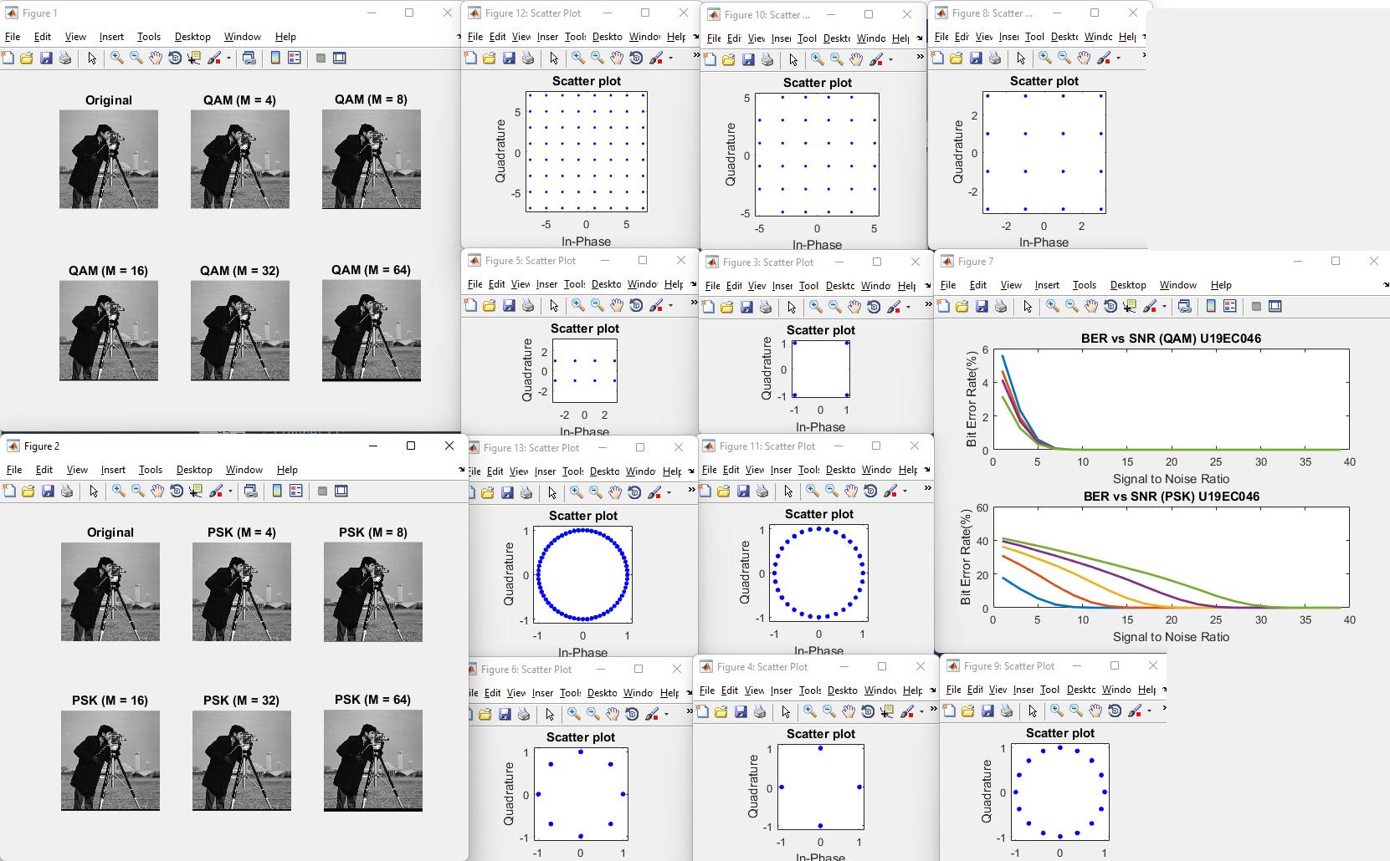

**CONCLUSION**

In this experiment we have successfully transmitted the input source image using different orders of PSK modulation technique and calculated the Bit Error Rates for different SNR values for each of them. It was observed that the BER in QAM reduces quickly as SNR increases as compared to PSK. Image quality decreases sligthly as modulation order increases.