**U19EC046 | WMC | LAB 4**

**AIM**

To study and observe the effect of doppler spread and delay spread for fast fading and slow fading channel and calculate the coherent bandwidth in MATLAB.

**THEORY**

As we know that radio frequency signal takes different path to reach the destination due to multiple paths. These multiple paths cause reflection, refraction and scattering of radio signal. Hence when the signal is transmitted from one place to the other, multiple copies of the signal is received with different amplitudes and different delays (leads to different time of arrival) at the receiver.

For example, if an impulse is transmitted then it will be no longer an impulse when it is received at the other end, but it will become a pulse with spreading effect. The effect which makes this spreading of signal is known as Delay spread.​ To measure performance of a wireless system different scenarios from low to medium to high delay spreads are considered for test purpose. Delay spread helps determine coherence bandwidth and coherence time of a wireless system. ​

Coherence time = (1/Doppler spread)​

In doppler spread, how fast the transfer function of the time-varying channel changes with time for a fixed frequency is to be studied. Doppler spread and the coherence time are used for the same. In delay spread, how fast the transfer function of the time-varying channel changes with frequency at a particular time instant is to be studied.​

**Doppler Spread:**

Doppler shift is the random changes in a channel introduced as a result of a mobile user’s mobility. Doppler spread has the effect of shifting or spreading the frequency components of a signal. Types of fading on the basis of doppler spread are fast fading and slow fading. ​

* Fast fading: Channel impulse response changes rapidly within the symbol duration. ​
* Slow fading: Channel impulse response changes at a rate much slower than the transmitted symbol bandwidth. ​
* Doppler spread is expressed in the following formula. As mentioned, doppler spread is defined as maximum doppler shift (fm). ​

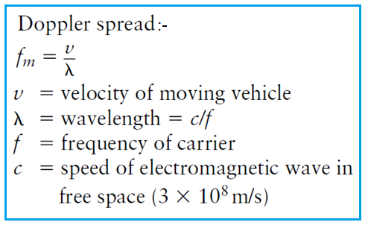

**Coherence Time:**

The coherence time is the time over which a propagating wave may be considered coherent. In other words, it is the time interval within which its phase is, on average, predictable.​

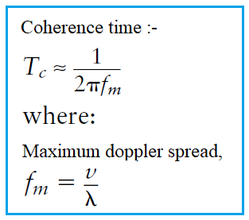

**Algorithm:**

* For fast fading doppler spread, Consider the signal cos 2𝜋𝑓𝑜𝑡 𝑓𝑜 = 1 MHz. Also let the rate at which the delay (𝜏𝑗) is changing with time be randomly chosen as TAU_J = [0.62 1.84 0.86 0.37] for fast fading.
* Hence the corresponding Doppler shift for the frequency 𝑓𝑜 in the corresponding paths is obtained as DJ = −𝑓𝑜*TAUJ and the actual shift in the frequency is given as fshift = |DJ + 𝑓𝑜| = [0.38 0.84 0.14 0.63]
* Attenuation in individual paths, BETA = [0.23 0.17 0.23 0.44]
* Thus the received signal is represented as (𝑗)cos(2 ∗ 𝜋 ∗ 𝑓𝑠ℎ𝑖𝑓𝑡 𝑗 ∗ 𝑡)
* Plot the received signal and the corresponding spectrum.
* For slow fading doppler spread, take Tau as [0.0042 0.0098 0.0030 0.007] and Beta as [0.2691 0.4228 0.5479 0.9427];

**MATLAB CODE**

|  |
| --- |
| ***%% fast fading***  **clc;**  **clear all;**  **close all;**    **Tau0 =0;**  **f=1;**  **nop =4;**  **Tauj = [0.62 1.84 0.86 0.37];**  **BETA = [0.23 0.17 0.23 0.44];**  **fshift=[];**  **for j=1:1:nop**  **fshift(j)=abs(-f+Tauj(j));**  **end**  **rxsignal =[];**  **tvtf = [];**  **t = 0:(1/100):100;**  **txsignal = cos(2*pi*f*t);**  **for t =0:(1/100):100**  **rx =0;**  **tf =0;**  **for p=1:1:nop**  **rx = rx+ BETA(p)*cos(2*pi*fshift(p)*t);**  **tf = tf+BETA(p)*exp(-1i*2*pi*f*Tau0)*exp(-1i*2*pi*f*Tauj(p)*t);**  **end**  **rxsignal = [rxsignal rx];**  **tvtf = [tvtf tf];**  **end**    **figure(1)**  **subplot(2,2,1)**  **plot(txsignal)**  **axis([1 1000 -2 2]);**  **title('Transmitted signal U19EC046');**  **xlabel('Samples in time domain with Ts = 1/100 micro secs');**  **ylabel('amplitude');**    **subplot(2,2,2)**  **fre = (0:1:length(rxsignal)-1)/100;**  **plot(real(rxsignal),'r')**  **axis([1 1000 -2 2]);**  **title('Received signal U19EC046');**  **xlabel('Samples in time domain with Ts = 1/100 micro secs');**  **ylabel('amplitude');**    **subplot(2,2,3)**  **plot(fre, abs(fft(txsignal)));**  **axis([0 2 0 1000]);**  **title('Spectrum of transfer signal U19EC046');**  **xlabel('Frequency in MHz');**  **ylabel('amplitude');**    **subplot(2,2,4)**  **plot(fre, abs(fft(real(rxsignal))));**  **axis([0 2 0 1000]);**  **title('Corresponding spectrum of received signal U19EC046');**  **xlabel('Frequency in MHz');**  **ylabel('amplitude');**    **figure(2)**  **subplot(2,1,1)**  **plot(abs(tvtf));**  **axis([0 1000 0 2]);**  **title('Time varying transfer function value magnitude U19EC046');**  **xlabel('Samples in time domain with Ts = 1/100 micro secs');**  **ylabel('amplitude');**    **subplot(2,1,2)**  **plot(phase(tvtf));**  **axis([0 1000 -25 0]);**  **title('Time varying transfer function value phase U19EC046');**  **xlabel('Samples in time domain with Ts = 1/100 micro secs');**  **ylabel('angle');** |

|  |
| --- |
| ***%% slow fading***  **clc;**  **clear all;**  **close all;**    **Tau0 =0;**  **f=1;**  **nop =4;**    **Tauj = [0.0042 0.0098 0.0030 0.007];**  **BETA = [0.2691 0.4228 0.5479 0.9427];**  **fshift=[];**  **for j=1:1:nop**  **fshift(j)=abs(-f+Tauj(j));**  **end**  **rxsignal =[];**  **tvtf = [];**  **t = 0:(1/100):100;**  **txsignal = cos(2*pi*f*t);**  **for t =0:(1/100):100**  **temp =0;**  **temp1 =0;**  **for p=1:1:nop**  **temp = temp+ BETA(p)*cos(2*pi*fshift(p)*t);**  **temp1 = temp1+BETA(p)*exp(-1i*2*pi*f*Tau0)*exp(-1i*2*pi*f*Tauj(p)*t);**  **end**  **rxsignal = [rxsignal temp];**  **tvtf = [tvtf temp1];**  **end**    **figure(1)**  **subplot(2,2,1)**  **plot(txsignal)**  **axis([1 10000 -2 2]);**  **title('Transmitted signal U19EC046');**  **xlabel('Samples in time domain with Ts = 1/100 micro secs');**  **ylabel('amplitude');**    **subplot(2,2,2)**  **fre = (0:1:length(rxsignal)-1)/100;**  **plot(real(rxsignal),'r')**  **axis([1 10000 -2 2]);**  **title('Real part of received signal U19EC046');**  **xlabel('Samples in time domain with Ts = 1/100 micro secs');**  **ylabel('amplitude');**    **subplot(2,2,3)**  **plot(fre, abs(fft(txsignal)));**  **axis([0 2 0 1000]);**  **title('Spectrum of transfer signal U19EC046');**  **xlabel('Frequency in MHz');**  **ylabel('amplitude');**    **subplot(2,2,4)**  **plot(fre, abs(fft(real(rxsignal))));**  **axis([0 2 0 1000]);**  **title('Real part of corresponding spectrum of received signal U19EC046');**  **xlabel('Frequency in MHz');**  **ylabel('amplitude');**    **figure(2)**  **subplot(2,1,1)**  **plot(abs(tvtf));**  **axis([0 10000 0 2.3]);**  **title('Time varying transfer function value magnitude U19EC046');**  **xlabel('Samples in time domain with Ts = 1/100 micro secs');**  **ylabel('amplitude');**    **subplot(2,1,2)**  **plot(phase(tvtf));**  **axis([0 10000 -4 0]);**  **title('Time varying transfer function value phase U19EC046');**  **xlabel('Samples in time domain with Ts = 1/100 micro secs');**  **ylabel('angle');** |

|  |
| --- |
| ***%% delay spread***  **clc;**  **clear all;**  **close all;**    **TAU0=0;**  **t0=1;**  **nop=4;**  **BETA=rand(1,nop);**  **TAUJ=(rand(1,nop)*2-1);**  **rxsignal=[];**  **BETA= [0.9575 0.9649 0.1576 0.9706];**  **TAUJ= [0.9143 -0.0292 0.6006 -0.7162];**  **tv_tf_comp_at_t0=[];**  **z=1;**  **t1=1;**    **for f=0:(1/1000):0.999**  **temp=0;**  **temp1=0;**  **for p=1:1:nop**  **temp1=temp1+BETA(p)*exp(-1i*2*pi*f*TAU0)*exp(-1i*2*pi*f*TAUJ(p)*t0);**  **end**  **tv_tf_comp_at_t0=[tv_tf_comp_at_t0 temp1];**  **end**    **figure;**  **plot((0:(1/1000):0.999)*1000,abs(tv_tf_comp_at_t0));**  **title('Time Varying Transfer Function computed at the time instant t0=1us U19EC046')**  **xlabel('Frequency in Khz');**  **ylabel('Amplitude');** |

**OUTPUT**

1. Fast Fading

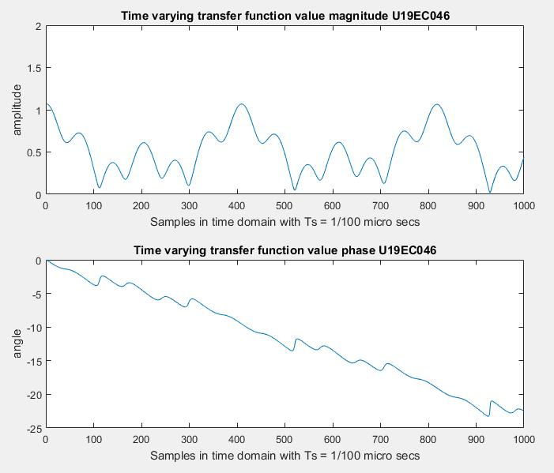

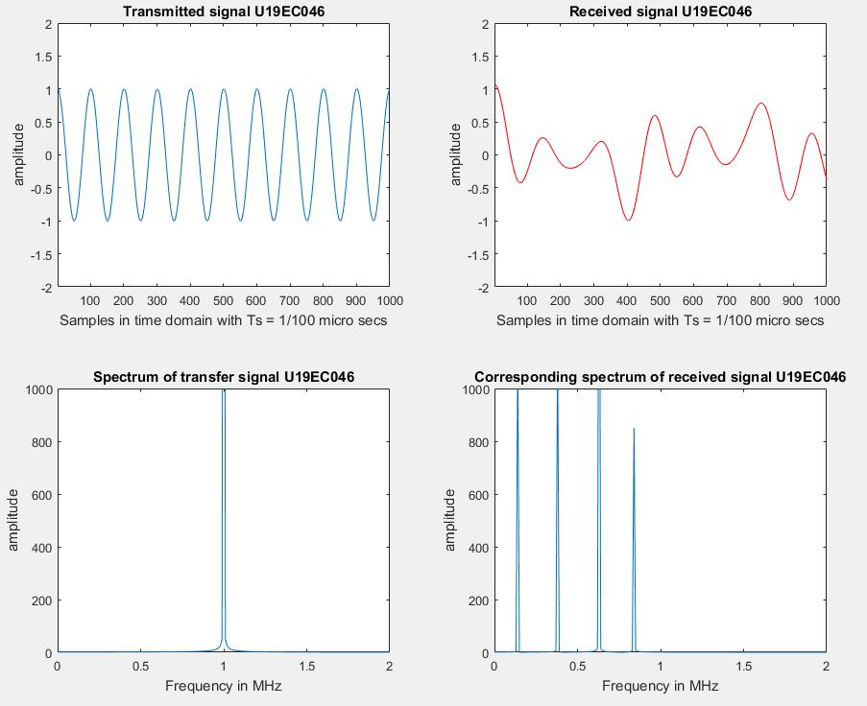

1. Slow Fading

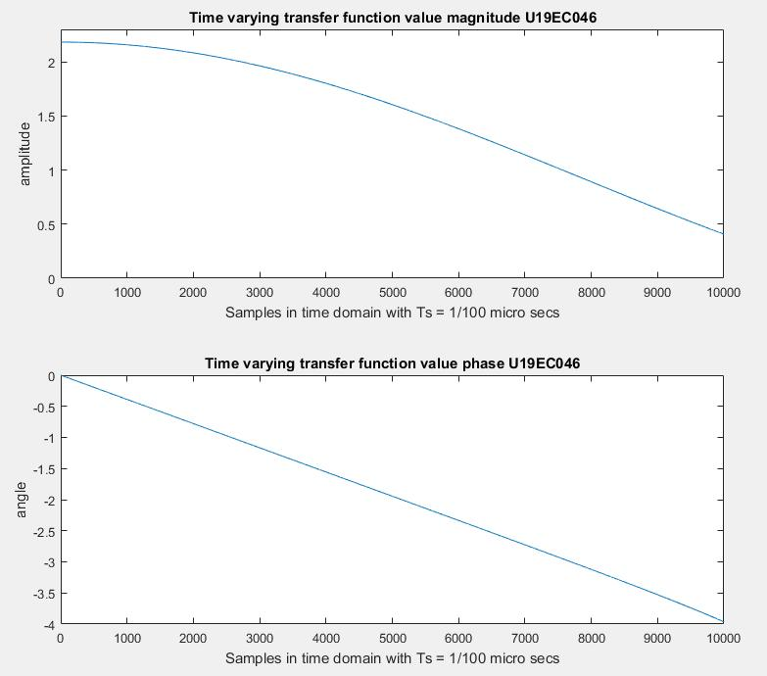

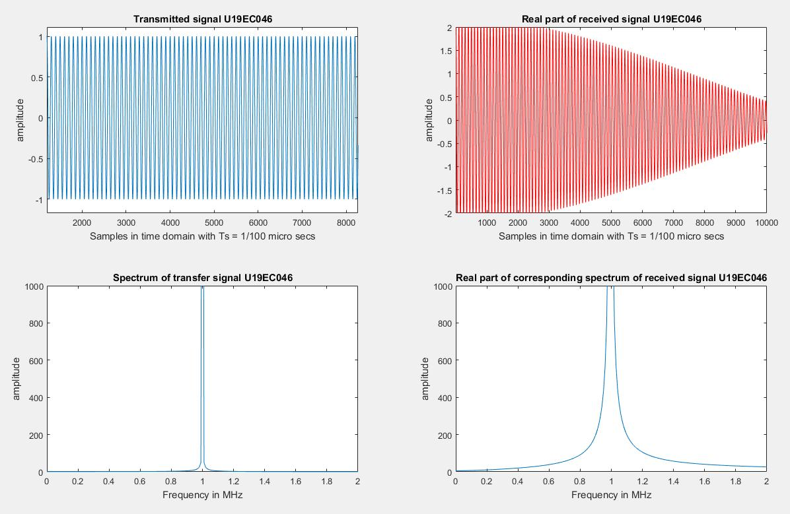

1. Delay Spread

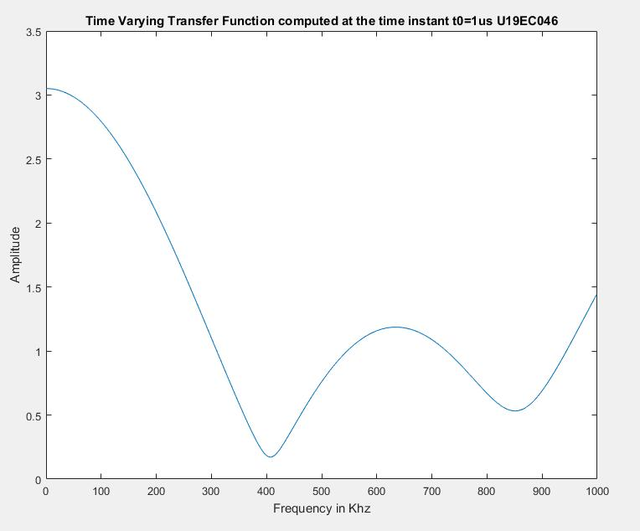

**Calculation:**

Coherence Time = 1/2D = 73us

Delay Spread L = 1.6306

Coherence Frequency = 1/2L = 306KHz

**CONCLUSION**

In doppler spread, we studied that how fast the transfer function of the time varying channel changes with time for a fixed frequency. Doppler spread and the coherence time are used for the same. In delay spread, how fast the transfer function of the time-varying channel changes with frequency at a particular time instant.