**U19EC046 | WMC | LAB 5**

**AIM**

To study CDMA spreading/dispreading techniques and apply it on the Communication link in MATLAB

**THEORY**

Multiple Access Techniques:

Multiple access techniques are used to allow a large number of mobile users to share the allocated spectrum in the most efficient manner.

* As the spectrum is limited, so the sharing is required to increase the capacity of the cell or over a geographical area by allowing the available bandwidth to be used at the time by different users
* And this must be done in a way such that the quality of the service doesn’t degrade within the existing users
* A cellular system divides any given area into cells where a mobile unit in each cell communicates with a base station.
* The main aim in the cellular system design is to be able to increase the capacity of the channel i.e., to handle as many as calls as possible in a given bandwidth with a sufficient level of quality of service.

These includes mainly the following:

1. Frequency division multiple-access(FDMA)
2. Time division multiple-access(TDMA)
3. Code division multiple-access(CDMA)

**FDMA:**



* Each individual user is assigned a pair of frequencies while making or receiving a call as shown in Figure.
* One frequency is used for downlink and one pair for uplink. This is called frequency division duplexing (FDD).

**TDMA:**



* In digital systems, continuous transmission is not required because users do not use the allotted bandwidth all the time. In such cases, TDMA is a complimentary access technique to FDMA.
* Global Systems for Mobile communications (GSM) uses the TDMA technique.
* In TDMA, the entire bandwidth is available to the user but only for a finite period of time. The users are allotted time slots during which they have the entire channel bandwidth at their disposal, as shown in Figure.

**CDMA:**



* In CDMA, the same bandwidth is occupied by all the users, however they are all assigned separate codes, which differentiates them from each other shown in Figure .
* CDMA utilize a spread spectrum technique in which a spreading signal (which is uncorrelated to the signal and has a large bandwidth) is used to spread the narrow band message signal.

**MATLAB CODE**

1. Part I

|  |
| --- |
| **clc**  **clear all**  **data = randi([0 1], 1046, 1);**  **[n m] = size(data);**  **expanded_data = repmat(data, [1, 8]);**  **H = commsrc.pn(...**  **'GenPoly', [3 2 0], ...**  **'InitialStates', [0 0 1], ...**  **'CurrentStates', [0 0 1], ...**  **'Mask', [0 0 1], ...**  **'NumBitsOut', 8);**  **pn=generate(H);**  **pn_repeated = repmat(pn', [n 1]);**  **xored = xor(expanded_data, pn_repeated);**  **M=2;**  **data_vector = reshape(xored, [numel(xored)/M M]);**  **decimal_data_vector = bi2de(data_vector);**  **transmitted = pskmod(decimal_data_vector, 2^M);**  **SNR = -10:10;**  **BER = zeros(length(SNR), 1);**  **for i = 1:length(SNR)**  **received = awgn(transmitted, SNR(i));**  **demodulated = pskdemod(received, 2^M);**  **binary_data_vector = de2bi(demodulated);**  **binary_data = reshape(binary_data_vector, size(expanded_data));**  **despread_data = xor(binary_data, pn_repeated);**  **msg_rx = round(mean(despread_data, 2));**  **BER(i) = mean(abs(msg_rx - data));**  **end**  **plot(SNR,smooth(BER, 0.5));**  **title('BER vs SNR');**  **xlabel('SNR');**  **ylabel('BER');** |

1. Part II

|  |
| --- |
| **clc;**  **clear all;**  **close all;**  **for k=1:3**  **ber = [];**  **input_signal = randi([0,1],1000,1);**  ***%PN sequence***  **if k==1**  **H = commsrc.pn('Genpoly',[3 2 0],'InitialStates',[0 0 1],'CurrentStates',[0 0 1],'Mask',[0 0 1],'NumBitsOut',8);**  **pn = generate(H);**  **elseif k==2**  **H = commsrc.pn('Genpoly',[4 3 0],'InitialStates',[0 0 0 1],'CurrentStates',[0 0 0 1],'Mask',[0 0 0 1],'NumBitsOut',8);**  **pn = generate(H);**  **else**  **H = commsrc.pn('Genpoly',[5 3 0],'InitialStates',[0 0 0 0 1],'CurrentStates',[0 0 0 0 1],'Mask',[0 0 0 0 1],'NumBitsOut',8);**  **pn = generate(H);**  **end**  ***%expanding msg data***  **msg_signal = repmat(input_signal,[1,8]);**  ***%pn = repmat(pn,[1000/8,8]);***  **for i=1:size(msg_signal,1)**  **for j=1:8**  **spreaded_data(i,j) = xor(msg_signal(i,j),pn(j));**  **end**  **end**  **spreaded_data = reshape(spreaded_data,8000,1);**  **spreaded_data = reshape(uint8(spreaded_data),size(msg_signal));**  ***%qpsk mod nd demod***  **for snr=-10:10**  **M = 4;**  **m = log2(M);**  **X1 = spreaded_data(:);  *%reshape(x,[],1)%***  **zer_pad = rem(length(X1),m);**  **if(zer_pad~=0)**  **X1 = [X1;zeros(m-zer_pad,1)];**  **end**  **INPUT = reshape(X1,length(X1)/m,m);**  **INPUT = bi2de(INPUT);**  **y = pskmod(double(INPUT),M);**  **y = awgn(y,snr);**  **z= pskdemod(y,M);**  **z1 = de2bi(z,m);**  **if(zer_pad~=0)**  **z1 = z1(1:end-(m-zer_pad));**  **end**  **output = reshape(uint8(z1),size(spreaded_data));**  **output = reshape(output,[1000,8]); *%output***  **for i=1:size(msg_signal,1)**  **for j=1:8**  **despread_data(i,j) = xor(output(i,j),pn(j));**  **end**  **end**  **msg_rx = round(mean(despread_data,2));**  **ber = [ber mean(abs(msg_rx-input_signal))];**  **if k==1**  **Ber1 = ber;**  **elseif k==2**  **Ber2 = ber;**  **else**  **Ber3 = ber;**  **end**  **end**  **end**  **snr = -10:10;**  **plot(snr,smooth(Ber1, 0.5),snr,smooth(Ber2, 0.5),snr,smooth(Ber3, 0.5));**  **legend('Signal-1','Signal-2','Signal-3');** |

**OUTPUT**

1. Part I

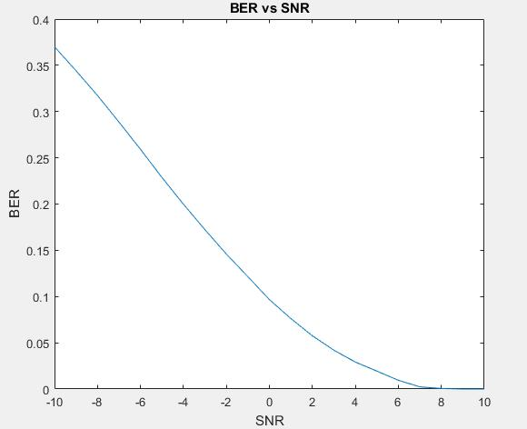

1. Part II

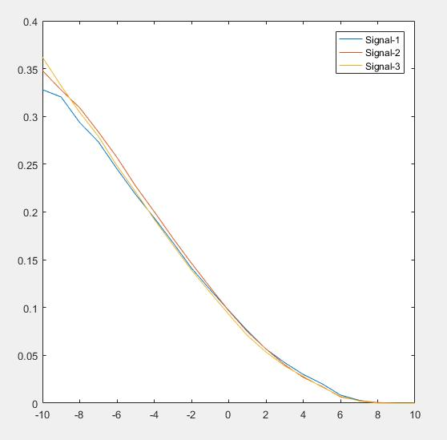

**CONCLUSION**

In this practical we have seen the CDMA spreading and despreading techniques and we also plotted BER vs SNR for three messages.