**U19EC046 | WMC | Android Task**

**AIM**

To take two numbers from the user and perform multiplication

**Team members:**

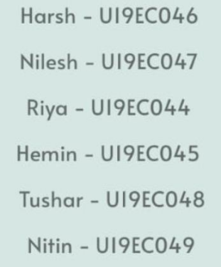

**ALGORITHM**

1. Import necessary libraries.
2. Create an event click listener on “calculate” button.
3. On click get the expression from the expression field.
4. We are using mxParser library to evaluate the math expression string. Pass on this expression.
5. Create a new instance of expression class with expression string as parameter.
6. Call calculate method on this instance to get the result.
7. Convert this result to string and update the textView.

**CODE**

1. MainActivity.java

|  |
| --- |
| **package com.example.multiplier;**  **import androidx.appcompat.app.AppCompatActivity;**  **import android.os.Bundle;**  **import android.view.View;**  **import android.widget.Button;**  **import android.widget.ImageButton;**  **import android.widget.TextView;**  **import org.mariuszgromada.math.mxparser.Expression;**  **public class MainActivity extends AppCompatActivity {**  **@Override**  **protected void onCreate(Bundle savedInstanceState) {**  **super.onCreate(savedInstanceState);**  **setContentView(R.layout.activity_main);**  **Button clickButton = (Button) findViewById(R.id.submitBtn);**  **ImageButton infoButton = (ImageButton) findViewById(R.id.infoButton);**  **ImageButton closeButton = (ImageButton) findViewById(R.id.closeButton);**  **View overlayView = (View) findViewById(R.id.overlayContainer);**  **TextView expressionField = (TextView) findViewById(R.id.expressionInput);**  **clickButton.setOnClickListener(v -> {**  **String expression = expressionField.getText().toString();**  **System.out.println(expression);**  **Expression e = new Expression(expression);**  **Double result = (Double) e.calculate();**  **String resultStr = result.toString();**  **expressionField.setText(resultStr=="NaN"?"Invalid expression":resultStr);**  **});**  **infoButton.setOnClickListener(v->{**  **overlayView.setVisibility(View.VISIBLE);**  **});**  **closeButton.setOnClickListener(v->{**  **overlayView.setVisibility(View.GONE);**  **});**  **}**  **}** |

**OUTPUT**

|  |  |  |
| --- | --- | --- |
|  |  |  |