**U19EC046 | WMC | LAB 10**

**PRACTICAL-10**

**Aim**

Study of Direct Sequence Spread Spectrum(DSSS) Modulation and Demodulation process.

**Practical-10.1**

**Aim**

Study of Spreading and Despreading based on Spread Spectrum Technique.

**Apparatus**

ST 2115 CDMA Trainer Kit

CRO

CRO Probes, Patch Codes

**Procedure**

Refer to the figure 1. while configuring setup for the experiment.

1. Switch data switches to 1 or 0 as per your choice of binary data pattern.
2. Connect any two of the four taps viz. A, B, C or D to the inputs of EX-OR gate of PN sequence generator. Connect 240 KHz clock signal on board to the clock input of the PN sequence generator.
3. Now switch ON the power supply and observe the output of Binary Data Generator and PN sequence generator. Since the data generator frequency used here is 30 KHz and that of PN Sequence Generator is 240 KHz, and hence there are 8 PN sequence bits per data bits for spreading the binary signal.

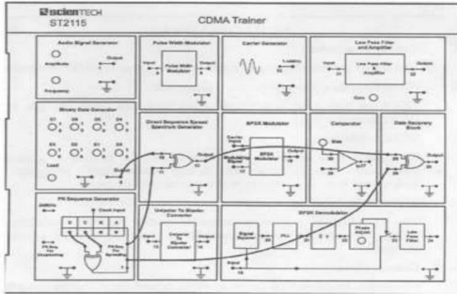

Fig 1. Spreading and Despreading Set Up

1. Change the positions of taps for feedback in the PN Sequence Generator Block to obtain deferent patterns of the PN sequences. Now, switch OFF and then ON the power supply to reload the changes, if changes do not appear in the output on changing the tap positions.
2. Connect output of binary data generator to one of the inputs of Direct Sequence Spread Spectrum generator input.
3. Connect output of PN sequence generator to the other input of DSSS EX-OR gate.
4. Now turn ON power supply and observe the output of DSSS generator block. This is our DSSS signal.
5. Now connect output of this DSSS block to the one of the inputs of EX-OR gate of Data Recovery Block. Connect the same output of PN sequence generator, which we have taken for spreading to the other input of this recovery gate for despreading. Note that the PN sequence used for dispreading is taken from the same output pin from where the PN sequence is taken for spreading the signal. This is because of the fact that there is complete synchronization between the spread signal and PN sequence. In other words there is not any significant delay involved in spreading process.
6. Observe the output of this data recovery block. This is recovered output without almost any error.
7. Now change the tape positions of shift registers (A, B, C or D) to get a new PN sequence and repeat the above process again. Thus you will observe that with each different sequence we are quite able to recover the original data also with different PN sequences, the modulated (Spread) data looks different i.e. we can recover the data if and only if we are using the same PN sequence for both modulation and demodulation. This is the reason that this DSSS technique has a large potential for being a multiple access technique. This multiple access technique is known as “Code Division Multiple Access” (CDMA) technique.

**Waveforms**

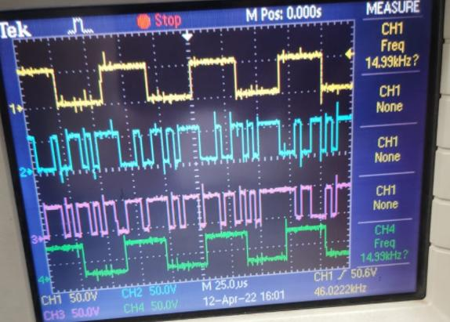

**Conclusion**

We were able to understand and perform spreading and dispreading based on spread spectrum technique using CDMA Trainer kit.

**Practical-10.2**

**Aim**

Study of Direct Sequence Spread Spectrum(DSSS) Modulation/Demodulation using an Analog signal and Digital signal as inputs individually.

**Apparatus**

ST 2115 CDMA Trainer Kit

CRO

CRO Probes, Patch Codes

**Procedure for Analog Signal**

1. Make the connections as shown in the figure 1.

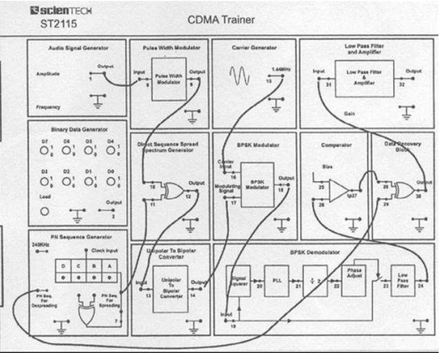

Fig 1. DSSS Set Up

1. Observe the output of audio signal generator block.
2. Observe the output of DSSS block.
3. Observe the output of BPSK modulator.
4. Observe the output of data recovery block. Adjust phase of recovered carrier and bias of comparator until you see an exact replica of pulse width modulated data at the output of this recovery block.
5. Observe the output of low pass filter section and compare it with the input Audio signal. Change gain of the amplifier to remove any nonlinearity errors. If still output is not proper then change amplitude of the input audio signal and adjust the gain of the output amplifier to remove distortions.

**Procedure for Digital Signal**

Refer to the figure 2 while configuring setup for the experiment.

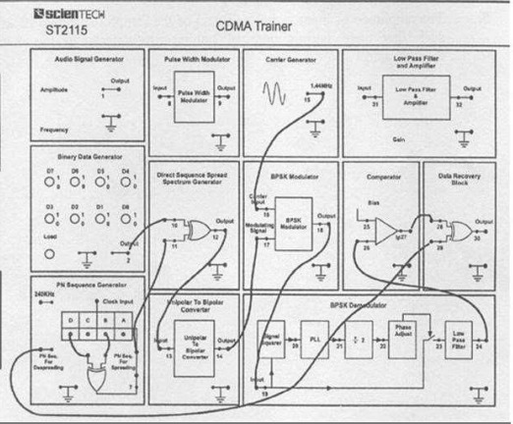

Fig 2. CDMA Trainer Set Up

1. Switch data switches to 1 or 0 as per your choice of binary data pattern.
2. Connect any two of the four taps viz. A, B, C, or D to the inputs of EX-OR gate of PN Sequence generator. Connect 240 KHz clock signal on board to the clock input of the PN sequence generator.
3. Now switch ON the power supply and observe the output of Binary Data generator and PN sequence generator. Since the data generator frequency used here is 30 KHz and that of PN Sequence Generator is 240 KHz, and hence there are 8 PN sequence bits per data bits for spreading the binary signal.
4. There are two outputs of PN Sequence Generator shown on the board. One of the outputs is for spreading the binary data signal and the other one is for dispreading the coded signal to recover back the original data(when BPSK modulation is used for RF modulation of Spread signal).
5. Connect binary data and PN sequence outputs to the EX-OR gate of DSSS block. Connect the output of DSSS block to the input of unipolar to bipolar converter. Take the output of this converter to the input of BPSK modulator. Connect sinusoidal carrier from Carrier Generator to the carrier input of BPSK modulator. This completes the modulator connections.
6. Now connect output of BPSK modulator to the input of BPSK demodulator block. Connect output of this block to the comparator input. Here we would receive original chipped data.
7. Connect the recovered chipped data (output of comparator) to one of the inputs of data recovery block. Connect ‘PN Sequence for Dispreading’ output of PN sequence generator block to the other input of data recovery gate.
8. Now turn power supply ON. Observe data and PN Sequence at their respective output pins. Press load button if data is not appearing.
9. Observe the output of DSSS block. This is called ‘Chipped Data’.
10. Observe the output of BPSK modulator. This is RF modulated chipped data.
11. Observe the output of comparator and then Data Recovery Block. Adjust phase of recovered carrier in BPSK modulator section and bias of comparator until you see a complete replica of original binary data.
12. Change data pattern and repeat the whole procedure with this new data. Again adjust phase and bias of comparator so as to recover the data completely.
13. Change chip (PN Sequence) pattern and observe the results.

**Waveforms**

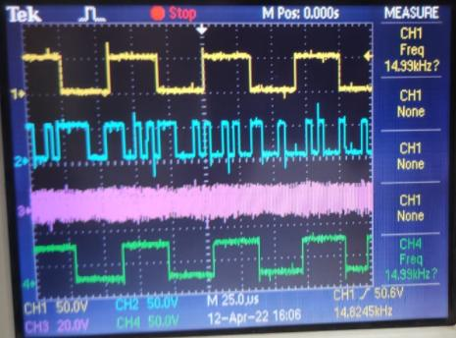

**Conclusion**

We were able to understand and perform the Direct Sequence Spread Spectrum modulation and demodulation using CDMA by taking analog and digital signals as inputs.