**U19EC046 | WMC | LAB 11**

**Aim**

To study about Software Defined Radio

**Theory**

***Introduction of GNU based Software Defined Radio (SDR):***

Software Defined Radio (SDR), sometimes shortened to software radio (SR), was introduced for the first time in 1991 by Joseph Mitola. The word of SDR was used to show a radio class that could be re-configured or re-programmed, thus resulted a kind application of wireless communication with mode and frequency band determined by software function. Ideally, SDR offers flexibility, re-configurability, scalability and as multi-mode as possible. SDR architecture is developed based on conventional radio functions. The difference is all functions of signal processing on conventional radio are carried out fully by hardware while the functions of signal processing on SDR are carried out as much as possible by software. The major key in building SDR is the placement of ADC and DAC components as a divider between analog and digital domain, thus the signal processing can be carried out using software.

The more realistic SDR architecture places ADC/DAC wideband after Down Converter/Up Converter, thus the conversion from analog to digital or its reverse is carried out on Intermediate Frequency (IF) signal which possesses lower frequency than RF signal. Today, that type of architecture are being developed widely and researched for the implementation. The Fig.1 shows the SDR architecture for both transmitter and receiver which can be represented using block diagram as shown in Fig.2. Based on Fig.2, the SDR platform performs transmitting and receiving functions. The transmitter (Tx) will perform some process such as base band signal processing, modulation, digital IF signal processing, and sending RF signal to the air. The receiver (Rx) will perform some process such as RF signal processing, channelization, digital IF signal processing, demodulation, and base band signal processing. As shown in Fig.2, the computation process in the receiver will be more complex that in the transmitter. GNU Radio is a free & open-source software development toolkit that provides signal processing blocks to implement software radios. It can be used with readily-available low-cost external RF hardware to create software-defined radios, or without hardware in a simulation like environment. It is widely used in research, industry, academia, government, and hobbyist environments to support both wireless communications research and real-world radio systems.

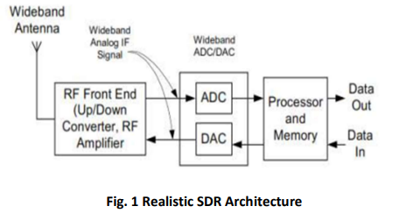

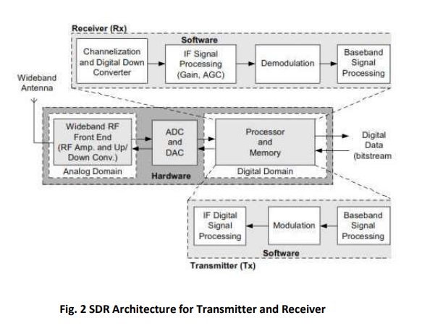

**Part 1 Block Diagram**

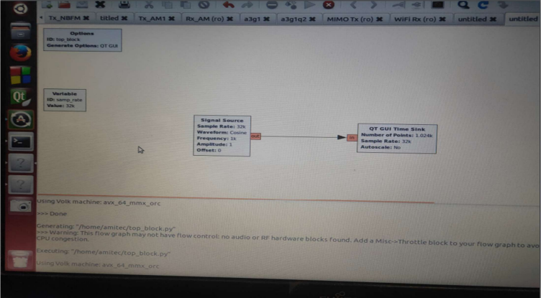

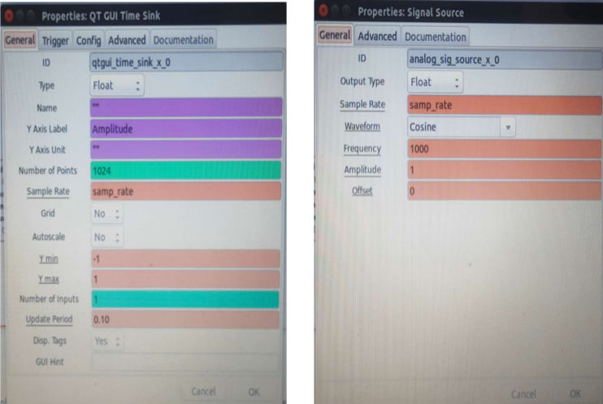

Properties QT GUI Time Sink Properties Signal Source

**Output 1**

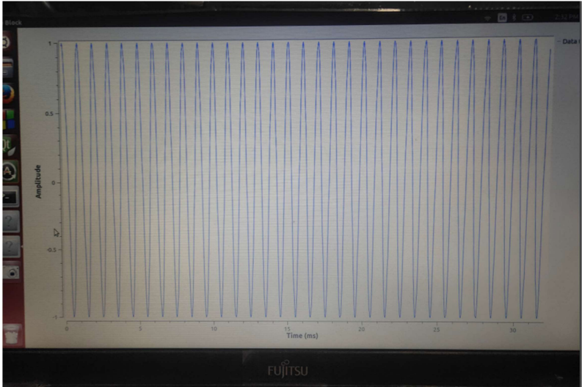

**Part 2 Block Diagram**

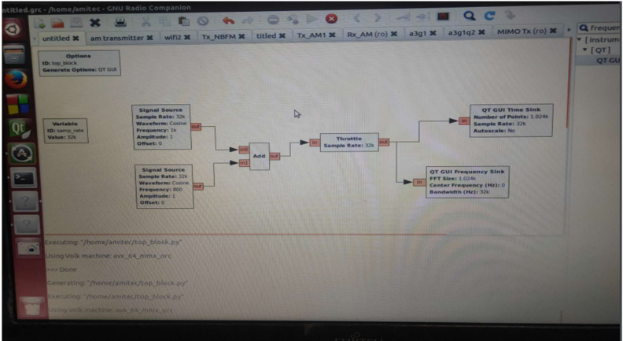

**Output 2**

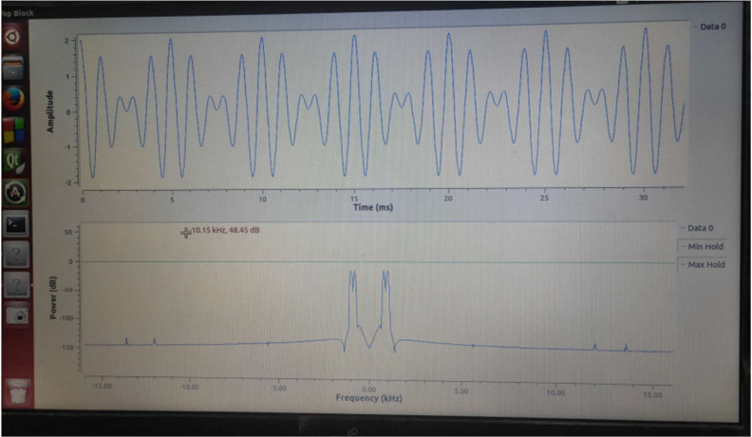

**Part 3 Block Diagram**

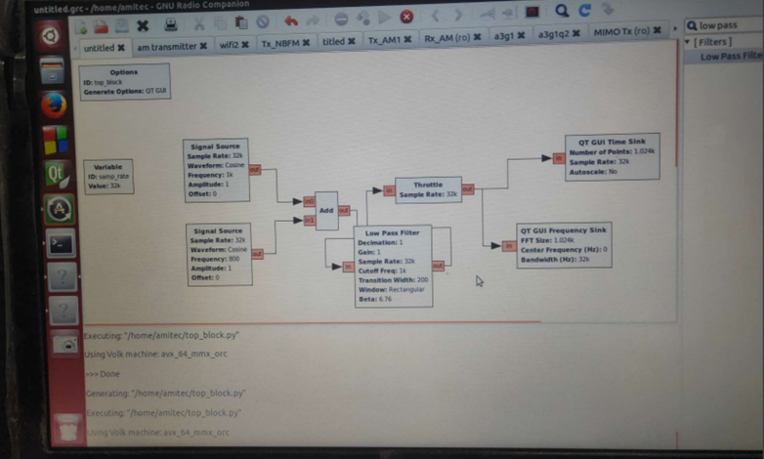

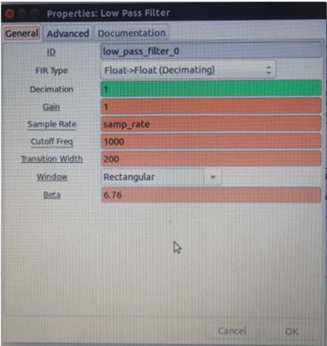

Properties of Low Pass Filter

**Output 3**

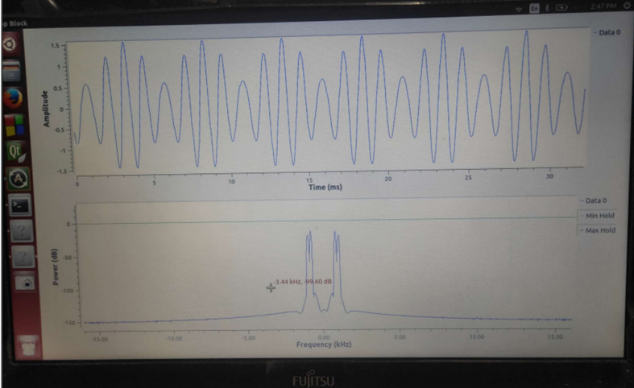

**Conclusion**

The basic understanding of SDR and GRC graphic tool was developed and the use of different block in different categories was understood. In this way, different functions can be generated using blocks from different categories.