European Union
(EU)

Background Guide AMBMUN ‘26
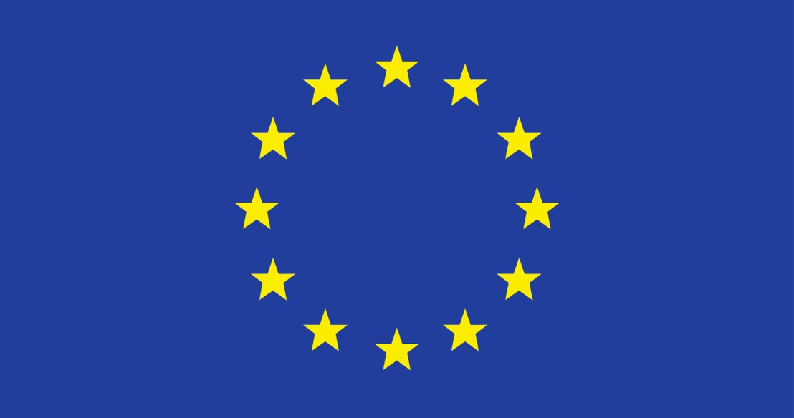

Topic:
Should EU Countries Have the Right to Refuse Admitting Refugees?

Chairs:
Layan Alsayed & Omar Sultan

Emails:
layan.alsayed@amb.sch.ae
omar.sultan@amb.sch.ae

Introduction to the European Union
The European Union (EU) is a single political and economic union consisting of 27 member states. Established on November 1st, 1993 by the Treaty of Maastricht, its main objective is to maintain peace, stability and prosperity throughout Europe, while promoting cooperation, solidarity and sustainable development within and beyond the continent. The European Parliament, the European Council, the European Commission, the Court of Justice of the European Union and the Court of Auditors are the five main institutions that make up the European Union. Together with its member states, it constitutes the world's largest source of development aid and plays an important role in global cooperation and development outside of Europe.
The EU only aims to continuously strengthen its unity through common policies and joint decision-making. Its objectives include economic integration, democratic governance, protection of human rights, and the rule of law. The Single Market, Common Trade Policy, Cohesion and Building Fund and other initiatives also aim to improve member countries' overall economic resilience, promote social inclusion and reduce regional disparities. Furthermore, the EU is actively working to address the contemporary challenges we face today, such as migration, digital innovation and climate change. We will help member states and foreign partners respond to short-term crises and long-term development needs by accelerating the green transition, funding research and renewable energy, and promoting humanitarian assistance and conflict prevention.

- Should EU Countries Have the Right to Refuse Admitting Refugees?

Background and historical information on the topic:
The ongoing discussion about whether countries in the EU should be allowed to turn away refugees is rooted in a history marked by violent events, instances of people being forced to move, and the growth of shared humanitarian principles on a global scale. During and after World War II, millions of people fled because of persecution, conflict, and political instability, leading to unprecedented levels of forced migration across Europe. Global nations took action, establishing the 1951 Refugee Status Convention, later updated through the 1967 Protocol. Together, these documents define who is considered a refugee and detail the legal obligations states place on asylum seekers. As European integration progresses, the EU has attempted to translate these international commitments into a coherent regional strategy. These endeavors led to the establishment of the Common European Asylum System (CEAS), with the goal of making similar the ways that asylum requests are handled, what protections are in place, and the rules for entering the country for all countries that are members. The aim was to maintain the integrity of the EU's internal borderless Schengen Area, while ensuring fairness, uniformity and global accountability. However, asylum policy remains a collective responsibility, giving governments significant room for maneuver.
Until now, EU member states have considered accepting refugees from the perspective of social issues, economic opportunities and political traditions. Divergent views on refugee protection are influenced by historical exposure to immigration, public attitudes toward integration, and differing interpretations of national sovereignty. As a result, the question of whether states should continue to have the power to refuse refugees remains a serious and unresolved issue, reflecting a broader conflict between individual states' desire to maintain control of border control, national policy, and collective humanitarian obligations.

Past Actions:
As a result of the refugee influx, EU member states have taken both individual and collective measures, and while this may prove the readiness of these states as well as their recognition of the issue, it also demonstrates division among them. In 2015, the European Migration and Refugee Crisis was one of the most significant events that influenced EU action, as the rapid increase of arrivals put mounting pressure on asylum systems. Due to their geographical location, Greece, Italy and Hungary take on disproportionately more asylum seekers than other European countries. This exposes structural weaknesses in the refugee system in Europe.

Consequently, the European Commission proposed a transfer procedure aimed at distributing asylum seekers more equitably among Member States. Thus, the EU hoped to reduce burdens on frontline countries and promote cooperation within the EU. However, many member states refused to comply, arguing that forced migration violates national sovereignty and raises issues of social inclusion and security. Due to legal barriers and political opposition, these programs failed, demonstrating the difficulty in implementing collective responsibility at the federation level. Moreover, each state has developed its own national strategy. In spite of their relatively liberal asylum laws, Sweden and Germany are capable of accepting a large number of refugees. Polish and Hungarian border fences, and the return process has been accelerated since the tightening of asylum conditions. Migration management at EU level has become increasingly dependent on external cooperation. An EU-Turkey statement issued in 2016 offered financial assistance, resettlement, and political cooperation in exchange for returning asylum seekers. The deal has been criticized by humanitarian groups, even though issues with asylum and outsourced refugee protection will significantly reduce arrivals. In response to Russia's invasion of Ukraine in 2022, the EU issued a Temporary Protection Directive, taking a different stance than before. This decision means that for the first time, millions of displaced Ukrainians will be able to benefit from immediate protection, settle in the country and access services without having to file a separate refugee claim. This approach demonstrated the EU's ability to act swiftly and jointly, as well as strengthening the debate about uniformity, fairness, and selective application of refugee protection.

Current Situation:
Migration remains a sensitive and unevenly shared issue within the European Union, with ongoing debates about whether member states should continue to have the power to reject refugees. Even though the number of refugees arriving has decreased since the 2015 crisis, the flow continues due to ongoing wars, political instability, economic struggles, and climate change, particularly from regions like the Middle East, Africa, and South Asia. In response, the EU introduced changes through the New Pact on Migration and Asylum. This strategy seeks to expedite asylum procedures, enhance border controls, and establish a system of "flexible solidarity." Member states have the option of accepting relocated asylum seekers, offering financial assistance, or providing operational and technical support. Although this system attempts to strike a compromise between national sovereignty and the EU's common commitments, critics contend that it permits nations to avoid directly accepting refugees, weakening the concept of shared responsibility.
There are still significant political differences among the member states in spite of everything. Some nations continue to advocate for tighter border controls, quicker return procedures, and greater collaboration with non-EU nations, citing security concerns, social cohesion problems, and domestic political pressure. Meanwhile, others argue for stronger, legally binding solidarity measures and emphasize the need to follow international refugee laws.

Questions a Resolution Must Answer:

1.⁠ ⁠How can the EU balance national sovereignty with collective humanitarian
obligations under EU law and the 1951 Refugee Convention?

2.⁠ ⁠What role should EU institutions (like the European Commission, Frontex, or
the European Parliament) play in enforcing refugee policy standards?

3.⁠ ⁠What measures can be taken to prevent discrimination against refugees?

4.⁠ ⁠What programs can be implemented to improve integration and reduce
cultural tensions between host communities and refugees?

5.⁠ ⁠Should there be penalties or incentives for countries that refuse or accept
Refugees?

Credible Sources:
United Nations High Commissioner for Refugees (UNHCR). (1951). Convention
relating to the status of refugees (28 July 1951, entered into force 22 April 1954).
United Nations Treaty Series, 189,
137. https://www.refworld.org/legal/agreements/unga/1951/en/39821

European Commission. (2024). Asylum in the
EU. https://home-affairs.ec.europa.eu/policies/migration-and-asylum/asylum-eu_en

