GENERAL ASSEMBLY THREE
(GA3)
Background guide
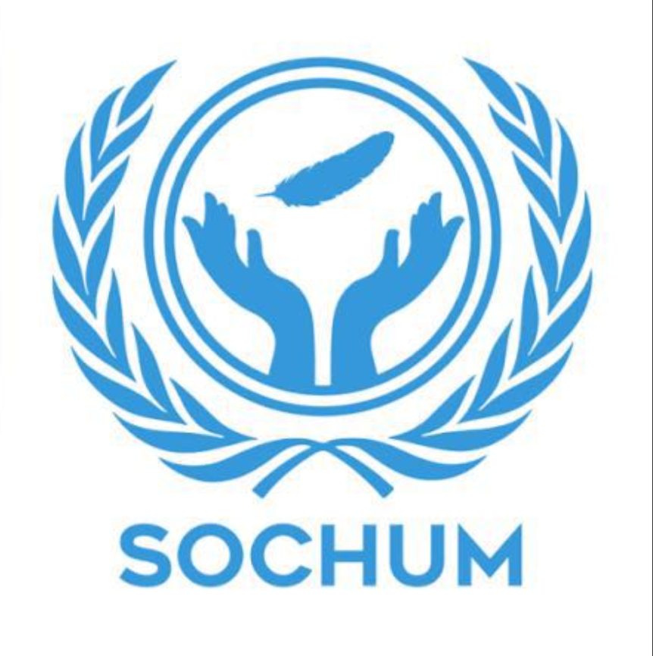
Chairs:
Remas Spartali : remas.spartali@amb.sch.ae
Mohammed AlFalahi : mohammed.alfalahi@amb.sch.ae
Selim Mohamed : selim.mohamed.amb.sch.ae

Introduction to the Third Committee of the General Assembly
The Third Committee of the General Assembly, called the Social, Humanitarian, and Cultural Committee, provides a central place for debating international human rights issues and reporting straight to the General Assembly. Through its mandate, the Committee will examine many topics related to the support and safeguarding of the basic human rights, social progress, women's equality and treatment of refugees and internally displaced persons. GA3 is a key player in creating global norms and standards, which frequently serves as the first agency to submit draft resolutions pertaining to specific human rights conditions within a nation, or the operational processes of other human rights organisations. Since Yemen is currently experiencing such extensive and complicated problems as a result of mass violations of international human rights and humanitarian law by all parties involved in the conflict, GA3 is seeking out cooperative, long-term solutions to these issues according to international law, and that place humanitarian protection first because there is no current international mechanism to investigate these violations.

- Protecting human rights in Yemen’s Conflict-Affected and occupied regions
Background and historical information on the topic
As a result of the conflict and the complete breakdown of the political transition process following the 2011 Arab Spring in Yemen, the escalation of hostilities in late 2014 began when the Houthi movement, also known as Ansar Allah, backed by Iran, took control of the Yemen capital city of Sanaa. In March 2015, the Saudi-led Coalition (SLC) intervened to restore the legitimate government of Yemen (which is currently represented by the Presidential Leadership Council), which was operating from Aden, its temporary capital. The war that began with Houthis' control of Sanaa has since led to a fragmented Yemen, with three different areas of control: the Houthis in the north and west; the Presidential Leadership Council and their allies in the east and parts of the south; and the Southern Transitional Council (STC) supported by the United Arab Emirates, in control of large portions of southern Yemen. This fragmentation, combined with the collapse of the state's institutional capacity, has created a humanitarian disaster and widespread human rights violations, as all parties to the conflict, including the SLC, Houthi forces, and all associated militias, have been accused of committing serious violations of international human rights and humanitarian law through such actions as indiscriminate shellfire and airstrikes on civilian infrastructure, arbitrary arrest and detention and torture, enforced disappearances, and the conscription of children.

Past actions:
The international community's diplomatic and accountability efforts have produced a mixed bag of results. To date, Security Council Resolution 2216 (2015) serves as an anchor point for all future diplomatic efforts supporting the government's preservation of statehood and sovereignty. One of the most significant achievements from the UN's diplomatic reach is an agreement on a "nationwide ceasefire" from April to October 2022. Although this ceasefire was not upheld, it allowed for a significant reduction in violence and a major exchange of prisoners.The UN Special Envoy for Yemen has been actively engaged in mediating the conflict and developing a roadmap for resolving the conflict politically and achieving a lasting ceasefire. The Envoy has encountered many hurdles and the progress on the negotiations has been slow. The Human Rights Council established a Group of Eminent International and Regional Experts (GEE) on Yemen in 2017 to investigate allegations of human rights violations and compile reports on the findings. The GEE's findings indicated that all parties involved were likely committing war crimes, and the GEE recommended a referral to the International Criminal Court (ICC). However, in October 2021, when the Human Rights Council did not vote to renew the GEE's mandate, the GEE's controversial termination occurred. Since then, the Human Rights Council has transitioned its focus from international accountability for these crimes to providing Technical Assistance and Capacity Building for the Yemeni National Commission of Inquiry (NCIAVHR), as outlined in resolutions such as A/HRC/RES/60/31 (Technical Assistance and Capacity-Building for the Yemeni National Commission of Inquiry (NCIAVHR), where the focus is now on providing support to enable local authorities within Yemen to perform their functions adequately). Other entities of the UN, including the UN Mission to Support the Hodeidah Agreement (UNMHA), have continued to operate, with the Security Council regularly renewing UNMHA's mandate to monitor the implementation of the Hodeidah ceasefire and redeployment process.

Current situation:
The crisis in Yemen is both a humanitarian disaster and an escalation of geopolitics in the region, with increasing tensions between the Houthis (who control the Central Bank), and the PLC (which controls the Central Bank in Aden) contributing to overwhelming economic ruin for Yemenis. The informal ‘truce’ that had largely kept internal conflict at bay for the last two years is at risk due to economic warfare between these two factions on many levels. Since last year (late 2023), this humanitarian crisis has been exacerbated globally by increased Houthi attacks on shipping throughout the Red Sea and Gulf of Aden (again an effect of larger conflict dynamics in the Middle East). Escalation of military responses in the region by foreign armies has immediately compromised options for successful internal peace agreements and has shifted worldwide attention and resources from Yemen to fight against and provide for the humanitarian needs of the Yemeni population. Humanitarian crises are reaching catastrophic levels, with reports from UN agencies that up to two-thirds of the country’s estimated 23 million people require humanitarian assistance and services to protect them from acute malnutrition (especially among children), while tens of thousands continue to be internally displaced due to ongoing conflict. Humanitarian efforts are being severely impeded by a lack of sufficient funding and support, with the most recent United Nations fundraising appeal for the Yemen Humanitarian Response Plan already falling several billion dollars short of its original projected target. Aid delivery is also being severely restricted as a result of the restrictions imposed by the Houthis and the arbitrary detention of staff working for aid organizations such as the UN and other NGOs. These actions are exacerbating the already limited amount of safe spaces available to both civilians and humanitarian workers.

Questions a Resolution Must Answer:
- What measures should be taken to protect vulnerable groups and ensure access to food, healthcare, and essential services?

- How can support for Yemeni human rights institutions be strengthened to improve domestic accountability and compliance with international standards?

- How can safe, unhindered humanitarian access be guaranteed and the protection of aid workers ensured across all areas of control?

- What measures can be takes to protect civilians from violations such as indiscriminate attacks, arbitrary detention, and child recruitment?

