UN Women (United Nations Entity for Gender Equality and the Empowerment of Women)

Background Guide

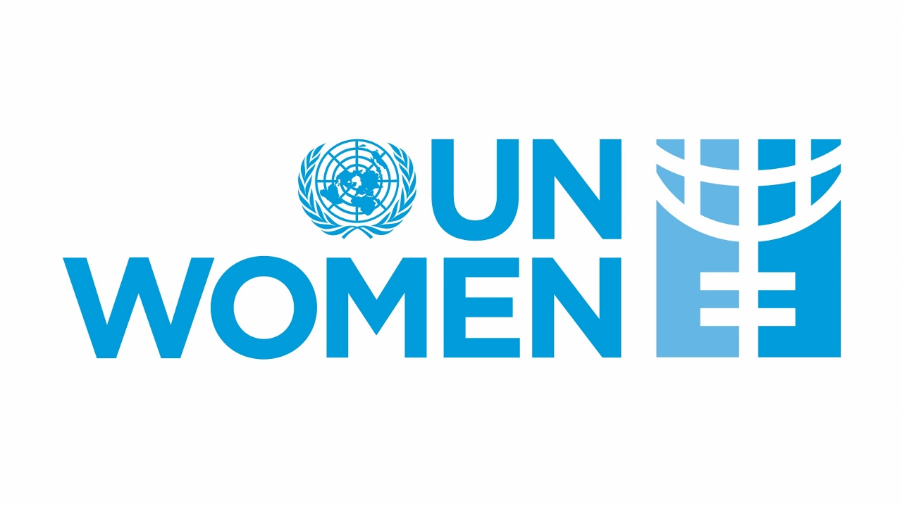

Introduction to the United Nations Entity for Gender Equality and the Empowerment of Women (UN Women)

The UN Women Organisation has been established to provide a united voice and to take a leading role in women’s rights and to be a tool for women to use to create their own future with the support of the UN. The goal of UN Women is to ensure the equal participation and full empowerment of women and girls in all areas of life, and to support Member States in achieving these goals while also creating an enabling environment for the full participation of women and girls through International Development Assistance (IDA). The focus of UN Women is to create a more equitable and inclusive world by removing systemic barriers to gender equality and by strengthening normative policies, such as the Beijing Platform for Action, developing a global policy framework, and providing technical and financial assistance to Member States. As part of the Global Partnership for Gender Equality, UN Women supports the mainstreaming of gender in the implementation of the 2030 Agenda for Sustainable Development and works towards the development of a more coherent and coordinated UN System in Gender Equality.
The facilitation of change also creates a pathway towards justice, health, and security for countries. UN Women provides support for international conventions (e.g. CEDAW) and promotes equal and full participation of women, as well as providing humanitarian responses, which allows or enables countries to solve some of the most serious human rights problems such as gender-based violence, lack of economic independence, and leadership and peacebuilding roles of women.
Today, UN Women is seen as a global leader in advocating for women and girls and providing political will, technical expertise and strategic partnerships to develop solutions to address global problems and to drive worldwide transformative changes toward equal rights for all.

- The Criminalization of Care: A Violation of Human Rights and an Impairment of Public Health

Background and historical information on the topic

One of the most serious violations of the human rights of women is the fact that care, especially with respect to abortion, is considered a crime. This is a significant impediment to reaching both global public health goals as well as gender equality goals, and it is rooted in the inequitable power relationships and sexist attitudes towards a woman's right to choose what happens to her body and the utilization of the legal system as a means to control a woman’s right to have an abortion through criminal prosecution of the woman and the medical provider of the abortion.

Over the years, the reproductive rights movement has changed from a focus on population control and family planning to a universal recognition that the right to obtain an abortion is one of the most critical aspects of gender equality and the right to live. CEDAW is at the foundation of UN Women and has played a major role in establishing the monitoring body known as the CEDAW Committee and, along with the UN Human Rights Committee, continue to uphold the importance of ensuring that women in all regions of the world have access to obtain abortion services free from criminal penalties, asserting that any laws that restrict or prohibit a woman from obtaining an abortion infringe on her rights to life, health, freedom from discrimination, and freedom from cruel, inhuman or degrading treatment. In spite of there being agreement between these two monitoring bodies that the various laws that restrict women from obtaining and having an abortion through criminal penalty violate multiple CEDAW articles related to a woman’s rights, 42% of the total number of women in the world still live in countries that have laws prohibiting or restricting abortion services and the fight to provide equal access to safe abortion care continues.
Legislative restrictions remain in part due to the legal code in many states where women are not granted access to appropriate, affordable and respectful abortion care even when medically indicated for the health of the woman.4 In addition to the legacy of institutional injustice facing women seeking abortions, the absence of clear legal standards and protections for physicians who provide medically indicated abortion services creates what is essentially a Public Health Crisis. Unsafe abortion is the leading preventable cause of maternal mortality and morbidity in many parts of the world.

Past Actions:

With the support of UN Women, the global community has worked extremely hard to create an effective normative system to promote access to safe abortion through:

• CEDAW and BPfA2 Resolution - Both the Beijing Declaration (BPfA) and CEDAW require all Member States to take all measures needed to address discrimination against women in all healthcare fields, including guaranteeing universal access to comprehensive sexual and reproductive rights (SRR).

• WHO Guidance2 - The World Health Organisation provides evidence-based guidance to healthcare providers on all public health issues globally and continues to do so on abortion. Furthermore, its recent guidelines have reiterated its long-held position that the practice of abortion should be fully decriminalised and regulated under health code as necessary.

• Recommendations from UN Treaty Monitoring Bodies2 - UN treaty-monitoring bodies worldwide have published numerous concluding observations and general comments encouraging countries to decriminalise their abortion laws and eliminate punitive measures for abortion. Many bodies have stated that creating penal codes on abortion creates substantial barriers, and also contributes to the stigma attached to abortion.

• Alignment with SDGs2 - In its work with partners, UN Women has highlighted that the Laws and Policies to Provide Safe Care for Women and Girls, which are necessary to meet the Sustainable Development Goal of Reducing Maternal Mortality Ratio (SDG 3.1) and to achieve Gender Equity (SDG 5), are significantly undermined by Laws preventing Access to Safe Care for Women and Girls. Laws that Limit Access to Safe Care increase the Burden and Risk that Women and Girls Face.

Current Situation:

Globally, maternal mortality rates continue to be a critical global health issue. Additionally, despite some positive trends in the number of maternal mortality rates over the years, progress in reducing maternal mortality rates seems to be stagnating or reversing in some areas of the world. Evidence is emerging that the criminalization of reproductive health care, especially through disciplinary legislation surrounding abortions, is linked to the stagnation of maternal mortality rates. These laws tend to neither ensure nor prevent abortions but make it easier for women to become mothers prematurely.

When abortion regulations are very strict in a country, women or pregnant women often encounter legal obstacles that make it difficult for them to seek emergency care that is sometimes the difference between living or dying. A lot of times, the threat of police prosecution causes doctors to deny women emergency care for pregnancy-related issues such as miscarriage or ectopic gestations, sepsis, or other fatal complications of pregnancy. This is often called the “Criminalization of Care.” It is clear that certain sections, namely low-income women, rural communities, refugees, young women, and women who are survivors of sexual violence, are significantly disadvantaged by these legislative regulations. This is since such women do not possess the resources or mobility to seek services elsewhere.

International human rights bodies such as UN Women, the Office of the High Commissioner for Human Rights (OHCHR), or the Committee on Discrimination Against Women (CEDAW) have clearly stipulated that any lack of access to reproductive health care is a violation of the right to life, health, privacy, freedom from discrimination, or freedom from cruel, inhuman, or degrading treatment. It is pertinent to note that despite such declarations, there is still little accountability for state policies that contribute to the death of mothers.

Moreover, the stigma attached to abortion and reproductive issues still prevents women from speaking out about maternal mortality related to abortion, keeping the issue underground with a significant rate of maternal mortality not yet documented. Also, it is important to state that any maternal death that is indirectly related to strict legislation is not necessarily traced back to legislative failure. With the approaching critical deadline of global agreements like the Sustainable Development Goals, especially SDG 3: “Good Health and Well-Being” or SDG 5: “Gender Equality,” any continued facilitation of maternal mortality through criminalized care is a significant hindrance to sustainable development. This challenge must be dealt with both through transformations in the health care system, as well as through legal responsibility and global collaboration to ensure that no woman is faced with the “choice” between complying with the law or living through the process of conception.

Questions a Resolution Must Answer:

- How can states be held accountable under international law for maternal deaths that result from restrictive abortion laws and the criminalization of reproductive healthcare?
- What legal protections can be implemented to ensure healthcare providers are able to deliver lifesaving maternal and reproductive care without fear of prosecution?
- How can states balance national legal frameworks with international human rights obligations when regulating abortion and maternal healthcare?
- What role should international organizations, particularly UN Women and the WHO, play in monitoring, reporting, and addressing maternal deaths linked to criminalized care?
- How can international cooperation and peer accountability between states be strengthened to discourage policies that contribute to preventable maternal deaths?

