United Nations Development Programme
(UNDP)
Background Guide
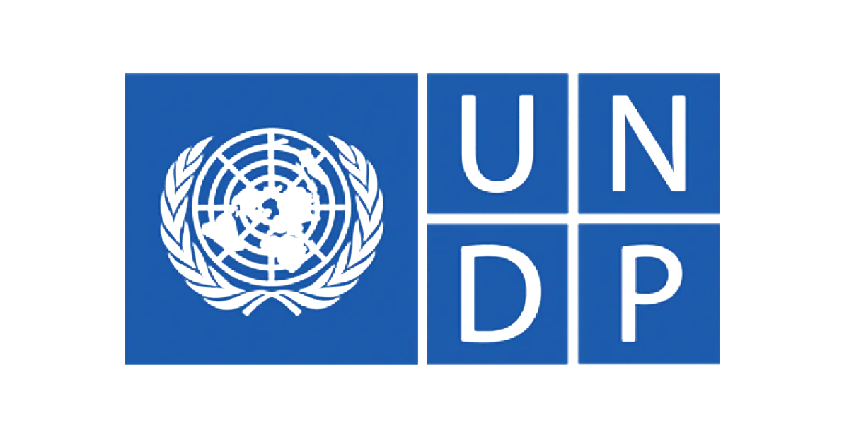AMBMUN 26’
Topic:
Rebuilding Health and Education Systems in Countries Hit by War.
Chairs:
Omar Abdaljawad
omar.abdaljawad@amb.sch.ae
Sara Kasem
sara.kasem@amb.sch.ae

Introduction to the United Nations Development Programme:
The United Nations Development Programme (UNDP) was founded in 1965 and remains a central entity within the UN today, dedicated to eliminating poverty, reducing inequality, and fostering stability in communities and regions. Its overarching goal is to ensure sustainable development, and it actively supports the achievement of the Sustainable Development Goals (SDGs) in approximately 170 countries, all of which have UNDP country offices.
The UNDP's core mission is to contribute to building a better future globally, and it focuses its efforts on three main areas: crisis prevention and recovery, democratic governance and peace-building, and sustainable development. By addressing critical challenges such as climate change, social instability, and institutional reform, the UNDP helps countries tackle destabilizing issues. Additionally, the organization provides a framework for justice, human rights, and resilience, supporting the development of democratic institutions, advocating for green energy and sustainable practices, and assisting communities in recovering from disasters.
As of now, the UNDP is recognized as the world's leading development agency, combining innovation, expertise, and strategic partnerships to create solutions that address global challenges. Through its work, the UNDP empowers nations to make lasting progress toward sustainability and positive change.

- Rebuilding Health and Education Systems in Countries Hit by War.

Topic Presentation:
Armed conflict leaves countries with shattered health services, collapsed education structures, and communities struggling to survive without the most basic support systems. Rebuilding these sectors is essential for long-term recovery, human development, and sustainable peace. The UNDP plays a leading role in restoring these foundations, ensuring that post-war societies can rebuild not just their infrastructure, but their resilience and stability.
Background and Historical Context:
Throughout modern history, whether in Afghanistan, Rwanda, Iraq, or Syria, wars have systematically destroyed hospitals, schools, supply chains, and the workforce needed to operate them. Doctors flee or are killed, teachers are displaced, and generations of children lose access to learning. These setbacks push countries decades behind in development and create long-term cycles of inequality and poverty.
The UNDP has long recognized that recovery from conflict cannot happen without strong health and education systems. After the major conflicts of the late 20th century, the UNDP began integrating health, education, governance, and economic recovery into one unified post-crisis strategy, understanding that rebuilding one sector cannot succeed without strengthening the others.

Past International Actions
The international community has attempted to address these crises through multiple initiatives:
UNDP Crisis Response and Early Recovery Programmes, which restore basic services, rebuild infrastructure, and train local workers.
UNESCO’s Education in Emergencies framework, supporting rapid deployment of temporary schools and teacher training.
WHO-led global health restoration missions, particularly in conflict zones such as Libya.
The Sustainable Development Goals (SDGs) - especially SDG 3 (Good Health and Well-Being) and SDG 4 (Quality Education), which set long-term targets for rebuilding and improving these sectors.
While these efforts have made progress, they also exposed how fragile post-war systems remain without sustained support and proper local capacity-building.
Current Situation:
Currently, many conflict-affected countries still face collapsing systems and limited access to essential services. Millions of children remain out of school, and large populations lack access to basic healthcare. Diseases spread easily in unstable environments, chronic illnesses go untreated, and maternal and child mortality rise sharply. Education systems often restart slowly, with unsafe buildings, shortages of qualified teachers, and a lack of learning materials.
UNDP continues to operate in more than a dozen active or recently post-conflict environments, such as Ukraine, Gaza, and Syria, focusing on rebuilding infrastructure, strengthening institutions, supporting local governance, and restoring community-level resilience. However, the scale of need often outweighs available resources.
Key Problems and Barriers
However, several obstacles continue to block recovery:
- Destroyed Infrastructure – Hospitals, clinics, schools, and transportation routes are often heavily damaged or completely lost.
- Lack of Skilled Professionals – Doctors, nurses, teachers, and administrators are frequently displaced or killed, creating massive shortages.
- Insufficient Funding – Long-term reconstruction requires sustained investment, which many countries fail to receive due to donor fatigue or political barriers.
- Security Instability – Ongoing violence or political unrest makes it difficult to rebuild or maintain development projects.
- Weak Governance Systems – Corruption, lack of coordination, and fragile institutions slow down reforms and reconstruction efforts.
- Inequality and Vulnerable Populations – Women, children, refugees, and rural communities often face the greatest barriers to health services and education access.
- Limited Local Capacity – Even when resources are available, many countries lack the administrative and technical ability to implement large-scale recovery programs.
Questions a resolution must answer:
- How will countries rebuild damaged hospitals and schools after war?

- How can we bring back or train new doctors, nurses, and teachers?

- Where will the long-term funding for rebuilding come from?

- How will vulnerable groups, like children, refugees, and women—get access to health care and education again?

- How can we help governments manage and run these systems properly?

- What can be done to keep rebuilding projects safe in unstable areas?

- How can technology or innovation help rebuild health and education systems?

- Who should UNDP partner with to make rebuilding faster and more effective?

- How will we make sure new schools and hospitals are sustainable and built to last?

- 10. How will progress be tracked to make sure countries are improving?

Recommended Sources to Review

- https://www.worldbank.org/en/topic/fragilityconflictviolence

- https://www.icrc.org/en/what-we-do/health

- https://www.undp.org/pakistan/our-focus/poverty-reduction-and-inclusion

