United Nations Human Rights Council
(UNHRC)

Background Guide

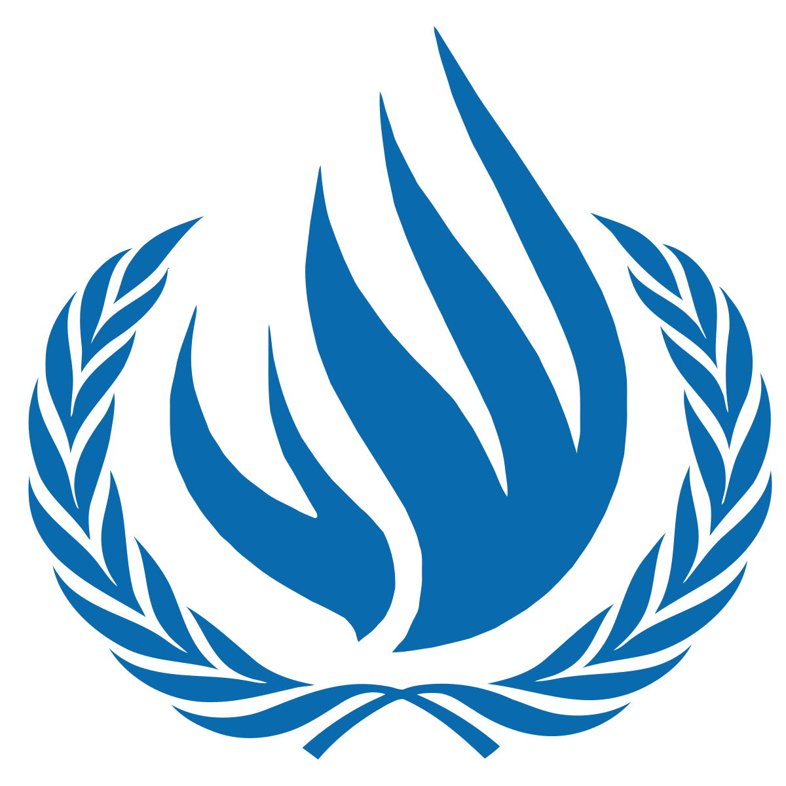

Introduction to the United Nations Human Rights Council

The United Nations Human Rights Council (UNHRC) was created on March 15th, 2006, and its objective was straight away. To be a dedicated body within the UN and be the one responsible for the promotion and protection of human rights everywhere. UNHRC is made up of 47 Member States and addresses, develops and responds to human rights emergencies with fact-finding missions, Special Procedures, and the Universal Periodic Review as tools. The UNHRC dissects the human rights record of every UN member nation by means of these instruments. By using these tools, the UNHRC is crucial in demanding accountability, creating a level playing field, and, thus, ensuring the very basic rights of people throughout the world.

The principal aim of UNHRC is to protect and advance human rights all over the world, and assume the roles of probing, stopping and compensating for the violations of human rights in the process. This it does through country monitoring, crisis area assistance, and laying down rights and institutions through legal means. Hence, it has a vital role in establishing justice, equality, and human liberties which in turn lead to a more peaceful and stable world. The present UNHRC is the international body that has been recognized as the main channel for cooperation among nations, impartial scientific knowledge, and a support system for the accountability of rights protection and violations, as well as the delivering of justice.

- Protecting Ethnic and Religious Minorities from Systemic Discrimination

Background and Historical Information on The Topic

Endemic discrimination of ethnic and religious minorities can be considered one of the most common violations of human rights and a significant challenge to social stability, equal opportunities, and sustainable progress. Historically based and grounded on inequality of power, exclusionary practices or laws, such discrimination is usually expressed in the form of limited opportunities for education, employment, political representation, and justice. Minorities have endured forced segregation and targeted violence across different regions of the world, undermining social cohesion to contribute to long-term instability. Such tendencies are a direct contradiction of the values on which the international human rights instruments are built and an impediment to the process of inclusive development. In that regard, according to the directive of the United Nations Human Rights Council (UNHRC), safeguarding the ethnic and religious minorities against systemic discrimination is an urgent agenda to respect dignity, equality, and peaceful coexistence across the globe.

Ethnic and religious minorities have been the focus of the international human rights paradigm. The important milestones in human history in the field include the Universal Declaration of Human Rights (1948), the International Covenant on Civil and Political Rights (1966), especially Article 27, and the UN Declaration on the Rights of Persons Belonging to National or Ethnic, Religious and Linguistic Minorities (1992). Systemic discrimination is still a prevalent phenomenon despite these instruments. A report by the UN has indicated that the minorities experience poverty, lack of representation and violence, in most cases, through the exclusionary laws and the state practices. The fact that this discrimination persisted is a pointer to the deep-rooted institutional bias, prejudice in the society as well as poorly enforced mechanisms that deny the minorities the equal protection and opportunity as a basis of social cohesion and sustainable development.

Ethnic and religious minority discrimination systems are still in place due to several reasons. Social exclusion, economic marginalization, and political marginalization further worsen the legal protection, discriminatory policies, and lack of access to justice. In most of the areas, the minority communities experience limited access to education, jobs and government services, which strengthens the inequality and susceptibility cycles. Crises, like armed conflict, forced migration or a global crisis, have only aggravated these differences, revealing vulnerabilities in the international protection systems. The negative effects in the long run are social fragmentation, intercommunal tensions and economic stagnation; all these are profound challenges to peace and development and achievement of universal human rights.

Past Actions:
The state discrimination practices against ethnic and religious minorities still exist to various degrees such as through unequal citizenship laws, religious worship prohibition, language suppression, and the monitoring and detaining of these minority groups. The reports submitted to the United Nations Human Rights Council (UNHRC) indicate that minority populations are often more than their share of the displaced and collectively punished during the conflicts and political crises. The UNHRC, therefore, has been dealing with discrimination against minorities through resolutions, Special Sessions, and Special Procedures which include working on minority issues and freedom of religion or belief. These methods have shown how systematic such practices are, and they have also exposed the forced displacements, denial of cultural rights, and exclusion from governance as patterns. The discriminatory practices do not get confined to individual cases; on the contrary, they start spreading through society very slowly, which gives rise to divisions, and hence, instability risk that might last longer than the conflict itself. This is the reason why the demand for international supervision and accountability in terms of monitoring and supporting the situation is stronger than ever.
The foundation for systemic discrimination practiced against ethnic and religious minorities can be traced back to historical marginalization and exclusionary state policies, combined with an entrenched societal prejudge. In many regions, the bad effects of the citizenship laws that discriminate by race, the differences in the legal protections offered to different communities and the restrictions imposed upon the use of a minority's language, religion, and cultural expression, continue to affect the minorities. The UN Human Rights Council (UNHRC) has used mechanisms such as the Universal Periodic Review (UPR) to frequently report on minority underrepresentation in governance, high poverty rates among minorities and little access to public services, as a pattern. Furthermore, the Council created the position of Special Rapporteur on minority issues, whose mandate includes the investigation of cases of forced displacement, segregation, and denial of religious freedom. Studies referred to in UN reports indicate that minorities are more prone to being unemployed, having lower educational attainment, and suffering from over-policing which reinforces their marginalization and the inequality throughout society.
However, the complexity of the question concerning the protection of minorities from systematic annihilation still persists even after such a lengthy period of worldwide acknowledgment. The three horsemen of the apocalypse, i.e., armed conflict, political instability, and extreme nationalism, are all contributing to the deterioration of the situation as they stir up animosity among different ethnic and religious groups. One of the measures undertaken by the UN Human Rights Council to confront this problem is the formation of monitoring missions and inquiry commissions to look into the cases of large-scale violations such as the cleansing of races, evil deeds, and the imposition of restrictions on the practice of religion. During the times of humanitarian crises, the minority group usually bears the brunt as they are the ones who get the first spot in the list of displacements, lack of assistance, and being killed. This situation, however, brings to light the frailties in the international protection system. The legal standards and monitoring mechanisms have become somewhat improved, but the relentless violations have become a loud-voiced reminder of the need for more vigorous enforcement, accountability, and international cooperation to guarantee the rights of everyone and to protect the minorities of ethnic and religious groups all over the world forever.
Current Situation:
The global scenario today is such that the political turmoil, nationalism, and identity politics have pushed the ethnic and religious minorities towards greater vulnerability. In several places, the minority groups are blamed for the troubles and hardships that the society faces leading to the use of discriminatory language, adoption of restrictive measures, and loss of legal protection. The digital mediums have greatly aided the propagation of hate speech and misinformation against the minority groups, thus, making it a norm to exclude and be hostile towards them. More than 75% of the entire world's inhabitants are living in nations where religious restrictions and social hostilities related to religion are at the highest level, which is a clear indication of the prevailing situation. The above-mentioned factors have created a situation where discrimination is not only accepted but also, in some instances, indirectly backed by the political discourse, thereby, making the distrust between the communities and state institutions deeper.
Then again, the armed conflicts and the forced migration continue to be the major calamities that strike the ethnic and religious minorities harder than others. The minorities are mostly living in the regions that are either disputed or marginalized, which makes them vulnerable to violence, confiscation of their lands, and forced removal. The refugee and internally displaced minority populations usually face difficulties in getting humanitarian aid, documentation, and safe return, which keeps them in a state of insecurity for a long time. The current global trends in displacement show that the minorities are more likely to get stuck in displacement for a longer time which increases their vulnerability to poverty, exploitation, and lack of the citizenship right, and also, their participation in the process of rebuilding is limited.
The socio-economic exclusion of minorities continues to be the most evident characteristic of the present scenario. In various regions, minority communities face a situation of greater unemployment, lower educational level, and so on.
Even with these problems, there has been an increase in the international spotlight on the protection of minorities, with more civil society actors, regional organizations, and UN authorities participating to a greater extent. Nevertheless, there are still gaps in the implementation of the measures especially in the places where there is no political will or where the mechanisms for holding public officials accountable are being obstructed. Some governments have taken actions to promote inclusion and representation, but still the progress is very slow and vulnerable to reversal. Presently, the world is in such a state that it very clearly shows the need for continuous monitoring, better, and stricter enforcement of commitments as well as inclusive policymaking to make sure that the ethnic and religious minorities are not the ones to be abandoned during the times of instability and transformation in the world.

Questions A Resolution Must Answer:
1) How can governments create and improve laws that protect ethnic and religious minorities from discrimination and unfair treatment?

2) What can be done to help ethnic and religious minorities have a stronger voice in government and decision-making?

3) How can countries make sure minorities have equal access to jobs, education, healthcare, and public services?

4) How can the United Nations Human Rights Council better monitor and respond to discrimination and human rights violations against minorities?

5) What actions can the international community take to protect ethnic and religious minorities during wars, displacement, and humanitarian crises?

6) How can countries reduce hate speech, stereotypes, and misinformation that target ethnic and religious minorities, especially online?

7) How can societies encourage peaceful coexistence and mutual respect while allowing minorities to maintain their cultural and religious identities?

Resources To Begin With:

https://www.ohchr.org/en/hrbodies/hrc/home

https://www.ohchr.org/en/instruments-mechanisms/instruments/international-covenant-civil-and-political-rights

https://www.ohchr.org/en/instruments-mechanisms/instruments/declaration-rights-persons-belonging-national-or-ethnic

https://www.ohchr.org/en/hr-bodies/upr/upr-home

