The United Nations Children’s Fund
(UNICEF)

Background Guide
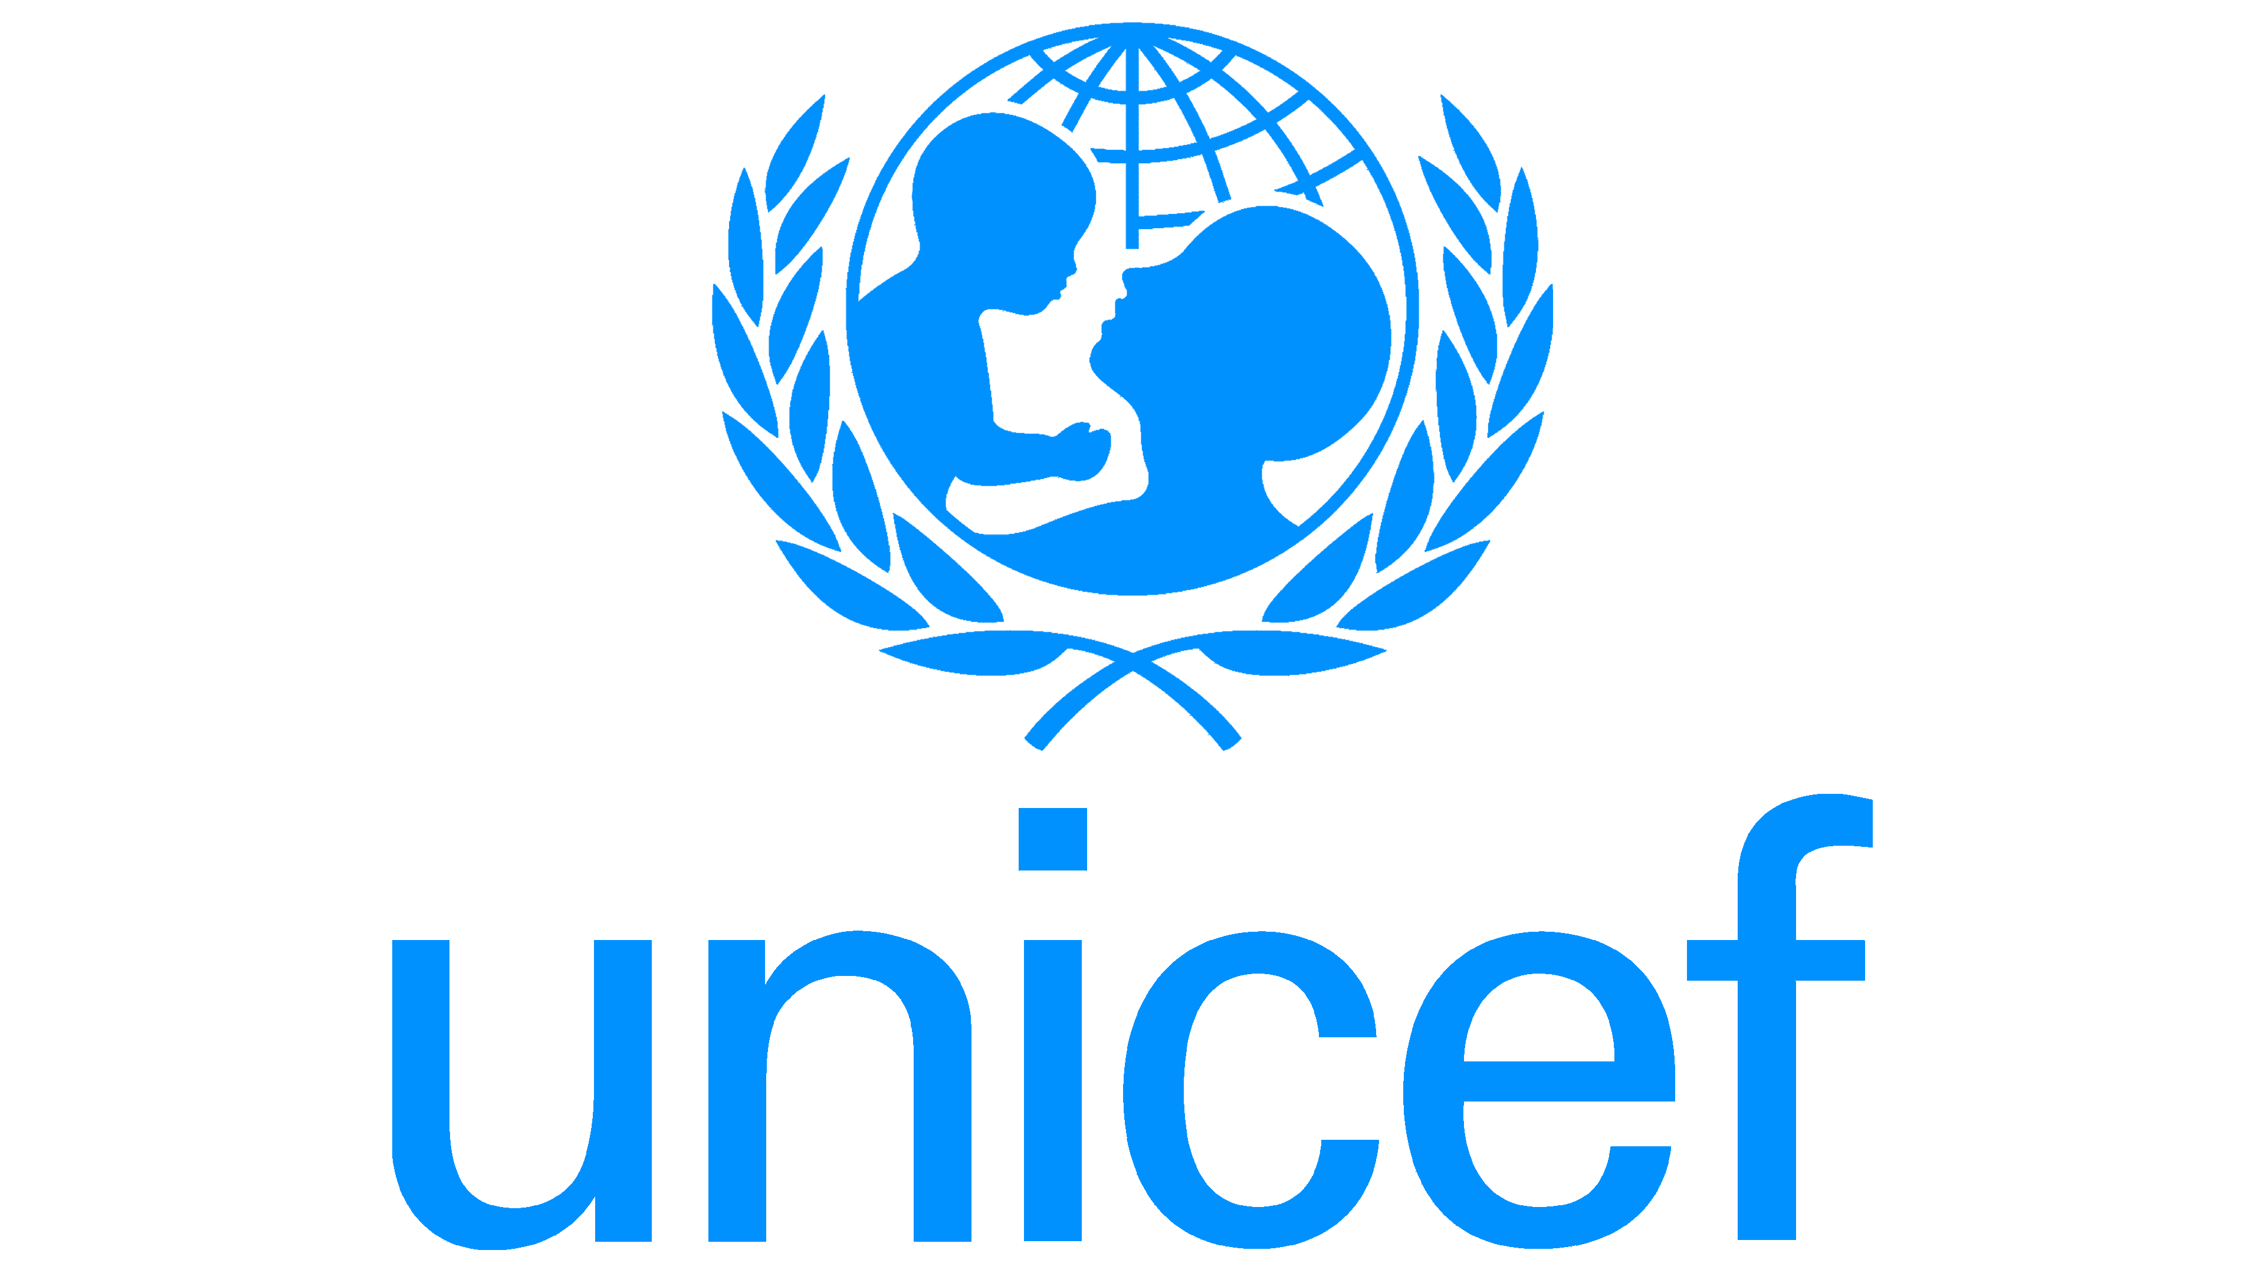

Introduction to The United Nations Children’s Fund
The United Nations Children's Fund: It is the United Nations body that combats for the rights of children, their welfare, and ensures that children, irrespective of their background, have access to basic services like health care, education, shelter, among others. UNICEF works in 190 countries and territories, grounded in its mandate through international instruments such as, primarily, the Convention on the Rights of the Child of 1989, by which states are obligated to uphold the rights of children who become caught up in the crises of war, displacement, or poverty.
While UNICEF is engaged in support of the long-term development programming agenda, its role assumes an even more urgent significance for children living in conflict-affected zones where state systems are failed, such that children risk threatened insecurity through neglect, exploitation, malnutrition, violence, or separation from their families.
Within the context of the Russian-Ukrainian War, UNICEF is very instrumental in terms of emergency provisions, establishing a safe learning environment, caring for children who are displaced along borders, and reporting information that verifies humanitarian needs for national governments and also for UN bodies. Children's rights are non-negotiables in UNICEF, not optional support even in times of active warfare.
- Maintaining Children’s Rights: Within the Russian-Ukrainian War
Background and historical information on the topic
The situation with the humanitarian crisis in the Ukraine is one that occurred both as a result of globally contentious territorial disputes as well as what can be observed to form a separation of social divisions that occurred with the falling of the Soviet Empire. It must be noted that the area that is eastern Ukrainian had a conflict since 2014 before the invasion of 2022. Children who belong to that area were exposed to uncertainty for a long time with respect to their learning since it is also psychologic stress for that long of a time before this war escalated into a national crisis. In accord with UNICEF, there are millions of children actually exposed to the “immediate and growing threat to their survival and well-being” since these foundational systems that were initially taken for granted-in such areas as electricity, learning, “safe housing, and sound health careaccess are regularly undermined by the violence, rocket attacks, and mass displacement caused by the invasion.”
A study by Eurochild in 2023 found that the “sudden spike in child trauma and mental health problems mean that a whole generation is at risk of having no stable identity formation, educational track, or support system for communities.” History clearly suggests that children in such conflicts that happened throughout the world continue to live with “long-term development deficits caused by the war interruption of their childhood, learning, or family stability.” This is what is occurring within the borders of the Ukraine too (Del Monte & Mentzelopoulou, n.d.). Apart from the threat of physical harm, the Russian-Ukrainian War has imposed other challenges that are not as visible but have caused enormous damage.
If Ukrainian children are relocated to Russian-occupied territories, it causes an international furore with regard to issues of identity, citizenship, and cultural identity. Judging by historical records, children who are brought up outside of their communities or national systems of education face severe challenges in re-identifying themselves.
And the burden it imposes on international bodies is that of documentation, accounting, and repatriation when finally the war ends. And one of the things which keeps emerging in humanitarian reports is that the longer the child is kept outside of school and normal conditions, the more difficult it is for that child to re-join their educational streams.

PAST INTERNATIONAL ACTIONS
International agencies have sought various ways to address such ills, some of which are still pending. For instance, UNICEF has been involved in on-site operations since the onset of response to the emergency. This agency "has supplied critical elements of relief, including water, warm clothing and blankets, construction material to provide shelter and hygiene kits" Tuman 2011). The UNICEF mobile health services have begun visiting affected families who live in isolated or heavily damaged villages in addition to psychosocial support. According to UNICEF emergency reporting systems, "millions of children have benefited from some form of humanitarian relief efforts to date. This includes safe play areas, child counseling or temporary learning spaces among other services".
A-U: An OCHA-developed Humanitarian Needs and Response Plan for Ukraine in 2025 mentions continuity in education. The said plan uses modalities such as fixing schools, utilizing digital learning tools, and providing funding for protective shelters where children could attend school despite bombardments. 3.2 Education | Ukraine Humanitarian Needs and Response Plan 2025 | Humanitarian Action, 2025 The European Parliament also calls for the enhancement of protective measures for the displaced Ukrainian minors, particularly in areas pertaining to anti-trafficking, and streamlining the process of securing guardianship for children to be able to go to school in other borders of the European Union.
There are also international legal acts, like the Convention on the Rights of the Child, to consider. Some of the articles which give a particular emphasis on measures for the protection of children against violence, and their living conditions being at least of a desired standard and for the continuation of the educational process despite the conflict, are articles 19, 27, and 28. Although some of the countries represented by Ukraine are signatories to such acts, their very implementation is actually very difficult in wartime. UNICEF has repeatedly called for support in that respect.
Good structures though exist, yet little international action is observed at various relief areas. Short-term humanitarian funding has seldom lived up to long-term demands in the areas of education and psychology. A system of governance at the local Ukrainian administration levels has not been able to coordinate efforts with relief bodies in an environment which is hampered by impaired transport networks, availability of the Internet, and uncertain security for newly prioritized zones. The proof that there is more than one plan for strategy, more than one legal document, or more than one emergency plan for children is that it is recognized, the situation is serious enough to warrant effective collective responses from the international community.

CURRENT SITUATION
This protracted conflict remains to pose millions of children with uncertain and insecure environments. This is accompanied by thousands of schools that have been damaged or destroyed, with the vast majority of schools still functioning having no electricity, bomb shelters, or safe ways of commuting children to schools. Teachers face unimaginable tasks in their work as this takes place with air raid signals, evacuation orders, and uncertain strikes on civilian infrastructure. E-learning solutions brought about as alternatives are not consistent given the interruptions in internet services, phone communication services, and electricity interruptions that do not enable uninterrupted charging of computer devices. There were warnings by UNICEF that millions of children face unprecedented learning losses, with loss repairable only after a protracted period of hostilities.
Facilitating access to clean water, nutrition, and heating is still an issue, especially in those areas that are closer to the current military conflict. Also, the presence of winter's harsh conditions is very likely to impede humanitarian access in that it causes respiratory illnesses, malnutrition, among other health issues. It could also be noted from the humanitarian reporting that children have limited access to medical care and vaccinations.
“Psychological trauma is a big issue too. It is found that about two-thirds of the children in Ukraine show signs of anxiety, prolonged fear, and traumatic stress. Loud explosions, loss of beloved relatives, uncertainty about the future, and difficult journeys faced while displaced are some factors adding to the emotional challenges in children. When children face trauma for the first time in their lives, it can affect their ability to focus, memorize, or learn for the rest of their lives if psychological help is not taken. “It's very important that children be shielded from psychological effects, such as being displaced from their homes, schools, communities, or even a sense of security. Major issues of security remain. Children who are displaced and lack documentation are at risk of being trafficked, abducted through illegal adoption, forcefully relocated, as well as further abused through points of entry. Reports from humanitarian agencies point out that children without accompanying adults remain the group that is most at risk in the current conflict. Given that transport infrastructure is insecure and means of communication remain destroyed, it is difficult to carry out identity registration and tracking.
There are numerous issues that make it difficult for children's rights to be protected. It is actually difficult for children to enjoy access to safe educational institutions, adequate shelter, food security or psychological support. It is utterly impossible for children to enjoy uninterrupted learning through millions of students in schools since learning institutions are destroyed, online learning is hampered by power shortages or internet which is not consistent. It is difficult for children to enjoy their rights since funding is limited to plan for the future since funds are utilized for survival and not for structural schools or psychological support services.
Lastly, it is difficult for children to enjoy their rights through adequate legal systems which would make it difficult for children to lose their identity through separated families or lack of documentation. It is difficult for children with psychological disorders to enjoy their rights since there is limited access to a psychological support unit, given that children in large proportions are left without the services of professionals. Finally, it is difficult for children to enjoy their rights since humanitarian bodies find it difficult to coordinate efforts given that there is no consistency in transport, infrastructure damaged, routes for delivery not safe, or communication between ministries of the concerned governments is poor between NGOs and United Nations agencies.

Questions a resolution must answer:
I. Questions an MUN Resolution Must Answer:
1. What is the problem? Explain what the problem is as clearly as possible.
2. Who is taking the initiative? State clearly the countries, United Nations agencies, or organizations involved.
3. What actions are being taken? The solutions that are being suggested can now be implemented once the resolution passes.
4. How will it be implemented? This is an explanation of how the plans will be carried out.
5. How is it going to be funded? State the source of funds.
6. Benefits. Who are the parties impacted by, and who is benefitted, from this conflict?
7. How will progress be tracked? Make provisions for evaluation, reporting, or review.
II. Questions involving UNICEF:
1. In what way is this of assistance to the children? Each clause has to be of relevancy towards specifically the UNICEF committee and its issues.
2. Target group. Who are targeted? State age ranges, vulnerable sectors, etc.
3. Is it child rights-friendly? Make it consistent with the Convention on the Rights of the Child.
4. Is implementation child-friendly? Safety, accessibility, and cultural relevance.
5. Are families and communities involved? Community involvement is encouraged and led on by UNICEF.
Notes:
- Think not only of short-term assistance but of long-term
- ⁠form your resolution bloc with countries that have the same stance and align with your countries beliefs
Recommended Sources:
1. https://www.ohchr.org/en/press-releases/2025/03/ukraine-devastating-impact-hostilities-childrens-rights - By the OHCHR
2. https://www.unicef.org/emergencies/guidance-protecting-displaced-children-ukraine - by UNICEF
3. https://ombudsman.gov.ua/report-2022/en/rights-of-children
4. https://warchildhood.org/children-and-armed-conflict-legal-framework/
5. https://www.humanium.org/en/children-in-armed-conflict-the-ukraine-crisis/

