United Nations Security Council
(UNSC)
Background Guide

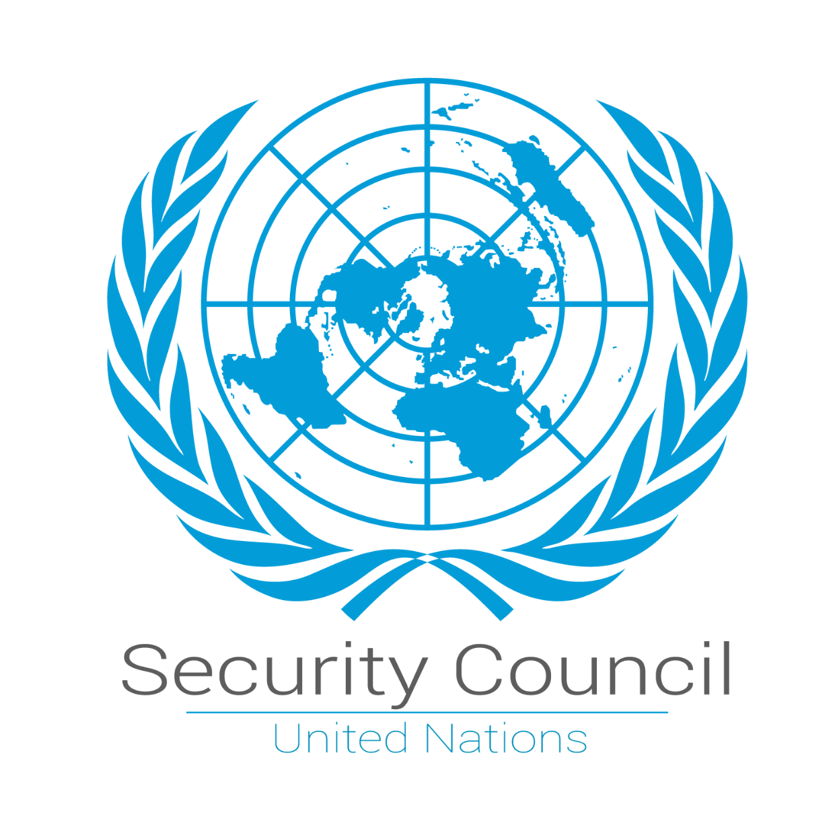

Introduction to the United Nations Security Council:
For many years, the United Nations Security Council, otherwise known as UNSC, has faced several challenges in ensuring peace and stability across all corners of the world. As one of the six major organs of the United Nations, the United Nations Security Council is one of the most powerful deliberative bodies in the world, responsible for the maintenance of global peace and security, approving proposed additions to the UN membership to the General Assembly, and accepting modifications to the UN Charter.
The UNSC was established on October 24th, 1945, in the wake of the devastation of the Second World War and is made up of fifteen total members. The UNSC has ten non-permanent members who are elected every 2 years along with five permanent members with veto powers: China, the French Republic, the Russian Federation, the United Kingdom, and the United States.
The UNSC has a broad mandate, which includes the authorization of peacekeeping missions, the imposition of economic sanctions, the establishment of international monitoring mechanisms, and the coordination of post-conflict reconstruction efforts. Although humanitarian aid work is usually headed by other organs of the UN, such as the General Assembly and/or the Economic and Social Council, the UNSC is a crucial factor when there is a humanitarian crisis caused by a conflict.
In post-conflict states, the UNSC finds itself progressively involved in the planning stages of reconstruction as part of a broader peace-building approach. This concept of reconstruction is not limited to the rebuilding of a state but is a stabilization mechanism intended to minimize the potential for conflict by securing essential services and improving the conditions of life for the affected civilians.

- Planning Gaza’s Reconstruction: Coordinating International Efforts within the UNSC to Address Humanitarian Needs to Restore Gaza’s infrastructure
Background/history information on the topic:
The Gaza Strip represents a heavily populated coastal area that has experienced multiple cycles of conflict, politics, and exclusion for many years. However, after Israel’s withdrawal of its settlers and forces in 2005, Gaza entered a new phase of governance problems. Hamas took over Gaza in 2007 as a result of violent fights with the Palestinian Authority, resulting in a division between Gaza and the West Bank. Since then, Gaza has been subject to land, sea, and air restrictions imposed by Israel, with Egypt also controlling access through its southern border.
Although such restrictions are legitimized as security needs of the state of Israel, they have caused severe humanitarian and economic implications for the affected population. It seems that the economy of Gaza has been unable to function due to reduced access to markets, resources, and jobs. Even prior to major escalations, Gaza faced chronic electricity shortages, inadequate water and sanitation systems, and a healthcare sector heavily reliant on international aid.
There have been identifiable conflicts involving violence between Israel and Gaza’s armed groups in various years, including 2008-2009, 2012, 2014, 2021, and the latest and most aggressive escalation which took place on the 7th of October 2023. The conflicts have had far-reaching negative impacts on Gaza’s infrastructure, affecting housing, health care, learning, transportation, and water treatment and supply. Individually and collectively, these attacks have made Gaza’s infrastructure vulnerable to meet the needs of its suffering population.
The reconstruction process in the aftermath of previous conflicts has been quite slow. Although the international community has committed a lot of money to the reconstruction of Gaza, effective positive change appears to be non-existent because of political disagreements, security concerns, restrictions on construction materials, and the absence of a unified Palestinian governance structure. The mechanisms in place to ensure that materials are used only in a civilian arena have also hindered the rebuilding process.
The reconstruction of Gaza has historically been considered a technical issue and a humanitarian one that is separate and apart from political peace talks. This makes it challenging for Gaza to sustain reconstruction, as rebuilt infrastructure has repeatedly been damaged or destroyed in subsequent escalations. Gaza is, therefore, stuck in a cycle of destruction, dependency, and reconstruction.
Past actions:
The United Nations Security Council has dealt with the Gaza issue using a combination of resolutions, statements, and other indirect methods designed to reduce the humanitarian toll and prevent the escalation of the conflict. Over the years, the UNSC has adopted a series of resolutions focused on achieving a ceasefire, protecting civilians, and ensuring respect for international humanitarian law. Such resolutions include those highlighting the need for all sides to facilitate access and avoid targeting civilian infrastructure.
In the aftermath of major escalations, the UNSC has been facilitating the reconstruction process internationally in cooperation with UN agencies, including the United Nations Relief and Works Agency for Palestine Refugees in the Near East (UNRWA), the United Nations Development Programme (UNDP), and the United Nations Office for the Coordination of Humanitarian Affairs (OCHA), in repairing homes, renewing water and electricity networks, and providing healthcare and education infrastructure.
To address worries that building materials might find their way into the hands of armed organizations, the United Nations created the Gaza Reconstruction Mechanism, or GRM, which was established in 2014. This was basically an effort at ensuring the flow of construction materials while at the same time taking into consideration the security concerns raised by the government of Israel. Although the mechanism allowed a little reconstruction work, the procedure was considered bureaucratic. Despite several international donor conferences with pledges in the billions of dollars regarding reconstruction in Gaza, the UNSC has found it difficult to affect the reconstruction plans. This lack of action can be largely attributed to the differing political considerations of members in the UNSC regarding issues of accountability, governance in Gaza, and the Israeli Palestinian conflict. Therefore, previous decisions by the UNSC have been largely responsive to humanitarian needs in Gaza.
Current situation:
The latest escalation, which started on 7 October 2023, has raised Gaza to a humanitarian and infrastructural crisis never seen before. The destruction of areas in residential buildings, health facilities, schools, roads, and water and electricity infrastructure has left a big portion of the population without access to basic services. The health sector is on the verge of complete collapse, with further deterioration of humanitarian conditions regarding displacement, food, fuel, means of subsistence, and health products.
Currently, a ceasefire agreement mediated by international and regional third-party mediation has provided a temporary shutdown of hostilities, which has allowed some access to humanitarian aid entering Gaza. While that may be temporary relief to innocent civilians and humanitarian workers, this ceasefire is unmistakably the most contentious issue and definitely not a solution to the political and security-related impediments that hitherto obstructed any prospect of reconstruction.
On the diplomatic front, there have been suggestions regarding Gaza's future after the conflict; these include a policy agenda for peace and stability in the region by ex-U.S. President Donald Trump, which focuses on reconstruction linked with security plans. While these plans show greater international interest in long-term solutions for the future of Gaza, these strategies fall beyond the UNSC agenda.
In the UN Security Council, the divisions among the permanent members have yet to allow any decisive course of action to go through. Even though the UNSC has largely agreed on the seriousness of the need for humanitarian assistance and reconstruction, it has struggled to reach any accord on the rebuilding of Gaza's governance, security guarantees, accountability frameworks, and the management of reconstruction materials. While one takes full advantage of the opportunities opened up by the present ceasefire, a full understanding of the fact that Gaza's infrastructure is still badly damaged and that critical government services remain at a considerably minimized capacity must be recognized. Without any international coordination, a sustainable ceasefire, and a comprehensive plan for reconstruction adopted through the UNSC, there is every likelihood that either further delay or reversal may take place.

Questions a resolution must answer:
- How will the UNSC guarantee sustained humanitarian access and the safe delivery of reconstruction materials while addressing the security concerns of all parties involved?
- What UN-mandated mechanism will coordinate international donors, UN agencies, and regional actors to prevent duplication of efforts and ensure efficient, transparent reconstruction?
- How will funding for Gaza’s reconstruction be mobilized, allocated, and monitored to ensure long-term rebuilding rather than short-term emergency relief?
- What role, if any, should international monitoring or supervision play in overseeing reconstruction projects and ensuring civilian use of materials?
- How can reconstruction efforts be linked to ceasefire compliance and de-escalation measures to reduce the risk of renewed destruction of rebuilt infrastructure?
- How will the resolution address governance and administrative challenges in Gaza to ensure effective implementation of reconstruction projects without exacerbating political divisions?

Resources:
- United Nations. (2024, April 2). Joint World Bank–United Nations report assesses damage to Gaza’s infrastructure. United Nations Information System on the Question of Palestine.
https://www.un.org/unispal/document/joint-world-bank-un-report-assesses-damage-to-gazas-infrastructure-report-and-pr-2apr24/
- United Nations Office for the Coordination of Humanitarian Affairs. (2024). Humanitarian situation update: Gaza Strip (Situation Report No. 311). OCHA.
https://www.ochaopt.org/content/humanitarian-situation-update-311-gaza-strip
- United Nations in Palestine. (2025, February). Statement by the United Nations resident and humanitarian coordinator in the occupied Palestinian territory. United Nations.
https://palestine.un.org/en/289430-statement-united-nations-resident-and-humanitarian-coordinator-occupied-palestinian
- United Nations in Palestine. (2024). Gaza: $70 billion needed to rebuild shattered enclave, says UN. United Nations.
https://palestine.un.org/en/303257-gaza-70-billion-needed-rebuild-shattered-enclave-says-un
- United Nations Educational, Scientific and Cultural Organization. (2024). Assessment of damage and reconstruction needs of higher education institutions in Gaza. UNESCO.
https://www.unesco.org/en/articles/unesco-presents-assessment-damage-and-reconstruction-needs-higher-education-institutions-gaza
- World Bank Group & United Nations. (2024). Interim rapid damage and needs assessment: Gaza. United Nations.
https://palestine.un.org/en/265021-joint-world-bank-and-un-report-assesses-damage-gaza%E2%80%99s-infrastructure
- International Organization for Migration. (2024). Displacement and humanitarian needs in Gaza. United Nations System. https://www.iom.int/gaza-response

- Ross, D., Neumann, N., Jacobson, M., al-Omari, G., & Yaari, E. (2025, December 12). Getting to Phase 2 in Gaza: Red lines and recommendations. The Washington Institute for Near East Policy. https://www.washingtoninstitute.org/policy-analysis/getting-phase-2-gaza-red-lines-and-recommendations

- Frankel, J. (2025, February 5). A timeline of the Gaza Strip in modern history. PBS NewsHour. https://www.pbs.org/newshour/world/a-timeline-of-the-gaza-strip-in-modern-history

