World Health Organization
(WHO)

Background Guide

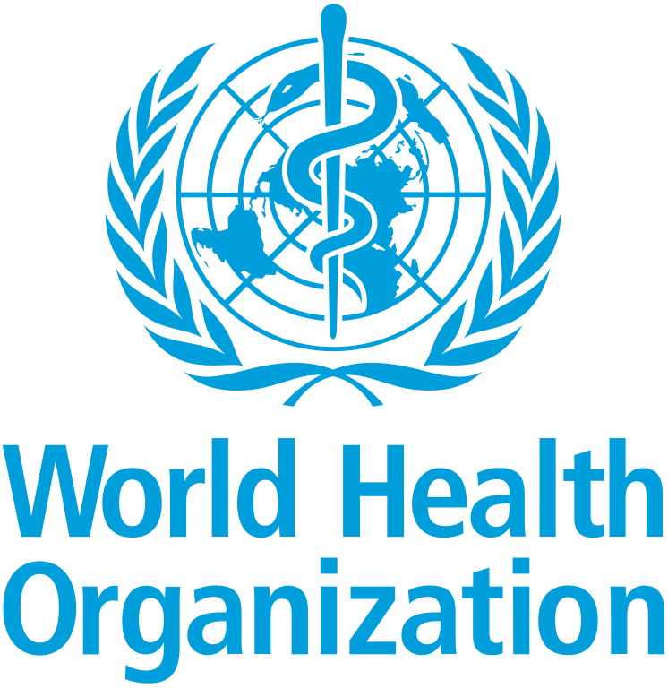

Introduction to the World Health Organization

Established in 1948, the WHO is currently the guiding and coordinating agency for international health matters for the United Nations. Its mandate is the “attainment by all peoples of the highest possible level of health,” through the promotion of better health conditions for nations, controlling and preventing diseases, and developing better health systems for nations among other objectives. Therefore, WHO carries out its various roles with presence in all regions of the globe through collaboration with governments and other partners of more than 190 member states.

Universal health coverage, health emergency protection, and healthier lives are some of the major priorities that are being addressed by the WHO. Not only does it prioritize its work with the ambition to protect and enhance public health around the world, but it focuses on some key areas that include universal health coverage, health emergency protection, and healthier living. Moreover, it allows the nations to provide an opportunity for collective efforts for dealing with challenges like epidemics, pandemics of diseases, rising non-communicable diseases, and various health inequalities. Furthermore, it assists in developing robust health systems by developing global standards, advancing key guidance, and supporting the nations to improve their health preparation.

Within the current international context, the WHO is recognized as the key global health authority that aims to combine scientific knowledge with policy coordination and global collaboration. It works by promoting collaboration between states, as well as between researchers and institutions, with the ultimate aim of meeting global health challenges effectively while seeking sustainable improvements in global health.

- Addressing the WHO’s response to the rapid decrease in international health aid

Background and historical information on the topic
Every living creature - regardless of identity, race, gender, ethnicity, or religion - possesses the basic human right to access proper medical care. Access to health care is defined as having timely use of personal health services to achieve the best possible health outcome.

Historically, this human right has been practiced through expanding international health assistance. This growth occurred in the late 20th and early 21st centuries. The main drivers were responses to infectious disease outbreaks, humanitarian crises, and commitments to universal health coverage. The "golden era" began as development assistance for health peaked during the 2010s and early 2020s. This growth enabled low- and middle-income countries (LMICs) to build resilient health systems, combat infectious diseases, and pursue universal health coverage.

Development assistance for health (DAH) is a crucial component of global health financing. It supports maternal and child health services, disease prevention, vaccination programs, and health emergency preparedness. DAH funding for HIV/AIDS rose to 26% of total DAH by 2015; funding for malaria increased to 6.4%; and funding for tuberculosis increased to 3.5%. Global health spending continued to increase in 2021, the second year of the pandemic, to US$ 9.8 trillion, reflecting international cooperation in addressing health emergencies.

Despite the Sustainable Development Goal 3 (SDG 3) commitment to “ensure healthy lives and promote well-being for all at all ages,” progress has declined. This goal calls for preventing needless suffering from preventable diseases and premature death. It stresses the need for increased investment in research and development, health financing, and health risk reduction and management. However, global political and financial commitments have increasingly diverged from these goals. The world now faces a global threat: a steep decline in international health funding.

Since 2021, development assistance for health (DAH) funds have plummeted, with global health aid projected to decline by up to 40%, leading to a fall of approximately $38.4 billion, the largest such drop not seen since 2009, representing a 40-billion-dollar loss since peak funding. This is all due to newfound economic uncertainty, competing financial demands, and, most significantly, the deliberate withdrawal and retrenchment of major donor nations, particularly the United States’ deliberate withdrawal from the World Health Organization in January 2025, coupled with substantial funding reductions by European donors such as the United Kingdom, France, and Germany, has eradicated one of the main pillars of the global health financing system, creating what WHO Director-General Dr. Tedros Adhanom Ghebreyesus has described by stating, “We are living through the greatest disruption to global health financing in memory.”

Past Actions:
The matter of healthcare aid and funds being reduced and cut remains an up-and-rising issue, and throughout this issue, many different measures have been taken in order to find the most practical way to provide fair, adequate healthcare to all nations, specifically developing nations.

For instance, WHO Member States have increased health aid by approving the 20% rise in assessed contributions as part of the $4.2 billion from 2026 to 2027 WHO budget, marking the second consecutive increase following a similar rise in 2024–2025. Although all nations still face economic constraints, this decision demonstrates a renewed political commitment to sustainable and improved global health financing, addressing recent funding cuts that have since hindered the WHO’s capacity to support long-term health programs.

These measures are viewed as a way to reduce reliance on a small group of donors, strengthen global health security and resilience, and align funding with WHO’s long-term global health strategy (GPW 14). In addition, WHO’s work is aligned with the Sustainable Development Goals (SDG) target 3.8, and thus, focuses on achieving universal health coverage. This will include financial risk protection and access to quality health care.
Lastly, the WHO has released new guidance for countries on ways to counter the immediate and long-term effects of sudden and severe cuts to external funding called the “Responding to the health financing emergency: immediate measures and longer-term shifts”, however, it is not enough, the global health fund continues to decline and will continue to do so if proper solutions are not found.

the WHO has released new guidance for countries on ways to counter the immediate and long-term effects of sudden and severe cuts to external funding called the “Responding to the health financing emergency: immediate measures and longer-term shifts”, however, it is not enough, the global health fund continues to decline and will continue to do so if proper solutions are not found.

Current Situation:
The‍‌‍‍‌‍‌‍‍‌ worldwide health system is presently undergoing a drastic reduction in global health aid, which poses problems for the World Health Organization (WHO). After producer countries temporarily increased their funding during the COVID-19 pandemic, many of them are now retreating from their financial contributions. The main reasons behind this retreat are the economic slowdowns, inflation, increasing national debt, and the fact that governments are prioritizing domestic spending over international aid. Therefore, the WHO is under the financial pressure when it is, in fact, a time of global health threats.

One of the most significant elements that worsen the situation is the decision of the United States to disengage from the World Health Organization, which change is expected to be effective in January 2026. The U.S. has not yet made the official step of leaving, but the mere announcement has already influenced funding stability. The U.S., being the WHO’s most significant contributor, was responsible for about 15–18% of its total budget. From 2022 to 2023, U.S. contributions were more than $1 billion. Such a situation has led the WHO to prepare for enormous budget shortfalls and has caused some donor countries to be alarmed and reconsider their own financial commitments.

The way the WHO is funded only worsens the problem. Most of its budget is from voluntary contributions, and the majority of these funds are allocated to specific projects. Hence, the WHO can hardly use this money to respond to any urgent or unforeseen health crises. Due to lack of funds, several programs that are vital to the continuation of life and health, such as vaccination campaigns, disease monitoring, maternal and child health services, and emergency response, have been slowed or reduced. In low-income and conflict-affected areas, health funding cuts can lead to a 20% increase in preventable deaths.

The reduction of money for global health also jeopardizes global health security. If less money is spent on disease surveillance and outbreak preparedness, it will take longer for new pandemics to be discovered and, therefore, they will have more time to spread. Research indicates that for every $1 invested in pandemic prevention, $10 can be saved on response costs. However, this does not seem to be happening as vaccination programs are being interrupted, and more than 14 million children are missing routine immunization in 2023. At the same time, antimicrobial resistance causes about 1.27 million deaths annually, and global warming escalates health risks like heat-related illnesses, food insecurity, and the spread of infectious diseases.

WHO has made efforts to adjust to the lack of funds. These actions include the appeal for essential member state contributions which create less than 25% of the WHO budget, expanding cooperation with development banks and philanthropic institutions, and prioritizing cost-efficient and impactful health programs. WHO also used digital health solutions more extensively and the agency has better coordination with other UN agencies, thereby, achieving more with less.

Nevertheless, the circumstances are still unstable. The reduction of international health aid, plus the planned U.S. withdrawal , are the reasons behind the global health situation that could go backwards and undo the achievements made over the years while at the same time deepen the gap in health between the richer and the poorer ‍‌‍‍‌‍‌‍‍‌countries.

Questions a Resolution Must Answer:

- How would the WHO ensure that basic health service delivery is maintained even with cuts in international health funding?

- How can the following strategies be adopted by developing nations in order to enable them to strengthen their own health financing systems and minimize their reliance on external funding?

- What are the health programs that must be protected or expanded only through limited resources, and how should the WHO make such decisions?

- In what ways could the role of public-private partnerships, NGOs, or regional bodies be developed in an ethical manner to fill the gap left by declining international funding?

- What should be done for low income states that are worst affected by reductions in health programs?

- What measures could the WHO take in order to improve efficiency, transparency, and accountability in the application of the remaining funds in order to retain the confidence of its funding bodies as well as the member states?

- How could innovation, technology, and data-informed thinking be leveraged in order to support health outcomes even with resource challenges?

