Phase shifts in light-pulse atom interferometers from a Baker–Campbell–Hausdorff expansion
First Author and Second Author
Affiliation line (institute, city, country)
(Dated: September 14, 2026)
We outline how the phase of a Mach–Zehnder light-pulse atom interferometer follows from an operator-algebraic treatment of the free evolution and the beam-splitter pulses. Expanding the product of evolution operators with the Baker–Campbell–Hausdorff formula isolates the gravitational phase and shows which commutators contribute at each order in the pulse separation. The treatment is extended to a linear gravity gradient and to finite pulse duration, and the shot-noise-limited sensitivity is derived. This document is a typesetting test: every equation was inserted with the Recorde add-in, and Sec. IV exercises every option the add-in offers.

I. INTRODUCTION
Light-pulse atom interferometers measure inertial effects through the phase accumulated along two spatially separated paths [1, 2]. For a three-pulse sequence with pulse separation , effective wave number 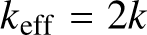 and local acceleration , the leading phase is 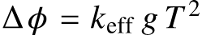. The internal-state labelling introduced by Bordé [3] makes the two arms distinguishable at read-out.
The scaling with 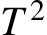 is what makes long drop times attractive: at a phase of order  accrues, and a resolution of 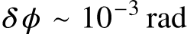 translates into 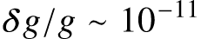. Realising this requires control of the gravity gradient 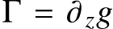 and of the finite pulse duration , both treated below.
We write the evolution as a product of unitaries and expand it to expose the commutator structure. Section II states the Hamiltonian and the expansion, Sec. III gives the phase, the gradient correction and the sensitivity, and Sec. IV collects typesetting checks. The appendix carries the explicit commutator algebra.
II. OPERATOR TREATMENT
A. Hamiltonian
For a two-level atom of mass m in a uniform gravitational field, driven by a travelling wave, the Hamiltonian in the rotating frame reads
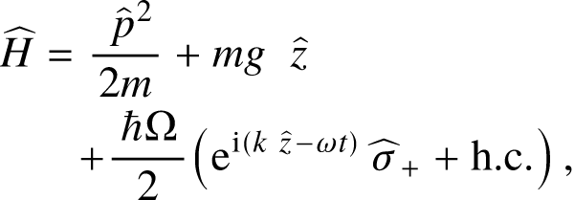 | (1)
where 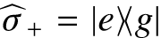 raises the internal state and is the Rabi frequency. Between pulses the atom evolves freely under the first two terms, 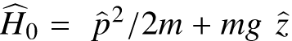. A linear gravity gradient adds 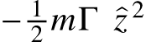.
B. Baker–Campbell–Hausdorff expansion
The free-evolution operators of the two arms do not commute with the momentum kicks. Their product is rewritten with
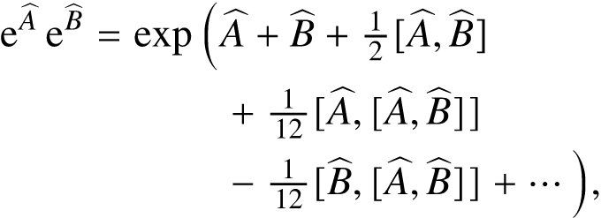 | (2)
which terminates for the quadratic Hamiltonian of Eq. (1) because 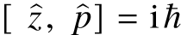 is a c-number: all nested commutators beyond the second order vanish identically. The free evolution over is
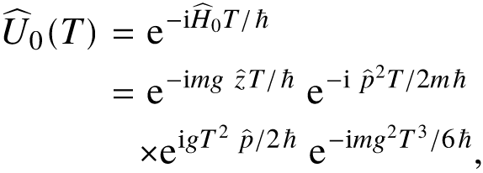 | (3)
where the last two factors are exactly the second-order commutator terms. With a gradient the algebra no longer closes at second order; keeping terms to first order in Γ,
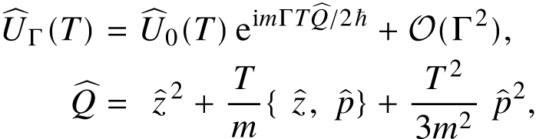 | (4)
with the anticommutator 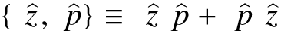.
C. Beam-splitter pulses
In the 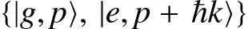 basis a resonant pulse of area and laser phase 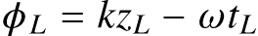 acts as
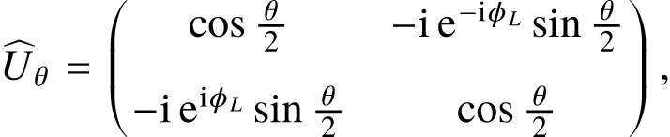 | (5)
so that 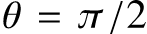 splits and mirrors. The laser phase 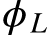 imprinted at each pulse is what the interferometer reads out; the population in the excited state after the sequence is
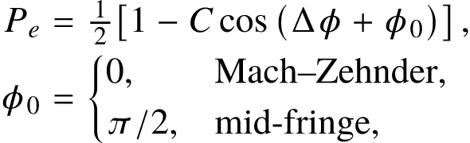 | (6)
with contrast .
III. RESULTS
A. Phase and gradient correction
Collecting the c-number terms of the expansion for the π/2–π–π/2 sequence gives the familiar phase
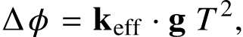 | (7)
independent of the initial momentum. The gradient contributes through the initial position and velocity of the wave packet,
(8)
to first order in Γ — the source of the systematic that gradiometer configurations cancel. Finite pulse duration rescales the effective separation,
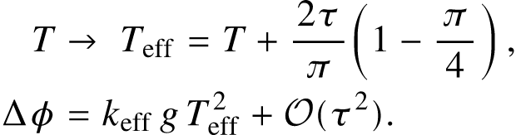 | (9)
B. Sensitivity
For rubidium () and the phase amounts to about . With N detected atoms at the shot-noise limit the acceleration sensitivity per shot is
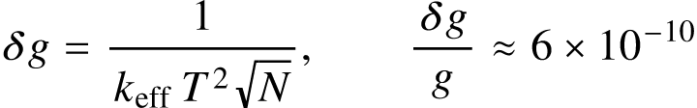 | (10)
for 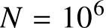. Averaging shots of cycle time 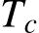 improves this as the square root of the total time, giving the Allan deviation
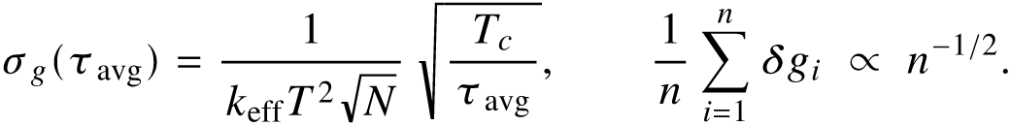 | (11)
The velocity distribution of the source enters through the Doppler detuning 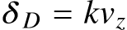; integrating the two-level response over a Gaussian of width gives the contrast
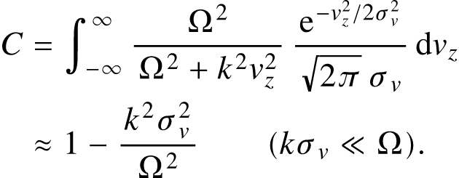 | (12)
IV. TYPESETTING CHECKS
This section exists to exercise the add-in rather than the physics; every equation here is click-to-edit like the others.
A. Numbering styles
The paper numbers its equations flush right in a borderless table (the journal style). The same counter can also place the number inside the picture, trailing the equation:
or as a native Word SEQ field, which Word itself keeps in sequence (desktop only; Alt+F9 reveals the field code):
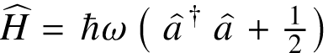 | (1)
Renumber all reorders every static number in document order and refreshes the fields.
B. Typefaces
The same equation set in each of the six bundled MathJax fonts. Termes matches the Times body text; the others are shown for comparison.
Computer Modern (tex)
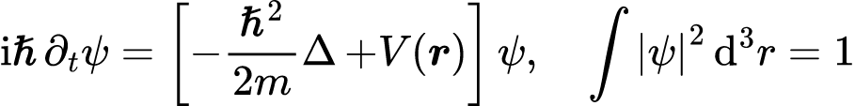
New Computer Modern (newcm)
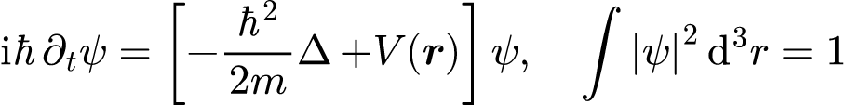
Termes (termes) — the paper default
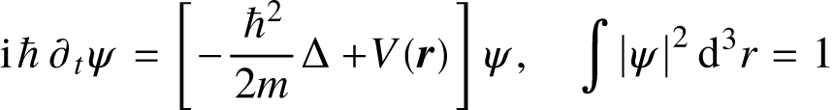
STIX Two (stix2)
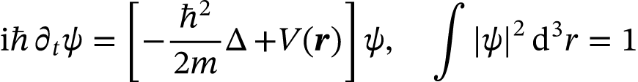
Pagella (pagella)
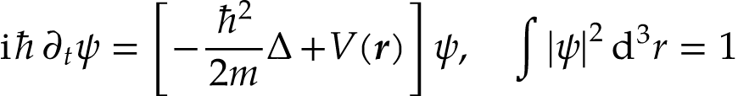
Asana Math (asana)
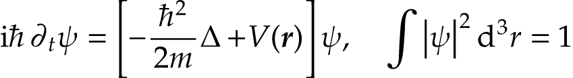
C. Sizes and colour
Fixed sizes in running text: 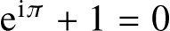 at 10 pt, at 8 pt, 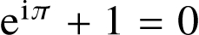 at 12 pt and 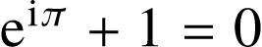 at 14 pt; descenders such as 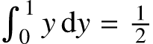 sit on the baseline on desktop Word.
A whole equation in a swatch colour, and colour inside an equation through the built-in AFP palette macros:
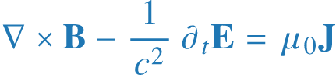 | (14)

 | (15)
D. Alignment
Display equations follow the Settings → Display choice: left (LaTeX fleqn, indented by the 25 pt math indent) is the default; centred is the plain-LaTeX look. Both, forced here regardless of the setting:
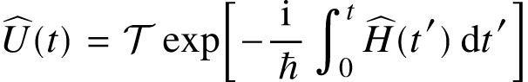 | (16)

(17)
E. Macro preamble
The built-in preamble ports the author’s paper template: operators, delimiters, derivatives, vectors, a siunitx subset (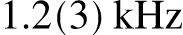, 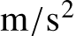) and the colour names used above are available in every equation without a \require.
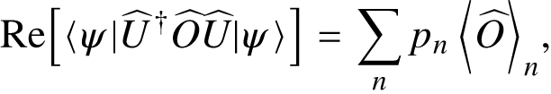 | (18)

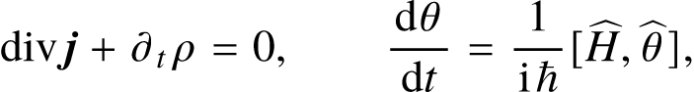 | (19)

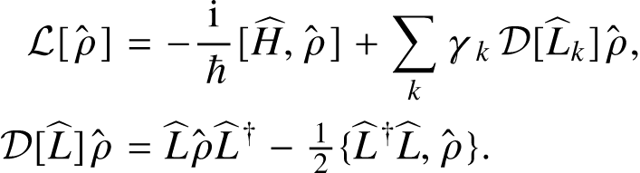 | (20)
V. CONCLUSION
The operator expansion reproduces the standard result and makes the order-by-order bookkeeping explicit; the gradient and finite-duration corrections follow from the same algebra. In Word, the equations above are vector pictures with their LaTeX source stored in the document: click any of them to reopen it in the pane, or list them in the pane’s equation list.
ACKNOWLEDGMENTS
This document was generated by the Recorde add-in as a typesetting test; a byte-compatible twin is produced headlessly by mjx-docx from the same source.
APPENDIX: COMMUTATOR ALGEBRA
With 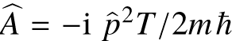 and 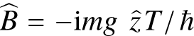 the commutators needed in Eq. (2) are
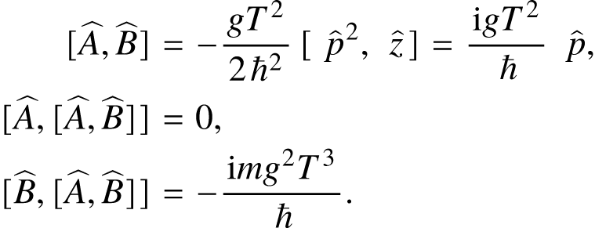 | (21)
Inserting these into the expansion and using the disentangling identity, valid when 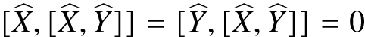,
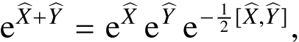 | (22)
yields Eq. (3). The three-pulse phase then follows from the c-number factors alone, with 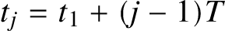:
(23)
[1] M. Kasevich and S. Chu, Phys. Rev. Lett. 67, 181 (1991).
[2] A. Peters, K. Y. Chung, and S. Chu, Nature 400, 849 (1999).
[3] Ch. J. Bordé, Phys. Lett. A 140, 10 (1989).
[4] P. Storey and C. Cohen-Tannoudji, J. Phys. II France 4, 1999 (1994).
[5] K. Bongs, R. Launay, and M. A. Kasevich, Appl. Phys. B 84, 599 (2006).
[6] A. Roura, W. Zeller, and W. P. Schleich, New J. Phys. 16, 123012 (2014).

