UTKU ACAR 250206062

LAB-1 REPORT

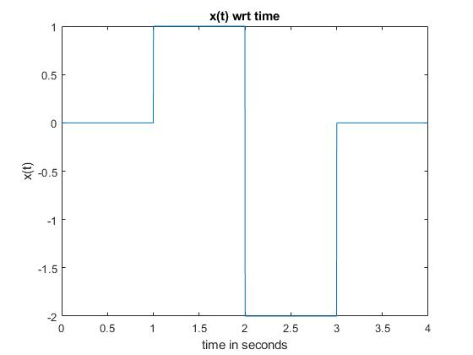

**Figure 1:** **2.1.b**

Four parts of the piecewise function concatenated with total of 2001 elements with respect to time. (501 for [0-1], 500 for (1,2], 500 for (2,3] and 500 for (3,4]) in Figure 1.

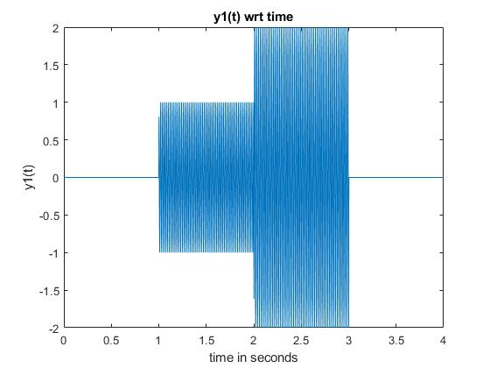

**Figure 2:** **2.1.d**

The y1(t) function (Figure 2) is a piecewise function multiplied by the cosine function. Since for times between 0,1 and 3,4 seconds, the piecewise function gives 0 so the output y1(t) always gives 0 regardless of values of the cosine wave at the same time periods. For the other parts of the piecewise function, they just scale the amplitude of the cosine wave.

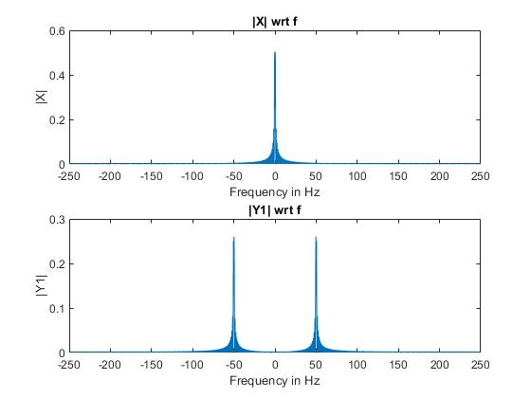

**Figure 3:**  **2.2.a**

In Figure 3, magnitudes of Fourier transforms of x(t) and y1(t) functions has been given( with respect to frequency). Which can be obtained by taking the absolute values of the functions ang dividing to N. The shifting is also needed to displaying better result.(to center). X(f) has frequency 0 Hz (DC) while Y1(f) has frequency -50 and 50 because of x2(t) is cosine wave with frequency 50 Hz.

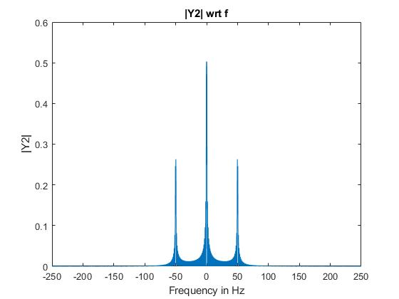

**Figure 4:** **2.2.b**

I used the multiplication in frequency domain equals to convolution in time domain which is the one of properties of the Fourier transformation. I took Fourier transform for both of input and impulse response then multiplied them by vector multiplication (.*) and It gave me the Y2(f) then I took absolute value of it then divided it to N and centered with fftshift command then I got this result in figure 4 which is magnitude of Y2(f).

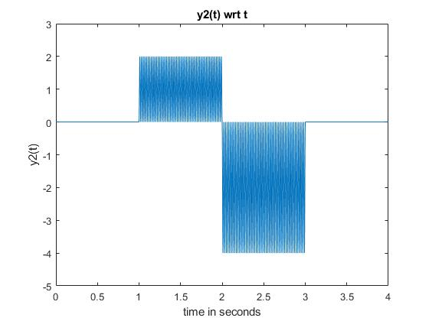

**Figure 5:** **2.2.c**

I took Inverse Fourier transform of Y2(f) and It gave me y2(t) which should be equal to the circular convolution (because of DFT) of the signals x and x2 in time domain you can see the result on Figure 5.



**Figure 6:**  **2.2.d**

I did make a convolution on x and x2 inputs with linear convolution command(conv). The result was different from 2.2.c. Then I realized that we are making the Discrete Fourier Transform. So, the property does not satisfy for this case. Which means that linear convolution was not the right choice for this problem, so I used circular convolution (cconv) with the length of the function N (2001), and It gave the same result (Figure 6) as in part 2.2.c (Figure 5). The reason for I use the circular convolution over linear convolution is to avoid overlapping in periodic cases caused by linear convolution process. In circular convolution overlapping cannot occurs in periodic cases.