UTKU ACAR 250206062

LAB-2 REPORT

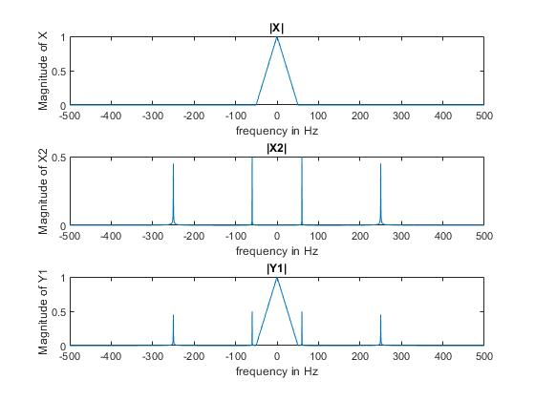

**Figure 1:** 2.1.d

The first graph of sublot has been given to us by lab document and I create corresponding signal with triang() command. I observed X2(f) from fourier transform of x2(t) and it has four components at -250Hz, +250Hz and -60Hz, +60Hz with magnitudes 0.5 (halving amplitude). Y1(f) has been observed by summing X(f) and X2(f) (in frequency domain). Corresponding magnitudes and frequency were correct.

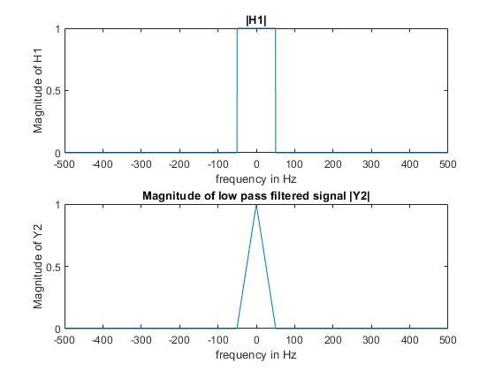

**Figure 2:** 2.2.b

The low pass filtering is multiplying adjusted unit step like function with our signal in frequency domain to eliminate other components at the output. The question was asking to get X(f) as Y2(f) with using suitable frequency range suitable for that which I choose abs(f)<=50 for an ideal low pass filter I obtained the X(f) signal with correct magnitude and frequency components.

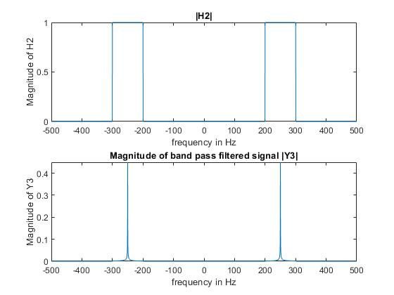

**Figure 3**: 2.2.d

Bandpass filtering is also multiplying modified unit step like function with corresponding output to get desired frequency components in frequency domain. The question was asking to get 250 Hz signal components from the Y1 signal in frequency domain. So, I designed Ideal bandpass filter which only allows to pass frequencies between 200 Hz and 300 Hz. Since our desired output in that frequencies and nothing other frequency components in that range the desired output components has been easily observed.

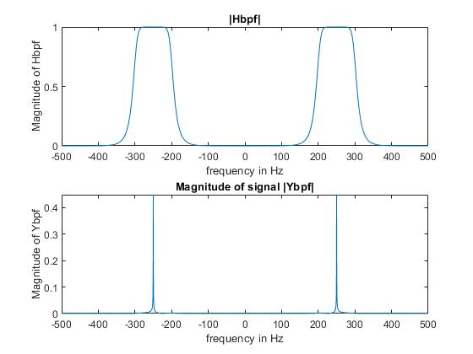

**Figure 4:** 2.2.f

The question was asking to filter the output for getting only 250Hz components of the signal with a butter(.) command. I used same range as ideal bandpass filter (2.2.d) because the range is enough for non-ideality of the butter filter. I used freqz() function to get magnitude response of the filter with sampling frequency Fs but it was giving just positive frequency components of the filter so I concatenate two of frequency response and 0 for synchronizing with frequency array. As conclusion I got similar response with ideal filter but it has some extra range from its original range(200,300) which is expected because of non-ideality of the filter.