UTKU ACAR 250206062

LAB-3 REPORT

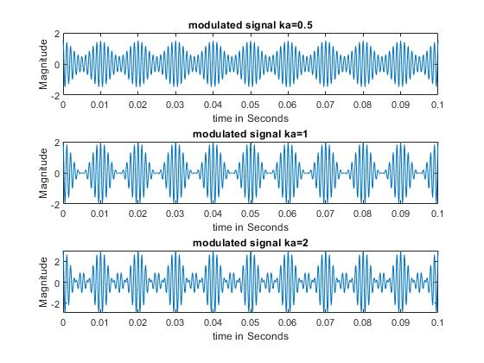

**Figure 1:3.2.d**

(3.2.c) The first subplot shows us a under modulated signal because the Ka<1. This affects the magnitude of the modulated signal (1.5). The second subplot shows us fully modulated signal there is no envelope distortion at this point and magnitude becomes 2 (1+1). The third subplot shows us the overmodulated signal which has some distortions and phase reversal, and its amplitude becomes 3(1+2).

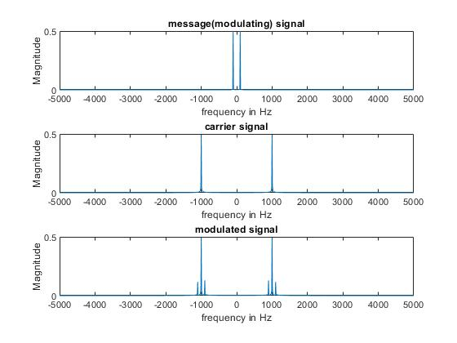

**Figure 2:3.2.f**

Our message signal has -100hz and 100hz components in frequency domain and magnitude halved due to fourier transform. Carrier signal has -1kHz +1kHz components. Magnitude also halved due to fourier transform. Our modulated signal components has been doubled as like 2 of them at 900Hz and 1100Hz and exact copy of that at negative frequencies as expected because of the shifting property. And magnitude of the modulated signal has been reduced by 4 (0.125) because of the formula.

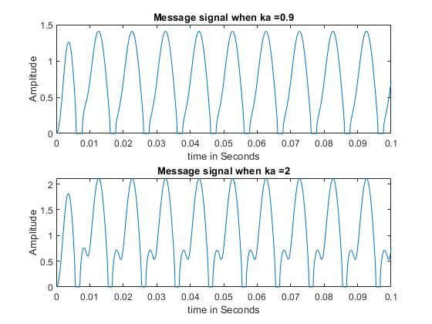

**Figure 3:3.3.c**

I choose filter order as 6 because its sufficient to filter the signal as I increase the order the filtered signal has been vanished and I choose 2 times message frequency + 50 Hz as my cutoff frequency of low pass butter filter and the reason is getting the message signal at the output with minimized noise/distortions and filter out high frequency components around carrier frequency(Bandwidth becomes 2W). Both graphs have some errors at first cycle (aperiodicity). But then we got message signal with offset the offsets change with modulation factor as expected at the square rooter output.