UTKU ACAR 250206062

LAB-4 REPORT

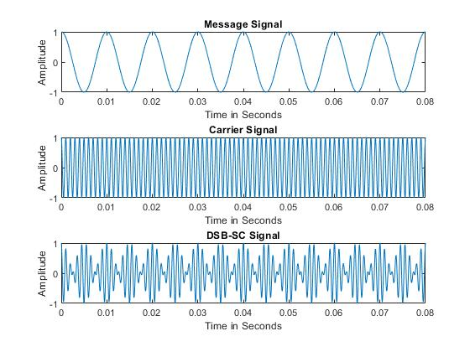

**Figure 1: 2.1.c**

In the Figure 1, we can see that first one is our message signal which is 100 Hz, 1 amplitude cosine signal second one is carrier signal, and it has 1kHz component and 1 amplitude while the last one is modulated signal which composed by multiplying carrier wave with message signal in time domain and it has also 1 amplitude at peak.

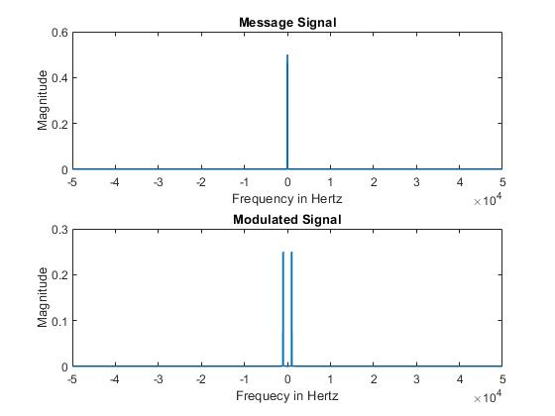

**Figure 2: 2.1.d**

In Figure 2 at first figure has 2 frequency components at -100 Hz and 100 Hz and has magnitude of 0.5 which is expected because in Fourier transform the magnitude get halved (and has 2 dirac function according to its frequency). At second figure we can see that there are 4 frequency components at 900 Hz and 1100 Hz and exact same on the left half plane (-900,-1100) with magnitude 0.25 which comes from the modulated signal s(t)’s frequency domain representation ((*Am*Ac)/4) and frequencies can be explained by shifting property due to Fourier transform and trigonometric identities.

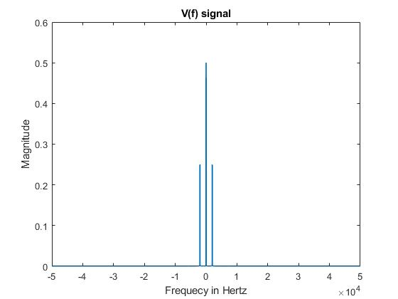

**Figure 3: 2.2.b**

In figure 3 we can see that there is 6 frequency components at 100 Hz, 1900 Hz, 2100 Hz and exact same at left half plane (-100,-1900,-2100) which is expected because we multiplied the s(t) signal with modified carrier signal (Ac’=2, theta=0, fc=1kHz) which results shifting the already shifted signal by fc again which results -+fm around -+fc components and also at the center our original signal at -100,+100 Hz with magnitude of 0.5 and 0.25 for around 2kHz components. Normally the magnitude becomes 0.25 for +-100 Hz components and 0.125 for the components around 2*fc (1900,2100) when I picked same magnitude for modified carrier signal which comes from local oscillator. Since our message signal has amplitude as 1 I set the Ac’ as 2 to get our original message signal amplitude at output.

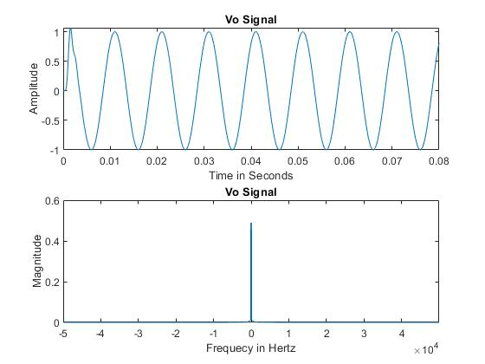

**Figure 4: 2.2.d**

I have designed a lowpass butter filter with order 9 for getting more ideal results (comes from z transform poles zeros etc.) and I choose cutoff frequency Fc as 875(fc-fm-25) which is between [W,2*fc-W) which equals to [100,1900]. The cutoff could have been any value between this interval (based on Simon Haykins book) Which is logical because we have frequency component at -1900 Hz and 1900 Hz, and we want to get message signal back which has just +-100 Hz components at center. In figure 4 we can see that our demodulated signal has Amplitude as nearly 1 (0.998) and has some error at first cycle but then the figure gets more likely to a sinusoidal signal. We can see that there are 2 frequency components which are -100 Hz and 100 Hz at second figure, and they have magnitude as 0.5 which is expected from Fourier transform halving the magnitude feature. But while I am comparing the main message with our demodulated signal I realized there is a phase difference between them and made it minimum with changing cutoff frequency and order of the filter and make them nearly same.

Note: I have changed the theta to pi/3(60 degree) in carrier at demodulator part and it did not affect the phase error. It affected only the amplitude of the signal(halved) and in frequency domain the signal v has same amplitude for all frequency components (0.25). The amplitude can be explained by cos (60) =1/2. So, I think the phase error is not caused by the theta It causes by fft function or nonideal filter.