UTKU ACAR 250206062

LAB-6 REPORT



**Figure 1: 2.1.e**

As we can see in figure 1 the increasement of sensitivity factor increases the width in some part of the signals so the other parts shrink this is proportional to integral when integral result is high waves shrinks and when integral result is low waves dilates (more waves when message signal has max amplitude and less waves when the message signal has low amplitude) . We can think as drive the message to carrier by its frequency (difference between AM Modulation and FM Modulation). This way provides us the ability of carrying information without changing carrier amplitude instead of we manipulate frequency. The s1 signal is narrowband signal (B=0.2<1) which can be obtained by the formula B=kf*Am/fm (5*2/50), the s2 signal is wideband B=1 (25*2/50) and the s3 also wideband B=2 (50*2/50). The more explanation can be found in frequency domain figure. (figure 3)



**Figure 2: 2.2.b**

In figure 2 we can see that we got what we expected. The message signal has 1 magnitude and carrier signal has 0.5 magnitude and they both have 2 components one of them is positive one of them negative. For message signal there are -50 and +50, for carrier signal there are -200, and 200 Hz components. Magnitude and frequency components can be explained by Fourier transform halves the magnitude and gives two impulsive components symmetrically with respect to Y axis with frequency of the corresponding signals.



**Figure 3: 2.2.c**

When Kf=5(s1) the modulation index B equals to 0.2(Kf*Am/Fm) (5*2/50). So, its narrowband(B<1) that means the Transmission Bandwidth equals to ruffly 2*fm which is 100 Hz. Carlson rules says it should be 120Hz (2w*(1+B)) but it is generally for wideband, so we accept bandwidth of 100Hz. When Kf equals to 25 (s2) B equals to 1 (25*2/50) so its wideband and its transmission bandwidth becomes 200Hz (2*50*(1+1)) For the last part Kf=50 (s3) B equals to 2 (50*2/50) which is wideband signal so our Transmission Bandwidth again can be found with Carlson rule and it gives us 300 Hz (2*50*(2+1)). The wideband signals used to carry high quality audio in radio stations. The narrowband bandwidth is very similar to the Conventional AM bandwidth. As the Beta increases the significant frequency bands also increases. We can explain these frequency variations with Bessel functions



**Figure 4: 2.3.b**

We can clearly see that the most approximate result is second one with Beta=1. The shape of the first graph is most distorted one along the others and it has lowest Beta=0.2. Normally the amplitudes were half of the messages signal, so I multiplied demodulated waves with Am to get same amplitude as our message signal. (Please look for the note below). We got more distortions when we increase the Beta due to 1 radian or decrease it again due to 1 radian (bounds to kf or Am while fm unchanged).

For further comment I saw that we need to limit the maximum frequency deviation delta f to stabilize the gain profile of frequency dependent FM system to restrict the message signal how much imparted from carrier signal.

Note: I have put Am to the s(t) function with multiplying it with cumsum(.) function. I corrected this process with using fmmod(.) function it gave me same answer with Am multiplied version of s(t)’s with all sensitivity factors. So, I decided to comment fmmod(.) functions instead of removing them. The other graphs get different when we do not multiply the Am with cumsum function instead of multiplying Am after the demodulation process. For this case, the first demodulated signal is more distorted than first case, but the third graph (kf=50) is more like our original message signal while first case third graph were getting distorted with same kf (50). But I have not multiplied the Am with cumsum(.) function for the results as expected from us in the lab document. The corresponding

Manually s(t) function with Am multiplied with cumsum(.) function graphs are below:

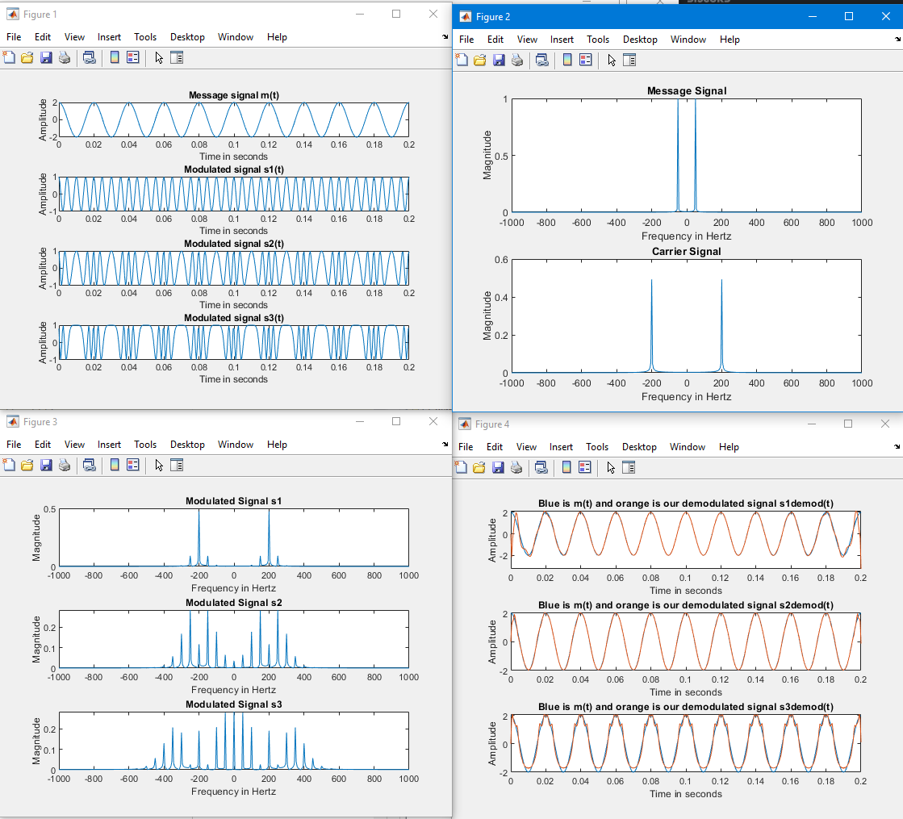

With Matlab’s fmmod(.) function graphs are below:

