CENG 422 FINAL PROJECT

UTKU ACAR 250206062 ELECTRONICS AND COMMINICATION ENGINEERING

The general system looks like this. If you want to see in detail you can open the project because I wrote IP addresses on the project Every PC has IP addresses and gateway for accessing other elements.

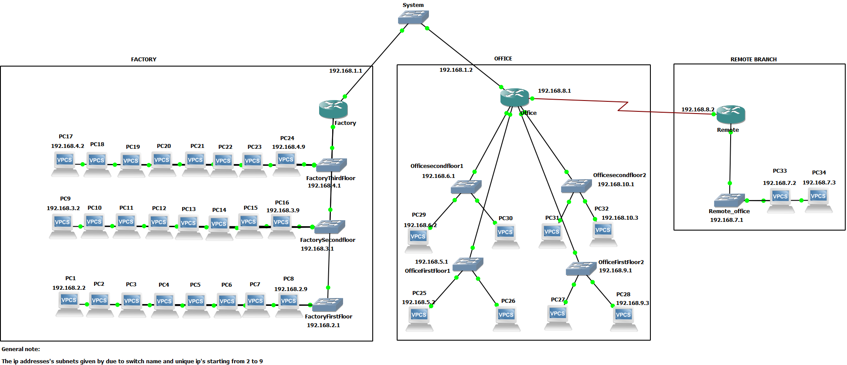

The proofs of we can see each PC from any pc are below of the configs of routers. I created the system with a switch for connecting factory and offices. Then I used three Cisco 3640 routers for managing switches for each building for each floor. I used this configuration because this is more like real world implementation as I know. The “1” subnet is for routers, “2”, “3” and “4” subnets for Factory floors, “5”, “6”, “9” and “10” subnets for Offices, “7” subnet for Remote office, and “8” subnet for Serial PPP between Offices and remote. For PC’s I gave IP addresses due to which switch has been connected each individual pc. For example, I gave 192.168.2.2 to PC 1 because it is connected to factory first floor which is 192.168.2.1 and continuing this way, I gave IP addresses consequently for each subnet with switch’s IP as gateway.

For serial ports for PPP, I have used 192.168.8.1 and 192.168.8.2 addresses and for the mask I have used 255.255.255.0 so “8” subnet for making modem between Office and Remote control (You can check it from below). Since the authentication is required for secure connection, I did set password as “1234” by ‘auth chap Password’ command on the serial 1/0 ‘s of the switches.

One of the problems I have encountered is a pc from remote office cannot reach other IP’s on factory and office. I solved this problem by IP routing which is saying what should router do when we request to reach PC’s on other buildings. For example, I wrote on remote office console that “IP route 192.168.6.0 255.255.255.0 Serial 1/0” which means that if we want to reach to Office which has subnet “6” from one of the PC’s from remote office then the request has been send to Serial 1/0 which is connected to the office router and office router can direct the signal to the destination point. In pinging process, the ping signal can be timed out at first but if we try again the process works correctly.

I have designed system first with more routers but the subnet requirement for previous design is 34 and have 2 IP addresses for each subnet. This was inefficient than my actual design, so I changed the design by adding switches each floor instead of routers. This process simplifies the system and reduced complexity of subnets and increased efficiency by reducing subnet requirements.

For Factory, system looks like this:

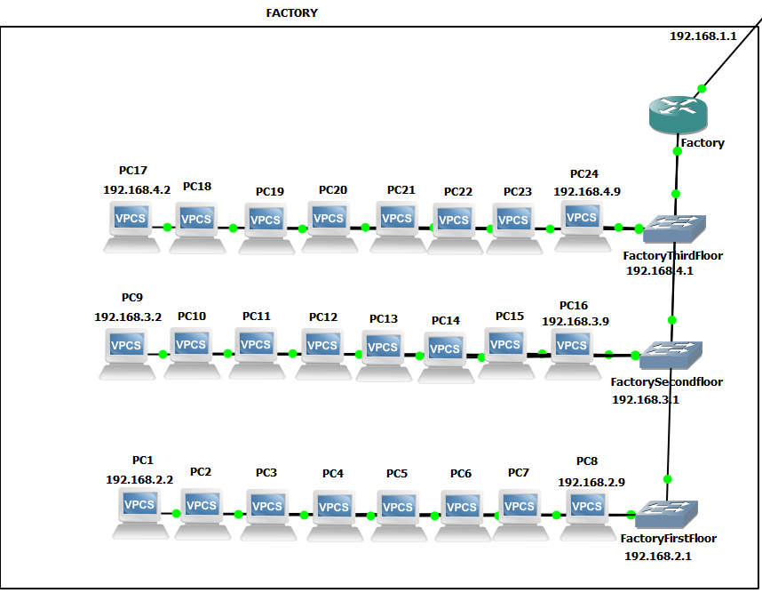

We have the config below for factory:

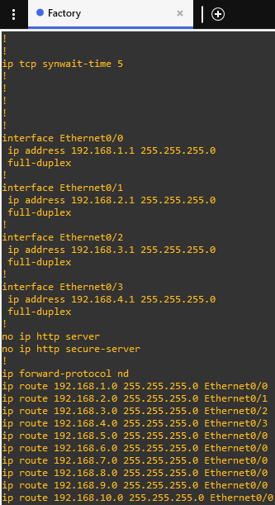

For Office, system looks like this:

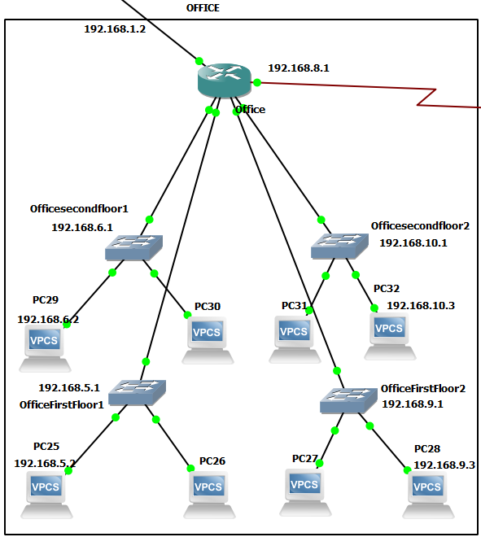

We have the config below for office:

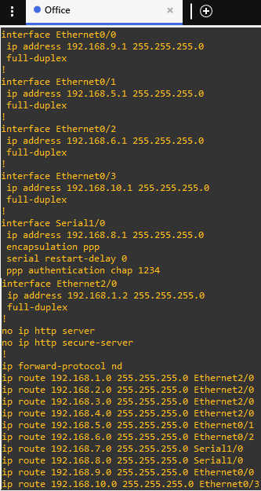

For Remote Control, the system looks like this:

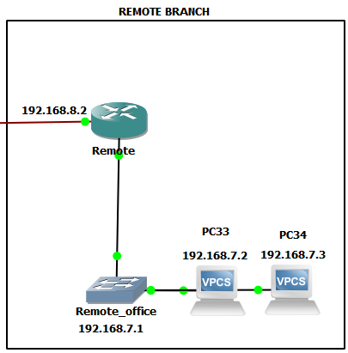

We have the config below for remote control:

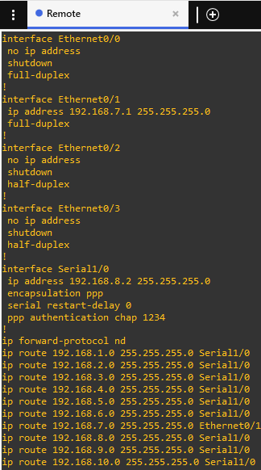

The proofs of every pc can see each other and routers:

The proof that pc’s on factory can see all the other elements:

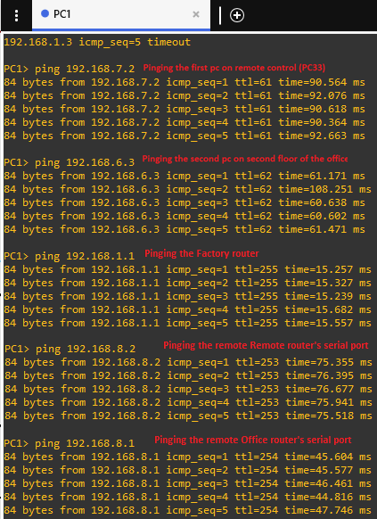

The proof that pc’s on office can see all the other elements:

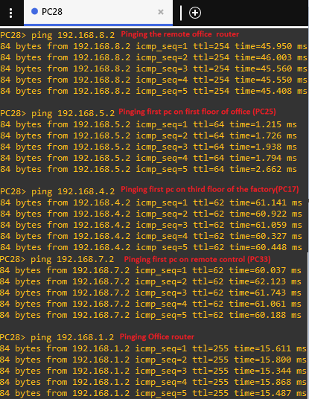

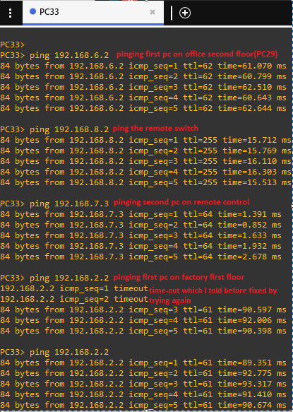The proof that pc’s on remote control can see all the other elements:

The proof that Remote router can see other Buildings

