In the edX course, Introduction to Hyperledger, Only the Iroha project had an architecture stack diagram.
Others like Fabric and Sawtooth do not present the architectural protocol layers as they were presented in the Iroha section.
The Iroha stack diagram helped me to quickly get an initial understanding on Iroha architecture.
Just so you understand what I am talking about, here are 3 examples of protocol stacks.
The first one is the edX course Iroha stack.
The second one is an example of a Blockchain stack.
The third one is an old classic computer network protocol stack from the 1990's that helped people understand computer networks and the internet.
Iroha protocol stack From Hyperledger edx class
Course Chapter 5. Introduction to Hyperledger Iroha Key Components Architecture Overview
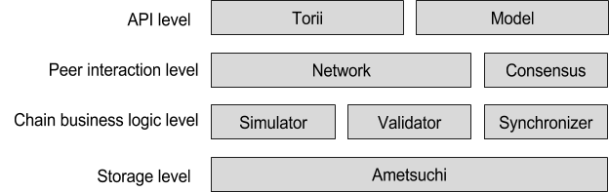

Example of a Blockchain stack
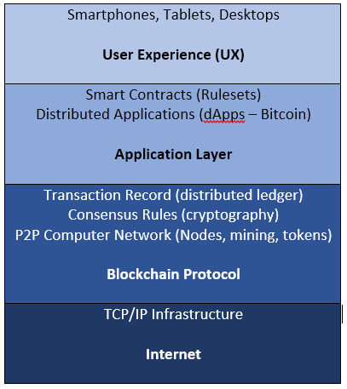

OSI/ISO Network protocol stacks from the 1990’s
