Forum Design Decisions (for Studio 38, Project Jetson)

# History

|  |  |
| --- | --- |
| Created by | Rupert |
| Created | 11-07-2008 |
| Last modified by | Rupert |
| Last modified | 29-01-2009 |

# Introduction

This document refers to the term forum as discussion forum solely. There are other types of forums, such as support forum, which is intended to support users for specific (e.g. technical) questions. Support forums are not intended to seek new members. “The community model thrives on the enthusiasm of members and always seeks to initiate new ones” (from [1]). Our purpose is the latter one.

Discussion forums are also known as message boards or bulletin boards.

# Terminology

The following terms are taken from [1].

|  |  |
| --- | --- |
| Forum | A forum is a collection of threads. A forum may contain a forum. |
| Forum Status | The “status” of a forum determines, if and how the forum should be displayed. Currently, the status has two values, public and draft. |
| Thread | “A thread is a series of messages (posts) left by forum members in response to the initial topical post created by the thread-starter”. (from )  In other words: “A thread is a series of messages posted by forum members which are woven together under one title.” (from )  So, a thread is just an abstract item. A thread is just the collection of several posts. The “attributes” (heading) of a thread is defined by the heading (subject) of the first post. |
| Sticky Thread | “We know that a thread is a series of messages posted by forum members which are woven together under one title. What about sticky thread? A sticky thread is a thread that continually appears at the top of a forum. Think of it as a note that contains an important task that you may have "stuck" on your desk or refrigerator. Sticky threads provide important rules or warnings about the forum topic. Examples might be a topical FAQ, rules for posting, or a news item relevant to the forum.” (from ) |
| Post | “A forum post is simply a message left or "posted" on an Internet bulletin board (discussion forum) “(from ) If a post does not “reply” to another post, it defines a new thread. The term “post” has no relevance from the user’s point of view! |
| Reply | A reply is simply a post with the addition, that it refers to another post (So, it “replies” to a post. |
| Bump | “In a busy discussion forum, everyone wants to be heard. Sometimes there are more forum members posting new threads than there are members replying to them. Most forums sort threads by newest first, the most recent appearing at the top of the page. Each new thread pushes the old ones further down the forum. What does one do when no one answers?  A common inclination is to "bump" such a thread back to the top. A member does this by posting a second time to the thread he originated, making it viewable again at the top of the forum's front page. His second post might be "Anyone?" or simply the word, "bump." Not all discussion forums allow bumping. It's a good idea to check the forum's Terms of Service before bumping a thread.” (from ) |
| Sig | “A unique text phrase, link, or graphic that appears below a member's message post usually offering information about themselves or their company. Interesting or humorous quotes are often used in these ‘signatures.’” (from )  So, a sig would be part of the user profile, which can be displayed at some place. |

## Synonyms

|  |  |  |  |
| --- | --- | --- | --- |
| **Term (en)** | **Synonyms (en)** | **Term (de)** | **Synonyms (de)** |
| Thread | Topic, Discussion | Thema | Thread, Diskussion |
| Sticky Thread | ? | ? | ? |
| Post | -- | Beitrag |  |
| Reply | Comment | Antwort | Kommentar |
| Bump | ? | ? | ? |
| Sig | ? | ? | ? |

# Model

The model of a forum is as follows: The forum model consists of a container holding several forums. A Container is just a collection of forums related to any object (e.g. a website or a user or any other object) by a generic reference. From the user’s point of view, this item is not relevant.

A forum itself can contain any numbers of nested forums. Several root level forums are held under a container.

A post either defines a thread or a reply to a thread. It is a thread, if it does not have any parent posts and has a reference to a forum. It is a reply, if it refers to another post. A post can be implemented in a single model, but needs not to. It also can be split into a “thread” model and a “reply” model. For performance (and other) reasons, the latter approach is preferred. Replies also differ slightly in their attributes from threads.

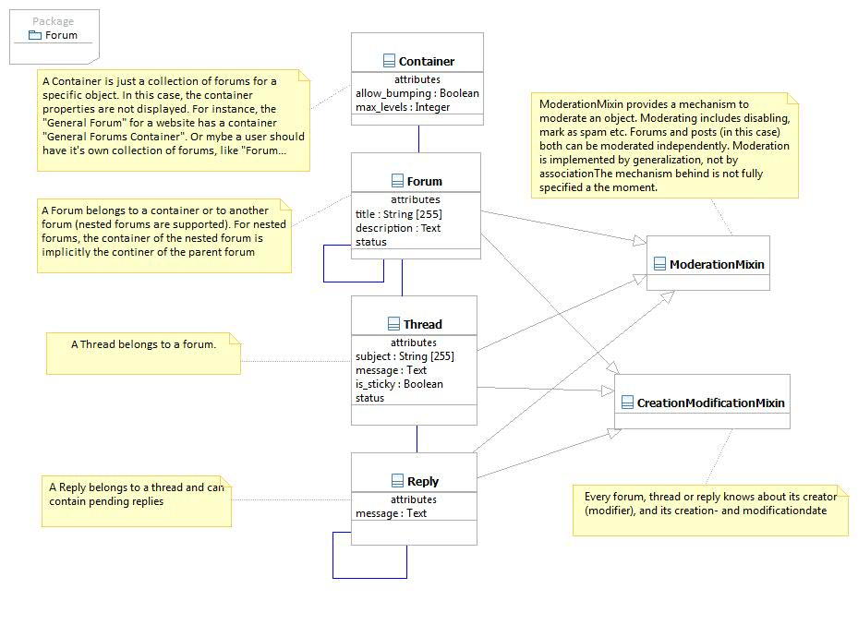

1. Uml2 Model for Forum Application

# Examples

Using this model, you can define for instance the following forum structure:

|  |  |  |
| --- | --- | --- |
| **(Forum) Computers** | | |
|  | **(Forum) Programs** | |
|  |  | **(Thread) (sokrates posted thread): I like Django**  (platon replied @sokrates): I don’t  (Anaxagoras replied @platon): I do  (anaximes replied @sokrates): Me too  (Thread) (platon posted thread): I like Ruby on Rails  (sokrates replied @platon): I don’t  (anaxagoras replied @sokrates): Why?  (sokrates replied @anaxagoras): It’s not Python |
|  | **(Forum) Hardware** | |
|  |  | **…** |
| **(Forum) Books** | | |
|  | **(Thread) (platon posted thread): I have written a book about caves**  (sokrates replied @platon): Nice!  (anaximenes replied @platon): Nice!  (anaxagoras replied @platon): Nice!  **(Thread) (anaxagoras posted thread): I have also written a book: …** | |
|  | **(Forum) English Books** | |
|  |  | **…** |
|  | **(Forum) German Books** | |
|  |  | **…** |

# Forum Moderation

A forum needs moderation. Under some circumstances, a forum moderator should be able to disable the whole forum including all its threads and replies (for instance, if the forum runs out of control or there are some impious or insulting posts). Moderation options are not yet fully specified at the moment. A first approach could be as follows:

Suppose, there is a thread in a specific forum, which has some insulting replies. Each of those replies should be disabled by a moderator. There can (but need not to) be some “reason for removal” displayed instead of the original reply. The same could be applied to whole threads or even whole forums. Forum moderation is implemented by a generic “moderation mechanism”, which can also be applied to other objects like a blog or comments etc.

# Privileges for Forum Users

For each forum, users have distinct privileges to add new nested forms, moderate, make threads sticky, allow bumping etc. Currently, privileges are defined at the top-level forum. It is not possible to “overwrite” privileges to nested forums. This is obviously sufficient for most cases. There are three groups of users, called roles : owners, moderators and members. The privileges are defined as follows:

|  |  |  |  |
| --- | --- | --- | --- |
| **Privilege** | **Description** | **Applies to Role** | **Applies to Object** |
| can_apply_forum_options | Permission to apply global options . These options are set in the forum container and apply to all forums “under” the forum container. The following attributes can be set: allow_bumping , max_levels | Owners | Forum Container |
| can_set_forum_status | Permission to set the status attribute for a forum. A status can be one of these: public, draft. Mind, that there is a difference between setting a forum status and moderate the forum (see below). | Moderators | Forum |
| can_moderate | Permission to moderate a forum (for more details, see chapter 6) | Moderators | Forum |
| can_add_forum | Permission to add a new forum | Moderators | Forum Container |
| can_change_forum | Permission to change a forum. Either edit the contents or the hierarchy | Moderators | Forum |
| can_delete_forum | Permission to delete a forum in a forum | Moderators | Forum |
| can_add_thread | Permission to start a new thread in a forum | Members | Forum |
| can_set_sticky | Permission to set any thread of a forum sticky | Moderators | Forum |
| can_change_thread | Persmission to change any thread of a forum | Moderators | Forum |
| can_change_thread | Persmission to change any thread of a forum | Moderators | Forum |
| can_change_self_post | Permission to edit any self written post (thread or reply) in a forum | Members | Forum |
| can_delete_self_post | Permission to delete a self written post (thread or reply) in a forum | Members | Forum |
| can_change_any_post | Permission to edit any post in a forum | Moderators | Forum |
| can_delete_any_post | Permission to delete any post in a forum | Moderators | Forum |
| can_reply | Permissions to reply to any thread (or reply to any reply) in a forum | Members | Forum |
| can_read_forum | Permissions to read any thread or any reply in a forum. | Members | Forum |

# Restrictions

Currently, there should be some restrictions to any forum (container):

* Only leaf node forums may have threads. If you try to create a new forum under a forum, which have existing threads, all threads will be moved to the new leaf node. It will not be possible to create any thread for the (parent) forum any more.

# References

|  |  |
| --- | --- |
|  | „Forum Point, Forum resources worth posting about“, Forum Point.com, 2008, available via http://www.forumpoint.com/terms/thread/ |