NEO-V3
Autonomous ML Engineering Platform
Design & Engineering Document
Version 3.0 · July 2026
Audience: Engineering · Confidential

Contents
Contents 2
1. Objective 3
2. The Solution We Are Providing 3
3. Use Cases 4
4. End-to-End Workflow 6
4.1 The user's 4-step workflow 6
4.2 Inside one search run 6
4.3 The self-improvement loop 7
4.4 The ReAct agent workflow (non-search tasks) 7
5. Feature Catalog 9
5.1 Search engine (agent/search/) 9
5.2 Knowledge & self-improvement (agent/knowledge.py) 9
5.3 LLM layer (agent/llm/) 9
5.4 Execution, safety, observability 9
5.5 ML pipeline tools (ReAct toolset) 10
6. High-Level Architecture 11
7. Low-Level Architecture 11
7.1 Key design decisions 12
7.2 Data flow of one node (sequence) 12
8. Infrastructure Requirements 14
8.1 Compute 14
8.2 Storage 15
8.3 External services & variable costs 15
8.4 What we explicitly do NOT need 15
9. Competitive Positioning vs **ML Agent** 16
10. Testing & Quality 16
11. Roadmap to Market 17
Appendix A — CLI Reference 17
Appendix B — Environment Variables 17

1. Objective
Build and ship an autonomous ML engineering platform that outperforms **ML Agent** (**ML Agent**.com) — the current market leader claiming #1 on MLE-Bench (34.2%, Aug 2025) — on both benchmark performance and product capability, and take it to market.
ML engineering today is dominated by manual, slow iteration: writing training scripts, running experiments, reading logs, fixing failures, tracking metrics, and repeating for days. General coding agents (Cursor, Claude Code, Codex) write code but do not own the experiment loop. **ML Agent**'s core insight — an agent that runs the full engineering loop autonomously — is correct; our objective is to execute that insight better.

Success criteria
- Benchmark: match or beat **ML Agent**-class results on MLE-Bench-style tasks through systematic tree search, parallel exploration, and cross-run learning.
- Capability: cover **ML Agent**'s entire documented surface (IDE/MCP integration, BYO-LLM, evals, fine-tuning, RAG, deployment) and exceed it where they are weak (transparent budgets, resumable runs, self-improvement).
- Trust: every run produces inspectable artifacts — solution tree, code, metrics, reports — with no opaque credit system and no data leaving the user's infrastructure.
- Time-to-market: engine already implemented and tested (54/54 automated tests); productization gaps are enumerated in Section 11.

2. The Solution We Are Providing
Neo-v3 is a fully autonomous ML engineer. Given a natural-language task ('Predict churn, maximize AUC') and a pointer to data, it plans, writes complete solution scripts, executes them in a sandbox, reviews the results, and iterates — debugging failures and improving winners — until a budget is spent. It then hands back the best solution, a full experiment report, and everything it learned.
Four properties distinguish it from both general coding agents and **ML Agent**:
- Systematic search, not a chat loop. An AIDE-style solution tree (draft → debug → improve) with a reservation-aware parallel scheduler. Multiple complete solutions are generated, executed, and measured concurrently — **ML Agent** expands one node at a time.
- Self-improvement across runs. After every run, a reflection step distills generalizable lessons into a bounded playbook, and the run is archived in a full-text-searchable index. Future runs receive the playbook and similar past runs as prior art. **ML Agent** starts every task cold; Neo-v3 compounds.
- Radical transparency. Crash-safe journals, resumable runs, explicit token/time/step budgets, per-run reports with the full solution tree, and a live dashboard. No opaque credits.
- Runs anywhere, on your terms. BYO-LLM (Anthropic, OpenAI, Gemini, Groq, Ollama, vLLM, any OpenAI-compatible endpoint), Docker or plain subprocess execution, local-first data handling, and an MCP server that plugs into Claude Code, Cursor, Windsurf, and Zed.

Delivery surfaces
Surface | What it provides | Status
CLI (neo) | run / solve / team / serve / mcp-serve / playbook / sessions — scriptable, CI-friendly | Shipped
Interactive REPL | Conversational agent with the full 40+ tool set | Shipped
Web dashboard | Live step feed (WebSocket), session browser, search-run tree viewer, playbook view | Shipped
MCP server | neo_submit_task / neo_task_status / neo_get_messages / neo_list_tasks for any MCP client | Shipped
IDE extension | VS Code / Cursor sidebar (**ML Agent** parity) | Roadmap
Managed cloud | Zero-setup hosted runs (**ML Agent** parity) | Roadmap

3. Use Cases
The platform serves the same seven workload families **ML Agent** markets, executed through one uniform workflow (Section 4).
Category | Representative tasks | How Neo-v3 executes them
Model building & AutoML | Tabular classification/regression, time series, anomaly detection, churn/fraud models | Tree search generates competing pipelines (feature engineering x model families x HPO), measures each on held-out splits, returns the best
LLM evaluation & benchmarking | Model comparisons, eval harnesses, LLM-as-judge suites, prompt A/B tests, regression gates | ReAct agent builds eval scripts and datasets; search optimizes prompts against measurable scores
Fine-tuning | LoRA/QLoRA instruction tuning, domain adaptation of open-weight models, quantized exports | Built-in PEFT pipeline (transformers + peft + datasets); GPU sandbox; checkpoint comparison in reports
RAG systems | Repo-RAG, multimodal RAG (PDF/OCR/audio), chunking & retrieval tuning, grounded QA | ChromaDB + sentence-transformers indexing tools; search loop tunes chunking/thresholds against retrieval metrics
Agent & pipeline development | Multi-step agent workflows, data pipelines, deployment packaging | Multi-agent orchestrator (planner-coder-reviewer-tester) plus deployment tools (FastAPI app, Dockerfile, ONNX/pickle export)
Debugging & optimization | Fix broken training pipelines, hunt data leakage, speed up inference | Self-correction policy classifies errors and injects hints; doom-loop guard prevents wasted cycles; static gate catches broken code pre-execution
Continuous engineering | Nightly retrains, scheduled evals, regression watchdogs via MCP/CLI in CI | Deterministic CLI exit codes; resumable runs; MCP task lifecycle for orchestration from other agents

Concrete example
neo solve "Predict customer churn from ./data/churn.csv. Metric: AUC." -d ./data -s 24 --workers 4 --token-budget 500000
One command: the platform previews the data, injects lessons from past runs, explores 24 candidate solutions four-at-a-time inside its sandbox, and returns best_solution.py, report.md (solution tree + metric history + failure analysis), and an updated playbook.

4. End-to-End Workflow

4.1 The user's 4-step workflow
- Describe the task. Natural language, including the target and metric. No prompt engineering.
- Point at context. A data directory (auto-previewed: file tree, dtypes, CSV heads, JSON keys), optional evaluation notes, optional model choices.
- Let it run. The engine iterates within explicit budgets (steps, wall-clock, tokens). Runs are crash-safe and resumable; long runs can be watched live on the dashboard or polled over MCP.
- Review and steer. Inspect the solution tree and report, resume with more steps, tighten the task, or promote best_solution.py to production.

4.2 Inside one search run
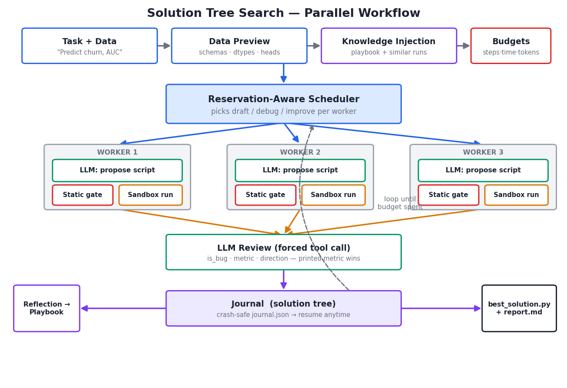
Figure 1 — Parallel solution tree search: propose → gate → execute → review → journal.
Scheduling. Each worker asks the policy for an action. The policy drafts until num_drafts independent roots exist (in-flight drafts count toward the quota), then debugs buggy leaves (cheapest-expected-fix first, capped at max_debug_depth consecutive attempts) with probability debug_prob, otherwise improves a top-k good node (epsilon-greedy: 70% best node, 30% a runner-up — preserving the diversity the drafts paid for). Reservations guarantee two workers never touch the same leaf.
Static gate. Before any sandbox execution, the candidate script is AST-parsed. Syntax errors, missing metric prints, and guaranteed hangs (input()) are scored buggy immediately — the debug branch fixes them one full sandbox round-trip cheaper. The gate only rejects certain failures; runtime uncertainty always executes.
Execution. Docker when available (memory/CPU caps, bind-mounted workspace, runaway-process kill on timeout) or a cross-platform subprocess backend (hard wall-clock timeouts, head+tail output truncation). Per-node timeouts shrink automatically to fit the remaining wall budget.
Review. A second, low-temperature LLM call is forced (tool call) to return {is_bug, summary, metric, lower_is_better}. The script's own printed 'Final Validation Metric' line overrides the reviewer on disagreement — regex plus reviewer, not vibes.
Journal. Every node (code, output, verdict, metric, lineage) is appended to a tree persisted after every step. This powers crash-safe resume (--resume <run_id>), the report, and the dashboard tree view.

4.3 The self-improvement loop
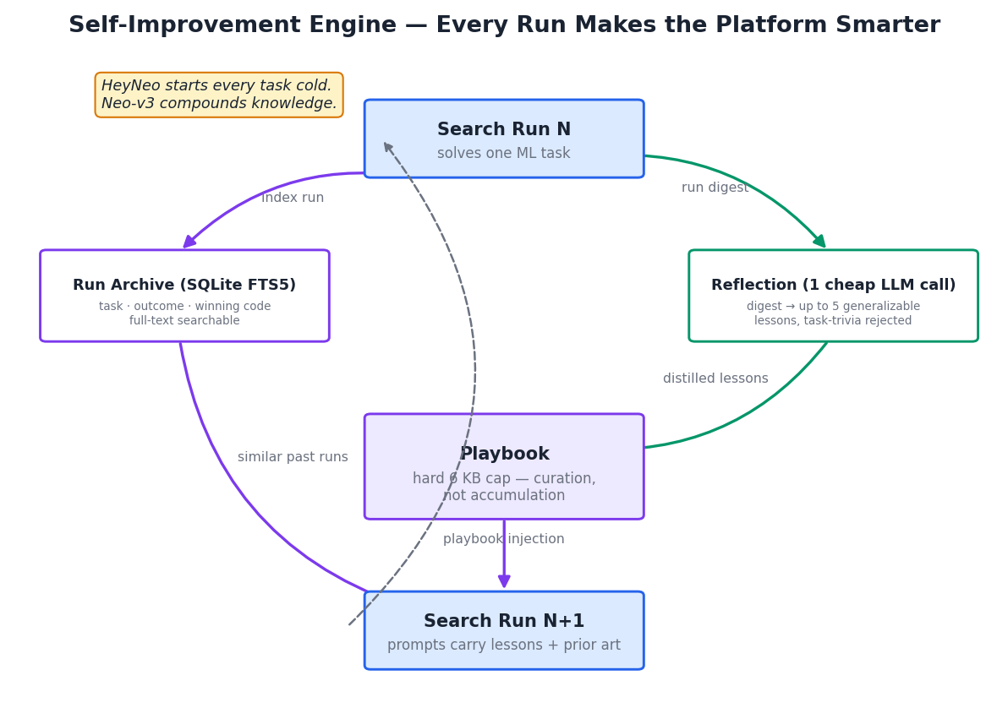
Figure 2 — Reflection distills lessons; the archive supplies prior art; future prompts carry both.
After a run completes, one cheap reflection call reviews the run digest and extracts up to five generalizable lessons — task-specific trivia is explicitly rejected by the prompt. Lessons merge into a playbook with a hard 6 KB cap: when full, the oldest lessons are dropped, forcing curation over accumulation (a design borrowed from NousResearch's hermes-agent). Every run is also indexed (task, outcome, winning code) in a SQLite FTS5 archive. At the start of any new run, the playbook plus the three most similar archived runs are injected into every prompt.

4.4 The ReAct agent workflow (non-search tasks)
For open-ended engineering tasks (fix this pipeline, build an eval harness, index this repo), the ReAct loop drives 40+ tools: data loading/validation, feature engineering, model training with Optuna HPO, evaluation with plots, deployment packaging, fine-tuning, RAG indexing/search, MCP client tools, and solve_ml_task itself. Three protective layers run on every tool result: guardrail scan (prompt-injection patterns), self-correction (error classification + hints, abort after 3 consecutive failures), and the V3 doom-loop detector (same-call-same-result repetition triggers a corrective note; result-hashing means polling never false-positives). Conversations are auto-compacted beyond a size budget so long runs never blow the context window.

5. Feature Catalog

5.1 Search engine (agent/search/)
Feature | Detail
Parallel tree search | N workers pipeline propose/execute/review; reservation-aware policy; dense, unique journal steps under concurrency
Draft / debug / improve policy | Configurable num_drafts, debug_prob, max_debug_depth, improve_topk (epsilon-greedy)
Static gate | AST checks pre-execution: syntax, metric-print presence, interactive-input hangs
Budgets | steps, wall-clock seconds, LLM tokens; graceful drain of in-flight work on exhaustion
Checkpoint / resume | journal.json saved every step; --resume <run_id> adds more nodes to a finished or killed run
Trust-but-verify review | Forced-tool LLM review + printed-metric override + exit-code checks
Data preview | File tree, CSV dtypes/heads, JSON keys injected into prompts so code targets real columns
Reports | ASCII solution tree, metric history, failure analysis, token usage per run

5.2 Knowledge & self-improvement (agent/knowledge.py)
Feature | Detail
Bounded playbook | 6 KB hard cap, dedup, oldest-dropped-first; inspect/clear via 'neo playbook'
Post-run reflection | 1 low-temp LLM call, forced tool, max 5 generalizable lessons; never fatal to the run
Run archive | SQLite FTS5: task, summary, best metric, winning code; similarity search at run start
Prompt injection | Playbook + top-3 similar runs added to every draft/improve/debug prompt

5.3 LLM layer (agent/llm/)
Feature | Detail
One-string model spec | [provider:]model[@base_url] — e.g. openai:gpt-4o, vllm:Llama-3.1-70B@http://gpu:8000/v1
Providers | Anthropic (native, prompt caching), OpenAI, Gemini, Groq, Together, Ollama, vLLM, any OpenAI-compatible, scripted mock for offline tests
Phase-based routing | Separate NEO_CODE_MODEL / NEO_FEEDBACK_MODEL — premium model for code, cheap model for review (**ML Agent** parity)
Resilience & accounting | Exponential-backoff retries, normalized usage tracking feeding the token budget

5.4 Execution, safety, observability
Feature | Detail
Docker backend | Persistent container, bind-mounted workspace, mem/CPU caps, timeout kills the runaway container
Subprocess backend | Windows-safe (sys.executable), hard timeouts, structured ExecResult with exit code and timing
Guardrails | Prompt-injection scan on tool results + injection-benchmark harness
Self-correction | Error detection/classification, diagnostic hints, consecutive-error abort
Doom-loop guard | Result-hash-aware repetition detection with corrective prompt injection
Context compaction | Deterministic head+tail truncation of old tool results past a char budget
OpenTelemetry | Optional spans around every LLM call and tool call (OTLP exportable)
Sessions | Every ReAct run logged as typed steps; browsable via CLI and dashboard

5.5 ML pipeline tools (ReAct toolset)
Area | Capabilities
Data | CSV/Excel/Parquet/SQL/S3/GCS loaders, pandera schema validation, z-score outlier checks, missing-data handling
Features | sklearn ColumnTransformer pipelines, leakage-safe fitted transformers
Training | Linear/logistic, RandomForest, XGBoost, LightGBM, PyTorch MLP; task auto-detection; Optuna HPO
Evaluation | Classification/regression metrics, confusion matrices, ROC/PR curves, residual plots
Deployment | joblib/ONNX export, generated FastAPI serving app + requirements + Dockerfile
Fine-tuning | PEFT LoRA/QLoRA on open-weight models (transformers/datasets/accelerate; QLoRA on CUDA)
RAG | AST-chunked repo indexing, multimodal ingestion (PDF text/tables, OCR, Whisper audio) into ChromaDB
Multi-agent | Planner → Coder → Reviewer → Tester pipeline with role-restricted toolsets

6. High-Level Architecture
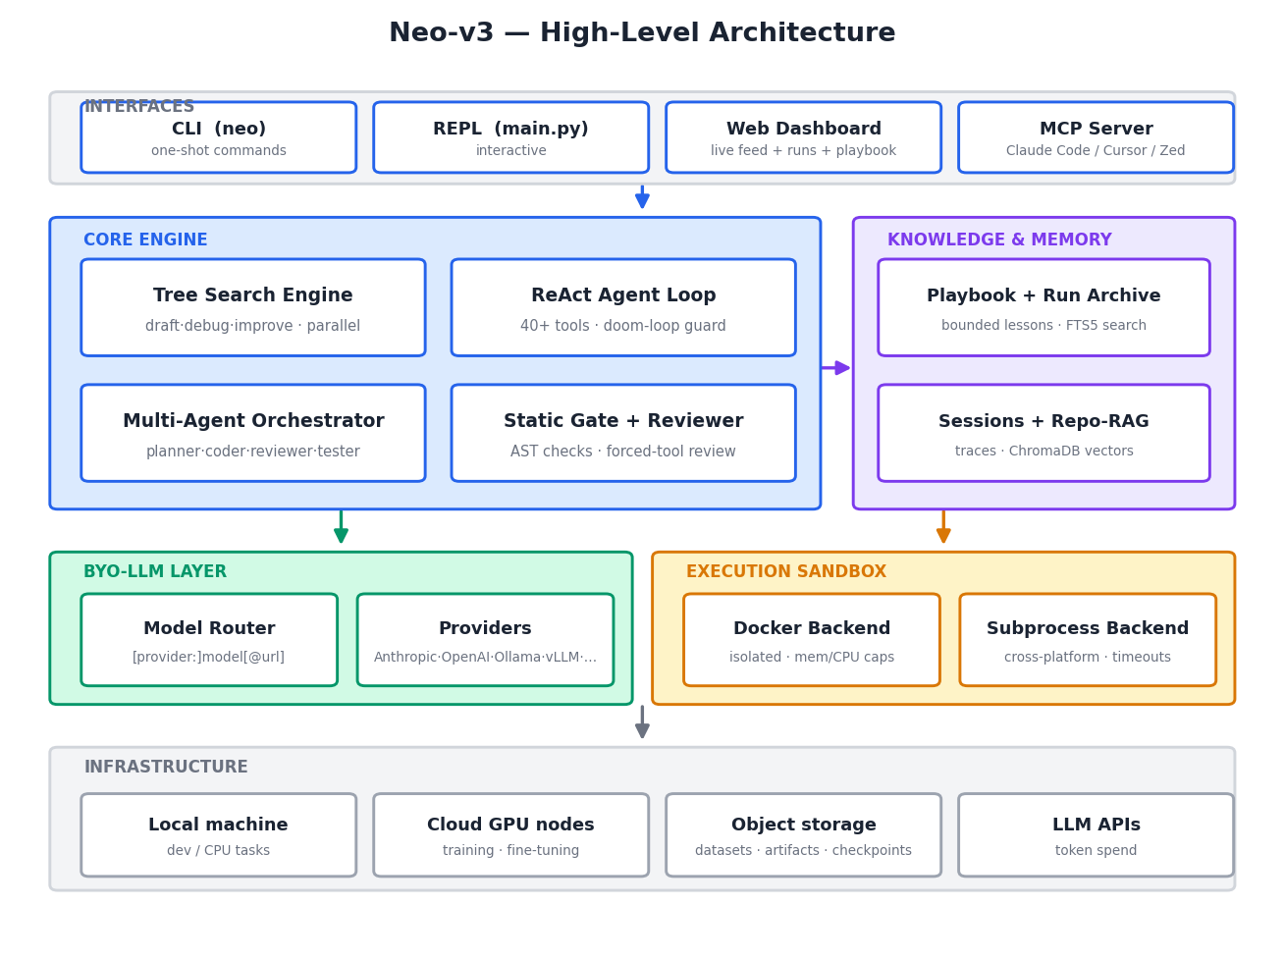
Figure 3 — Five layers: interfaces, core engine, knowledge, LLM + execution, infrastructure.
Interfaces. Four thin entry points (CLI, REPL, dashboard, MCP server) share one engine. Nothing user-facing holds state of its own; everything reads the same journals, sessions, and knowledge stores on disk.
Core engine. Two complementary brains: the tree-search engine for measurable ML tasks (optimizes a metric under budget) and the ReAct loop for open-ended engineering (drives tools). The orchestrator composes role-restricted ReAct instances into a review pipeline. The static gate and forced-tool reviewer keep both honest.
Knowledge & memory. The self-improvement stores (playbook + FTS5 archive), per-run journals, ReAct session traces, and the ChromaDB vector store for repo/multimodal RAG.
LLM + execution. Any model behind one router spec; any code inside one sandbox interface. Both are swappable without touching engine code — the mock LLM client and the subprocess backend make the entire engine testable offline.
Infrastructure. Local-first by default; scales to CPU/GPU cloud nodes without architectural change (Section 8).

7. Low-Level Architecture
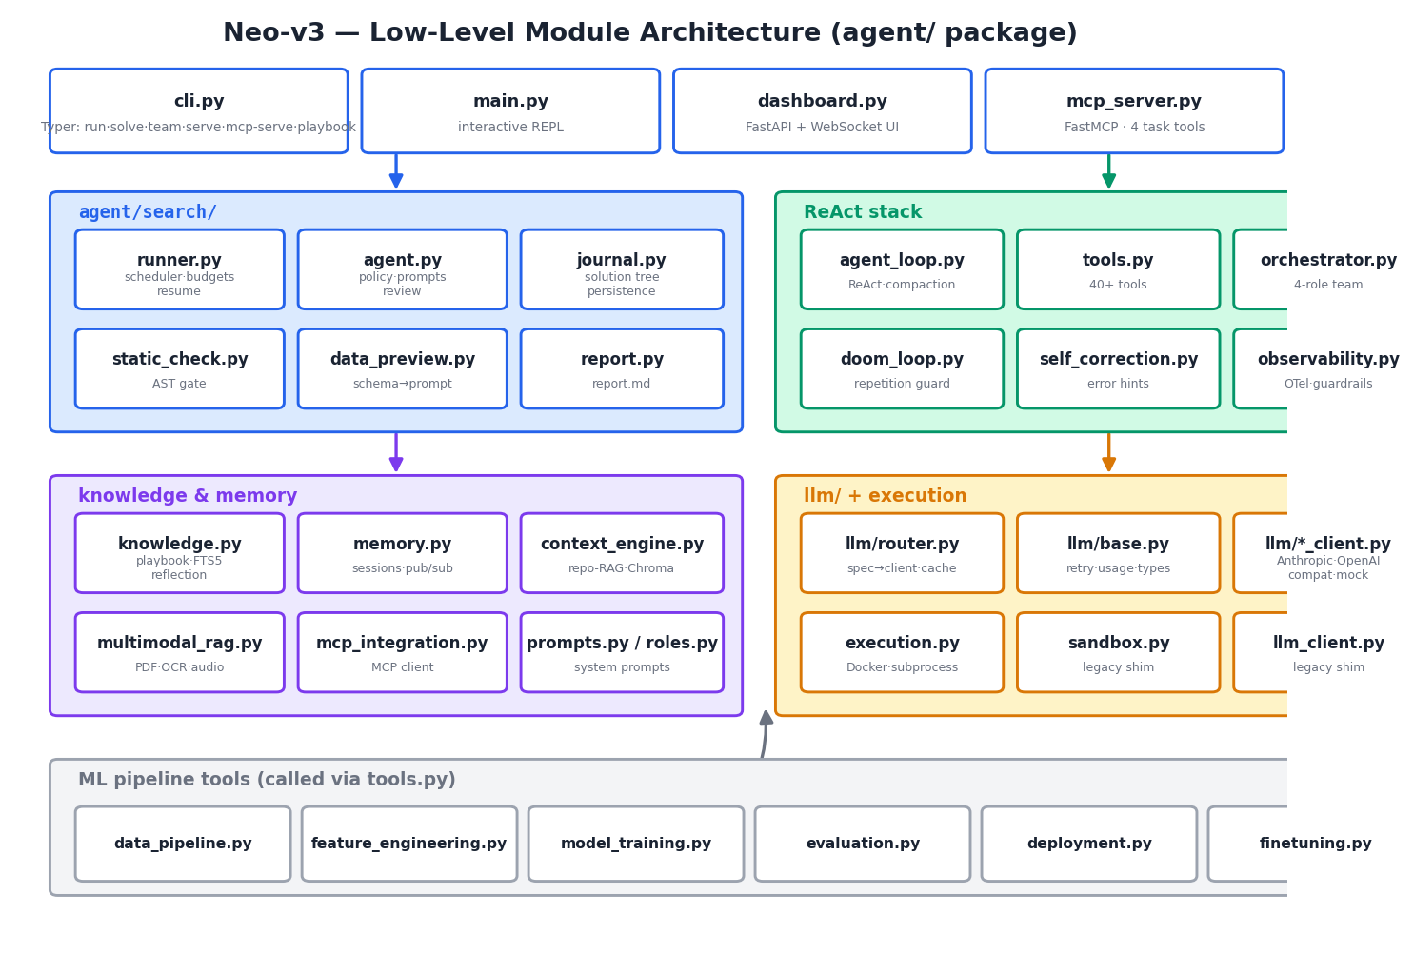
Figure 4 — Module map of the agent/ package (~10,500 LOC Python).

7.1 Key design decisions
- Threads over async. The parallel scheduler uses a ThreadPoolExecutor: LLM calls and sandbox executions are I/O-bound, workers share no state (the scheduler owns the journal under a lock), and synchronous provider SDKs stay simple.
- The journal is the source of truth. Policy decisions, resume, reports, and the dashboard all derive from the persisted tree — there is no hidden in-memory state to lose.
- Everything degrades gracefully. No Docker → subprocess. No knowledge dir → empty context. Reflection fails → run still succeeds. Review call fails → printed metric wins. A worker exception costs one node, never the run.
- Offline testability as an architectural property. The scripted mock provider + subprocess backend let 54 automated tests exercise the full loop — including parallel scheduling, resume, budgets, gating, and the complete self-improvement cycle — with zero network calls.

7.2 Data flow of one node (sequence)
# | Step | Component | Artifact
1 | Policy picks draft/debug/improve (+ parent) | search/agent.py choose_action | reservation
2 | Prompt assembled: task + data preview + playbook + similar runs + journal memory | search/agent.py + knowledge.py | prompt
3 | Code LLM generates plan + complete script | llm/<provider> via router | Node(plan, code)
4 | Static gate parses AST | search/static_check.py | gate verdict
5 | Sandbox executes with fitted timeout | execution.py | ExecResult
6 | Feedback LLM reviews via forced tool; printed metric overrides | search/agent.py review | verdict + metric
7 | Node appended, tree saved | search/journal.py | journal.json
8 | On run end: reflect + archive + report | knowledge.py + report.py | playbook, runs.db, report.md

8. Infrastructure Requirements
The platform is local-first: everything runs on a laptop for tabular-scale work. Competing with **ML Agent**'s 'runs for days on your GPU cloud' story requires the tiers below.
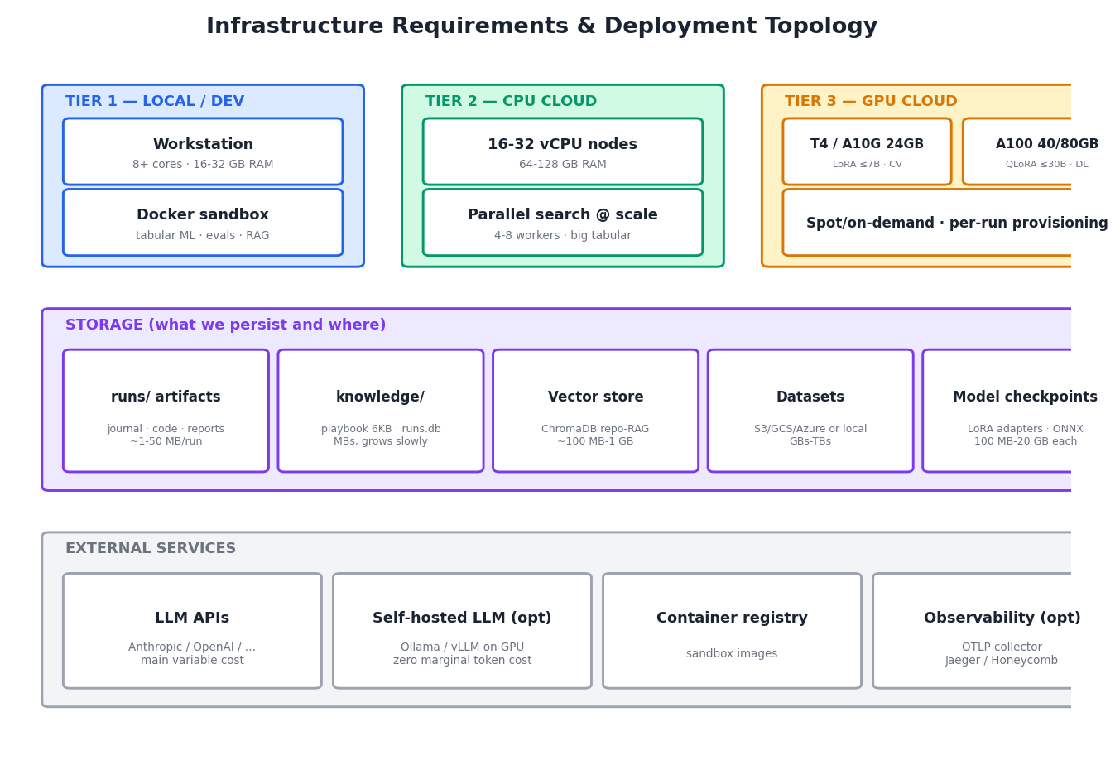
Figure 5 — Compute tiers, storage inventory, external services.

8.1 Compute
Tier | Hardware | Workloads | Notes
Local / dev | 8+ cores, 16-32 GB RAM, Docker Desktop | Tabular ML, evals, RAG indexing, prompt optimization | Default; subprocess fallback works without Docker
CPU cloud | 16-32 vCPU, 64-128 GB RAM (e.g. c7i.4xlarge-8xlarge) | Parallel search (4-8 workers) on large tabular data; batch evals; CI | One node per concurrent run; stateless — journal on persistent volume
GPU - entry | NVIDIA T4/A10G (16-24 GB VRAM), 8 vCPU, 32 GB RAM | LoRA fine-tunes up to ~7B, CV training, embedding jobs | Spot instances fine — runs are resumable
GPU - heavy | A100 40/80 GB (or H100), 12+ vCPU, 128 GB RAM | QLoRA up to ~30B, deep learning experiments, large batch inference | On-demand for long runs; VRAM rule of thumb: bf16 ~2 bytes/param + ~20% optimizer overhead
Self-hosted LLM (optional) | 1-2x A100/H100 running vLLM | Zero-marginal-cost code generation for the search loop | Cuts the dominant variable cost at scale; router supports it today (vllm:model@url)

8.2 Storage
Store | Contents | Size envelope | Medium
runs/ | Per-run journal.json, workspace, best_solution.py, report.md | 1-50 MB per run; grows linearly | Local disk / persistent volume; archive old runs to object storage
knowledge/ | playbook.md (6 KB cap) + runs.db (FTS5 archive) | MBs; grows slowly by design | Local disk; back up — this is the platform's accumulated learning
Vector store | ChromaDB collections (repo-RAG, multimodal) | 100 MB - 1 GB per indexed corpus | Local disk
Datasets | User training data (copied or symlinked into run workspaces) | GBs - TBs | S3 / GCS / Azure Blob; loaders already support cloud URIs
Model checkpoints | LoRA adapters (100-500 MB), full fine-tunes (up to ~20 GB), ONNX/pickle exports | GBs per fine-tune | Object storage with lifecycle rules
Sessions & traces | ReAct session JSON + summaries | KBs - MBs per session | Local disk

8.3 External services & variable costs
Service | Purpose | Cost driver
LLM APIs (Anthropic/OpenAI/...) | Code generation + review calls | Dominant variable cost. A 20-step search run: ~40+ LLM calls; --token-budget caps it per run. Cheap feedback model (NEO_FEEDBACK_MODEL) cuts review cost ~5-10x
GPU cloud (AWS/GCP/Lambda/vast.ai) | Fine-tuning + DL experiments | Hourly; spot-friendly because runs resume
Object storage | Datasets, checkpoints, archived runs | Cents/GB-month
Container registry | Sandbox images (python:3.11-slim + ML stack) | Negligible
OTLP collector (optional) | Production tracing (Jaeger/Honeycomb) | Per-span pricing or self-hosted

8.4 What we explicitly do NOT need
- No proprietary model training to launch — BYO-LLM rides on frontier APIs or self-hosted open weights.
- No Kubernetes for v1 — one process per run; a queue + VM pool suffices for early scale.
- No customer-data lake — local-first design keeps user data on user infrastructure (a selling point **ML Agent** also markets).

9. Competitive Positioning vs **ML Agent**
Dimension | **ML Agent** (documented) | Neo-v3 (this platform)
Search strategy | Iterative experimentation, one node at a time ('100s of experiments') | Same tree policy plus parallel workers — N drafts for one draft's wall time
Cross-task learning | None documented — every task starts cold | Playbook + FTS5 run archive injected into every run; compounds with use
Run continuity | 'Runs for days'; no resume documented | Crash-safe journal + --resume; spot-instance friendly
Cost control | Opaque credit system (Lite/Pro modes undocumented) | Explicit token/time/step budgets per run; transparent usage in reports
BYO-LLM | Anthropic, OpenAI, OpenRouter | Those plus Gemini, Groq, Together, Ollama, vLLM, any OpenAI-compatible endpoint (self-hosted = zero marginal token cost)
Failed-code cost | Executes everything | Static gate scores guaranteed failures without a sandbox run
Loop protection | Auto Mode self-check (coarse) | Doom-loop detector (result-hash aware) + context compaction + self-correction
IDE / MCP | VS Code + Cursor extension; neo-mcp (4 tools) | MCP server shipped (same 4-tool lifecycle); IDE extension on roadmap
Managed cloud | Yes (50 MB upload cap, 7-day session expiry, CPU default) | Roadmap
Benchmark claim | #1 MLE-Bench 34.2% (Aug 2025) | To be validated — engine implements the AIDE-family approach that leads that benchmark, plus parallelism and learning on top

10. Testing & Quality
54 automated tests (up from 31 pre-V3) run offline in seconds — no API keys, no network — via a scripted mock LLM provider and the subprocess backend.
Suite | Covers
test_llm_layer | Model-spec parsing, message/tool translation across providers, retry semantics
test_execution | Subprocess execution, timeouts, truncation, exit codes, working dirs
test_journal | Tree operations, best-node selection, persistence round-trips, prompt memory
test_search_agent | Policy transitions, top-k improve bounds, reservations, review parsing, printed-metric override
test_static_check | Every gate rule, plus the no-false-veto guarantee
test_knowledge | Playbook curation/caps/dedup, FTS5 archive search, reflection (incl. junk-input safety)
test_doom_loop | Repetition shapes, polling false-positive immunity, compaction budgets
test_e2e_search | Full sequential run on synthetic data: broken draft → working solution → artifacts
test_parallel_resume | Parallel journal integrity, resume continuation, gate-skips-execution, token-budget stop
Additionally verified end-to-end: the complete self-improvement cycle (run 1 learns a lesson → run 2's prompts carry it plus similar-run prior art), CLI surface, and MCP server tool registration.

11. Roadmap to Market
Phase | Scope | Est. effort
1. Benchmark validation | Run MLE-Bench-style suite with real models; tune policy constants; publish results — the marketing centerpiece | 2-3 weeks + GPU/API spend
2. IDE extension | VS Code/Cursor sidebar wrapping the MCP server: task submit, live tree view, playbook browser | 3-4 weeks
3. Managed cloud beta | Auth + run queue + VM pool + artifact download; per-seat billing with transparent token metering | 4-6 weeks
4. Hardening | Multi-user isolation, secrets vault, richer guardrails, SSO/audit logs for enterprise | ongoing

Appendix A — CLI Reference
neo run "task" one-shot ReAct agent (full toolset)
neo solve "task" -d DATA -s N --workers W --token-budget T tree search
neo solve "task" --resume RUN_ID -s N continue a run
neo team "task" planner->coder->reviewer->tester pipeline
neo playbook [--clear] view / reset learned lessons
neo mcp-serve MCP server (Claude Code, Cursor, Zed, ...)
neo serve [-p PORT] web dashboard
neo sessions / recall / index / guardrail-benchmark utilities

Appendix B — Environment Variables
Variable | Purpose | Default
NEO_MODEL / NEO_CODE_MODEL / NEO_FEEDBACK_MODEL | Model specs (global / search code / search review) | claude-sonnet-4-6
<PROVIDER>_API_KEY | Anthropic, OpenAI, Gemini, Groq, Together keys | —
NEO_SANDBOX | docker | subprocess | auto-detect
NEO_EXEC_TIMEOUT / NEO_SANDBOX_IMAGE | Per-call timeout (s) / container image | 300 / python:3.11-slim
NEO_SEARCH_WORKERS | Parallel solution nodes | 1
NEO_KNOWLEDGE_DIR | Playbook + archive location | <repo>/knowledge
NEO_MAX_ITERATIONS | ReAct iteration cap | 30
NEO_CONTEXT_CHAR_BUDGET | Compaction threshold (chars) | 400000

