Preliminary

The following sections in which I present a design for a ratio detector and ramp filter is firmly based in the design present by Adams and Kwan in their paper “A Stereo Asynchronous Digital Sample-Rate Converter for Digital Audio” which was published in 1994, and elements taken from their patent emanating from their work in this field. I don't claim any ownership of these ideas, but chose to use their design as the basis for a ratio detector and ramp filter since it is perhaps one of the most elegant solutions to the problem that I've seen. Whilst I did come up with my own scheme for achieving the same solution, which was equally effective, I chose to utilise the Adam's/Kwan design since it is much more space efficient with respect to an FPGA implementation.

The Sample Rate Conversion algorithm is my own, although many before me have utilised similar schemes.

Ratio Detector

The ratio detector is a fairly simple circuit. It is displayed in the figure below, and is nothing new. It's simply an event counter – it counts how many time event A occurs over a period of N event Bs. When you think about it, it's exactly what we want. We have input frames (left/right samples) occurring at the sample rate, and 64 clocks per output sample frame, so we have complete information regarding the output to input sample rate ratio.

The lower register counts up every input frame sync pulse to a terminal value, which triggers another register to latch the value of a counter that increments every time an output clock event occurs. The following register is only enabled upon terminal count, and if its output is greater or less than the value of the Fso count register. In this way we implement what is known as hysteresis – which is a fancy term for the fact that there is some slack in the value, so that only significant changes in the input give rise to a change in the output. At the output of this register we have the input to output sample rate ratio with an integer range of 0 to 15.

Following on from this, we apply the ratio to a very simple low pass filter. Actually, this filter is what is known as a leaky integrator (I've never questioned why it is called leaky, Google probably knows why). The integrator output slowly changes with response to an input stimulus until the input and output are equal in value. How does it work I hear you ask? Conceptually it is very simple! Firstly, to understand what the circuit does, we need to understand what integration is. Integration is a mathematical concept where, given a continuous line with X and Y coordinates, we calculate the area under the line. In discrete time systems, this amounts to continually adding values of a signal to itself. This is achieved by adding a register output to its input – producing an error term. Sounds simple really, and it is.

Now to explain the circuit. The output of the integrator is subtracted from the input signal – producing an error term. This error term is added to the output of the integrator (this is how it performs integration) which is registered to be output on the next clock cycle. What does this achieve? Well, in terms of the ratio detector, we are producing a signal that is constant, and so we expect the integrator to slowly rise or fall from its current value to the value presented to its input. How fast it does this is dependent on its programmed gain, and the result is very much like a simple RC low pass filter – which is because just like an RC low pass filter, it is a first order filter. So, by utilising this integrator, we only allow the output to change slowly with any given input.

Finally, the output of the integrator is presented to a limiter. Earlier I mentioned that the calculated ratio could have an integer value in the range of 0 to 15, well the limiter restricts the total range of the ratio output to values between zero and one. The fractional portion is critically important, and I'll explain that later when I discuss the SRC algorithm, but form now, it's only important to know that the output of the ratio detector cannot be greater than one.

Now, I should mention that whilst none of these components are novel in and of themselves, they were first presented in this format in US patent 5471411 back in 1995. At least some of the inventors worked for Analog Devices at the time this patent was granted, and maybe still do. You may have heard of the AD1896? I believe that, at least from what I can tell from the datasheet, this circuit is still in use. Thanks go to Adams, Kwan, and Coln for this work.

Ramp Filter

The ramp filter is what is known as a first order integrator, whose input is an input sample request relative to an output sample request. It's important to remember that in an output sample request could arrive at any time between to successive input samples, there could be several output sample requests (in the case of up-sampling), or even none at all (in the case of down-sampling. Also, given the asynchronous relationship between input samples arriving and output sample requests, in order to execute decent sample rate conversion, we need very precise information regarding the time (or phase) relationship between an output sample request, and the arrival of a previous input sample.

So, how do we calculate this? Below is a figure of a circuit that calculates just this – the usefulness of all the information generated will be explained just a little later.

FIGURE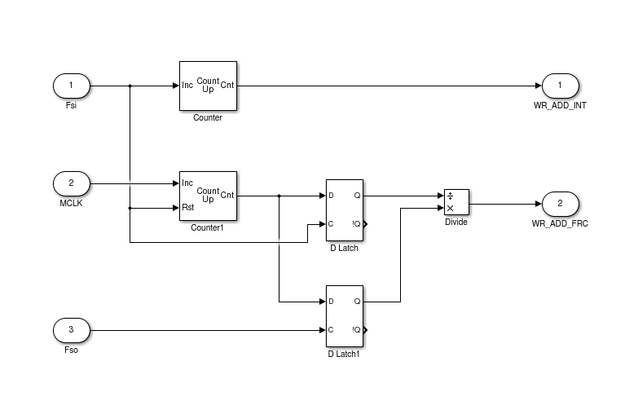

Considering this picture, we can see two counters. The upper counter simply counts how many input samples frames have arrived. This is passed to a ring buffer as a write address, and also onto the filtering function which will be discussed soon.

The second counter counts master clocks, and is reset whenever an input sample frame arrives. This is followed by two latches. The upper latch simply takes the value of the counter every time an input sample arrives, thus giving us the number of master clocks occurring between successive input samples. The lower latch takes the value of the counter every time an output sample is requested, and remembering that the counter is reset at the time of input sample arrival, this latch gives us the number of master clocks occurring between an output sample request and the previous input sample arrival. If we divide these two latches (lower/upper), we get the a fractional input pointer value. If we append the result of the division to the upper counter, we have a complete input pointer, that increments by Fsi/Fso each time an output sample request is made.

As a note, the result of this division can never be equal to or greater than one. So as an optimisation, I have implemented a radix 2 divider that only produces the remainder of the division of its inputs. This results in a significant saving with respect to processing cycles.

Now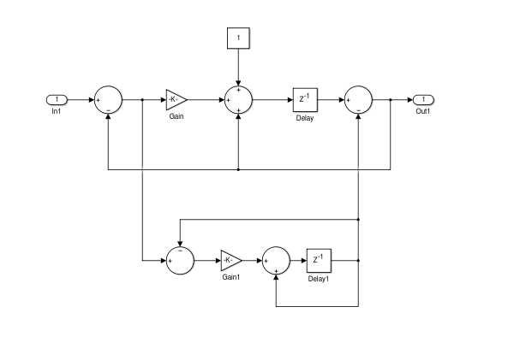 let's look at the first order integrator, into which the input pointer is fed.

Firstly, let's start by considering the output delay element (Z-1). The output of this latch is fed back is added to an input from the gain block. The latch takes this input as its value every time an output sample request is made. In this way we have constructed an integrator – it's an integrator because it is effectively accumulating the input (albeit scaled by the gain block).

Now let's try to understand the input to the integrator. As said above, an Fsi/Fso accumulator is fed to the input of this filter, which has the output of the integrator subtracted from it. In this way we have produced an error term which should be a constant when the filter has reached steady state. How do I know that? Well, the input, as said before, is an accumulator of Fsi/Fso which implies that it is increasing at a constant rate with Fso. So, the difference of the integrator output, and the Fsi/Fso accumulator input should therefore be constant, and reflect the magnitude that the integrator should increment by at each Fso. We attenuate this error with the gain block of course, which simply affects the speed with which the the filter will settle – more feedback results in a faster settling time, and conversely, less feedback results in a slower settling time. It also affects how the filter reacts to sudden changes in its input – the slower the filter, the more it is able to reject spurious changes in the input. And this is a good thing, because the result is a filter that is able to reject jitter on its input, which in turn leads to averaged timing information with little variance.

The bottom half of the ramp filter is a feed forward cancellation mechanism. At steady state, it subtracts a constant value from the output of the integrator, which is desirable since we never want the output of the ramp filter to cross over the actually ring buffer write address under dynamic conditions.

The output of the ramp filter has two main parts to it:

1. An integer part that can be used as an initial address into out ring buffer RAM that we'll perform a convolution over; and
2. A fractional part which itself can be broken up into two parts:
   1. The seven most significant bits provide a reference to the first address within our polyphase filter that we'll convolve with the RAM elements mentioned above; and
   2. The 13 least significant bits which provide an interpolation factor that we'll use to interpolate our polyphase filter.

This technique of extracting addressing and interpolation data from a fractional input pointer was first presented, to my knowledge, by Smith and Gossett in their paper “A Flexible Sample-Rate Conversion Method,” 1984.

Note that I have omitted the mathematical analysis of the circuit here. The interested reader is encouraged to model it themselves. If suitable interest exists I can present present it, although it will take a while to get together.

Lock Detection

Ratio Detector Problem

So, the problem here is, how do we know when the SRC has obtained lock? What does it mean to have lock? What are we locking to?

Well the latter two parts of the problem are fairly easy to explain. Simply put, we have lock when the output sample rate to input sampling rate detector becomes stable. A fairly useless explanation in the sense that we haven't defined stability, so we'll describe what that means first. Here's out stability criteria:

1. Input and output clocks should be present. With respect to the input clock, we actually only need the left/right strobe signal – but the SRC is designed so that you can use either by synthesis configuration;
2. The output to input sample rate ratio should be greater than 0.125. Why? Because we simply don't have enough RAM available internally to accommodate down-sampling by a factor greater than 7.5:1 – and although 0.125 implies down-sampling by 8, it's close enough (and simple enough to implement);
3. The first derivative of the input to output of the integrator used for ratio tracking should be close to zero. This might require some explaining, and actually, the explanation is probably more difficult that the actual implementation.

To explain point 3 above, let's consider how the integrator behaves. Below is an image of the output of the integrator.

FIGURE

When unchanging input and output clocks are present the integrator is presented with a constant input. When the integrator has reached steady state, its output should reflect the input precisely. In other words, the output should eventually become constant. Now, the derivative of the output simply looks at its rate of change over time – and since it is constant, this should settle to zero (and will therefore be non-zero when I/o clocks change).

In mathematical terms, under steady state conditions, we can see that

f(x) = C

Where x is the ratio function. Therefore, taking the derivative of f(x) we can see that:

dx/dt = 0

Implementing such a thing is really quite simple. We simply subtract the input of the integrator from its output (i.e. the rate of change of its input and output) and look at the absolute value of the result. This gives us positive value to compare against a threshold for ratio lock.

Ramp Filter Problem

This is only part of the picture though. Remember, we have a ramp filter (or what Adams calls an auto-centring circuit) to consider too, and if this filter hasn't reached steady state then it's possible that we'll hear what is known as a doppler of the input signal.

So, we ideally want the ramp filter to have settled to some value too. And this makes sense when we consider that the output of the ramp filter provides critical timing information, including:

1. The initial address for RAM lookup (our ring buffer into which input samples are stored);
2. The initial address for our filter coefficient ROM; and
3. The interpolation factor that we use to interpolate the filter.

So having the ramp filter settle is really critical. It can be seen that the ramp filter has a fast response that we use to coarsely track to our intended steady state, and a slow response so that the filter doesn't respond overly to perturbations in its input (i.e. jitter). The selection of fast versus slow filter response is controlled by the ratio lock detector outlined above, but once in slow mode, how can we tell if the filter has reached steady state?

The answer is similar to the method used in the ratio lock detector – except this time we look at the second derivative of the ramp filter output. Why the second derivative? Well, remember from above that if a signal is unchanging at steady state, then the derivative of that signal will be zero. In this case we have a ramp to consider, and the first derivative of the this signal will be some constant greater than zero – so we take this and call it the first derivative of the ramp output. If we take the second derivative, baring in mind that the first derivative is some non-zero constant, then the result should be zero under steady state conditions.

The maths makes this pretty easy to understand. The formula for a straight line in:

f(x) = mt + C

Where f(x) is the output of the ramp filter, m is some slope of a straight line, and C is some constant. The first derivative, therefore, is:

dx/dt = m

And then, just as describe above, the derivative of this is:

d2x/dt2 = 0

However, we need to consider the fact that if the filter has settled in fast response mode, then the second derivative may have gone to zero at the time of mode switch to slow mode. Switching response modes will upset the ramp filter, so we wait for the second derivative to climb above some threshold, and then approach zero again before we declare that the SRC as a whole has achieved lock. Let's look at how the actual ramp filter behaves in practice.

FIGURE

Here, in zone 1 we can see the ramp filter rise from reset conditions and settle quite quickly. Zone 2 shows the reaction of the filter to the sudden gain change caused by the change from fast response, to slow response. The filter changes to some peak before settling around zero. So, when in slow mode, we detect that the second derivative of the ramp filter has risen above some value and settled again before SRC lock is declared.

When does the SRC leave lock mode?

Simple, if either of the ratio or ramp lock detector derivative values rise above some threshold then we say that we have left lock. Also, should either the input or output sample clocks halt, when we declare the ratio lock detector to have “unlocked” and therefore the SRC to leave locked state.